**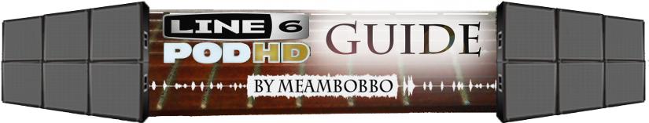**

**Welcome**

This guide is not designed to be read front to back, and it is not a light read. If you are new to this guide, I suggest looking at the introduction section before proceeding. If you are looking for quick tips or troubleshooting advice, I recommend you go to the [quick guide](#_II._Quick_Guide) or [troubleshooting](#_IX._TroubleShooting) pages. Each section is relatively-independent of the others and are linked when there are cross-references. It is best used as an on-hand reference for any given task you are attempting to accomplish with the Pod.

For a more general FAQ, see [this helpful link](http://line6.com/support/docs/DOC-2300) provided by Line 6.

Also available in the following printable formats:

[.pdf/Acrobat](http://foobazaar.com/podhd/toneGuide/MeAmBobbo_PodHD_Guide.pdf)

[.docx/Word](http://foobazaar.com/podhd/toneGuide/MeAmBobbo_PodHD_Guide.docx)

**Brief Contents**

* [I. Introduction](#_I._Introduction)
* [II. Quick Guide](#_II._Quick_Guide)
* [III. Guitar Setup](#_III._Guitar_Setup)
* [IV. Pod Setup](#_IV._Pod_Setup)
* [V. Amp/Distortion Tone](#_V._Amp/Distortion_Tone)
* [VI. Cab/Mic Tone](#_VI._Cabs_and)
* [VII. EQ](#_VII._EQ)
* [VIII. Tips and Pitfalls](#_VIII._Tips_and)
* [IX. Troubleshooting Guide](#_IX._TroubleShooting)
* [X. FAQ and Links](#_X._FAQ_and)
* [XI. Wishlist](#_XI._Wish_List)
* [XII. Effects](#_XII._Effects)
* [XIII. Glossary](#_XIII._Glossary)
* [XIV. Change Log](#_XIV._Change_Log)
* [Appendices](#_Appendix_A_–)

**Full Contents**

[**I. Introduction**](#_I._Introduction)

* [Section Overview](#_Section_Overview)

**[II. Quick Guide](#_II._Quick_Guide)**

* [A. Quirks](#_A._Quirks)
* [B. Patch Building Tips](#_B._Patch-building_Tips)
* [C. High Gain Amp Round-Up](#_C._High-Gain_Amp)
* [D. Cab/Mic Round-Up](#_D._Cabs/Mics_Roundup)
* [E. Pre-EQ'ing a Distortion Tone](#_E._Pre-EQ'ing_a)
* [F. Distortion Effect Round-Up](#_F._Distortion_Effects)
* [G. Gain Staging](#_G._Gain_Staging)
* [H. EQ Effect Round-Up](#_H._EQ_Effects)
* [I. Top Ten Tweaks](#_I._Top_Ten)
* [J. Killing Fizz](#_J._Killing_Fizz)
* [K. Mids for Metal](#_K._Mids_for)
* [L. Dual Cabs](#_L._Dual_Cab)
* [M. Noise Gate Usage](#_M._Noise_Gate)
* [N. Amp DEP's](#_N._Amp_DEP's)
* [O. Cab DEP's](#_O._Cab_DEP's)
* [P. Output Modes](#_P._Output_Modes)
* [Q. Input Settings](#_Q._Input_Settings)

**[III. Guitar Setup](#_III._Guitar_Setup)**

* [A. New Strings](#_A._New_Strings)
* [B. String Gauge](#_B._String_Gauge)
* [C. Action](#_C._High-Gain_Amp)
* [D. Fret Buzz](#_D._Fret_Buzz)
* [E. Intonation](#_E._Intonation)
* [F. Pickups](#_F._Pickups) 
  + [i. Single-Coil vs. Humbuckers](#_i._Single-Coil_vs.)
  + [ii. Pickup Position](#_ii._Pickup_Position)
  + [iii. Signal-to-Noise Ratio](#_iii._Signal-to-Noise_Ratio)
  + [iv. Frequency Response](#_iv._Frequency_Response)
  + [v. Actives vs. Passives](#_v._Actives_vs.)
  + [vi. All about Blackouts](#_vi._All_about)
  + [vii. Pickup height on passives](#_vii._Pickup_Height)
  + [viii. Pickup height on actives](#_viii._Pickup_Height)
  + [ix. Pickup Suggestions](#_ix._Pickup_Suggestions)
* [G. Bridge](#_G._Bridge)
* [H. Nut](#_H._Nut)
* [I. Body/Fretboard/Tuners/Neck-through/etc.](#_I._Body/Fretboard/Tuners/Neck-throu)

**[IV. Pod Setup](#_IV._Pod_Setup)**

* [A. Understanding Output Modes](#_A._Understanding_Output) 
  + [i. Simple Guide for Settings](#_i._Simple_Guide)
  + [ii. Where Confusion Sets In](#_ii._Where_Confusion)
  + [iii. Global EQ](#_iii._Global_EQ)
  + [iv. Live-Voiced Cabs](#_iv._Live-Voiced_Cabs)
  + [v. Cab/Mic Simulation](#_v._Cab/Mic_Simulation)
  + [vi. Bass-Boost](#_vi._Bass_Boost)
  + [vii. Output Mode Feature Chart](#_vii._Output_Mode)
* [B. Internal Signal Routing](#_B._Internal_Signal)
* [C. Running "direct" (PA/board/computer or DAW/monitors/headphones)](#_C._Running_Direct) 
  + [i. Simple method (no real amp)](#_i._Simple_method)
  + [ii. Using a real amp as a pre-amp](#_ii._Using_a)
* [D. Running to an amp ("live")](#_D._Running_to) 
  + [i. Amp without effects loop](#_i._Amp_without)
  + [ii. Pod as Effects Only after pre-amp](#_ii._Pod_as)
  + [iii. Simple setup for amp with effects loop](#_iii._Simple_setup)
  + [iv. 4 Cable Method](#_iv._4_Cable)
* [E. I Tried This and It Doesn't Sound Good](#_E._I_Tried)
* [F. Dual Outputs](#_F._Dual_Output)
* [G. Wet/Dry/Wet Output](#_G._Wet/Dry/Wet_Output)
* [H. Using Multiple Instruments](#_H._Multiple_Instruments/Independent)
* [I. Input Settings](#_I._Input_Settings)
* [J. The FX Loop](#_J._The_Effects)
* [K. The Mixer Block](#_K._The_Mixer)
* [L. Effects Order/Position](#_L._Effects_Order/Position)
* [M. Gain Staging](#_M._Gain_Staging)
  + [i. Principle](#_i._Principles)
  + [ii. Practice](#_ii._Practice)

**[V. Amp/Distortion Tone](#_V._Amp/Distortion_Tone)**

* [Distortion Types/Overview](#_A._Distortion_Types/Overview)
* [B. Pre-EQ'ing](#_B._Pre-EQ'ing)
  + [i. Frequency Chart](#_i._Frequency_Chart)
* [C. Gain Staging/Layering Distortions](#_C._Gain_Staging/Layering)
* [D. High-Gain Amps](#_D._High-Gain_Amps)
  + [i. Park 75](#_i._Park_75)
  + [ii. Plexi Bright](#_ii._Plexi_Bright)
  + [iii. JCM-800](#_iii._JCM-800)
  + [iv. Uberschall](#_iv._Uberschall)
  + [v. Dual Rectifier](#_v._Dual_Rectifier)
  + [vi. Fireball](#_vi._Fireball)
  + [vii. Elektrik](#_vii._Elektrik)
  + [viii. Dual Rectifier "Pre"](#_viii._Dual_Rectifier)
  + [ix. SLO Overdrive](#_ix._SLO_Overdrive)
  + [x. Doom](#_x._Doom)
  + [xi. Epic](#_xi._Epic)
* [E. Distortion Effects](#_E._Distortion_Effects) 
  + [i. Tube Drive](#_i._Tube_Drive)
  + [ii. Screamer](#_ii._Screamer)
  + [iii. Classic Distortion](#_iii._Classic_Distortion)
  + [iv. Overdrive](#_iv._Overdrive)
  + [v. Facial Fuzz](#_v._Facial_Fuzz)
  + [vi. Line 6 Distortion](#_vi._Line_6)
  + [vii. Line 6 Drive](#_vii._Line_6)
  + [viii. Others](#_viii._Others)
* [F. Power Amp DEP's](#_F._Power_Amp)
* [G. Dual Amps](#_G._Dual_Amps)
* [H. "Full" vs. "Pre"](#_H._\"Full\"_vs.)
* [I. The Elusive Pure Clean Tone](#_I._The_Elusive)
* [J. Noise Gates](#_J._Noise_Gates)

[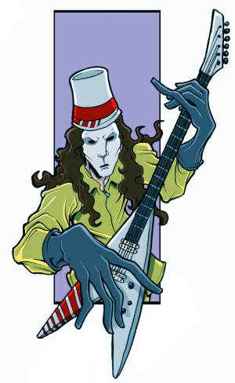](#_V._Amp/Distortion_Tone)

**[VI. Cabs and Mics](#_VI._Cabs_and)**

* [A. Cab/Mic Overview](#_A._Cab/Mic_Overview)
* [B. Cab Selection for Direct Tones](#_B._Cab_Selection)
  + [i. My Favorites](#_i._My_Favorites)
  + [ii. General Tips](#_ii._General_Tips)
  + [iii. Hiway 4x12](#_iii._Hiway_4x12)
  + [iv. Tread V-30 4x12](#_iv._Tread_V-30)
  + [v. XXL V-30 4x12](#_v._XXL_V-30)
  + [vi. Greenbacks 4x12](#_vi._Greenbacks_4x12)
  + [vii. Uber 4x12](#_vii._Uber_4x12)
  + [viii. Brit-T75 4x12](#_viii._Brit-T75_4x12)
* [C. Cab Selection for Live Tones](#_C._Cab_Selection)
* [D. Mic Selection](#_D._Mic_Selection) 
  + [i. SM57 On/Off Axis](#_i._SM57_On/Off)
  + [ii. Dynamic Mics](#_ii._Dynamic_Mics)
  + [iii. Condenser Mics](#_iii._Condenser_Mics)
  + [iv. Ribbon Mics](#_iv._Ribbon_Mics)
* [E. Dual Cabs](#_E._Dual_Cabs)
  + [i. Introduction](#_i._Introduction_1)
  + [ii. Getting the Patch Ready](#_ii._Getting_the)
  + [iii. Phase Correction](#_iii._Phase_Correction)
  + [iv. EQ'ing the Tone](#_iv._EQ'ing_the)
  + [v. Other Amp Settings](#_v._Other_Amp)
  + [vi. E.R. Settings](#_vi._E.R._Settings)
  + [vii. DSP Management](#_vii._DSP_Management)
  + [viii. My Favorite Combinations](#_viii._My_Favorite)
* [F. Cab DEP's](#_F._Cab_D.E.P.'s)
* [G. E.R.](#_G._E.R.)

**[VII. EQ](#_VII._EQ)**

[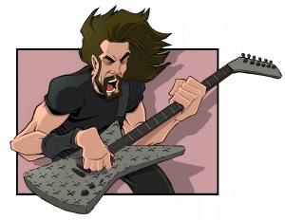](http://foobazaar.com/podhd/toneGuide/logClick.php?URL=www.facebook.com/pages/Tim-Lattie-Lattie-Ink/286798551346605)

* [A. Classifying the Frequency Spectrum](#_A._Classifying_the)
* [B. How to EQ a Hard Rock Tone](#_B._How_to)
* [C. The Pod HD's EQ Effects](#_C._The_Pod)
  + [i. Graphic EQ](#_i._Graphic_EQ)
  + [ii. Parametric EQ](#_ii._Parametric_EQ)
  + [iii. Studio EQ](#_iii._Studio_EQ)
  + [iv. 4 Band Shift EQ](#_iv._4_Band)
  + [v. Mid-Focus EQ](#_v._Mid-Focus_EQ)
  + [vi. Q Filter](#_vi._Q_Filter)
* [D. EQ'ing your Patch](#_D._EQ'ing_your)
* [E. Fizzy Spots](#_E._Fizzy_Spots)

**[VIII. Tips and Pitfalls](#_VIII._Tips_and)**

[**Tips :-)**](#_A._Tone_Matching)

* [A. Tone Matching](#_A._Tone_Matching)
* [B. Branching/Evolving Patches](#_B._Branching/Evolving_Patches)
* [C. Setlist Tips](#_C._Setlist_Tips)
* [D. Effect Switching/Tips](#_D._Effect_Switching/Tips)
* [E. Recording Tips](#_E._Recording_Tips)
* [F. Monitoring](#_F._Monitoring)
* [G. DSP Allocation/Advice](#_G._DSP_Allocation/Advice)
* [H. Mesa/Boogie Mark II/IV tone](#_H._Mesa_Boogie)
* [I. Clean Boost](#_I._Clean_Boost)
* [J. Leveling Patches](#_J._Leveling_Patches)

[**Pitfalls :-(**](#_K._Clarifying_Confusing)

* [K. Clarifying Confusing Volume Controls](#_K._Clarifying_Confusing) 
  + [i. The Pad Switch](#_i._The_Pad)
  + [ii. The MASTER Knob](#_ii._The_MASTER)
  + [iii. Ch. Vol./VOLUME Knob](#_iii._Amp/Channel_Volume)
  + [iv. Mixer Levels](#_iv._Mixer_Levels)
  + [v. The Master DEP](#_v._Master_D.E.P.)
* [L. Clipping Guide](#_L._Clipping) 
  + [i. Input Clipping](#_i._Input_Clipping)
  + [ii. Signal Clipping](#_ii._Signal_Clipping)
  + [iii. Effects Clipping](#_iii._Effects_Clipping)
  + [iv. Clipping External Devices](#_iv._Clipping_external)
  + [v. "Digital" Clipping (Crossover Distortion) on "Full" Amp Models](#_v._\"Digital_Clipping\)
* [M. Bad Monitoring](#_M._Bad_Monitoring) 
  + [i. Acoustic Tone](#_i._Acoustic_Tone)
  + [ii. Bad Monitors](#_ii._Bad_Monitors)
  + [iii. Bad Room](#_iii._Bad_Room)
  + [iv. Low Volume](#_iv._Low_Volume)
* [N. Wrong Output Mode](#_N._Wrong_Output)
* [O. Gain Staging](#_O._Gain_Staging)
* [P. Outside vs. Inside a Mix](#_P._Outside_vs.)
* [Q. Using Others' Patches](#_Q._Relying_on)

**[IX. Troubleshooting Guide](#_IX._TroubleShooting)**

* [A. Too much noise](#_A._Too_much)
* [B. Tone is fizzy](#_B._Tone_is)
* [C. Tone is harsh](#_C._Tone_is)
* [D. Tone has digital clipping](#_D._Tone_has)
* [E. Tone is muffled](#_E._Tone_is)
* [F. Distortion is muddy/fuzzy/farty](#_F._Distortion_is)
* [G. Distortion is dirty/gritty](#_G._Distortion_is)
* [H. Tone is thin](#_H._Tone_is)
* [I. Software Knobs move on their own](#_I._Software_Knobs)
* [J. I'm Getting DSP Limit Reached Errors](#_J._I'm_Getting)

[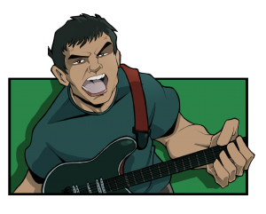](http://foobazaar.com/podhd/toneGuide/logClick.php?URL=www.facebook.com/pages/Tim-Lattie-Lattie-Ink/286798551346605)

**[X. FAQ and Links](#_X._FAQ_and)**

* [A. Frequently Asked Questions](#_A._Frequently_Asked) 
  + [i. Tone](#_i._Tone)
  + [ii. Output/Routing](#_ii._Output/Routing)
  + [iii. Usage](#_iii._Usage)
  + [iv. Compatibility/Hardware](#_iv._Compatibility/Hardware)
  + [v. Misc](#_v._Misc.)
* [B. Links](#_B._Links) 
  + [i. General](#_i._General)
  + [ii. Forums](#_ii._Forums)
  + [iii. Pod HD Reference Material](#_iii._Pod_HD)
  + [iv. Guides](#_iv._Guides)
  + [v. Patches](#_v._Patches)
  + [vi. Site Artwork](#_vi._Site_Artwork)

**[XI. Wish List](#_XI._Wish_List)**

* [A. Output Modes, Cabs, and IR's](#_A._Output_Modes,)
* [B. Amps](#_B._Amps)
* [C. Utilities](#_C._Utilities)
* [D. Routing](#_D._Routing)
* [E. EQ's](#_E._EQ's)
* [F. Footswitches/Controls/Midi](#_F._Footswitches/controls/Midi)
* [G. Effects](#_G._Effects)
* [H. DSP Saving Features](#_H._DSP_Saving)
* [I. Devkit](#_I._Devkit)

[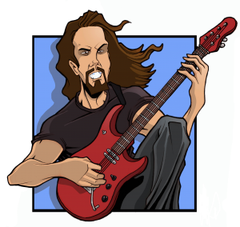](http://foobazaar.com/podhd/toneGuide/logClick.php?URL=www.facebook.com/pages/Tim-Lattie-Lattie-Ink/286798551346605)

**[XII. Effects](#_XII._Effects)**

* [A. Preferred Effects](#_A._Preferred_Effects)
  + [i. Chorus](#_i._Chorus)
  + [ii. Flangers](#_ii._Flanger)
  + [iii. Compressors](#_iii._Compressors)
  + [iv. Reverb](#_iv._Reverb)
  + [v. Delay](#_v._Delay)
  + [vi. Pre-EQ](#_vi._Pre-EQ)
* [B. Dialing in the Flangers](#_B._Dialing_in)
* [C. Substitutes](#_C._Substitutes)
* [D. Ordering](#_D._Ordering)

**[XIII. Glossary](#_XIII._Glossary)**

* [A. Signal-Based Terms](#_A._Signal-Based_Terms)
  + [i. Clipping](#_i._Clipping)
  + [ii. Distortion](#_ii._Distortion)
  + [iii. Signal](#_iii._Signal)
  + [iv. Noise](#_iv._Noise)
  + [v. Signal-to-Noise Ratio (SNR)](#_v._Signal-to-Noise_Ratio)
  + [vi. Impedance](#_vi._Impedance)
  + [vii. Signal Chain](#_vii._Signal_Chain)
  + [viii. Mono](#_viii._Mono)
  + [ix. Stereo](#_ix._Stereo)
  + [x. Field](#_x._Field)
  + [xi. Balance](#_xi._Balance)
  + [xii. Pan](#_xii._Pan)
* [B. EQ-Based Terms](#_B._EQ-Based_Terms) 
  + [i. Frequency Response](#_i._Frequency_Response)
  + [ii. Equalization/EQ](#_ii._Equalization/EQ)
  + [iii. Filter](#_iii._Filter)
  + [iv. Band-Stop](#_iv._Band-Stop)
  + [v. Band-Pass](#_v._Band-Pass)
  + [vi. Low/High Pass](#_vi._Low-Pass/High-Pass)
  + [vii. Shelf](#_vii._Shelf)
  + [viii. Peak/Valley](#_viii._Peak/Valley)
  + [ix. Q](#_ix._Q)
  + [x. Cutoff](#_x._Cutoff)
  + [xi. Parametric EQ](#_xi._Parametric_EQ)
  + [xii. Graphic EQ](#_xii._Graphic_EQ)
  + [xiii. Notch EQ](#_xiii._Notch_EQ)
* [C. Tone-Based Terms](#_C._Tone-Based_Terms)
  + [i. Tone](#_i._Tone_1)
  + [ii. Fizz](#_ii._Fizz)
  + [iii. Buzz](#_iii._Buzz)
  + [iv. Grinding](#_iv._Grinding)
  + [v. Crunchy](#_v._Crunchy)
  + [vi. Chunky/Punchy](#_vi._Chunky/Punchy)
  + [vii. Fuzzy](#_vii._Fuzzy)
  + [viii. Cold](#_viii._Cold)
  + [ix. Warm](#_ix._Warm)
  + [x. Hot](#_x._Hot)
  + [xi. Dry](#_xi._Dry)
  + [xii. Wet](#_xii._Wet)
  + [xiii. Dark](#_xiii._Dark)
  + [xiv. Bright](#_xiv._Bright)
  + [xv. Smooth](#_xv._Smooth)
  + [xvi. Squishy/Saturated](#_xvi._Squishy/Saturated)
  + [xvii. Djenty](#_xvii._Djenty)
  + [xviii. Splatty](#_xviii._Splatty)
  + [xix. Crackly](#_xix._Crackly)
  + [xx. Clanking](#_xx._Clanking)
  + [xxi. Ice-Pick](#_xxi._Ice-Pick)
  + [xxii. Harsh](#_xxii._Harsh)
  + [xxiii. Muddy](#_xxiii._Muddy)
  + [xxiv. Thin](#_xxiv._Thin)
  + [xxv. Brittle](#_xxv._Brittle)
  + [xxvi. Thick](#_xxvi._Thick)
  + [xxvii. High Gain](#_xxvii._High-Gain)

**[XIII. Change Log](#_XIV._Change_Log)**

# [Appendix A – Line 6 Effect Processing Diagrams](#_Appendix_A_-)

# [Appendix B - Line 6 Effect Processing Table](#_Appendix_B_-)

[**Appendix C – Cabinet/Mic Phase Correction Timing Data**](#_Appendix_B_–_1)

[**Appendix D – DSP Usage of Effects**](#_Appendix_D_–)

# I. Introduction

The purpose of this guide is to provide the details Line 6 didn't provide, mostly geared towards getting high gain tones with the Pod HD 500, which can take a ton of effort to properly dial in. It also applies to the Pod HD 300, 400, Desktop, and Pro; however, there may be a few things here and there impossible to do on the 300/400 (like using multiple effects), or that don't make sense on the Desktop.

It may seem like I'm treading a lot of ground that [the manuals](http://line6.com/support/manuals/podhd500) covered, but while I'm covering the same topics, I'm providing details on these topics that were not clearly spelled out, which I've learned through personal experience or from other members on this forum.

The Pod HD seems geared towards a wide variety of users. The high gain folks got some attention, but I don't think they got enough. I have absolutely ZERO patches that I find sound like a real mic'ed amp and cab that don't use numerous EQ effects and involve using different cab and mic models than the default for that amp model. People using the unit for different genres seem to have had a much different experience. Many reviews have mirrored this sentiment.

Simply put, the default high gain settings sound more like a cheap modeler than a real amp. The tone is unbalanced, sounding muffled, harsh, fizzy, or simply lacking that rich quality that inspires awe. Often, an amp's distortion is too muddy or dirty, or simply not djenty enough. After a few hours, many users have posted on the forums saying that the unit is no good for metal, declaring their regret in selling off their XT or X3.

Dialed in correctly, the HD blows away the XT/X3. It requires a fine attention to detail that this guide provides. This involves hooking and setting up the Pod properly. It involves knowing the common pitfalls, which can make the Pod start clipping unexpectedly. You will likely have to EQ your tone before your distortion phase to "sculpt" your distortion tone. You'll have to get a firm grip on the nuances of the cabs and mics, initially ignoring their diverse and varied general frequency responses. You'll have to learn how to use the EQ effects to compensate for the cab/mic frequency responses as well as dial in a balanced tone.

I primarily focus on high gain tones, but I also like some nice clean, classic rock, and blues tones. Some of the artists I've sought to emulate include SRV, EVH, Satch, Vai, Petrucci, KSE, Periphery, Meshuggah, Metallica, Randy Rhodes, AC/DC, and Opeth. If you can dial in all those sounds, you should have no problem dialing in almost any rock tone you want. I cover all 5 of the high gain amps, plus the Park 75 and Plexi. While this guide is primarily geared towards high gain, the methods described here will work for other tones. I consider my guide on [clipping](#_L._Clipping) essential reading for all Pod HD users.

You can jump around in this guide. I don't expect many people to read it front to back; it's a lot of material. If you have a particular issue or are curious about an aspect or two of the unit, use the table of contents to find its location and jump straight to it. If you're just looking for a quick piece of advice, try the [quick guide](#_II._Quick_Guide).

### 

### Section Overview

Use the [Quick Guide](#_II._Quick_Guide) for brief advice on dialing in a patch. All the subjects are covered in-depth elsewhere. It does not include hookup/setup advice.

The [Guitar Setup](#_III._Guitar_Setup) page doesn't really deal with the Pod at all but covers some common issues guitarists may have dialing in a high gain sound. Topics include pickups, string gauge, action, intonation, fret buzz, and bridge setup.

[Hookup/Setup](#_IV._Pod_Setup) covers output modes, signal routing, input settings, and physical connections between the unit and other pieces of gear. It explores your options for the gear you have and what the advantages and disadvantages are.

[Distortion/Amp Tone](#_V._Amp/Distortion_Tone) starts with a description of distortion types and how a signal's frequency response affects distortion. Then I describe the tone of the high-gain amps and the distortion effects I most commonly use, along with how I like to use them and pitfalls to avoid. I discuss how the Amp DEP's affect tone and how I like to use them.

[Cabs and Mics](#_VI._Cabs_and) covers cab and mic selection, using dual cabs, and the Cab DEP's.

[EQ Guide](#_VII._EQ) starts as a general discussion of EQ'ing a guitar tone. It includes my more detailed breakdown of a guitar tone's frequency spectrum, rather than lumping the frequency spectrum into the terms bass/mid/treble/presence that I find aren't narrow enough and have floating definitions. I break-down the EQ effects included in the Pod HD and how I like to use them, including eliminating fizz.

[Tips and Pitfalls](#_VIII._Tips_and) - tips for tone matching, evolving patches, setlist organization, effect switching, recording, monitoring, and managing DSP; tricks for using the FX loop for wet/dry or dual output; pitfalls such as bad monitoring, wrong output modes, clipping and gain staging, low volume tweaking, tone outside vs. inside a mix, and relying on others' patches.

[Troubleshooting](#_IX._TroubleShooting) describes common complaints I've heard on the forums. I offer a quick piece of advice or two, then redirect you to the appropriate section of this guide that describes the issue in detail.

[FAQ/Links](#_X._FAQ_and) has answers to the most common questions I've heard beyond really simple stuff that glancing at the manual would answer. I also post lots of links to reference material, forums, guides, etc.

The [wishlist](#_XI._Wish_List) has all the features I wish the Pod HD had. Hopefully you agree and send Line 6 feedback on this.

# II. Quick Guide

* [A. Quirks](#_A._Quirks)
* [B. Patch Building Tips](#_B._Patch-building_Tips)
* [C. High Gain Amp Round-Up](#_C._High-Gain_Amp)
* [D. Cab/Mic Round-Up](#_D._Cabs/Mics_Roundup)
* [E. Pre-EQ'ing a Distortion Tone](#_E._Pre-EQ'ing_a)
* [F. Distortion Effect Round-Up](#_F._Distortion_Effects)
* [G. Gain Staging](#_G._Gain_Staging)
* [H. EQ Effect Round-Up](#_H._EQ_Effects)
* [I. Top Ten Tweaks](#_I._Top_Ten)
* [J. Killing Fizz](#_J._Killing_Fizz)
* [K. Mids for Metal](#_K._Mids_for)
* [L. Dual Cabs](#_L._Dual_Cab)
* [M. Noise Gate Usage](#_M._Noise_Gate)
* [N. Amp DEP's](#_N._Amp_DEP's)
* [O. Cab DEP's](#_O._Cab_DEP's)
* [P. Output Modes](#_P._Output_Modes)
* [Q. Input Settings](#_Q._Input_Settings)

This guide is too long. Here are some quick tips to get you dialed in without having to bust out your reading glasses. Note that, if you want more info, all of these topics are covered throughout the guide in more depth.

## A. Quirks

There are a few quirks with this unit you should always keep in mind to get the most out of it. If you miss these, you might become unnecessarily frustrated with the unit.

**Single Lines = Stereo Signals**

All the lines you see in the Pod editor's signal path and in the HD Edit software are stereo signals, including each for Channels A and B. You do not need to use both Channel A and B to get stereo functionality.

**Mixer Pan Controls**

The Mixer blocks "pan" controls do not push the complete left/right stereo signal into the left or right field when panning full left or right. It simply drops the opposite field. In other words, panning full right on Channel A means you are simply muting the left field of Channel A.

**Mono-Summing vs. Stereo Effects**

Many of the effects will sum to mono before processing. In other words the stereo input signal is mixed down to a mono signal, processed, then split back into a stereo signal with equal left/right fields. This means anytime you use a mono-summing effect, you will get identical left/right output. If you use a stereo effect before a mono-summing effect, the stereo aspect of it will be eliminated. Thus, you should use stereo effects last in the chain. The most common mono-summing effects are the dynamic and distortion effects, as well as the amp blocks. EQ, delay, and reverb effects are stereo.

[Appendix A](#_Appendix_A_-) has diagrams that show how the four types of processing are applied inside the effects.

[Appendix B](#_Appendix_B_-) has a table that tells you which type of processing each effect uses.

**Use Channel A Only for Single-Amp Patches**

The easiest way to design your patches if you are not using dual amps is to place everything in Channel A (the top line after the signal path split). Then you mute Channel B in the mixer and pan Channel A to center. You may have to select an amp model before being able to move the amp block into Channel A.

This means Input 1 is routed to Channel A and Input 2 is routed to Channel B where it is muted. Thus, you don't have to worry about the Input 2 issue. Also, it means the Mixer is the last piece of your chain and can be used to set the final output volume of the patch, allowing you to keep earlier volume settings conservative, so you don't max out the internal signal resolution or get other unwanted clipping.

As mentioned above, Channel A is a stereo signal, so you still retain all stereo effects.

**Signal Routing**

Input 1 is sent to the left field of the initial stereo signal, and Input 2 to the right field. When the signal hits the channel split, the left field goes to Channel A and the right to Channel B. So you can use two different instruments in the Pod as long as you do not place any mono-summing effects in front of the channel split, and select different input sources for Input 1 and 2.

**Mono-summing Outputs**

The 1/4" unbalanced outputs sum to mono if only one of the outputs has a cable inserted. If you want to use the left 1/4" output and right XLR output, you have to put a dummy cable (attached to nothing else) in the right 1/4" output. The XLR outputs never sum to mono.

**MASTER Knob**

This knob only affects analog output volume (1/4", XLR, and headphones). The manual recommends setting it to max for the best signal-to-noise ratio. I agree, but sometimes this means you are clipping whatever you are running the Pod into. Then you have to back off a bit. Also, when running the four cable method with some amps like the Peavey ValveKing and 6505 that do not have a true Master Volume knob, you have to use the Pod's MASTER knob to control your volume and may end up setting it far lower than max.

**Input Settings Global/Patch Option**

Even though the Input Settings are located in the System Menu, they are not necessarily global. There is a setting on that page that determines whether they apply globally or per patch. I like to use per patch. Even though I almost always use the same Input 1/2 settings, I occasionally change Input Impedance.

**VOLUME Knob/Ch. Vol. Functionality**

The VOLUME knob (Ch. Vol on the amp block in HD Edit) is a tone-independent volume control that affects the output level of the amp block. The Master DEP is what should be used to get a "pushed" power section, not this control. I recommend keeping this knob at conservative levels (~50% or less), otherwise you can get unwanted clipping - either of sensitive downstream effects like many of the EQ's or of the Pod's internal digital resolution.

**Input 2**

I like to set Input 2 to Variax. This isn't an issue if you put everything in Channel A for a single amp patch as mentioned above; however, I often run dual amp patches. Input 2: Guitar/Same seems to create a slight phasing effect, which becomes very apparent when running a mono-summing effect such as a Distortion effect before the path split. It also seems to create a louder than expected signal that pushes effects and amps harder than they seem to be designed. For example, with Input 1 and 2 set to Guitar, a Screamer effect in front the path split distorts, even at 0% Drive. Or for a Blackface Dbl amp model in front the path split, you will get crossover distortion even at very low Drive settings, sometimes even 0%.

If you have already created single amp patches where you did not put everything in Channel A, try changing Input 2 to Variax (or Mic or some other unused input) and make this a global setting and demo all your patches. You may need to add gain/compression to your earliest effect(s) to get them back to the distortion or compression or volume level you want, but they will likely sound a bit more crisp and responsive.

**Dual Path Phase Issues**

One thing that particularly confused me at first was that certain effects apply a very slight latency to the tone, particularly EQ's and compressors. Putting these in one of the Channels before the mixer but not the other can cause a comb filter effect, cancelling out some high end frequencies or maybe even more. So if you want to put an EQ in Channel A, you may want to put the same EQ in Channel B with neutral settings to avoid the comb filter effect.

I tend to like to use what I can dual cabs - dual amps with the same amp model but different cab/mic settings. The issue is that certain combinations run into the phasing issue. I take advantage of the EQ/compressor latency to resolve this as much as possible. With the right settings, the tone has less of a looseness and phasing to it, and regains crisp high-end. See [here](#_iii._Phase_Correction) for more info.

**Sensitive EQ Effects**

Many EQ effects will clip on even a barely hot signal going into them. As mentioned above, I like to keep the VOLUME knob (Ch. Vol.) low to prevent this after my amp block. But it can even occur if they are the first effect in your chain. The Mid-Focus EQ is the worst offender, followed by the Parametric EQ. The Studio EQ is the best.

To prevent clipping, I'll often put a Volume effect in front of such EQ's, attenuating the signal strength. The Volume effect uses barely any DSP. Just be sure to disable the default expression pedal control and manually set it to the exact setting to prevent the EQ from clipping. If you're using the Mid-Focus EQ, you can boost the signal strength back up using its Gain parameter. Or if you have a Compressor, boost the signal level with that. Otherwise, just use more Drive from either a downstream distortion effect or amp block.

[Top of Quick Guide](#_II._Quick_Guide)

## B. Patch-building Tips

I divide my tone hunt into several groups: [amp selection](#_C._High-Gain_Amp), [cab/mic selection](#_D._Cabs/Mics_Roundup), [pre-EQ'ing](#_E._Pre-EQ'ing_a), [gain staging](#_G._Gain_Staging), amp EQ'ing, [post-EQ'ing](#_H._EQ_Effects), [amp DEP's](#_N._Amp_DEP's_1), [cab DEP's](#_O._Cab_DEP's_1), and [effects](#_XII._Effects). I usually approach any patch in that order, but as the patch comes together I start jumping around and making various improvements.

I start by choosing what I think is the ideal amp model - that also clues me in to whether I want to pre-EQ the amp, and how I want to do so. For instance, I know if I want a really warm tone, I'll use a Tube Drive, and if I want it to have a nice crunch I'll use a Marshall amp. Try to familiarize yourself with how each amp is affected by pre-EQ'ing using EQ's, the Tube Drive, and the Screamer effects - those are the main filter/boosts you're likely going to use, and they have more impact on tone than the Amp or Cab DEP's, post-EQ'ing, or other effects. If I'm going for an artist's tone, I try to match his rig as a starting point.

For a direct tone, if you need a lot of effects (or expensive effects like pitch shifting or spring reverb), you probably won't have enough DSP to do a dual amp setup, so you can use dual cabs. Otherwise, I recommend you try a dual cab configuration. It takes a bit more time to dial in, but the tone is worth the payoff. See [here](#_L._Dual_Cab_1) for instructions to set that up. If you are running to a real amp or using external IR's, don't worry about dual cabs, or dual amps in general.

I add effects to my patch in the order of importance. That way if I run into DSP limit errors, I don't need to rebuild my patch. Be aware of how expensive each effect/amp is DSP-wise. You can find that info [here](#_G._DSP_Allocation/Advice). Be aware of common substitutions or other ways to save DSP.

[Top of Quick Guide](#_II._Quick_Guide)

## C. High-Gain Amp Roundup

For more detail on amp models, see the [Distortion/Amp Tone page](#_V._Amp/Distortion_Tone).

**Plexi Bright**

Think early Van Halen - classic Marshall tone. Great amp model with few pitfalls. Sounds even better with a Tube Drive in front. All the distortion is coming from the power section, so the way you EQ it will affect the distortion tone.

**Park 75**

Similar to the Plexi, but with a bit more of a vintage vibe - it's hard to a djent palm mute out of it. Makes for a good AC/DC tone. Again, all the distortion is in the power amp, so watch your EQ, especially the presence. Too much presence sounds like the amp is damaged.

**J-800**

Classic high-gain Marshall hair metal tone. This isn't the best model, IMO. It has more gain than the Park and Plexi, but also less dynamic response and sounds a little less quality. I like to boost the Master DEP to about 65% to get more power amp distortion, which gives it more bite. Again, EQ'ing matters, but presence is more forgiving. Sounds good with a Tube Drive or Screamer in front. I use it for Megadeth tones.

**Uber**

By default this model is too muddy for my tastes. I always pre-EQ it, filtering out some low end. I find boosting the Hum DEP a touch gets it in a Mesa/Boogie Mark II/IV ballpark. Boosting it a bit more gets it closer to a 5150. After making these tweaks, it's one of my favorite amp models, considering I love the Mesa and Peavey amps I just mentioned.

**Treadplate**

Very aggressive tone. The "full" model has much more bite than the "pre" model. If you prefer the "pre", try backing off the Master DEP when using the "full" model to find the sweet spot. It's difficult to really change the tone by simple pre-EQ'ing, but a Screamer can tighten it up nicely. I find boosting some warm (lower) mids before the amp can make it a bit less agro and have a sweeter tone. The bass it puts out is obnoxious. I find I need to use a Parametric EQ with Freq at 15% and Gain around 35% to get it in the same ballparks as other amp models. In general this amp model is too aggressive for my tastes, but it is great when tamed.

**F-ball**

Great amp model - captures the distinct ENGL tone. Good on its own but can be made more aggressive and djenty with a presence-emphasis by pre-EQ'ing out some bass. Goes well with a Screamer in front. I make this amp my go-to for a nice modern metal tone.

**Elektrik**

Not a fan. Seems like a watered-down version of the Uber. The initial draw is that it doesn't have the muddiness issue the Uber does, but once you tweak the Uber to get rid of that, the Uber sounds better than this model. Also, the default setting for the Master DEP is 100%, which I think sounds awful - if you're gonna use it, make that's the first thing you adjust.

**SLO Overdrive**

I think of this as the Plexi on roids. It's a bit looser than some of the other amps, so I find I don't use it much for a metal tone; but it has a great hard rock tone. This model responds oddly to boosts, and its EQ controls don't impact the tone as much as you'd expect.

**Doom**

Think sludgy Marshall. This is generally not my thing, so I don't use this model much. It takes boosts well, and you can get a very wide range of tones from it.

**Epic**

Very bizarre model here. I find the preamp distortion harsh and broken up or splatty. I keep Drive low, but the poweramp distortion is quite smooth, focused, and tight. So that's what I like to use to get a good tone from this amp, which makes dialing it in more difficult. The tone is very clear and dry - it's great for getting a heavy distortion tone that can chug but you also want to clearly hear every note, even inside big chords.

[Top of Quick Guide](#_III._Guitar_Setup)

## D. Cabs/Mics Roundup

For more detail on cabs/mics, see the [Cab/Mic Selection Page](#_VI._Cabs_and).

**Hiway 4x12**

This is my go-to cab. Of all the 4x12's, it seems to be the only one that sounds like real guitar speakers. It's got a well-defined midrange and high-end - nothing sounds washed out. I like to use it with the SM 57's, preferably on axis. It can be a little harsh on the high end, but that's easily filtered out by the Mid-Focus EQ. When I use dual cabs, I always make this one of the cabs. I like to reduce the Res. Level DEP a bit to make it even crispier.

**XXL V30 4x12**

Something sounds a bit off on this cab by itself, like the mids and highs are a little washed out. Boosting Res Level DEP up a bit helps bring out some mids. Still, the main draw of this cab is its huge low-end response. It's very punchy, making it great for a metalcore tone. But it can also be a little too boomy, requiring EQ to remove some low-end drone. By itself, the 409 Dyn mic tends to help bring out a decent high-end response from it. I like to use it in combination with the Hiway in a dual cab configuration using a SM 57 mic.

**Other 4x12**

The Greenbacks and Treadplate cabs have a high quality to them, but they're not as good as the Hiway. The Greenbacks do have a more unique sound, which is worth experimenting with. The Treadplate is very bright and louder than the other cabs, which needs to be compensated for. The Blackbacks and T-75 cabs sound fake and not worth using to me, but they also have their own unique tones which are worth exploring. The T-75's might be good for a vintage tone. The Uber cab is good, but it's kind of in no-man's land. I'd use it for the same applications I'd use the Hiway or Treadplate for, but the Hiway is better. It does have a better low-end response than many of the cabs though, and is a good conservative choice.

**Other cabs**

I like to use the Fender 2x12 for my Fender cleans, and for vintage tones, sometimes the G-12H sounds nice, but otherwise, I don't mess with these. Most of them sound thin and harsh, except for the PhD, which sounds a bit lacking in the mids/presence department.

**SM 57's**

The SM57 on axis is my go-to mic. By itself it can be a little bright, but it works well in a dual cab config when using the XXL as one of the cabs. It can also be EQ'ed to add in the punch and warmth it initially appears to be missing. The reason I like this mic so much is because it seems to have the least amount of noise, so all you hear is rich guitar tone. It can be a little harsh on the high end, but that's easily filtered out by the Mid-Focus EQ. The off axis variant is a little more buzzy than crisp-sounding. On its own it sounds more like a real guitar tone than the on-axis, but with EQ'ing I find they can be quite similar. I prefer the on-axis because the off axis seems to be a touch noisier and less focused in the high end.

**Dynamic Mics**

The dynamic mics sound a bit more scooped than the SM57's, and can sound a bit more aggressive in the high-end. They're also a little noisier. I prefer the 409, but I occasionally use the 421 but only in a dual cab config.

**Other mics**

Other mics are too noisy for my tastes. The '67 Condensor isn't bad tonally, but is just too noisy compared to alternatives. I might try these out for a clean or vintage tone, but I ignore them for a modern distorted tone.

[Top of Quick Guide](#_II._Quick_Guide)

## E. Pre-EQ'ing a Distortion tone

More on this [here](#_B._Pre-EQ'ing_1).

The key to getting the best-sounding distortion is pre-EQ'ing the signal before your main distortion stage, which could be a distortion effect, the amp model's pre-amp section, or the amp's power section. In the case of the amp's power section, that means the amp's EQ controls will affect the distortion tone. In the other cases, you'll likely have to add additional effects to the chain.

You can pre-EQ in several ways. The most common are to use Distortion effect as a filter or an EQ effect. To use a Distortion effect in this manner, you simply use low Drive settings. I like using one or more of the Q Filter, Line 6 Drive, Mid-Focus EQ, Parametric EQ, Tube Drive, Screamer, or even Wah Wah effects for this purpose. Other, cruder options are changing the Pod's input impedance settings or adjusting the Guitar's tone knob or changing your pickups.

The distortion tone will be defined mostly by the peak frequency range that hits the distortion stage. The way I like to think about this is going from low frequencies to higher ones, you get flubby, fuzzy, crunchy, djenty, tinny, then splatty distortion. You want to de-emphasize any aspects you don't want and emphasize the ones you do. For metal, that usually means having a nice mid-boost so you don't have any fuzz/flub or tin/grit but do have a solid crunch and djent. Of course, extreme pre-EQ'ing can hurt the tone, shrinking its frequency response causing it to be buried in a mix.

Keep in mind various amps or distortion units will respond differently to pre-EQ'ing than others.

[Top of Quick Guide](#_II._Quick_Guide)

## F. Distortion Effects Roundup

For more detail on distortion effects, see the [Distortion/Amp Tone Page](#_E._Distortion_Effects).

**Line 6 Drive**

Probably the best all-around Distortion effect. The distortion tone is great - not too much bite or anything off-putting about it. And for using it to EQ the tone, the Mids parameter acts as a center frequency, not a boost/cut. This lets you dial in the specific center frequency you want to boost an amp with.

**Tube Drive**

This is probably the most natural-sounding distortion effect. It basically adds an extra gain-stage to whatever amp you're using, although it can produce a nice distortion all on its own. I use it in front of a Plexi, and with various settings, this produces good Rhoads, Slash, and EVH tones. It has decent headroom, so you can use it as a basic compressor. It has bass/mids/treble controls that make it a good filter for pre-EQ'ing.

**Screamer**

Similar to the Tube Drive, it makes a good pre-EQ choice. I don't use it as a standalone distortion. It has a unique frequency response and compression that makes it ideal for modern metal - you get a djenty presence from it. It won't get 100% clean even at 0% drive, but its dirt tends to get incorporated into the distortion tone of whatever amp you feed it into. It's also a bit scratchier and colder than the Tube Drive.

**Classic Distortion**

This can sometimes makes a good pre-EQ filter, but is difficult to control on the bass side, often coming out too scooped. The Filter control requires experimentation to understand. The Treble control seems to affect very high frequencies and things can get harsh when boosted. I try to keep it at 50%. It will get clean at 0% Drive, and makes a decent compressor. I prefer to use the Tube Drive as a standalone distortion. I would try this out where the Tube Drive and Screamer just aren't working for some reason.

**Line 6 Distortion**

I use this as a standalone distortion, when I want a very tight, very distorted tone, similar to a Boss Metal Zone. I'll actually pre-EQ this effect, to dial in exactly the distortion I want. In this sense, it's like having an additional high-gain amp, but you have to pair it with the right amp to get a good tone out of it. I like the Park 75, as it seems to deliver a more natural frequency response than some other amps. Also the Divided by 13 works well.

**Overdrive**

I actually like to use this for a standalone distortion. Pre-EQ'ing a little bass in front gives it a nice warm fuzz tone, and it's not wonky like a lot of the other fuzzes.

**Facial Fuzz**

I use this as a part boost/part standalone distortion into a Plexi for a Hendrix tone. It's got that strange dynamic response you need for that kind of tone. By itself it's a bit much for my tastes. As a filter with mild gain, it's not really doing that much. I use medium gain and output, and let the Plexi add its distortion flavor on top the response.

**Others**

The others sound too wonky to me. The Muff in particular sounds like you're playing through damaged electronics, but maybe I'm just not using it right.

[Top of Quick Guide](#_II._Quick_Guide)

## G. Gain Staging

For more on this, see [here](#_C._Gain_Staging/Layering).

Many patches will have two or more gain/distortion stages. For instance, you may use a distortion effect, pre-amp distortion, and power amp distortion. This means you have to consider the signal level you feed each stage, how distorted the signal is when it reaches each stage, and how much gain to use on that stage.

I find I usually want a distortion effect to add a little compression and maybe a tiny bit of dirt to the signal, I want the pre-amp to provide the brunt of my distortion, and the power amp to maybe add a tiny bit of compression and/or distortion on top. Sometimes I take a different route, though, getting the brunt of my gain from a distortion effect or from the amp model's power section.

The key to finding the right tone is to experiment with the relative gain and output levels of all these stages. Sometimes you get a different tone using more output level from a distortion effect and less Drive on the pre-amp, even though the overall amount of distortion is the same. I also find distortion stages can sound overly thin or outright buggy when their Drive levels are set very low - I always try to keep them off 0%, and in the case of Marshall amps, try to keep them over 20%.

[Top of Quick Guide](#_II._Quick_Guide)

## H. EQ Effects Roundup

For more detail on EQ effects, see the [EQ'ing Page](#_C._The_Pod).

**Q Filter**

Probably the best way to pre-eq an amp or distortion effect. Use as band-pass with low Q to boost the amp. Dial in the frequency you want with the mix level you want. Increase Q to make the tone sound more focused but it'll start sounding more like a wah pedal as you go higher. Gain compresses the frequencies - this can help draw out the focused frequencies at lower levels or add more saturation to a distorted tone but can kill too much dynamics if too high.

**Parametric EQ**

The Lows and Highs parameters control shelf filters with fixed Q and cutoff frequency. They can help even out a tone, but don't rely too much on them. Frequency goes from 60 HZ to ~ 5000 HZ, with ~900 HZ at 50%. Low Q = wide boost/cuts, high Q = narrow. This effect is very useful for narrow cuts, to remove a fizz or harsh spot. It also works well for pre-EQ'ing, as you can dial in a nice mid-range hump in the exact sweet spot to get the distortion tone you want. It's also useful if you need to adjust a nice chunk of frequencies that fit between any two of the amp EQ controls. I find I often boost the punch or warmth that lies between the bass and mids knobs.

**Mid-Focus EQ**

This is useful to trim or roll-off the high and low ends of the tone. This is useful for both pre-EQ'ing and post-EQ'ing. I find it's necessary when using the SM57 on axis mic, especially with the Hiway 4x12, to get rid of the crackly high-end. The Gain parameter is a final output level, and has no control over how much filtering the EQ actually does. 50% Q is a quick drop off. Moving the Q higher will make the drop-off steeper, but also ends up boosting at the cut-off frequency (which may produce the opposite effect that you intended). 0% Q is a gradual roll-off. HP freq goes from 0-525 HZ; LP goes from 500-18,000 HZ - this is the only EQ that lets you really fine-tune the ultra high-end.

**Studio EQ**

Basically two parametric EQ's, but you cannot control Q (which is set to be quite wide) and have a limited number of center frequencies to choose from. It is most useful as a post-EQ to balance the tone when you need to get in between the amp's bass/mids/presence/treble controls. The Gain parameter boosts/cuts independent of the filtering, so I actually like this effect for a clean boost or otherwise to adjust the signal level without regard to EQ'ing.

**Graphic EQ**

5-band graphic EQ. Notice the highest adjustable frequency is 2200 HZ. This EQ is not suitable for fine-tuning presence or treble after the amp. It works best for pre-EQ'ing. Also, notice that even with completely neutral settings, it tends to brighten the signal a tad. It is useful where you want a W or otherwise irregularly-shaped curve - if you just want a simple hump or valley, use the Parametric EQ.

**4-band Shift EQ**

I never use this. It's kind of awkward and covers a lot of the same ground as the amp's bass/mids/presence/treble controls. See the [EQ Page](#_iv._4_Band) for more details.

[Top of Quick Guide](#_II._Quick_Guide)

## I. Top Ten Tweaks

1. **Pre-EQ**

Whether you use a distortion or EQ effect, pre-EQ'ing is the secret to getting the amp tone you want from the stock amps. You can remove mud or grit, make the tone warmer or more djenty, or draw out other nuances from the amp models.

1. **Mid-Focus EQ**

Using this behind the amp/mixer is great to roll-off excessive high-end and to dial in the perfect low-end. This is very helpful when using the SM57 on axis mic, or other excessively bright tones. It also works great to pre-EQ an amp - you can dial in exactly how much low-end flub and high-end grit to remove. You can also use it to set the final patch volume.

1. **Res. Level Cab DEP**

This really lets you fine-tune the cab tone, reducing some resonance to get more clarity and crispness from the cab, or increasing it to change the frequency response and add smoothness.

1. **Decay Cab DEP**

At first I wasn't sure how to use this, but now I use it all the time to thicken up an otherwise-thin tone. Turn it up to add a bit more punch to your attack.

1. **Bias X Amp DEP**

I find this is the secret knob to make your amp sound more vowel-y, where the notes sound like they're blooming. Turn it up for killer leads.

1. **Tube Drive**

Whether used as the main distortion stage, or just to warm up the tone before the amp, this effect keeps the tone sounding like a natural guitar tone. I find it can really draw out the warm mids in front of a Marshall, without causing it to lose any bite.

1. **Cab/Mic Selection**

While I tend to gravitate towards a few select cabs and mics, there are a lot of nuances in the cab/mic models that make them each unique. Sometimes a cab or mic change puts the patch over the top, especially once dialed in using the Cab DEP's.

1. **Parametric EQ**

Whether used as pre-EQ or post-EQ, this effect is perfect to dial in exactly the boost or dip you want. You can use it for small annoying frequencies, like fizz or low-end drone, or set it real wide to completely shift the frequency response.

1. **Dual Cabs**

The secret to how I get my tones to sound full-range yet crystal clear using the onboard cab/mic modeling is to use dual cabs. I'll use the XXL for its low-end punch and warmth and a brighter cab that has a clean midrange and high-end response. I can use the SM 57 on axis mic on both, and the tone comes out thick and full, rather than thin and fizzy.

1. **Input Settings**

I'm a Input 2: Variax fanboy now. For a while I just didn't hear the difference, but after some serious A/B'ing, I almost always use Input 2: Variax now. Input 2: Guitar/Same doesn't just deliver higher signal levels - it seems to have one of the signals slightly delayed, causing comb filtering and mushier tone. Using a null input like Variax gets me crisper tone. I use a mono-summing effect in front the path split to guarantee Channel B gets a signal when I have dual amps/cabs. Any Dynamic or Distortion effect should work.

As for impedance, I like to set this manually per patch. For some patches, turning it down to 230 K can dial out some grit to my tone, where I don't have the DSP necessary to pre-EQ some highs out. Also, rather than let the first effect set the impedance, sometimes I want to override it to a higher setting. For my darker guitar, I like to use 3.5 M to compensate, not 1 M which is the default for most effects when using Auto. Also, a real Tube Screamer is 500 K impedance, not 230 K which the Pod uses. So I prefer to use 1 M and trim its treble parameter rather than use 230 K.

[Top of Quick Guide](#_II._Quick_Guide)

## J. Killing Fizz

I go into this process in more detail on the [EQ'ing Page](#_E._Fizzy_Spots).

Sometimes a distortion tone will have some fizz to it. If this is just a lot of crackly high-end that can be fixed by rolling off the highs, I use a Mid-Focus EQ to do that. Also, consider a lot of the cabs/mics are rather noisy by nature, and you can't dial this out without losing a lot of the guitar tone. I like the SM 57 mics and the Hiway 4x12 as they seem to have the least noise.

Sometimes you still get an annoying fizzy sound stands out in the tone. You can eliminate it by using a Parametric EQ with a high Q value. Set your Looper to Pre position and record some playing that emphasizes the fizzy spot. Then use a Parametric EQ behind your amp, set the Q high (95%) and gain relatively high. Now sweep through the frequencies until the fizzy spot is overbearing, completely wrecking your tone. Set the Gain back to 50% and slowly dial it downwards. Stop when the fizzy spot is no longer standing out. If you cut to 0%, the fizzy spot will be gone, but it will also sound like someone took a knife to your tone.

[Top of Quick Guide](#_II._Quick_Guide)

## K. Mids for Metal

For more on EQ'ing, see the [EQ'ing Page](#_VII._EQ).

The key aspects of a metal tone are punch (200-350 HZ range), warmth (350-550), and "cold djent"(850-1400). Without these, your tone will simply sound weak or harsh when cranked up; and it won't cut through a mix. Which of these is most emphasized will define your tone; but even with one emphasized, you still want the others to be there.

I like to cut around 650 HZ (what I call "honk") to make the tone sound more metal and scooped, but if you cut too much your tone disappears, especially in a mix. Try to make the cut somewhat narrow - not too narrow or it'll sound off, and only cut a bit - don't completely kill those frequencies. I'll often complement this with a wide boost of all the midrange, with a peak around 1 kHZ.

If you want a good metalcore tone, you need plenty of punch. Old Metallica tone emphasized the hot djent area around 2 kHZ, which gets a good palm mute bite but can be a bit harsh. Warmth is the key to a really creamy lead tone.

[Top of Quick Guide](#_II._Quick_Guide)

## L. Dual Cab

For more on using dual cabs, see [here](#_E._Dual_Cabs).

I find none of the stock cabs give me a rock solid frequency response from the Earth-shaking lows to shattered-glass highs. So I like to set up patches that use 2 cabs. I almost always use the Hiway and XXL 4x12's. The Hiway is nice and bright and has great mids, while the XXL provides the punch and extreme low-end that thickens up the tone.

To do this I have to use dual amps, but I use the same amp on both, and the same amp DEP and drive settings. I want the amp tone to be nearly identical, but since the different cabs have different frequency responses, I do vary EQ between them. Sometimes certain frequencies will sound better on one cab than the other, so I'll emphasize them on that one and turn them down on the other. Sometimes it sounds best when they both have the same settings - experiment with each control for both amps.

You want to pan both channels to center in the mixer, and you may need to level them relative to each other. I'm going for a nice mono tone coming out the mixer, where the cabs are blended together. You can put stereo effects behind either amp or the mixer and still have stereo space to the tone.

The tricky part is depending on your cab/mic selections, you may get comb filtering, because one cab is slightly delayed compared to the other. I'd advise trying to stick to cab/mic combinations that seem to be in-phase. For instance, I like to use the Hiway with SM57 on axis and the XXL with SM57 on axis or 409 Dyn. These seem to work nicely together.

For other combinations, you may notice the tone is a bit wonky or the high-end is getting smothered. You have to try to phase correct the two cabs. You can do this by adding one or more EQ effects after one of the amps before the mixer. An EQ effect slightly delays the signal (even if it has no effect on the frequency response) and can achieve at least partial if not full phase correction. I'd advise you to follow the link above for a more detailed process on how to do this.

[Top of Quick Guide](#_II._Quick_Guide)

## M. Noise Gate Usage

For more details, see [here](#_J._Noise_Gates).

Don't use a noise gate if you don't have to. If you do, use the Hard Gate rather than the Noise Gate effect - the Noise Gate isn't a true gate and can suck some tone out the signal. If I have to use the regular gate (for DSP limit purposes), I keep its settings low so that it's only sucking out *some* of the noise when I'm not playing, making sure it isn't sucking out tone when I am.

Don't set it so high that it unnaturally cuts off sustaining notes. Try to set it so the softest note you want to play opens it and a decent mute closes it. For the Hard Gate, I set the close threshold lower than the open threshold; this prevents it from jittering open and close real fast when the signal level is approximately equal to the threshold. If you don't need it to close very quickly, you can also increase the hold time off 0 ms to prevent jitter. A slight decay works well for leads or other ambient tones, but I set it to 0 ms for a tight punchy rhythm.

[Top of Quick Guide](#_II._Quick_Guide)

## N. Amp DEP's

For more detail on Amp DEP's, see the [Distortion/Amp Tone Page](#_F._Power_Amp).

**Master**

I tend to like this at the default 50%. Turning it up gets more compression and power amp distortion. I find I turn it up to around 65% for the J-800 model, where power amp distortion is a huge part of the tone. Most of the true high-gain amps have more headroom and turning it up just makes the tone more compressed.

Power amp distortion tends to be a little more raucous than pre-amp, so if you want the tone to be a bit edgier, you may want to try adjusting this. I've experimented a lot with this, however, and found I tend to stay close to 50%. Turning it down does get the tone closer to the pre-amp only models, which tend to be a bit smoother, but I find they're not edgy enough.

**Sag**

I usually leave this one alone. Turning it down can make the tone more percussive and have a stronger attack, but also makes the tone a little thinner. I generally stay within 40-60%. Outside the tone is either too thin or has poor attack (and sounds kind of unresponsive).

**Hum**

The main thing to take away here is that turning this up can result in ghost notes that kind of sound like an old radio. I rarely find moving this off 50% has any positive impact on tone. The one case I like to boost it is on the Uber model. Boosting a tad gets that slightly darker tone similar to a Mesa Boogie. Boosting a bit more sounds more like a 5150.

**Bias**

This can slightly alter the frequency response, as well as the nature of any power amp distortion you have. Boosting can get the tone to be more aggressive-sounding and more midsy. Cutting makes the tone cleaner but more scooped. This control is definitely worth experimenting with per patch.

**Bias X**

Controls how much the Bias floats. I tend to leave this at 50%, but I find for some models, boosting it can make notes have more of a vowel-y sound, with the tone changing as the note decays, which is necessary for a Petrucci tone. You may conversely want to set it to 0%, so the Bias stays exactly where you set it - for instance if you want to use a really hot bias and make the amp sound like it's being pummeled.

[Top of Quick Guide](#_II._Quick_Guide)

## O. Cab DEP's

For more detail on Cab DEP's, see the [Cabs/Mics Page](#_F._Cab_D.E.P.'s).

**Low Cut**

Just a high pass filter. I tend to leave this alone and use a Mid-Focus EQ instead, which gives you more control.

**Res. Level**

Basically how hard the cab is being pushed. I stay within 25-60% or things get weird. It can make a cab more crisp but thinner at lower settings. Some cabs vary their frequency response on adjustments. I like to boost it for the XXL to get more mids.

**Thump**

Controls low-end resonance. I find this control works well to control how boomy the cab is, and it offers an alternative to the amp's bass control. I often like to turn it up to dial in some punch and warmth, as it seems focused there unlike the amp's bass control which controls the entire low end.

**Decay**

This is very useful to thicken up a tone. I often increase it to around 60-70% if my tone is too thin or percussive. It tends to preserve the attack, working better for that purpose than a compressor or pre-EQ.

[Top of Quick Guide](#_II._Quick_Guide)

## P. Output Modes

For more on output modes, see the [setup page](#_A._Understanding_Output).

There's a lot of confusion over output modes, but they're really not that tricky. Most only affect what the cab block does. If you select "no cab", most of the output modes don't do anything. The basic rule of thumb is to select the output mode for how you have the Pod hooked up. Stack is for full or 1/2 stacks (or closed-back 2x12's). Combo is for open back combos. Power amp is for running the Pod into a guitar power amp or a guitar amp's an effects loop return. Front is for an amp's guitar input. Studio/Direct is for direct to PA/mixing board, headphones, or DAW (when you're not using IR's to simulate a cab).

Output modes were designed so that you could dial in a patch using one output mode and hooked up to the appropriate real gear, then switch output modes for other gear and get the same tone. In reality, your tone will never be the same between different gear, despite changing output modes. Don't expect them to work this way, but they do offer slight compensations that may help get closer to that ballpark sooner.

You should use Studio/Direct if you want to use the cab/mic simulation provided in the Pod. This would be useful if you are recording directly to a DAW (and not using IR's in that DAW), running direct to the PA/mixing board, or are using headphones.

Other output modes use "live-voiced cabs". The mic model selected has no impact on the tone. The selected cab simply EQ's your tone mildly to slightly mimic the response of the cab, when run through a real guitar cab (or IR). This is no substitute for a mic'ed cab or IR. Without one of those, the tone will be very harsh.

The difference between stack and combo modes is that combo has a bass boost. Since combo amps generally have less bass, the idea was that the bass response would be consistent between gear. Again, it won't be magically the same between gear, but it can get you close.

The front output modes additionally include a crude global EQ designed to help neutralize any pre-amp coloration that will occur when plugging into the front input of an amp. A pre-amp does more than change the frequency response, so don't expect this output mode to truly neutralize a pre-amp. It's almost always best to run the Pod output into the effects loop return of a real amp.

[Top of Quick Guide](#_II._Quick_Guide)

## Q. Input Settings

For more on this, see [here](#_I._Input_Settings).

I recommend turning the Pad switch on the unit to Pad rather than Normal if you use "high-gain" humbucker pickups. This will prevent you from getting input clipping and can make your signal a bit more manageable inside the Pod's signal chain.

The default input settings are Input 1: Guitar + Aux + Mic + Variax, Input 2: Same. This is not ideal for Input 1 - all the noise from unused inputs is getting into your signal. Change this to Guitar if you're only using a guitar into the Pod.

As for Input 2, the best "rule" to go by is to set Input 2 to Variax (or Mic or Aux - any unused input) by default. (I prefer Variax because it is a digital signal, so there's no input noise.) If you're using dual amps and aren't getting output from Channel B, you need a mono-summing effect in front the channel split. Any Dynamic (Gate, Compressor) or Distortion effect will work. If you can't fit one of those effects, try using the FX Loop and using a patch cable to force mono-summing. The FX Loop can be a little noisy; you may prefer to use Input 2: Same/Guitar.

The "problem" with Input 2: Guitar/Same is that when it is doubling Input 1, it introduces a slight delay to one of the signals. This leads to a phasing sound, comb filtering, and a looser feel. It is much more noticeable on distorted patches, and it's worst when using a mono-summing effect in front of the channel split. Once I became aware of the impact on tone, I can't tolerate hearing it anymore. I'd prefer to add noise to my patch via the FX Loop than use Input 2: Guitar/Same, but you may feel differently, especially for a patch with low distortion.

The immediate impact of changing Input 2 to null is a reduced signal level. This can lead to tonal changes, as the signal level impacts how much compression/distortion effects and amps will add to the signal. You should still be able to get plenty of distortion for high-gain patches, but you may be able to get your clean patches a bit cleaner.

As for impedance, I usually set it to Auto per Patch, which almost always means 1M. If you have a noise gate first in your chain, you're using 1M. If you go right into an amp, you're using 1M. Some of the wahs and distortions use lower values, particularly the fuzzes, but they are usually behind a gate or an EQ. In general higher settings mean brighter tone with tighter response and sharper attack. If you find your tone is too sharp/bright, you can try to lower this value, but I find you'll have more control pre-EQ'ing your tone. I use "per patch" just in case I would ever want to set this fixed to something lower for a particular patch.

For instance, if a Screamer is my first effect, I prefer 1 M over the Auto 230 K (real Tube Screamer is 500 K). Also, if my patch is DSP-demanding and I want only a minor pre-EQ to remove some grit from the tone but can't afford it, I may use 230 K instead of 1 M. For my darker guitar, I use 3.5 M to give it just a bit more brightness and a sharper attack.

[Top of Quick Guide](#_II._Quick_Guide)

# III. Guitar Setup

* [A. New Strings](#_A._New_Strings)
* [B. String Gauge](#_B._String_Gauge)
* [C. Action](#_C._High-Gain_Amp)
* [D. Fret Buzz](#_D._Fret_Buzz)
* [E. Intonation](#_E._Intonation)
* [F. Pickups](#_F._Pickups) 
  + [i. Single-Coil vs. Humbuckers](#_i._Single-Coil_vs.)
  + [ii. Pickup Position](#_ii._Pickup_Position)
  + [iii. Signal-to-Noise Ratio](#_iii._Signal-to-Noise_Ratio)
  + [iv. Frequency Response](#_iv._Frequency_Response)
  + [v. Actives vs. Passives](#_v._Actives_vs.)
  + [vi. All about Blackouts](#_vi._All_about)
  + [vii. Pickup height on passives](#_vii._Pickup_Height)
  + [viii. Pickup height on actives](#_viii._Pickup_Height)
  + [ix. Pickup Suggestions](#_ix._Pickup_Suggestions)
* [G. Bridge](#_G._Bridge)
* [H. Nut](#_H._Nut)
* [I. Body/Fretboard/Tuners/Neck-through/etc.](#_I._Body/Fretboard/Tuners/Neck-throu)

## A. New Strings

You should be changing your strings every 2-3 months at the very least, more often if you play them a lot. Generally, it's a good idea to change them once a month. Many popular artists with dedicated guitar techs will put a new set of strings on after every show! New strings will stay in tune better, have longer sustain, produce a richer and brighter tone, and be easier to play. If you want to get more life from your strings, wash your hands before playing and wipe the strings down with some rubbing alcohol every now and then. You don’t want them to get covered in dirt and corrosive materials.

[Top of Guitar Setup](#_III._Guitar_Setup)

## B. String Gauge

Most stock guitars come in standard E tuning with 9's (.009-.042). These are easy to bend and are good for lead work, but I find them a bit lacking if you want a heavy rhythm sound. Because they are relatively loose, you'll get a strong attack on them that quickly fades to a whimper. In my mind, that sounds kind of vintage, not modern and heavy. For standard E tuning, I prefer 10's (.010-.046). If you like to play in drop D, you may prefer strings with a heavy bottom (.010-.052). The heavy bottom is nice, even if you don't play in a drop tuning - you generally don't need to make as strong bends on your thicker strings as you do on the thinner ones. Given that I'm a Petrucci nut, I basically use the exact same [string gauges](http://www.johnpetrucci.com/gear.htm) (Scroll down a little and there's a chart for all his tunings with the gauges used).

Also, thinner strings are easier to mute. This is mostly why I like them for lead work - you are less likely to have an unwanted string ring out. I find I sometimes like the sharper attack too, but not always. You will also have an easier time playing legato (hammer-ons and pull-offs) with thinner strings. I have two guitars tuned to standard E. One has 9's, the other 10's.

If you are tuning all your guitar strings down, you don't want 9's, or even 10's. I find I need at least 11's to play in standard D, at least 12's to play in standard C, and at least 13's to play in standard B. If you are additionally going to drop the 6th string a full step, I highly recommend getting a set of heavy bottoms. Again, see the chart on the Petrucci site linked above, or visit [this website](http://www.surveyor.com/guitar/stringtension.html), BROKEN LINK which has a Java Applet to calculate string tension using gauges and tunings. Here are the values I use for most of my guitars: notice you can specify the scale length, tuning, and type of strings. The first is D'Addario EXL120's, then D'Addario EXL110's, then D'Addario EXL110-7's with an additional .080 nickel wound string (for my Ibanez RGA8 8 string). Notice the 8 string has a longer scale length, but I tune it down a half step, acheiving roughly the same string tension.

len 25.5"   
E4 .009" PL == 13.13#  
B3 .011" PL == 11.01#  
G3 .016" PL == 14.68#  
D3 .024" NW == 15.77#  
A2 .032" NW == 15.77#  
E2 .042" NW == 14.77#   
total == 85.13#  
  
E4 .010" PL == 16.21#  
B3 .013" PL == 15.38#  
G3 .017" PL == 16.57#  
D3 .026" NW == 18.41#  
A2 .036" NW == 19.54#  
E2 .046" NW == 17.48#   
total == 103.59#  
  
len 27"   
E4b .010" PL == 16.2#  
B3b .013" PL == 15.36#  
G3b .017" PL == 16.55#  
D3b .026" NW == 18.38#  
A2b .036" NW == 19.51#  
E2b .046" NW == 17.46#  
B1b .059" NW == 16.46#  
F1 .080" NW == 16.55#   
total == 136.49#

Another point on string gauge - the thinner your strings, the less tension they'll have which means the more you'll stretch them when you pick them. This will cause them to go sharp initially and gradually lower their pitch until they find their natural sustaining volume. The harder you pick them, the sharper they'll go. For metal, where you often have to play fast and aggressively, picking hard will cause the initial attack to be sharper than the note you desire. This is another reason to use thicker strings for aggressive music like metal - otherwise, you can sound out of tune, even when you aren’t.

Lately much ado has been made about balanced tension between the strings - basically each string having near identical tension when tuned up. There's nothing wrong with unbalanced tension. Of course, a wide imbalance is going to feel awkward. I consider balanced tension a good ideal, but I find most commercial sets are close enough not to nitpick. D'Addario actually took notice and makes true balanced tension sets now, but the price is a bit too high right now for me to switch to them. Keep in mind also that the link above to the tension calculator is not perfect and should only be used as a rough estimate.

And a final point - thin strings are more likely to have [fret buzz](#_D._Fret_Buzz) with the attack. As I just mentioned, they will stretch more and thus be more likely to slap against frets above the one you are fretting. This can sound kind of nice for blues work, where you aren't always picking aggressively - it really emphasizes when you do. For metal, where you are constantly picking quickly and aggressively, it will make your playing sound like noise; it will be near impossible to hear the desired note pitch. This also depends on your...

[Top of Guitar Setup](#_III._Guitar_Setup)

## C. Action

Action can generally be described as the distance between your strings and your frets when you are not fretting them, usually measured as the distance between any string and the top of the 12th (or sometimes 24th) fret. This depends on your nut height, your bridge height, and your truss rod tension. Properly setting up your action is way beyond the scope of this guide; we are only focusing on how action affects your tone, assuming whether you can set up your guitar correctly for your desired action.

High action is often regarded to have "better" tone (see below), but can be more difficult to play. This is mainly due to poor setup in other areas, which causes a lower area to have too much fret buzz. It can also be more difficult to get a good [intonation](#_E._Intonation) (making you sound out of tune). Low action runs the risk of fret buzz, especially when other aspects of your setup are bad or you pick aggressively and use a thick pick. For metal, [fret buzz](#_D._Fret_Buzz) is a no-no (too noisy). I like a medium to low action across the board - high enough so that I don't get a strong buzz when I pick the strings at a low to medium strength.

A lot of people think action has little impact on tone, other than the amount of fret buzz. That might be true on a low-quality instrument or one that hasn't been set up properly because by the time you get the action low enough so that it affects tone, it's already getting quite a bit of sustaining buzz. With a great instrument well set up to allow a really low action with virtually no sustaining fret buzz, action has a strong impact on tone. At higher action, the strings don't have as much twang or pop to their attack and sustain a strong bass response. As you lower the action, the strings will occasionally hit the frets. This pop during attack can be regarded as good or bad. It tends to add a little brightness to the tone.

My advice here is not to try to basically EQ your guitar tone through the action. And if you have a strong bass response, you can always EQ it out later, whereas you can't EQ it in if it wasn't there to begin with. A boost pedal does a much better job of filtering out too much mud than a low action.

For reference, Petrucci's tech said in some forum that he runs a super-low action: ~1mm at 12th fret for all strings (~1.2 - 1.3mm @24th fret). You can hear how much pop and how little bass (and how much buzz) this gives the tone in the intro solo to Hollow Years on the Live at Bukokan DVD. Petrucci's setup has been said to be absurdly low. Most low action shred setups are around 1.5 - 2mm on the high E string at the 24th fret. For more on this, see [Ibanez Rules action setup page](http://www.ibanezrules.com/tech/setup/action.htm).

[Top of Guitar Setup](#_III._Guitar_Setup)

## D. Fret Buzz

Fret buzz is the bane of most guitarists' existence. As such, there is so much stigma and strong language around it that more novice players can be misled about what to expect from their instrument. This section is simply designed to clarify a few things.

Fret buzz is not the same thing as fretting out or choking. Fretting out is completely unacceptable - it means the string doesn't even have enough clearance above the frets higher than the one you're fretting to make a sustainable vibration. This can be caused by having your action too low, too much truss rod tension (making the fret board side of the neck convex), or unlevel frets. A bit of fret buzz, on the other hand, is acceptable; as long as it isn't having a strong impact on your tone.

You should gauge the amount of fret buzz you are getting by playing through an amp using a clean tone, not simply listening to the guitar when it's not plugged in. All electric guitars tend to have a little buzz, but that won't necessarily be heard by the pickups. Some people may try to completely eliminate all acoustic buzzing, making their instrument near unplayable for ABSOLUTELY NO tonal benefit.

Eliminating (reducing) fret buzz uses multiple points of attack. First, I want to make sure I'm using tight enough string gauges for the tuning I'm using (and the playability I desire). [See above](#_B._String_Gauge). The more tension on the strings, the smaller their vibration distance for a given volume, and the less fret buzz they'll produce. If I can accept a little more buzz for ease of play, I use a guitar with lighter strings. And when I say a desirable amount of buzz, I mean just a touch of it on the very initial part of my attack. I don't want it to occur through (and kill) my attack, and I DEFINITELY don't want it continue as I sustain. And again, I don't use that guitar for metal.

Next, make sure your neck is virtually flat. You need to adjust your truss rod to counter-balance the tension the strings exert on one side of the neck, but you still want the neck to have a little bow to it for the frets closest to the nut to avoid fret buzz. Again, [Ibanez Rules action setup page](http://www.ibanezrules.com/tech/setup/action.htm) is a good reference. Be careful when doing a truss rod adjustment - you don't want to turn more than a quarter turn without giving the neck time to adjust to the new tension. Make sure you're turning the right direction too. If this is your first time, have an experienced friend or commercial technician demonstrate the process for you. Or do lots of internet research. Also, be sure to re-tune to ensure the neck is receiving the right amount of tension after adjustments.

Finally, I want to raise my bridge (either adjusting the saddles or the entire bridge depending on the type of bridge). I'll raise it a bit at a time, retune at least one string to test, and see how much buzz I get playing a medium amount of pick strength across at a couple frets from 1-12. Make sure you retune after any bridge adjustment. If you raise the bridge, you may be tightening the string(s), resulting in less buzz...until you actually tune to the proper note. Or vice versa. If you are adjusting via individual saddles, be sure to keep the saddles at the same relative heights as the fret board radius. If you already have the saddles fit to the fret board radius, it's usually best to adjust the two bridge posts when possible. Also, watch out for how floating trem bridges make contact with the posts. You generally want the knife edges to hit at a perfect 90 degrees. This will vary with the bear claw tension in the back cavity of the guitar as well as the string gauge, tuning, bridge height, saddle heights. You basically have to adjust everything at once, slowly moving closer and closer to the ideal setup.

Beyond those adjustments, the only way to get your action lower with the same amount of buzz is to have the frets re-leveled or the nut filed down. I would get a professional to do such modifications, although there are plenty of tutorials on the web that can help you. I'd try to find several of them, as some may make them sound way easier than they are. Filing and/or replacing your nut is the far simpler of the two, but you'll need precise tools to do it at a professional level.

[Top of Guitar Setup](#_III._Guitar_Setup)

## E. Intonation

Intonation is basically how in tune the guitar is at different frets and strings. If a guitar is intonated poorly, it will sound out of tune when playing notes higher on the fret board. Chords will be notably dissonant when they shouldn't be.

Most people don't pay much attention to intonation, yet it is absolutely crucial to sound good, especially in a band or recording environment. It's also a fairly simple and risk-free adjustment, although it may take a little time.

The easiest way to intonate the guitar is by comparing the pitch of the 12th fret harmonic vs. the fretted note. If the fretted note is sharper than the harmonic, the string must be lengthened, which usually involves moving the individual bridge saddle away from the nut. If it is flatter, then the string must be shortened by moving the saddle closer to the nut. Once all your strings are intonated, tune up your guitar. You'll notice it will sound much better across the fret board, especially for chords.

Note that intonation is also dependent on the rest of your setup, particularly your action. If you have a high action, you have to press the string down a significant distance to fret it, which is adding tension (and possibly length) to the string. This is why it is difficult to intonate a guitar with high action. You can match the 12th harmonic to the 12th fretted note, but other spots on the fret board may not be consistently in tune. The same principle applies to a guitar with a high nut height. You have to exert more tension on the frets close to the nut to properly fret them, causing them to be sharper than other areas of the neck.

Thus, I like to intonate using at least 2-3 comparisons. I'll start with the 12th harmonic vs 12th fret, then I'll try the 7th fret vs. 19th fret. If that's off, maybe I need to lower my action a little. Then I'll try the 2nd fret vs. 14th. If there's a discrepancy there, it tells me how much impact my nut height is having on getting a proper intonation. If I can't get all of these 3 tests perfect, I'll compromise and get all 3 as close as possible rather than have one perfect and the other 2 way off.

Keep in mind that lower quality instruments might have issues with the nut or possibly even with the fret spacing. Unlevel frets can also throw off intonation, making it impossible to intonate. Technically, perfect intonation is impossible - the best you can do is a compromise to get all the notes as close to in-tune as possible.

[Top of Guitar Setup](#_III._Guitar_Setup)

## F. Pickups

I feel pickups are the most important part of an electric guitar. They determine the overall tone of your guitar's output. The biggest tonal improvement you can make on a cheap/mid-range stock guitar is to replace the stock pickups.

### i. Single-Coil vs. Humbuckers

In general, single-coils are noisier and glassier (have more shimmer in their high-end) than humbuckers. That makes them great for blues and funk (and most "clean" tones), but poor for hard rock and metal, where their noise gets compressed and amplified and high-end shimmer makes for a gritty sounding distortion. While single-coils are usually called "glassy", humbuckers are usually called "creamy" They can sound kind of nasal when used in a clean tone - lots of mids but not a lot of treble.

To be more technical, humbuckers consist of two single coil pickups in series with opposite direction windings. This causes them to cancel out interference and hum. Their increased impedance; however, also causes them to produce less higher frequencies, which gives them their strong mid-range output compared to single-coils which are generally brighter. Because they are two pickups in series, they produce stronger output generated by string vibration. Strong mids are great for distortion - bass tends to generate muddy distortion, and treble tends to generate splatty or gritty distortion. Mids distort in a smooth to searing manner, great for all variety of rock.

I really like a HSH setup - that's bridge humbucker, middle single-coil, neck humbucker. This let's you dial in some solid blues and funk tones, while still achieving most of the classic rock, hard rock, and metal tones you can dream of. Another versatile setup is the HSS (bridge humbucker + single coils middle and neck). If you only want mild crunch, grungy rhythm distortion, blues, funk, and classic rock tones, you may prefer the 3 single-coil setup.

If you want maximum versatility, look into getting humbuckers that have a coil tap (actually coil split) feature. These split the wire between the two coils, allowing wirings that can access the pickup as one of its single coils or as a humbucker, or wire the coils in parallel getting you a single-coil tone but still achieve hum-cancellation.

[Top of Guitar Setup](#_III._Guitar_Setup)

### ii. Pickup Position

Generally, the "tightest" and brightest tone will come from the bridge pickup. I use this pickup most of the time. You will be unable to achieve a tight, djenty metal tone without using a bridge humbucker. It also works for tight, shred leads. I find that for leads where you want a softer, singing-type sound, use the neck pickup. It will have less attack and a warmer sound - more of an "oo" than an "ii". You can also use it for a fat rhythm sound – I find Satch often uses such.

I tend not to use multiple pickups at the same time, at least for distortion. It kind of puts the tone in no man's land. You can get a good, "bigger" clean sound using multiple pickups, however. But you can get some interesting sounds by running the pickups out of phase.

[Top of Guitar Setup](#_III._Guitar_Setup)

### iii. Signal-to-Noise Ratio

One of the more important aspects of pickup selection is signal-to-noise ratio (SNR). Cheap stock pickups generally have poor SNR, and thus your tone always sounds washed out. Adding a noise suppressor is only masking the problem. Many "high-output" pickups claim they will make you sound heavier, but you probably don't need a high output signal to get the amount of distortion you want. You just want a high SNR, so that you can crank the gain without getting a really noisy tone. If you are maxing out the gain knob and still not getting enough distortion, you've either got very low output pickups, or you're using the wrong amp (or amp model).

[Top of Guitar Setup](#_III._Guitar_Setup)

### iv. Frequency Response

Pickups also have a strong effect on the output signal's frequency response. Some pickups are dark, whereas some are bright. Some will simply lack response in one area or another, or be prominent in some range. For a high gain sound, you'll want somewhat bright pickups, but you don't want them to lack bass or lower mids. I used to have EMG's, and I put the EMG 81 as my bridge pickup. I find this pickup is too thin and cold (not enough bass or lower mids). It's simply incapable of achieving a good vintage tone or really warm lead. I switched to Seymour Duncan AHB-1 Blackouts, which has a more even frequency response and better dynamics (less compression), but they have their own shortcomings and I swapped them out for D-Activators. REMEMBER: you can't add frequencies to your signal that never existed in the first place, but you can always filter them out down the road. Trying to add frequencies that aren't there means you will simply add noise.

[Here](http://www.youtube.com/watch?v=jZYDYiOIuC8) is a great comparison video of some different pickups and the effect they have on tone. You'll notice the distortion tone differs from one pickup to the next. This is mainly due to their varying frequency responses. You can EQ around these differences later on, but it's generally a good idea to start as early as possible with the tone you want rather than trying to dial it in later.

[Top of Guitar Setup](#_III._Guitar_Setup)

### v. Actives vs. Passives

It really depends on the pickup. Research the individual characteristic of the pickup, and generally disregard whether it is active or passive, except keeping in mind that actives have one negative aspect that passives don't: actives require you to fit (and occasionally replace) a 9V battery inside your guitar's electronics cavity. Some people like to run two 9V's in series to get 18V. I have heard this will improve the SNR on EMG's but has little effect on Blackouts.

Some people say that actives are more compressed sounding than passives. In general that's probably true, but again, it really depends on the pickup. Also, compression isn't necessarily a bad thing. Many artists like to run a compressor as the first piece of their signal chain. Just keep that in mind. If you want the versatility of more than one specific tone, you may want more dynamic pickups - you can compress dynamic pickups with other gear, but you can't decompress compressed pickups.

One positive to actives is that they are generally low impedance, which means less signal degradation over longer runs of cable. However, this problem can easily be remedied by a buffered pedal inserted in your chain before any giant runs of cable occur.

FWIW, I have given up on Blackouts and other active pickups. I'm just not getting the dynamic response and "life" to the tone I want. This means I will likely have a lower signal-to-noise ratio. So be it.

[Top of Guitar Setup](#_III._Guitar_Setup)

### vi. All about Blackouts

As far as Blackouts go, keep in mind there are 3 variants. I have heard the AHB-2's are generally not very good (but I have no first hand experience). The AHB-3's have a radically different frequency response from the AHB-1's. Also, the AHB-1 bridge is different from the AHB-1 neck. I like the AHB-1 bridge in the bridge position and AHB-1 neck in neck position. The difference is the magnet used - the AHB-1 bridge tends to sound a little less defined, but more compressed and "thick". Many people prefer the AHB-1 neck in the bridge position to get a cleaner sound. I tried it both ways - I think the AHB-1 bridge gets a great djent sound, whereas the AHB-1 neck was a little "crispier".

[Top of Guitar Setup](#_III._Guitar_Setup)

### vii. Pickup Height on Passives

Too low and you lose SNR and your dynamic response gets messed up, too high and you get input clipping on your device, as well as "pole pull", which can screw up your intonation and kill sustain. I recommend allowing them to have a safe distance. Also, don't confuse output level with SNR. Raising your pickups will increase their output level, but it is probably not improving their SNR unless they were very low (or extremely weak) to start.

[Top of Guitar Setup](#_III._Guitar_Setup)

### viii. Pickup Height on Actives

EMG recommends you to put them as close as possible. I followed this advice when I had these pickups and never noticed any problems with doing so. For the Blackouts, this is where things get a little interesting. The pickups seem to have some kind of buffer, so they will not output above a certain level. So it's like a limiter effect. If you raise them close, you will actually reduce the dynamics to your attack. I prefer to keep a medium distance on these pickups. They work pretty well at a distance. I actually have them as low as possible on my custom Jem (which actually isn’t THAT low). Even with some distance, they still have a higher-than-normal output. But if you go too low, you’ll notice you can’t get good artificial harmonics or softer notes to sound good.

[Top of Guitar Setup](#_III._Guitar_Setup)

### ix. Pickup Suggestions

Petrucci uses the Dimarzio Crunchlab and Liquifire combo. You can't deny his tone. I switched to these on an earlier model of his EBMM signature, and I like the tone better - it's very mid-focused but modern and thick. The earlier Steve's Special/Air Norton are also great pickups - slightly more chunk and bite to the tone. Vai uses Dimarzio Breed and Evolution pickups (EDIT: and now the acclaimed Gravity Storm pickups) - also a guy with great tone. I've played a stock Jem before and was surprised how easily you could get a great metal tone from it - I figured they would come off a little fatter and fuzzier. I've heard that EMG's \_\_X line of pickups have improved on the short-comings of their earlier models, but I am skeptical that they'd sound better than high-quality passives. I really, really like the Dimarzio D-Activators - very aggressive pickups. And while they cost a bit more, I hear that BareKnuckle Pickups are basically the best in the industry, although I've never used any in person - I personally think they're too expensive, but if money is no obstacle... In general, Seymour Duncan, Dimarzio, Lungren, Lace, EMG, and BareKnuckle are all popular brands, and you can find pickups suggestions all over the web.

[Top of Guitar Setup](#_III._Guitar_Setup)

## G. Bridge

I can't tell you much about how this type of bridge material will affect your tone, but I do know that a fixed bridge will best maximize your frequency response and sustain. If you have a floating bridge, you may lose a little brightness (or some thickness) - something to keep in mind for pickup selection and tone editing. You can use a Tremel-no or put a block of wood under the bridge to keep it from floating. I recommend the Tremel-no – it allows you to switch on the fly by turning a thumb-screw.

Also, if you have a Strat type bridge (whammy dives only) or floating bridge, I recommend stuffing the bear claw cavity in the back of the guitar with Kleenex or cotton balls or gauze. This will keep the springs from making any noise, so that they do not ring after you play a note. This is essential for hard rock and metal, where you use lots of compression/distortion and have to play punchy rhythm or lead sections that require you to quickly mute all the strings. This is a common technique, not some ill-thought-out hack. Similarly, mute the strings between the nut and tuner to prevent them from ringing. I like to use sticky-tack (earthquake putty), but you can also use foam or a wristband.

[Top of Guitar Setup](#_III._Guitar_Setup)

## H. Nut

The nut is an often overlooked area of the guitar. It needs to be positioned properly for the guitar to intonate correctly. It has a strong effect on the action. An improperly filed nut can cause tuning and sustain issues or cause buzzing/ringing on open strings. I recommend having a professional adjust your nut. To file it correctly it is best done with specialized filing tools, which are too costly to justify a one-time use. I like my nut to be like the 0th fret - providing a similar clearance over the 1st fret for open strings as they have over the 2nd fret when fretting the 1st fret. Any lower and they'll buzz. Any higher and intonation is off and action is unnecessarily high. The strings should make firm contact with the nut right where they leave the nut and travel over the fret board. The grooves should point directly towards the tuning pegs. They should be wide enough to fit the string in easily and so that it doesn't pinch when tuning or bending. It also has to be smooth so the string slides easily over it and doesn't break. But it can't be so wide as to allow the string to rattle in the groove. They have to be deep enough so the strings don't pop out, but shallow enough so the strings can easily fit into and out of the nut.

[Top of Guitar Setup](#_III._Guitar_Setup)

## I. Body/Fret board/Tuners/Neck-through/etc.

Some people claim all the "tone" is in other parts of the guitar. I've had people tell me I gotta get such-and-such tuners, or this kind of fret board, or a neck-through design, or a body made of this kind of wood, or this kind of paint job, etc. etc. While all these things certainly will affect the tone, I don't think they have nearly as much impact as the things I mentioned above. Very popular artists that have all achieved highly desirable tones throughout the ages have used a very wide variety of such things. Most fret boards are rosewood, but EVH played a maple one mostly. Jimmy Page used a 10+ lb. Les Paul, yet Steve Vai's Jem's are like 4 lbs.

Get tuners that help best tune your guitar. Set the guitar up properly. Worry about body weight and your bridge setting for sustain rather than tone. Paint the guitar the color you want. If any of these things really adversely affect the tone, you can generally use pickups that help counter these affects. For example, if they make your tone bright and thin, use pickups that are a bit darker. If your tone is dull, get bright pickups. Yes, you may lose a bit of potential tone; theoretically, you should maximize the richness of the tone towards your desired tone for every component. But you're not a rocket scientist, nor are you likely going to be able to build your guitar component by component.

Of course, this has limitations. If you're thinking about buying a guitar that sounds really dull, you won't achieve great results by getting really bright pickups. You can't EQ in frequencies that never existed to begin with. My main point here is don't sweat the small stuff. You'll likely get relatively larger tonal improvements by properly setting up your guitar and using good pickups than by spending a fortune building a 100% custom guitar. And your guitar will only get you so far. Even a great guitar still sounds like crap going straight to the board. You need the compression, EQ, and distortion that only post-guitar processing/amplifiers can give you.

Still with me?! Good, let's move on to...USING THE POD...

# IV. Pod Setup

* [A. Understanding Output Modes](#_A._Understanding_Output) 
  + [i. Simple Guide for Settings](#_i._Simple_Guide)
  + [ii. Where Confusion Sets In](#_ii._Where_Confusion)
  + [iii. Global EQ](#_iii._Global_EQ)
  + [iv. Live-Voiced Cabs](#_iv._Live-Voiced_Cabs)
  + [v. Cab/Mic Simulation](#_v._Cab/Mic_Simulation)
  + [vi. Bass-Boost](#_vi._Bass_Boost)
  + [vii. Output Mode Feature Chart](#_vii._Output_Mode)
* [B. Internal Signal Routing](#_B._Internal_Signal)
* [C. Running "direct" (PA/board/computer or DAW/monitors/headphones)](#_C._Running_Direct) 
  + [i. Simple method (no real amp)](#_i._Simple_method)
  + [ii. Using a real amp as a pre-amp](#_ii._Using_a)
* [D. Running to an amp ("live")](#_D._Running_to) 
  + [i. Amp without effects loop](#_i._Amp_without)
  + [ii. Pod as Effects Only after pre-amp](#_ii._Pod_as)
  + [iii. Simple setup for amp with effects loop](#_iii._Simple_setup)
  + [iv. 4 Cable Method](#_iv._4_Cable)
* [E. I Tried This and It Doesn't Sound Good](#_E._I_Tried)
* [F. Dual Outputs](#_F._Dual_Output)
* [G. Wet/Dry/Wet Output](#_G._Wet/Dry/Wet_Output)
* [H. Using Multiple Instruments](#_H._Multiple_Instruments/Independent)
* [I. Input Settings](#_I._Input_Settings)
* [J. The FX Loop](#_J._The_Effects)
* [K. The Mixer Block](#_K._The_Mixer)
* [L. Effects Order/Position](#_L._Effects_Order/Position)
* [M. Gain Staging](#_M._Gain_Staging)
  + [i. Principle](#_i._Principles)
  + [ii. Practice](#_ii._Practice)

This page covers how to physically connect the Pod to your gear and how to setup common settings as well as understand how they work. There are basically two operating modes for the Pod: "direct" or "live". "Direct" means you're connecting to a DAW, PA/mixing board, home stereo, or headphones, and you want the Pod to simulate a mic'ed guitar cabinet. "Live" means you intend to use an actual guitar cabinet/speaker. Note, if you are connecting to a DAW and using an external IR to simulate a mic'ed guitar cabinet, I treat that as a "live" setup, although all the physical connections are the same as a "direct" setup.

Unlike full-range speakers, guitar speakers are designed to generally have a unique (not flat) response that rolls off the low-end and high-end frequencies, typically around 120 HZ and 5 kHZ. See this graph of a typical Celestion speaker designed for guitar cabinets:

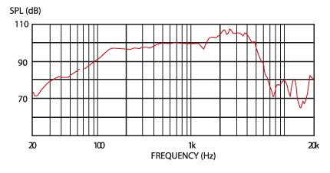

Additionally, they have certain features such as phase inaccuracy that contribute to a unique tone. They are often driven to distortion as well. Guitar cabinets are often driven to the point where the reverberations inside the cabinet and degree of air compression change the way the speaker(s) behave(s).

In contrast, most PA systems, headphones, monitors, home stereo speakers, etc. are designed to produce a relatively flat response with little distortion. Sending a guitar amp (or model) signal directly into such speakers is going to sound very harsh and buzzy. Even if you apply extreme EQ to roll-off the highs and lows, as well as accent the presence like a guitar speaker, you don't get a guitar speaker or cabinet's unique nuances.

Unfortunately, this breakdown isn't so simple. There are a wide range of products out there, from speakers to amps that enter a middle-ground - many look like traditional amps but are designed for use with modelers. This can introduce further confusion as to how to hook up your Pod. Depending on the product, you should follow its instructions as to how it should be treated. If it doesn't specify, you likely want to set it up as "direct", same as running to a PA or monitors; but I'd try it both ways and see which way you prefer. The Pod HD can also get kind of confusing as far as output modes, which I touch upon below.

## A. Understanding Output Modes

### i. Simple Guide for Settings

Line 6 isn't filled with evil jokesters who are trying to confuse you. How you physically connect your rig 95% of the time describes which output mode you should use. If you're going direct to the PA or your computer, use Studio/Direct mode. If you are running into the effects loop return of an amp or into a standalone power amp, use stack/combo power amp. If you are running into the front of an amp, use stack/combo front. Choose stack if you have a half or full stack, combo if you don't. [Unconventional settings](#_E._I_Tried) are described in the next section.

[Top of Pod](#_IV._Pod_Setup) [Setup](#_IV._Pod_Setup)

### ii. Where Confusion Sets In

The confusing part is that most people don't immediately understand that these choices are available. They figure if they select a cab and mic in the signal path, they are getting cab/mic simulation. However, what the cab/mic portions of the amp block do depends on the output mode selected. In Studio/Direct mode, it is indeed true cab/mic simulation by means of IR's. In the other modes, the microphone selection has no impact on the tone, and the cab selection applies a "live-voiced cab" which is a mild EQ effect, not true speaker simulation. On top of this, the Combo/Stack Front modes apply an EQ to the Pod's output, and the default selections can sound a little extreme, especially if it isn't connected to the real amp's guitar input. My [wishlist solution is to ditch output modes altogether](#_A._Output_Modes,) and have these distinct alterations to the tone show up in the signal path.

So what is actually going on? The Pod has basically four distinct components that are enabled/disabled depending on your output mode selection, which I cover below:

[Top of Pod Setup](#_IV._Pod_Setup)

### iii. Global EQ

The combo and stack front modes use a global EQ at the end of your signal chain to EQ the sound going into your real amp. This was designed to neutralize the coloration that a real amp's pre-amp will have on the tone coming from the Pod; however it can also be used as a general Global EQ if you like.

Note two things here. First, the EQ options here are helpful, yet insufficient to completely neutralize the EQ shift. Second, a pre-amp will do more than simply shift the EQ, compressing the tone (not equally at all frequencies) and maybe even distorting it. Bottom line - bypassing a real amp's pre-amp completely is the only method to guarantee it is not coloring your tone.

That said, you may have success using these controls regardless of how you actually connect the Pod to your amp (or if you are using external speaker simulation/IR's). There has been an [expressed desire for a global EQ](#_E._EQ's), so that the Pod's tone can be adjusted to a room once, and all the patches are dialed in. I believe these controls are too limited to perform the fine-tuning necessary for that application, but you may find that it works. Unfortunately, they are not available if you plan to use the Pod's onboard cab/mic simulation in Studio/Direct mode.

[Top of Pod Setup](#_IV._Pod_Setup)

### iv. Live-Voiced Cabs

The cab selections in non-Studio/Direct modes use "live-voiced" cabs which are a mild EQ effect designed to make whatever real cabinet you are using sound more like the cab model selected in the cab. Note: although you can change the selected microphone and there is a gap in audio as you change selections, it has no effect on the tone. These are disabled by selecting "no cab".

These have also been called cab simulation without mic simulation. "Cab simulation" is the wrong name. By itself, it does not come close to the frequency response changes made by real guitar speakers - it is designed to supplement, not replace, a real guitar cabinet (or speaker simulator/IR). Without such, "cab simulation" will sound nothing like a real guitar cabinet, mic'ed or not. It will be very harsh.

Note: simply because some speakers/cabs are marketed towards guitarists or look like a traditional guitar speaker cabinet does not mean their speakers have the frequency response of traditional guitar speakers. They may use full-range speakers, and the tone you get from your Pod through them will likely be harsh if you use a non-"Studio/Direct" output mode, unless you use some strong EQ'ing to roll off the high end frequencies.

I don't like using "live-voiced cabs" even with a real amp and guitar speaker. It seems to drop out some of the high end, leaving the Pod sounding a bit muffled. If I want to do this at all, I'd prefer to do it in an EQ effect where I have more control. Still, you might as well give it a shot to see if you prefer the tone. And don't just try the few cabs you want to sound like. The 1x12 and 2x12 models might give you a thicker tone than the 4x12's - they're not going to magically make your half stack sound like an open back 1x12.

[Top of Pod Setup](#_IV._Pod_Setup)

### v. Cab/Mic Simulation

In Studio/Direct output mode only, the cab block is essentially running the signal through an impulse response for that cab/mic combination. This is designed to simulate as if the signal was run through real speakers and mic'ed up with the selected mic model. This is disabled by selecting "no cab".

This is the only true speaker simulation. Use this mode for all "direct" setups as described [here](#_C._Running_Direct) to usually get the most natural/standard guitar sound. Everything else may sound incredibly harsh, unless you use an external speaker simulator/IR, because it is not applying true guitar speaker simulation.

[Top of Pod Setup](#_IV._Pod_Setup)

### vi. Bass Boost

The combo output modes apply a bass boost to the live-voiced cabs, designed to compensate for the lower bass response combo amps usually have. So if you dial in a tone for your combo amp but switch to a half/full stack (or vice versa), you can change the output mode and theoretically don't have to re-EQ the low-end response for your patch.

Some people like the combo modes even through a half/full stack, because they have more bass. This kind of defeats the reason there are different combo/stack modes. I'd rather use them like designed, so I can switch rigs without having my bass response thrown too far out of whack and having to dial in my patches again. If I need more bass on a half stack rig, I dial it in on the amp controls or an EQ effect. Or I check that I'm using the "full" amp models. See [full vs. pre](#_H._"Full"_vs.).

[Top of Pod Setup](#_IV._Pod_Setup)

### vii. Output Mode Feature Chart

|  |  |  |  |  |
| --- | --- | --- | --- | --- |
| **Output Mode** | **Global EQ** | **Live-Voiced Cabs** | **Cab/Mic Simulation** | **Bass Boost** |
| Studio/Direct |  |  | **\*** |  |
| Stack Power Amp |  | **\*** |  |  |
| Combo Power Amp |  | **\*** |  | **\*** |
| Stack Front | **X** | **\*** |  |  |
| Combo Front | **X** | **\*** |  | **\*** |

\* Only engaged when a cab is selected.

[Top of Pod Setup](#_IV._Pod_Setup)

## B. Internal Signal Routing

All the lines you see in Edit and the signal path window on the device are stereo signals.

Input 1 is routed into the left side of the first line in the signal. Input 2 is routed into the right side. This is important to know if you plan on using multiple instruments simultaneously.

When a signal hits a mono effect (including amp models), the stereo signal is mixed down into a mono signal, processed by the effect, then split back into a stereo signal with equal left and right signals.

When the signal hits a “True Stereo” effect, each half of the signal is processed separately and output to the same side of the stereo field that it entered. There are two other styles of stereo effects that blend the processed signals into the output and do not keep the two channels separate.

[Appendix A](#_Appendix_A_-) has diagrams that show how the four types of processing are applied inside the effects.

[Appendix B](#_Appendix_B_-) has a table that tells you which type of processing each effect uses.

When the signal hits the channel splitter, the left half of the signal is fed to Channel A and split into a stereo signal with equal left and right signals. The same thing happens with the right half of the signal and Channel B.

To keep Inputs 1 and 2 from being combined do not put any FX before the A-B Split OR use only “True Stereo” FX before the A-B Split (see Appendices A and B). Then after the A-B Split, Input 1 will go to Path A and Input 2 will go to Path B and you can use whatever FX you want without combining the two signals (until the Mixer). Same FX processing occurs through Paths A and B and After the Mixer.

Here are a few diagrams that I hope help:

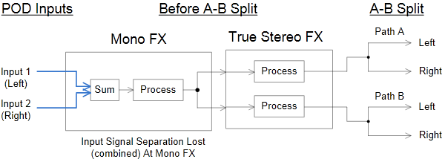

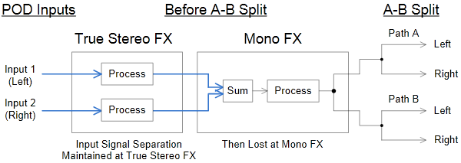

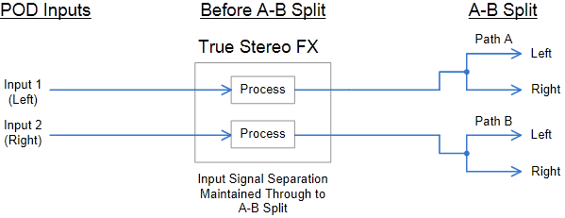

The mixer works a little bit deceptively. Think of it like this - first the mixer levels are applied to each Channel's stereo signal, adjusting the left and right signals equally. Then each channel has its pan setting applied to it. Think of pan as two separate volume controls for each channel - left volume and right volume. From 100% left to 0% (center), the left volume is 100%. As the pan moves from 0% to 100% right, the left volume goes from 100% to 0%. Vice versa regarding pan settings and right volume. So at 100% left the right half of the signal is completely muted and 100% right the left side is muted. At 0% both sides keep their original volume. Once each channel has the level and pan settings applied to it, the left side of Channel A and left side of Channel B are mixed down and output to the left side of stereo signal leaving the Mixer. Same for the right settings.

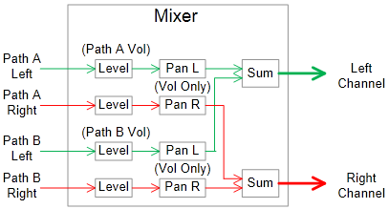

[Top of Pod Setup](#_IV._Pod_Setup)

## C. Running Direct (PA/board/computer or DAW/monitors/headphones)

Use this method if you want to run the Pod straight into a PA system, mixing board or mixing board for live purposes or a computer/DAW, home stereo, or headphones for recording or practicing. The Pod will completely simulate a guitar rig - amp (including pre-amp and power amp) and speakers (including cabinet). If you want, you can disable some of these features and use other gear to get that tone - like a speaker simulator device or a convolution reverb device/software that is using an impulse response (IR) designed to mimic a guitar cabinet.

You can additionally use effects from the Pod or use external effects, placing them before the Pod or in its effects loop (or even after if you use 1/4" or XLR output).

Running this way generally means you must choose "Studio/Direct" as your output mode, to enable cab/mic simulation (see [output modes](#_A._Understanding_Output) section), unless you are running external speaker simulation (such as an IR). Otherwise, your tone will be very harsh. Even in this case, I still recommend using "Studio/Direct" output mode and using the "no cab" option for your cabinet selection, simply to reduce complication.

However I should point out that you can use the cab models with a non-"Studio/Direct" output mode as a mild EQ effect, and it will sound relatively natural with an external speaker simulator/IR. I don’t recommend this, as it seems to dial out some of the high end, which is the area most difficult to dial in with the Pod; but it may be fruitful to experiment with if you don't mind losing some highs.

Here are a few guidelines to keep in mind for this connection type:

* If connected via USB, the Pod ASIO driver control panel has a default option of adding +18 db to the signal. This will often push it into clipping. If you have clipping, try turning this off.
* The Pod's ASIO driver is pretty low latency, if your computer is powerful enough to handle it. I've never had good experiences with high-quality audio over USB, so I connect via SPDIF to a firewire interface. My latency is extremely low (3 ms). I get no pops or clicks with 128 buffer size.
* Connecting digitally to a DAW (or an advanced mixing board) via USB, SPDIF, or AES avoids converting the sound to analog then back to digital, which will add a bit of noise and distortion into the tone.
* If you're using the 1/4" output(s) from the Pod and also using external effects, it's likely better to place them after the Pod's output rather than in its effects loop, to save on a possibly unnecessary D/A/D conversion. For other output connections or if your effects are level-sensitive, this might not be possible.
* The 1/4" outputs will sum to mono if only one of the two outputs is being used. In contrast, the XLR outputs will never sum to mono.
* The effects loop send connection is actually a 3-ring stereo connection. If you know what you're doing, you can use this as an additional unbalanced output.
* 1/4" unbalanced cable is subject to interference, often produced by florescent lighting. Use XLR where possible for better tone, especially where long runs of wire are necessary.

[Top of Pod Setup](#_IV._Pod_Setup)

### i. Simple method (no real amp)

This is the simplest connection method if you are not using a real amp as a possible pre-amp. Then you just hook an unbalanced 1/4" cable from your guitar to guitar in on the Pod.

If possible, use SPDIF or USB for a digital connection, which will produce the highest quality signal. But if this route produces sync or latency issues, use XLR outputs if your external device supports XLR. Otherwise use unbalanced 1/4" cable(s).

You can run all your external effects before the Pod or in its effects loop, depending on which effects you are using (see the [effects order](#_L._Effects_Order/Position) section). You can also run them from the unbalanced (or XLR if available on the effect) output(s). See the [effects loop](#_J._The_Effects) section for advantages/disadvantages to using the loop.

[Top of Pod Setup](#_IV._Pod_Setup)

### ii. Using a real amp as a pre-amp

You CAN run a real amp as a pre-amp and still output "direct"; but I do not recommend it, unless you are running an external IR. The problem is that in order to enable cab and mic simulation, you have to select and turn on an amp model. All the amp models in the Pod HD will color the tone. So you are essentially running two pre-amps.

That being said, if you really want to do so, run a cable from your guitar to Guitar In on the Pod, then the Pod Effects Loop Send to amp's Guitar In, then amp's Effects Loop Send to Pod's Effects Loop Return. You will have to put the FX Loop effect before your amp model on the Pod's signal chain.

Choose the cleanest amp model possible on the Pod (I would use the Blackface pre with drive set to 5% or less). You could use a "full" model to attempt to model a power amp, but you can't select JUST the power amp you want. You're going to get the pre-amp model too, and for most of the amp's, they will add distortion or dynamic coloration. This is especially true for the high gain amp models' pre-amps, although they generally have cleaner power amps. If you are using an external IR, I would set the amp to "no amp" (or turn the amp model off).

Any effects you want run before the pre-amp will have to be placed before the Pod or between the Pod's Effect Loop Send and the amp's Guitar In. Any effects after the pre-amp will have to be placed between the amp's Effect Loop Send and the Pod's Effects Loop Return.

[Top of Pod Setup](#_IV._Pod_Setup)

## D. Running to an amp ("live")

This is for when you are running specifically into a amp and speakers designed for use with guitar. Really, guitar speakers are what really roll off the high frequencies produced by guitar amplifiers or amp models. Guitar power amps also color the tone and may make it warmer, but their coloration is generally much less noticeable than guitar speakers.

(If you are instead using a full-range amplifier and full-range speakers, even if they are placed in an enclosure designed to look like a guitar amp, or marketed specifically for guitar, I recommend you use the [settings above](#_C._Running_Direct); otherwise, the tone will likely be very harsh and trebly.)

I recommend setting your output mode to the appropriate non-"Studio/Direct" mode. If you want to use your Pod for both "direct" and "live" purposes, I recommend leaving the output mode as "Studio/Direct" and setting your "live" patches up with "no cab" as your cabinet selection. When you use "no cab", you get the same output in every output mode (more-or-less) - all cab/mic simulation is simply disabled.

Thus, whether your tone is "live" vs. "direct" is patch dependent, and you can switch between the two without having to dig into the system menu to change output modes. The downside to this is that you have to make two versions of all your patches; however, I rarely find that simply switching the output mode produces the same tone live vs. direct. This is especially true if you have a power amp or speakers that add a lot of color to your "live" tone. So I have two versions of all my patches anyway.

The other alternative is to make one version of all your patches and switch output modes for whatever method you are using at the moment. The downside is that for "direct", you have to specify a cab and mic. When you switch the output mode for "live" use, the cab simulation will still be selected and run (see [output modes](#_A._Understanding_Output) section). Thus, it will be difficult to impossible to dial in a consistent sound between "direct" and "live", and you'll have to make purpose-specific patches anyway. I don’t like using the cab simulation for "live" purposes. It seems to muffle the high end of the tone, which is important for a high gain sound.

As for the actual cable hook-ups, there are a number of ways to do this. I will go from the least optimal/versatile yet simplest to best yet most complex.

Here's a few guidelines to keep in mind for this connection type:

* The only thing you should ever run your amp's power section output (sometimes labeled "speaker" or "16/8/4 ohm") to is a speaker cabinet or dummy load. Running it to the Pod will fry your amp and your Pod. Running it into nothing will fry your amp.
* You can bypass your amp's pre-amp circuit completely by running a signal into its effects loop return, sometimes labeled "power amp in". This is useful when you never want to use your amp's pre-amp, instead using the Pod's amp simulations.
* By using both your amp's and your Pod's effects loops, you can set up your rig for some patches to use your amp's pre-amp and others to use the Pod's modeling, switching between the two without having to switch any cables. This also lets you place effects in the Pod before and/or after your amp's pre-amp. This is known as the [4 cable method](#_iv._4_Cable).
* Some amps have only channel volume knobs, not a final master knob (Peavey ValveKing and 6505 for instance). When running the Pod's output into the effects loop return in these cases, your Pod's MASTER knob will act like a traditional master volume knob on an amp. When using the 4 cable method, for patches that use the amp pre-amp, you should use the channel volume knobs to level the volume equal to your patches where you bypass the amp's pre-amp completely, using the Pod's amp simulations instead.
* Even if you always use your amp's pre-amp for your amp tone, never using the Pod's amp models, you may still prefer to hook up the Pod via the 4 cable method, so that you can position effects before and after the pre-amp, rather than just after.
* The more pieces of gear you have in your signal chain, the more you have to be aware of [gain staging](#_M._Gain_Staging). I find it's best to start with everything putting out a low output, and start turning up the outputs on each piece of gear until you are clipping the next one then back off a bit. Your tone will likely start out noisier this way, but I find it's easier to systematically dial in each piece of gear like this than to just turn everything on, find some fuzz or clipping or nastiness in the tone, then start guessing as to where it's coming from.

[Top of Pod Setup](#_IV._Pod_Setup)

### i. Amp without effects loop

If your amp doesn't have an effects loop, you only have one option, as demonstrated below. You should set your output mode to "Combo Front" or "Stack Front" (see [output modes](#_A._Understanding_Output) section). These modes allow you to tweak the tone before it hits your amp to compensate for how your amp's pre-amp will color the tone. Set the amp/line switch to amp. Note that the "[]" section represents an optional section.

This setup is undesirable because you cannot bypass your amp's pre-amp. Whatever coloration it has on the tone cannot be avoided, only compensated for using the Pod's limited controls as mentioned above. Also, you have to run all your effects before said pre-amp, which may prevent you from achieving the dynamics you desired.

The only benefit is that if you like your amp's pre-amp, you can use it instead of the amp modeling on the Pod, using the Pod only for before pre-amp effects. But then why do you have a Pod anyway? I always try to get the most out of whatever gear I already have before even contemplating a new purchase; but honestly, unless you have a REALLY, REAAAAALLY transparent amp, I think you should start looking for a new amp, even if it’s a $300 to $400 1x12 combo.

The Pod works best when run into the effect's loop return of an amp. This bypasses the pre-amp and sends the tone directly into the power amp section of the amp. I use a used 1x12 Spider Valve Mk I combo, which I bought for less than the price of a Pod HD 500. For my purposes it works great. If I need more volume from it, I’ll get a 1x12 or 2x12 extension cab.

##### Guitar > [external effects >] Pod guitar in

##### [Pod effects loop out > external effects > Pod effects loop return]

##### Pod unbalanced out > [external effects >] Amp guitar in

[Top of Pod Setup](#_IV._Pod_Setup)

### ii. Pod as Effects Only after pre-amp

Here you will have the amp/cab model block in the Pod disabled (turned off or set to "no amp"). It doesn't matter what output mode you use, but to be safe (in case you one day decide to use the amp models and forget about this setup) choose one consistent with how you're hooking it up - Stack or Combo Power Amp.

Note: if your amp's level on the effects loop send is too hot for the Pod, and you cannot turn the send level down on the amp, you may have to run the amp's effects send to the Pod's effects loop return, then turn down the level on the effects loop return on the Pod.

##### Guitar > Amp guitar in

##### Amp effects loop out > Pod guitar in OR Pod effects loop return

##### Pod unbalanced out > Amp effects loop return (power amp in)

[Top of Pod Setup](#_IV._Pod_Setup)

### iii. Simple setup for amp with effects loop

This hookup is nearly the same as above, but you run into the effects loop return (power amp in) on the amp. Use "Combo Power Amp" or "Stack Power Amp" output mode (or "Studio/Direct" and make sure you choose "no cab"), and set the line/amp switch to line.

Here you bypass your amp's pre-amp completely, and you use the Pod's amp modeling instead. This gives you a very clean tone - power amps usually don't color the tone very much, at least not until you start really pushing the amp. In that case, you should see the ["pre" vs. "full" section](#_H._"Full"_vs.) for help in choosing the right amp models for your power amp.

The downside is that you do not have the option to use your amp's pre-amp. If you want that option, you have to use the 4 cable method, described below.

##### Guitar > [external effects >] Pod guitar in

##### [Pod effects loop out > external effects > Pod effects loop return]

##### Pod unbalanced out > [external effects >] Amp effects loop return (power amp in)

This is how I run the Pod to my Spider Valve combo.

[Top of Pod Setup](#_IV._Pod_Setup)

### iv. 4 Cable Method

This is the most versatile setup for the Pod. You can run effects before or after your pre-amp, and you use either your amp's pre-amp or one of the Pod's amp models. Which pre-amp you are running is completely patch-dependent. You can even toggle it inside a single patch using a single footswitch on the Pod.

You send your signal to the actual amp via the FX Loop effect on the Pod. You set up your patches with the Pod's FX Loop on and amp model off to use your real amp's pre-amp, or vice versa to the use the Pod's amp modeling. Place the FX Loop right in front or behind the amp/cab model in the Pod's signal chain to keep things simple, and only turn on one or the other. Effects before the FX Loop/amp model on the Pod will run before your pre-amp. Effects after are post-pre-amp.

For a more detailed guide, see [this](http://line6.com/support/docs/DOC-2522#_blank) and [this](http://line6.com/support/docs/DOC-2523#_blank) by Jim Reynolds, an especially helpful Pod HD community member. Both BROKEN LINK

##### Guitar > [external effects >] Pod guitar in

##### Pod effects loop out > Amp guitar in

##### Amp effects loop out > Pod effects loop return

##### Pod unbalanced out > [external effects >] Amp effects loop return (power amp in)

[Top of Pod Setup](#_IV._Pod_Setup)

## E. I Tried This and It Doesn't Sound Good

The above settings should work well for most gear. But perhaps your gear is different, or perhaps you simply have different tastes about what is harsh or sounds good. As long as you're not running the output of a real power amp into the Pod or other effect (high watt power amp output should only be run into speakers or a dummy load) or sending a line level (mostly anything not coming from an actual instrument) signal into the Pod's instrument level Guitar In input, you probably won't break anything by experimenting.

My friend used to run his Boss multi-FX processor into his Fender amp, and he got the best tone by using the speaker simulation in the Boss unit, even though he was running into real guitar speakers. When he told me his settings, I thought, "That's not right" and tried to tweak his gear how I thought it should be set up. I could never get a better tone than what he already dialed in using the "wrong" settings. Whatever gets you the best tone and doesn't break your gear is how you should run it, no matter how many people say that your settings are "wrong".

If the tone is too harsh and you're using "no cab", you want to switch output modes to non-"Studio/Direct" and try some of the cab models. They can help reduce highs.

If that still doesn't sound good to you, try switching to "Studio/Direct" and messing with different cabs and mics. There may be a particular combination that sounds great with your gear. See the [cab and mic selection](#_B._Cab_Selection) section for general pointers about what to expect for frequency response.

[Top of Pod Setup](#_IV._Pod_Setup)

## F. Dual Output

Many have asked if they could run a "dual output mode" - IE, have one set of outputs send a signal without cab/mic simulation to a guitar amp and cab and send another signal with cab/mic simulation to the PA. There's no built-in feature to do this, but you can do it with some trickery.

Since the cab/mic simulation is contained within the amp block, you have to use dual amps, which eats up lots of DSP unfortunately. Anyway, make sure you are in Studio/Direct output mode. Set one amp up with the cab/mic sim you want. Set the other one up with "no cab".

There are two ways to route the output. Both involve some trade-offs.

The simplest is to use the FX Loop effect block. Place the FX Loop at the end of either one of the channel paths, right before the mixer. At the mixer, mute the channel with the FX Loop to guarantee no signal is passing through. For the other channel, set the pan to full center - this allows both sides of the stereo spectrum for that channel to pass through to the analog outputs on the unit.

The upside for this method is that you get two stereo outputs (FX loop send is a stereo output). Also, if you don't want to use multiple/special cables to extract the stereo output, you can just use a single 1/4" unbalanced cable for each signal to get mono output. The downside is that you need to place the FX Loop before the mixer, so you have to apply any post-amp effects twice - once in each channel, which can run into DSP limit errors.

The other method is to use the mixer to pan each signal full left and right and not bother using the FX Loop. Then the two sides have different processing.

The upside is you can use (some) effects after the mixer, avoiding DSP limit errors. The downside is that they have to be true stereo effects, or the two signals will be mixed to mono. Also, you have to make sure you use 1/4" output cables in both the left and right outputs. If you just plug into 1/4" left or 1/4" right but don't insert a dummy cable into the other output, the unit will sum the stereo signal into a mono output. But you don't need to run the other cable to anything - just make sure it's plugged in. This isn't the case for the XLR outputs, though, which never sum to mono.

Another thing to keep in mind is that some stereo effects affect one side of the signal differently than the other. For example, the analog chorus and many of the delays. Thus, your PA tone would differ from your amp tone.

[Top of Pod Setup](#_IV._Pod_Setup)

## G. Wet/Dry/Wet Output

Similar to above, you can place an FX Loop effect with Mix set to 0% to output a "dry" signal before the signal hits "wet" effects and sends the "wet" signal to the main outputs. By using Mix at 0%, the signal is basically split at the FX Loop, being sent out the FX Loop Send but also passing straight on down the chain, regardless of whatever (if any) signal is returning into the loop.

So for instance, you may want this "dry" signal:

##### Screamer > Amp

and this "wet" signal:

##### Screamer > Amp > Reverb > Delay

Your chain would be:

##### Screamer > Amp > FX Loop > Reverb > Delay

The output from your FX Loop Send is the "dry" signal (which you can send to your monitors), and the main outputs carry the "wet" signal, (which you send to your PA).

If you cannot use the FX Loop as such, you won't be able to get stereo output; but you can get a mono wet and mono dry output by placing all your wet effects in Channel A and not in Channel B, then panning each Channel hard left/right in the mixer. Then your Channel A (left) output is wet, and the Channel B (right) output is dry. Just remember that if you are using the 1/4" analog outputs and aren't using both of them, you need to put a dummy cable in one of them to prevent the unit from summing them to mono (which would give you a 50% wet mix).

[Top of Pod Setup](#_IV._Pod_Setup)

## H. Multiple Instruments/Independent Paths

The Pod provides two independent signal paths. This path independence can also be used to handle multiple instruments, for example setting Input 1 to guitar and Input 2 to mic. Input 1 will go to Channel A, the top side of the path, and Input 2 to Channel B, the bottom. Just make sure you don't have any mono FX before the path/channel split. See [the input/output routing](#_B._Internal_Signal) section to understand how the Pod routes audio, mixing down stereo signals when they hit a mono effect. Follow the instructions from the [previous section](#_F._Dual_Output) to route the audio to different outputs.

[Top of Pod Setup](#_IV._Pod_Setup)

## I. Input Settings

#### Global/Patch

First of all note that just because the input settings exists in the system menu, it is not necessarily a global setting. There's a specific setting on this menu page to change whether it applies globally or per patch.

#### Multiple Sources = Noise

The default setting is input 1: guitar + aux + variax, input 2: same. This is not ideal - if any of the non-guitar inputs are generating any noise, it is being thrown into your signal. So change input 1 to guitar only, unless you need to use those additional inputs.

#### Input 2

Some people have noticed that changing input 2 to variax (a digital input, which ensures silence when not connected) (or an unconnected Mic or Aux) gives them a more desirable tone. Input 2: Same/Guitar does seem to be buggy. You don't just get equal Input 1/2 signals - one of them sounds partially delayed, causing some comb filtering (less bright highs) and making the tone sound looser and slightly out-of-phase. The difference can be very subtle - I had denied a tonal difference for over a year before only recently beginning to clearly see the difference.

For single-amp patches, Input 2: Variax is simple to use. If you were previously not using this setting, you just need to add more compression/gain.

For dual-amp patches, there is more work to do. You will NEED a mono-summing effect in front of the channel split, or no signal will be sent to Channel B. If you already have a Dynamic or Distortion effect, that will sum to mono. If I don't have one of those already in my patch, I like to use one of the following, listed in order of the DSP they consume: Hard Gate, Noise Gate, FX Loop. Luckily the FX Loop takes up very little DSP; however, it does add noise to the signal; so I save it as a last resort.

If you want to know exactly how the Pod is routing the inputs and audio streams, please check out the [signal routing](#_B._Internal_Signal) section.

You will find your patches initially have less gain when using this. I like to try to make up the difference on the earliest effect(s) in my signal chain. For instance, if my first effect is a Screamer, I increase the Drive a bit and also the Output. Or if I have a Mid-Focus EQ, I boost Gain. If I don't have any effects, I increase Drive on my amp blocks.

The lower gain can also be a positive if you are getting breakup on your clean tones, although I cover other ways to dial in [pristine cleans here](#_I._The_Elusive).

I have heard of splitting your guitar signal before the Pod and sending it to both the Guitar and Aux inputs, then setting Input 1: Guitar, Input 2: Aux (thanks to Line 6 forum member anglepod). This would eliminate the need for a mono-summing effect, and reduce problems trying to dial in heavy amounts of gain in some cases. It requires a little extra hardware but seems to be a better solution than using up effects blocks and DSP to try to force the signal into Channel B.

#### Impedance

With firmware v1.4 the PodHD got variable input impedance. Line6 says before this the impedance was always set to 1M, but I feel like something changed...for the better. The unit seems more responsive to me. Anyway, I like this setting at 1M or 3.5M. This allows the loudest, tightest, and brightest tone to pass from guitar to Pod, which helps dial in the high gain tones I like. If you prefer a muddier or fuzzier distortion or looser feel, you may want a lower value.

For the F-Ball amp model, I find it can get kind of gritty and nasty for the distortion if your guitar signal is a bit bright. When I want a smooth tone from this model, normally I like to use a Mid-Focus EQ to roll-off enough high-end to smooth the tone out. However, if I don't have enough DSP or effects blocks to do so, I will turn down the impedance to attenuate some highs. I like it around 230K for this.

Also, the "auto" setting works well - it matches the impedance to the first effect in your chain, which helps make fuzz boxes sound fuzzier. If the first block is the amp, your impedance is likely 1M, which is the setting for most amps. The [advanced manual](http://line6.com/data/6/0a06434dfb244f7b7f489af64/application/pdf/POD%20HD500%20Advanced%20Guide%20v2.0%20-%20English%20%28%20Rev%20A%20%29.pdf%22#_blank) shows you the input impedance values for each effect when you use "auto" on pages 2.5 - 2.7.

Remember, if you set the input settings to apply per patch, just because you changed the setting on one patch doesn't mean you are using the same settings for the patch you're currently tweaking. If the patch is noisy or you can't get the tone clean enough, be sure to double-check these settings.

[Top of Pod Setup](#_IV._Pod_Setup)

## J. The Effects (FX) Loop

Keep in mind where you place your FX Loop in the Pod's signal chain, particularly in relation to the amp/cab modeling. Effects will sound very different depending on how they are ordered (see [Effects Ordering](#_L._Effects_Order/Position) section) and this is particularly the case for the amp modeling. Also note that you can change the send and receive levels for the loop.

Given the option, not using the loop (by placing the effects in front or behind the Pod) may be slightly advantageous because it does not require you to add an FX Loop effect to the signal chain (for HD 500/Desktop/Pro), freeing up one block for an additional effect. It also saves the tone from an additional set of D/A/D conversions and reduces complexity in gain staging.

The best part about using the loop is you can use just one footswitch to toggle on/off all the effects in the loop, rather than having to tap dance on all the individual effects.

There have been complaints that the FX Loop is incredibly noisy. It definitely adds noise, but not to the point where it is unusable. I don't like to use it to do simple things like clean boosts or to force mono-summing, but since its DSP cost is so low, sometimes it's the only available effect to do so. I find boosting the signal inside the Pod via a Studio EQ before the FX Loop can reduce the noisiness a bit.

I've also read the loop causes your signal to lose a significant chunk of volume. I believe these claims, but I have not tried to determine how bad this actually is. Be aware that you may need to compensate for the loop. The best way is to boost via a Studio EQ before it, which additionally improves SNR. If you can't do that, you can increase the Return level on the loop itself.

[Top of Pod Setup](#_IV._Pod_Setup)

## K. The Mixer Block

The mixer allows you to adjust the panning and volume of both channels. The default setting has each track panned hard left and right with levels set to 0 +/-db - an ideal setup for a stereo patch. I generally use mono patches. I find the best way to do this is to mute one channel, and pan the other one to center. You'll get more volume by panning both channels to center, but I find this isn't necessary since the mixer lets you boost channel volume. There's another reason I like to only use one channel, which I cover in the next section. Just like the amp volume knob, the mixer boosts the level at that place in the chain, which can cause effects behind it to distort.

Be sure to understand how the pan controls work. Every line in the Pod's signal chain is a stereo signal. If you have a stereo effect in a channel after the path split but before the mixer, so that a different left/right signal is hitting the mixer, the pan controls basically adjust the volume of each left/right signal. If you pan full left on that channel, only the left side is going to pass through the mixer, into the left half of the mixer output. The left and right signals from that channel are not both being pushed into the left output of the mixer. The right half is essentially muted. The mixer is only mixing the left signals of channels A and B into the left half of the mixer's output. Same for the right half of the signals. So 50% left for a channel means that the right half of the signal has its volume cut in half while the left half passes through at full volume.

[Top of Pod Setup](#_IV._Pod_Setup)

## L. Effects Order/Position

Effects that affect dynamics or distortion are sensitive to what is being sent into them, compared to non-dynamic effects. Be aware of how ordering effects matters, and experiment with each effect before or after a compression or distortion element. For instance, the whole section on distortion character was mostly about how the way a signal is EQ'ed impacts how distortion will operate. EQ before distortion sounds completely different from EQ after distortion. This equally applies to Wah pedals, phasers, choruses, and other effects. On the other hand, certain effects will operate virtually the same and have negligible impact on other effects independent of where it occurs in the effects chain, such as a pitch shifter.

The best advice is to experiment, but here are some general tips:

#### Noise Suppressors/Gates

The general consensus is to make this the first effect in your chain. There it will simply mask your pickup noise when you are not playing. It has the most impact on tone at the end of the chain but can lead to unnatural sounding cut-off on notes. An interesting place for it is after a compressor but before distortion. Sometimes you can use two on each side of a compressor/gain stage to tighten up how effectively it works. This is how Periphery gets their very punchy tone, going quickly from searing power chords to complete silence. For more on noise gates, [see here](#_J._Noise_Gates).

#### Chorus/Phaser/Flanger

Generally, you get the expected swooshing sound behind your distortion phase, but placing it beforehand can give a very difficult to describe but interesting sound. I kind of like it in this position, because it has less of a swooshing sound to it, which I find detracts from the actual music. It also makes your distortion character change, which makes it a bit more interesting, especially if you're playing a very repetitive part, such as straight palm-muted single notes. I use mod effects in both positions.

#### EQ

As mentioned [in the amp/tone page](#_B._Pre-EQ'ing_1), EQ before distortion has a much larger effect on how the distortion operates than how the frequency response is changed. I generally use a single Studio EQ or Mid-Focus EQ to sculpt the distortion character, while I use multiple Parametric EQ's and/or a Mid-Focus EQ after distortion to dial in the desired frequency response in my final tone.

#### Delay/Reverb

I don't know how anyone gets away with putting delay before a distortion phase. The distortion will compress it and cause the delayed signal to be just as loud or nearly as loud as what you are currently playing, sounding like two guitars fighting for space, playing different things at the same time. People have said EVH put his delay in front his amp distortion, but I can't get it to sound right. I think they're wrong and his echoplex was being used for tonal changes, not actual delay.

I generally put my delay and reverb last (or close to last) in the chain. I don't think it matters which goes first. Occasionally I'll use two delays.

#### Pitch Shifters

(Octave, Whammy [Pitch Glide], Smart Harmony) - I like these in front my distortion phase usually. The whammy especially sounds more like a real whammy bar that way. Smart Harmony I like behind my distortion - then it sounds like you're playing with another guitarist or double-tracking it. When in front, it sounds more like you're playing double-stops. Experiment with the mix when pitch shifting, especially when you put it in front your distortion - low settings will subtly change your tone rather than sounding like you're adding another track at a lower volume.

Sorry if this section is a little light, but I'm not so much an effects guy. I focus on getting a good distortion sound, rather than layering up a bunch of effects.

[Top of Pod Setup](#_IV._Pod_Setup)

## M. Gain Staging

### i. Principles

You've probably heard the term before but don't know exactly what it means. A gain stage consists of an attenuator and an amplifier. The attenuator is usually attached to a knob or dial. This lets you attenuate the signal appropriately to get the desired tone from the amplifier. Depending on the type of gain stage, you may want to allow the amplifier to distort or to remain clean. Gain staging simply refers to how to set multiple sequential gain stages to achieve the desired tone while minimizing both noise and unwanted distortion.

Analog signals have a certain noise floor that you cannot shrink by attenuating the signal. Thus, the lower volume your signal is, the lower the ratio of the signal to your noise floor. If a low SNR signal is amplified, all that noise is amplified as well. If one gain stage introduces noise early in the signal, you will not be able to remove it later on. To get the cleanest, least-noisy tone, you want to set all your gain stages as high as possible. You use the last gain stage to control final volume - it has the least potential to introduce noise into the tone.

On the other hand, when an amplifier tries to boost a signal beyond its physical capacity, the signal gets distorted. Some gain stages are designed to distort in a pleasing way while others are not. Assuming you want a perfectly clean signal, you must attenuate the signal enough at each gain stage enough to prevents its amplifier from distorting.

Thus, gain staging is often about finding the sweet spot for each gain stage to minimize both noise and distortion. Most of the time, your signal chain isn't very complex, and gain staging is simple. Other times, when you are running unconventional chains and lots of effects units, it is essential to tweak just about everything.

Making things more difficult, some pieces of gear do not feature a complete gain stage, offering no means to attenuate the signal as it inputs the unit. On a hot signal, it may clip in an undesirable way. Your only options are to attenuate the signal via an additional piece of hardware before that unit or to reduce the output of the closest prior gain stage.

If you want distortion, you're probably not going to get the distortion you want by diming every gain stage in your chain. I find it's best to start by setting everything low enough so that there is no distortion anywhere in the chain. As you start to turn up any particular gain stage, make sure that others aren't being pushed into distortion as well - as you turn up one, turn down the next one in the chain. You want to determine which stages produce musical distortion and which should be kept clean. Once you identify the musical ones, you want to find appropriate proportions of one to another.

For example, when running a distortion pedal in front of an amp, sometimes you want to use mostly the distortion pedal's distortion, letting the amp stay clean or relatively clean. Other times you want the distortion pedal to provide a touch of distortion but let the amp provide the bulk of the distortion. Sometimes you want an even mix - I find this is often true when mixing pre-amp and power amp distortions. The main thing to remember is to avoid clipping other pieces of the chain that do not distort nicely. A thick amp distortion may mask that such is even there, but it will make your tone rougher and less defined.

### ii. Practice

Thinking in terms of analog gear, take the relatively simple example chain of:

##### Guitar > Tube Screamer > Amp > Chorus (in effects loop) > Amp

Even here, the Screamer has two gain stages - Drive and Output. The amp likely has 5 - Drive, Channel Volume, Loop Send, Loop Receive, and Master Volume. The chorus pedal likely has 1 - Output. You have 8 gain stages to tune, so that they all work in harmony. The Chorus does not have an attenuator on its input. You must set the effects loop send volume low enough to keep it from clipping. You probably want the Screamer to have low Drive (its "hot" gain stage), so that it only provides a touch of distortion, but you want to dime its Output (which stays clean). You want most of your distortion from your amp's preamp. So you crank Drive there. You don't want much power amp distortion, so you set Master Volume just below where the power section starts to break up. Channel Volume likely stays clean even at high settings, so you crank that up fairly high, but it's main purpose is to balance one channel's volume against another - you may have to keep it lower than 100% for that.

How does this translate for such controls in the Pod? The Pod features almost everything mentioned above digitally. Most of the time its algorithms are emulating exactly how an analog signal would be processed. So you want to follow the same advice as with an all analog chain.

**Particularly troublesome are the EQ effects. Some are worse than others. When I'm using an EQ as the first piece of my chain, I will get a nasty digital-sounding distortion when I pick hard. To compensate I add a Volume effect to attenuate the signal before the EQ. If I'm using EQ's behind my amp block, I need to keep the Ch. Vol./VOLUME knob relatively low (45%) to prevent from clipping EQ's. For single amp patches, I put everything in Channel A and use the Mixer Levels to set my final patch volume. For dual amp patches, I usually have a Mid-Focus EQ last, which provides a Gain parameter that I use to set my final patch volume.**

Digital devices feature the additional danger of digital clipping, where the signal level exceeds the digital resolution and produces a harsh distortion. Yet, if you follow proper gain staging, the principles are exactly the same. You will only achieve digital clipping by setting a gain stage too high (provided you aren't clipping the unit at its input A>D converter).

Some of the controls in the Pod adjust the signal level digitally, rather than emulate an analog gain stage. For instance, the amp block's Ch. Vol. (VOLUME knob) is not simulating analog circuitry. I believe the mixer levels and volume effect operate the same way. This basically takes the consideration of a noise floor out of the equation, but replaces it with loss of precision. Setting one of these REALLY low will not add noise to the tone but will introduce slight manipulations to the signal's waveform and lose certain details. Similar to distortion concerns, it's best to treat everything like an analog gain stage, setting them high enough to preserve the signal integrity.

I believe the Pod has three actual analog gain stages - FX Loop Send/Receive and the Master Knob (the right-most physical knob on the unit). Same rules as usual apply.

Note: the MASTER knob only affects the tone sent to the analog outputs. For the digital outputs (AES, SPDIF, USB), the signal is never converted back to an analog signal and never hits the analog Master Knob gain stage. The Pod's signal is mostly digital; it goes:

##### Input Source > A/D convertors > digital signal processing > D/A conversion > Master knob attenuation > analog outputs

Even when setting up a patch that is close to maxing out the Pod's maximum digital signal level, with the MASTER Knob at 100%, I do not hear any distortion occuring. So proper gain staging dictates setting this knob to 100%. Line 6 documentation echoes this opinion, saying this setting results in the highest signal-to-noise ratio from the unit. But be wary of what you're connecting the Pod into. I have clipped the effects loop return of my amp when setting this too high - my amp provides no control to attenuate the loop return signal.

The only time I recommend moving the MASTER Knob lower is when you are not using your main rig. By doing this, you are sacrificing tone for ease-of-use. You should gain stage and level your patches as above for your main rig. For other rigs that distort with the amount of volume you're sending them, the easiest way to attenuate the signal is using the Pod's MASTER Knob. Rather than digging into the mixer settings on all of your patches, you can just change one knob and be done for all patches. This may result in additional noise in the signal, but that's acceptable in this case. This applies equally to using headphones.

[Top of Pod Setup](#_IV._Pod_Setup)

# V. Amp/Distortion Tone

* [A. Distortion Types/Overview](#_A._Distortion_Types/Overview)
* [B. Pre-EQ'ing](#_B._Pre-EQ'ing)
  + [i. Frequency Chart](#_i._Frequency_Chart)
* [C. Gain Staging/Layering Distortions](#_C._Gain_Staging/Layering)
* [D. High-Gain Amps](#_D._High-Gain_Amps)
  + [i. Park 75](#_i._Park_75)
  + [ii. Plexi Bright](#_ii._Plexi_Bright)
  + [iii. JCM-800](#_iii._JCM-800)
  + [iv. Uberschall](#_iv._Uberschall)
  + [v. Dual Rectifier](#_v._Dual_Rectifier)
  + [vi. Fireball](#_vi._Fireball)
  + [vii. Elektrik](#_vii._Elektrik)
  + [viii. Dual Rectifier "Pre"](#_viii._Dual_Rectifier)
  + [ix. SLO Overdrive](#_ix._SLO_Overdrive)
  + [x. Doom](#_x._Doom)
  + [xi. Epic](#_xi._Epic)
* [E. Distortion Effects](#_E._Distortion_Effects) 
  + [i. Tube Drive](#_i._Tube_Drive)
  + [ii. Screamer](#_ii._Screamer)
  + [iii. Classic Distortion](#_iii._Classic_Distortion)
  + [iv. Overdrive](#_iv._Overdrive)
  + [v. Facial Fuzz](#_v._Facial_Fuzz)
  + [vi. Line 6 Distortion](#_vi._Line_6)
  + [vii. Line 6 Drive](#_vii._Line_6)
  + [viii. Others](#_viii._Others)
* [F. Power Amp DEP's](#_F._Power_Amp)
* [G. Dual Amps](#_G._Dual_Amps)
* [H. "Full" vs. "Pre"](#_H._\"Full\"_vs.)
* [I. The Elusive Pure Clean Tone](#_I._The_Elusive)
* [J. Noise Gates](#_J._Noise_Gates)

## A. Distortion Types/Overview

The most important part of getting a rock guitar tone is achieving the right distortion that you want. This certainly depends on which amp model you select; however, I want to address how to tweak a amp's tone before describing the available models. For any given amp, dialing in the desired distortion is often nowhere near as simple as turning the "drive" parameter on the amp or amp model up until the sound is as saturated as you like. A typical guitar rig will involve 4 main possible distortion stages - stomp box, pre-amp, power amp, and speaker, and you generally use one as your "main" distortion stage. However, any stage being pushed to breakup will distort in a certain way depending on the nature of the signal sent to it. This section mostly discusses what ways to expect a stage to breakup and how to alter the signal before reaching that stage to get the distortion you want.

The way any distortion stage breaks up is typically the result of the frequency response of the input signal, the waveform of that signal, and the nature of the distortion stage itself. These are tweaked by pre-EQ'ing, gain staging (or effect ordering), and amp/distortion selection, respectively.

As for distortion types, I generally identify 3: fuzz, crunch, and metal, which are derived from the peak frequency range fed into the distortion stage.

Fuzz is generated from distorting bass frequencies and is relatively loose in response to one's playing. Metal is the opposite, created from distorting mids/upper-mids frequencies, and is very tight. It is characterized by the djent sound created during palm mutes. Crunch sits in the middle, being a little boxier-sounding than metal, but not really fuzzy. I find the out-the-box Marshall tone is a perfect example of crunch, while the Treadplate and Fball amps characterize the metal tone.

The output of each distortion stage also depends on the waveform of the signal fed into it. Even if we were to EQ a guitar, banjo, violin, and piano signal to have roughly the same frequency response, the distortion produced by any particular distortion stage would have drastically different tones. For guitar, this is helpful, because we can alter a guitar signal before it hits a distortion stage, by using other distortion effects, modulation effects such as phasers, chorus, or flanger, time-effects such as reverb or delays, filter effects such as synths, and pitch effects such as octavers. This is a lot of ground to cover, so I'm not getting into it here, other than touching upon using multiple layers of distortion.

Unlike the simple pre-EQ distortion types identified above, the results of changing waveforms are more difficult to predict how they will impact the tone. In general, the amp or distortion effect has a relatively similar response given different signals, but you can still hear the impact of whatever effects placed in front of it. In other words, a Marshall will still sound Marshally with a Tube Screamer in front, but you can hear that there's a Tube Screamer in front.

Note that amps tend to "want" to distort one way or another. You can't make a Marshall JCM sound like an Mesa/Boogie Dual Recto just by putting some EQ on the incoming tone. Consider pre-EQ'ing more of a fine-tuning process, even though in some instances you are drastically altering the tone. You want to start by choosing the right [amp model](#_D._High-Gain_Amps). This requires seeing the potential in an amp even if you think it initially sounds like crap. You have to ask yourself questions like, "What if it sounded less muddy?" or "What if I could get the grittiness out the tone?"

I'm not really a fan of fuzz tones, and this guide won't help you dial those in. I prefer to keep the tone being distorted on the bright side. I don't want to dial the bass completely out, though. I like tight bass in my final tone. We want the bass there, and we want the distortion phase to compress it but not distort it. This should keep it well-defined and tight. We use the bass knob (or an EQ effect later in the chain if we're using power amp distortion) to boost the bass to the desired volume, relative to the other frequencies.

[Top of Amp/Distortion Tone](#_V._Amp/Distortion_Tone)

## 

## B. Pre-EQ'ing

As mentioned above, one of the main ways to alter a distortion tone is to add some EQ in front of that gain stage, which is commonly referred to as "pre-EQ'ing". Sometimes I refer to this as sculpting my distortion, as I'm carving out the desired frequency response curve.

Using EQ effects to pre-EQ is the most transparent way to do this, preserving a lot of the amp tone while manipulating it to sound like you want. Other methods will have more impact on the signal before it hits the amp, diverging further from its natural tone.

Distortion effects can also be used to EQ the tone. Commonly, this is referred to as a boost or overdrive, using the pedal not to add its own distortion but change how the amp distorts. These terms are misleading - they stem from early use of overdrive pedals when amps had limited distortion available. They boosted the signal level forcing the amps to distort more than they otherwise would. Modern high-gain amps don't need such a boost, but they remain popular because of how they EQ the signal before the amp, changing how it distorts. It's more appropriate to refer to this as using a distortion pedal as a filter, but boost/overdrive commonly amount to the same thing. Using distortion effects for pre-EQ'ing is less transparent, as the distortion effect is usually adding some slight compression and/or distortion of its own, which may or may not be desirable.

For power amp distortion, the power section occurs after the amp's bass/mids/treble/presence controls, so those are going to have more impact on the distortion tone than the final frequency response.

Below is a guide of what to expect when pre-EQ'ing. To take full advantage of this guide, listen to your distortion tone. Does it have too much fuzz or grit? Try reducing the frequencies that correspond to that kind of tone. You don't have to necessarily get the tone to sound totally different, just tweak out the bad and dial up the good.

[Top of Amp/Distortion Tone](#_V._Amp/Distortion_Tone)

### i. Frequency Chart

Here is a guide to how the tone is likely to sound with various peak frequency ranges hitting a saturated gain stage, or some frequency range being absent/deficient. Note: this is not foolproof - it depends on the amp/gain stage. Also, the numbers aren't an exact science - consider them to be fuzzy and use as a guideline only.

Also, please note that just because some frequency range is the peak doesn't mean it will dominate the tone. It is possible to have a mostly flat frequency signal with a slight peak in the muddy range, yet the signal won't be total mud - you'll get a bit of all the characteristics listed below. You can mix and match and balance certain aspects of the distortion with other ones. Usually that's exactly what you want to do. IE, a wide boost at 700 HZ will often add the djentyness and creaminess from the frequencies around it, rather than simply making the tone flat.

Make all these links to audio.

|  |  |  |
| --- | --- | --- |
| **Freq (HZ)** | **Peak** | **Lacking** |
| 0-150 | Muddy | Thin |
| 150-250 | Fuzzy | Thin |
| 250-500 | Creamy | Cold |
| 500-800 | Flat\* | Tinny |
| 800-1500 | Djenty | Buzzy |
| 1500-3000 | Crispy | Sterile |
| 3000+ | Gritty | Smooth |

\* Flat means there is no real distortion tone - it sounds like compressed mids.

Applying this logic to the fuzz/crunch/metal distortion types I mentioned above, fuzz tones obviously emphasize low-end and metal tones upper mids. Crunch tones tend to emphasize mids, but extend into both metal and fuzz territory - the result of mixing both of them together more-or-less.

[Top of Amp/Distortion Tone](#_V._Amp/Distortion_Tone)

## C. Gain Staging/Layering Distortions

As mentioned above, one of the main ways to alter a distortion tone is to place effects in front of that gain stage, that change the waveform of the incoming signal.

This is a very wide-open topic, but the general rule is to expect the final tone to be a mix of both. In other words, putting a phaser in front of a distorted amp will sound like phaser + the distorted amp tone. But it's obviously different than placing the phaser behind the amp. The way I differentiate between these is I think of anything placed before a distortion as "going into" that distortion, whereas anything placed after a distortion "goes on top of" the tone.

The main topic I wanted to discuss here was how to tweak having multiple distortions in the same signal chain, which is usually the case, even if only one of them is generating most of the distortion. My recommendation is to use one distortion stage as your main stage, with the others trying to complement it. That being said, zero'ing out the others usually gives me bad results.

Take a typical distortion effect -> preamp -> power amp chain, where each is contributing some distortion. I'll often use my pre-amp as my main distortion stage. While I am mostly using the distortion effect for pre-EQ, I may also want it to deliver a touch of compression and/or distortion. Depending on the distortion effect and amp, this slight distortion may warm up and smooth out the downstream amp distortion, or it may make it edgier and more aggressive-sounding.

As another example, let's say given the same chain I want the distortion effect to provide most of my distortion. Setting the amp's preamp Drive to 0% is going to sound weird. For a Marshall amp, I find I have to get it to at least 10% for the tone to start sounding natural, and about 20% to add the Marshall flavor. If this means the Marshall is also adding a little distortion, so be it. If I end up with too much distortion, I'll back off the distortion effect's Drive. Sometimes you also want to back off the distortion effect's output level, and dial in more pre-amp Drive from the amp or vice versa. This can have differing tonal effects even though you are getting the same total amount of distortion.

The same ideas apply for pre-amp vs. power amp distortion. Even if only one is your main distortion, you still want to give a little juice to the other.

[Top of Amp/Distortion Tone](#_V._Amp/Distortion_Tone)

## D. High-Gain Amps

### **i. Park 75**

**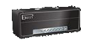**

This amp delivers a classic Marshall tone. By itself, it won't get you to high-gain territory; you'll need to boost the signal (such as with an overdrive pedal, distortion effect, or simple boosted EQ) heavily to get a saturated distortion from it. I don't recommend doing that - if you want more gain but a similar tone, try the JCM-800 model instead. I like this amp for medium gain tones (AC/DC), or if I want a Marshall tone but am using a distortion pedal/effect for my main source of distortion (Satriani). Compared to the JCM-800, it has a little less distortion available but it seems to be more reactive to picking dynamics. It gives you that clean-yet-distorted crunch feel.

I like to lower the amp's Bias (and Bias X which basically "locks in" my low Bias setting). This seems to make the amp sound more like a Marshall to me - a little more nasal sounding and you can get power amp distortion without it getting too gritty or splatty. I drop it between 0 and 20%. It also allows you to dial in a bit more distortion when you want to.

This amp model seems to be one of the ones that sounds better when you crank the power section. If I'm trying to make the model distort, I'll turn Master Volume up between 85-100%, then use the Drive knob to dial in the amount of distortion. For some reason, the power section responds very "poorly" when you turn up the Presence knob on the amp. I set low, often all the way to 0%. I also keep the Bass fairly low, to keep the power amp from distorting in a muddy fashion.

If I want it to stay clean, I turn down Drive first and if I need to go cleaner also Master Volume, but I generally try to keep the Master Volume higher than 50% and turn down Drive more. The power section gets you the Marshall tone. Also, the Bias setting is more responsive the higher you set Master Volume. But keep Drive above around 5-10%. Something weird happens to the tone if you go lower.

[Top of Amp/Distortion Tone](#_V._Amp/Distortion_Tone)

### 

### **ii. Plexi Bright**

**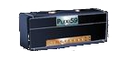**

This amp also delivers a classic Marshall tone. This model is VERY accurate. Comparing it to recordings that used this amp, it sounds almost identical. By itself, it won't get you to high-gain territory; you'll need to boost the signal (such as with an overdrive pedal, distortion effect, or simple boosted EQ) to get a saturated distortion from it, but that's not where it excels anyway. It's best for a clean-yet-distorted tone, in the vein of Randy Rhodes or early Eddie Van Halen. Compared to the JCM-800, it has less distortion available but it seems to be more reactive to picking dynamics and has a much more defined midrange.

The distortion is coming from the power section, so Bias and your EQ settings heavily affect the tone. I like to crank up presence, which gives it that real crunchy feel. Boosting treble too high makes it a little nasty. And boosting mids makes it a little too smooth for my tastes. I generally set mids and highs around the same spot, and boost presence as much or more than that. And turning up Drive all the way makes it too compressed. For the EVH tone, I like to crank the Bias.

[Top of Amp/Distortion Tone](#_V._Amp/Distortion_Tone)

### **iii. JCM-800**

**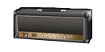**

This amp model sounds very similar to the Park 75, but more compressed and with much more drive. Without tweaking, it doesn't sound overly Marshally; but we can get it there. Tweaked properly, it can deliver great 80's metal tones. I hesitate to call it high gain. Although it can be dialed in to produce modern metal tones, I prefer to use other amp models to do so; however, I do use it for my Megadeth patches. My favorite patches with this are for a modern Satriani tone.

Like the Park, I like to turn down the Bias and Bias X. This gives you a more natural power amp distortion and a more nasal tone.

My prefered distortion from the amp is the power amp distortion. I particularly like the sound with the Master Volume set between 65-75%. Anything more is a little too extreme; anything less just doesn't get there. I find the sweet spot, then I tweak Drive to get the exact amount of distortion/saturation I want. But don't go too high with Drive, or you'll end up mixing a heavily distorted pre-amp section with a heavily distorted power amp section, and it can sound nasty. If you need more distortion with Drive up to 40-50%, I recommend putting a boost pedal in front the amp. This will at least tweak the pre-amp distortion, so it "plays nice" with the power amp distortion.

Note that when you have a saturated distortion using the power amp section, the nature of the distortion will respond to the pre-amp EQ settings. Turning up the Bass will make the distortion muddier. Cranking the Presence will make it splatty. I like to keep those knobs conservative and cranking Mids and/or Treble. I'll often turn Bass down to like 20% and Presence to 50%, while maxing out Mids and putting Treble between 70 and 90%.

If that leaves you with an unsavory frequency response to the tone, use EQ effects after the amp to boost the bass or presence, etc.

That said, don't try to make this amp something it isn't. Where this amp excels, is that rumbly, near-muddy Marshall distortion. While I generally prefer a smooth, tight low-end to my distortion, I found I wasn't impressed with the results when dialing in this amp like that. Other models simply do it better. My favorite tones from this model involve turning up the bass and not using so much gain as to make it super-saturated. I keep it percussive and buzzy, like a crunch tone from hell.

For distortion, sometimes I'll go the opposite route and turn the Master Volume down to about 35% and crank up the Drive knob. This creates a smoother distortion, but I find it has less character. I recommend using a distortion effect or EQ in front the amp, and tweaking it heavily to find your tone when dialing in the amp this way.

[Top of Amp/Distortion Tone](#_V._Amp/Distortion_Tone)

### **iv. Uberschall**

**http://foobazaar.com/podhd/toneGuide/pics/uber.png**

The Uberschall gets us into true high-gain territory. We don't need to crank power amps or use boost pedals to get a saturated distortion tone. It has a very creamy sound, which can sound great for a lead tone or some modern hard rock. But it's also a bit muddy and a little fuzzy. Without a lot of tweaking the Uberschall won't give you a tight, djenty metal tone. However, with tweaking, it sounds pretty awesome.

You can't get the distortion characteristics of this amp on any other models. The Park and Marshall models sound 80's-ish, while the Mesa, ENGL, and Elektrik sound quite modern. This sits somewhere in between. Until Line 6 adds a Soldano SLO, 5150, and/or Mesa Mark, this is probably the amp to use to get as close as possible to those tones.

Many forum members claimed that Line 6 "broke" the Uber with firmware version 1.2, because the newer version was WAY muddier. (Of course, they brought back the old Uber as the Line 6 Elektrik later on, leaving little room for complaint.) I like the changes to the tone - I think it sounds more like a real amp. But from all the clips I've heard of the real amp, I don't think it sounds like a real Uberschall. And I do not think the presence knob acts like the real thing (while the Elektrik does ironically).

You have to add a strong EQ to your signal before the tone hits the amp to get the tone where I feel it belongs. There's quite a few ways to do this. My favorite is to use a Mid-Focus EQ. You can set the high-pass frequency to around 40-60%, really dialing out the muddy low-end. With the low-pass, you can set it to 100% to keep all the searing high frequencies, or you can move it downwards making the tone more and more creamy and vowel-y. An interesting trick is to boost the low pass Q. This actually creates a resonant peak at the cutoff frequency, so you can boost the exact frequencies you want to draw out the exact distortion tone you want.

You can also use a Studio EQ, such as with Low Freq 75 HZ, -5.5db and High Freq 800/1500 HZ, +6 db. I found good results from doubling up two Studio EQ's, so you can fine-tune the punch and mids frequencies too, to keep the tone thick while keeping it mud-free. Or you can just use a Parametric EQ to boost the center frequency you want. Or use combinations of EQ's. I like using a Mid-Focus to trim the mud and grit, and use a Parametric EQ to boost the upper mids/treble with the perfect Q.

You can alternatively use a Tube Screamer and turn down Bass while cranking Tone, but leave Treble around 50% (for the Classic Distortion, turn up Filter to around 70-75% and turn up treble just a bit).

The EQ controls behave a little strangely. Mids seems to also affect the highs - I like to turn it up high and use EQ effects to really dial in the midrange response I want - usually I'll cut around 750 HZ a bit. Treble gives you good control over dialing in just the right amount of sizzle on top. Presence behaves more like a traditional presence control than the midrange-peak sweep on the actual amp, but watch out because strong settings will strongly affect the tone.

I tend to leave the DEP's alone or near 50%, with the exception of Bias X. I used to adjust Hum to about 70% which seemed to change the tone a little, but then I noticed there's this faint digital sounding tone in additional to the main guitar tone - it's most audible when doing slow bends on the higher strings. So I now leave it closer to 50%; however, you have more wiggle room as long as you keep Master around or lower than 50%. Bias X I like to turn up, which gives notes more of a blooming type sound and makes the amp more expressive. However, too much makes the tone sound a bit fake. I usually settle around 65-70%. If anything I'll reduce Sag a bit, but this will make the tone less djenty and more percussive. Bias can change the mid-range response heavily and make the tone a little more gritty at higher settings. The Master DEP alone doesn't seem to have a very strong effect on the tone, other than compressing the tone at higher settings. But in combination with the other DEP's, it acts to amplify or diminish their effect. So I treat it like a compressor, which comes in handy for tones where you don't want a heavily-saturated distortion, but you want good sustain. However, I balance the other DEP's against it, keeping them more conservative if I boost this. For a super smooth tone, I find 40-45% is good. Anything lower starts to lose tone. Anything higher introduces a bit of roughness.

[Top of Amp/Distortion Tone](#_V._Amp/Distortion_Tone)

### 

### **v. Dual Rectifier**

**http://foobazaar.com/podhd/toneGuide/pics/tread.png**

Line 6 dialed in the classic Mesa/Boogie Dual Rectifier tone beautifully. You can get a variety of great tones from it, from hard rock to metal. It will djent without a boost, and it doesn't have any awkward kinks that you have to dial out. I don't necessarily try to replicate an artist's rig when I'm trying to dial in their tone - I often find a different amp model dialed in a clever way gets me closer to the tone. This is not the case here. If I want to replicate an artist that uses a Boogie Rectifier, I use this amp model without hesitation. If you like its tone, you lucked out with Line6's implementation. I use this amp for modern Dream Theater and Meshuggah tones, as well as some of my own personal tones.

I find this is the most straight-forward high-gain amp on the Pod HD. All the controls behave as you'd expect them to. The only surprise is that it has loads of bass. When matched with the rather bright Treadplate cab; however, it gets canceled out and sounds great. The only thing to watch out for is the treble knob; it can dominate your tone at higher levels.

You probably don't need to use any form of overdrive/EQ before the amp - it is preset to djent. However, a mild EQ will dial out any mud if you have dark pickups. Also, a slight EQ boost at 1 kHZ will make it slightly more djenty. Using a Tube Screamer will make the tone super tight, which works great for the down-tuned metalcore or death metal stuff.

This thing has tons of bass in comparison to other models, and it is difficult to tame. I find a Parametric EQ with frequency around 15% works best, and I usually use that in conjunction with a Mid-Focus EQ - I'll set the high pass Q to 0% and move HP Freq from 0% upward until I find where the boominess is gone.

The most control over the distortion tone comes from the Master Volume parameter. Higher settings get a dirtier distortion - a lot more bite. I tend to set it lower - around 30%. This keeps the tone nice and spongy but still with a good bit of bite. I'm still experimenting with the rest of the DEP's, but if anything I'll just set Sag lower. I like the Bias controls usually at 50% for now. To get the super-cold sounding Meshuggah tone, I change it up a little - I like Master Volume pretty high (~80%). Hum seems to change the splatty-ness of the distortion. I believe I turn it down a little sometimes to make the tone more spongy.

[Top of Amp/Distortion Tone](#_V._Amp/Distortion_Tone)

### 

### **vi. Fireball**

**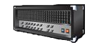**

A great representation of the ENGL sound - very midsy yet modern and djenty. It's a bit looser than the Dual Rectifier and a bit dirtier - it has a wonderful gritty tone, think Jeff Loomis. Has loads of distortion and is pretty simple to dial in. It's a great choice for any kind of modern metal when you don't want the Dual Rectifier sound. I use this amp mainly for Periphery and Scar Symmetry tones, but you can actually get a good 80's metal sound out of it due to its midrange response.

The Presence and Treble controls are a bit sensitive at higher settings, but sometimes you need them up high to get enough sizzle to the tone. They seem to provide very subtle changes during initial adjustments than start to hurt the tone, usually making it too harsh. Bass doesn't seem to do very much. Mids is more responsive but also more forgiving - I usually set it up fairly high and, like the Uber, use EQ effects to really dial in the midrange response.

A mids-boost on this amp can make it really djenty. Ola's hand job patch uses a Screamer with Bass down to 35%, tone up to 75%, and Treble at 45%. I also like using a Classic Distortion with Drive ~5-15%, Bass 35%, Filter 75%, Treble 60-65% to make it really aggressive - djenty but also dirty.

Another trick is to use EQ before the amp, boosting the mids, but turning down some of the really high end. This makes the tone much smoother sounding - Studio EQ with Low Freq at 700 HZ, +5 db, High Freq at 5000 HZ -4db.

I generally like to turn up the Master Volume to the 70-100% range for my Vai tone. This really makes the amp thump, but it also makes it a little looser. If you want a tighter tone, turn it down. This amp seems the most forgiving with its DEP's. For lower Master Volume settings, reducing Bias tends to make the amp sound more real in my mind, although this does suck out some mids which you'll have to add back in. For higher Master Volume settings, Bias tends to make the amp sound a little looser and more midsy and warm at lower settings, but tighter and crisper and colder at higher settings. For the life of me, I can't seem to notice any change in the tone with the Hum control.

[Top of Amp/Distortion Tone](#_V._Amp/Distortion_Tone)

### 

### **vii. Elektrik**

**http://foobazaar.com/podhd/toneGuide/pics/uber.png**

I'm meh on this model. It doesn't do anything the Uber doesn't do that I find the Uber does better, even if it takes more tweaking with the Uber to get there. I never use this amp. It sounds too much like a modeled amp, not a real amp to me. You can hear it in the mids. It sounds like some annoying kid going "uhh uhh uhhh".

Immediately selecting this amp, you will notice something doesn't sound right. For some reason, the default "Master Volume" DEP value is 100%!!!! Set that down to at least 50% or lower, and this amp becomes at least usuable.

The Presence setting is a little non-traditional. I find a value around 45% keeps the amp djenty. Higher values make the amp more crunchy like a Marshall. Otherwise, it behaves similarly to the Uber, especially the mids knob.

[Top of Amp/Distortion Tone](#_V._Amp/Distortion_Tone)

### **viii. Dual Rectifier "Pre"**

**http://foobazaar.com/podhd/toneGuide/pics/tread.png**

Normally I don't deal with the pre-amp only models because I feel like they're the same as their full counterparts, only missing bite and a full frequency response (they sound thin). Yet the Dual Rectifier's pre-amp sounds different from the full model - I consider it an entirely different amp model. It has a very smooth, spongy distortion, compared to the full model having more bite and grit. I like to use it for my Metallica black album tone.

You'll notice with the "Pre" variant, you have to use a bit more gain. Also, there's much less bass and more mids. So I generally turn down Mids and turn up Bass more than usual.

Otherwise the same rules apply as the full model, regarding boosts and EQ's. There are no DEP's to deal with.

[Top of Amp/Distortion Tone](#_V._Amp/Distortion_Tone)

### **ix. SLO Overdrive**

### 

This is easily one of the best models on the unit. It sings quality, especially in its rich midrange response. It has plenty of punch and warmth, so it never sounds thin like the Treadplate and Fball models. While the high-end is there and can be quite ronchy, it is never overbearing or harsh. But the real spectacle is the signal-to-noise ratio. This model has very little noise compared to the other models, making direct comparisons to them sound like a generational leap - like SD to HD.

The overall tone is probably somewhere between a Marshall and the Fireball. It doesn't feel quite "modern" enough for chugga chug downtuned metal, but it's certainly not vintage. It makes for a sweet 80's - 90's hard rock tone and will even work as a thrash tone. I find it does wonders for Vai tones.

One thing about this amp reminds me a lot of the Plexi model actually. It's got that nasal breakup to the pick attack that adds character to the tone. And as hard as I've tried, I could not dial that out. Which is good and bad - for some tones I like it, but it doesn't work for a sweet, super-smooth, high-gain lead tone. If you want the SLO tone without that nasal attack, try to boost the SLO Crunch - it's "cleaner" in this regard, but as you might expect, less saturated and more crunchy.

The natural tone of this amp has a bit too much low-end breakup to me, and doesn't sound focused enough. I like to put a Distortion pedal or some EQ in front of it to give it a bit of a mids-boost. Nothing too fancy or extreme - it doesn't need radical treatment to draw out the sweetness. I don't find the amp is very versatile. Extreme settings are more likely to sound ugly than interesting.

Another interesting point to this amp is that the EQ knobs are not as drastic as one might expect. I find I use them more to change distortion tone than to really EQ the tone. In that sense, they are similar to the Fball model. If I want more low-end or high-end, I'll use EQ effects after the amp. I usually keep the amp's EQ knobs a little over 50%, but find boosting mids higher can sweeten up the sound.

I have not had much success tweaking the DEP's. I find they sound best around 50%. Boosting Master can have some effect on the midrange - sometimes I move this up to around 60-65%. But beyond that the power amp distortion is too broken up for my tastes. As usual, Sag works as expected and can be set to taste. Hum gets swirly and ugly if turned up yet reduces the richness of the distortion if turned down. Bias almost acts like a mids control.

[Top of Amp/Distortion Tone](#_V._Amp/Distortion_Tone)

### **x. Doom**

### 

The Doom basically sounds like a heavily customized Marshall; and as you might guess from the name, it is dialed in towards doom, sludge, and black metal tones. It's kind of vintage and droning, but at the same time it stays focused and doesn't get a little weird like a Marshall would if pushed that hard. Personally, I don't really mess around with these tones, so I can't speak a lot on how to dial it in.

One thing that has been mentioned about this amp model is that it takes Distortion pedals very well. You can set the amp to provide a mild breakup, then drive it hard with a heavily distorted pedal. Or you can use a pedal with a slight breakup and drive the amp hard. Either way you get a usable tone without much tweaking. And this works across a wide variety of the distortion effects available on the Pod. So this will be my focus for the amp. I'm hoping it might deliver a better tone for some of the patches where I use a heavy pedal distortion into a slightly broken up Marshall, like my Satriani and Opeth tones.

[Top of Amp/Distortion Tone](#_V._Amp/Distortion_Tone)

### **xi. Epic**

### 

This amp requires heavy tweaking to get it in the "usable" range for me. But once there, it provides a tone no other model delivers. I would describe it as dry, thrashy, tight, and not-too-saturated. I think it should sound good for thrashy death metal tones like Opeth, Extol, or The Faceless.

If you try to get pre-amp distortion from this model, bring your broom. It's a mess. Rather than try to use EQ or boost pedal trickery to clean it up, let me save you some time. Don't bother. It sounds like a broken amp. Set Drive to 5% and forget about it. All the distortion is going to come from the power section. Crank the Master DEP to 100%.

I find a distortion pedal is necessary to focus the tone. Also, the amp's EQ plays heavily into the distortion tone you get from its power section. This is a bit tricky. While I like to boost mids in my pre-eq or distortion pedal, I find turning up mids (or even using 50% mids) can consume the tone, causing it to sound too dark and compressed, like a pedal distortion. I like to back off of it, even going down to like 15% to get more of a natural bite out of the tone. On the other hand, I boost Treble, and keep Presence slightly under 50%. Of course, these relationships change depending on how you pre-eq the amp. Be warned.

As for DEP's, again Master at 100% - it's the source of the distortion. I suppose you could turn this down if you wanted to use a pedal for your distortion, but this amp has so many pitfalls, I'd be scared to try to dial that in. Sag can be set to taste, but I find the amp is still tight and percussive at 50% and sounds more natural than if you set it any lower. Hum I actually turn down a little. With Master cranked, the amp can easily get into "broken power amp" tones, swirling and such. Turning down Hum a little helps prevent this, along with smart EQ settings and amounts of gain. Bias I turn down a little - this makes the tone have a bit more bite, but going too low makes it sound thin and scooped. Bias X I turn down all the way. I don't like what turning this up at all does to the tone - seems to make it sound flat and overly compressed.

[Top of Amp/Distortion Tone](#_V._Amp/Distortion_Tone)

## E. Distortion Effects

My favorites here are the [Line 6 Drive](#_vii._Line_6), [Tube Drive](#_i._Tube_Drive), and [Screamer](#_ii._Screamer). The Line 6 Drive seems the most versatile due to how it uses the mids parameter. It also has a natural distortion tone. I liken it most to a Boss DS-1. The Tube Drive also has a natural tone, and it is great for warming up an amp - I think of it as adding an extra tube gain stage to the amp. Its distortion tone is a bit vintage-sounding, yet I usually use it to make a vintage-sounding amp model more modern sounding. The Screamer has its classic tone, which seems to be a be a bit colder and tighter than the other options.

### i. Tube Drive

This is probably my most commonly-used distortion Effect. It works well as a filter. It tends to make the tone a bit warmer and smoother. It also works well as a primary distortion, getting the kind of tone I'd expect from a Boss DS-1 or a general-purpose distortion pedal that uses a tube for distortion tone.

I use this frequently with the Marshall amps. It helps give them a bit more lower midsy warmth without losing bite. I find it can add a touch of compression, so you can preserve the distorted-yet-clean Marshall crunch while still having a thick lead tone and nice sustain. I use it in front of the Fireball to get a less djenty sound, while still still keeping the crisp high-gain tone from the amp.

I use this in my early Van Halen, Slash, Rhoads, Vai, Satriani tones. I even use it for a Meshuggah tone. I use it in various other patches when I need a solid distortion effect.

I avoid turning the Treble knob too high here. Bass I often turn up fairly high, and I'll set mids even higher sometimes. But Treble can make the tone a bit harsh when cranked up.

[Top of Amp/Distortion Tone](#_V._Amp/Distortion_Tone)

### ii. Screamer

The Tube Screamer is one of the most infamous pedals of all time. Used by Stevie Ray Vaughn to God Forbid, it's a classic choice for enhancing an amp's distortion. I don't find myself ever using it as a standalone distortion, as it comes off a bit thin and harsh. But using mild Drive levels and pre-EQ'ing amps has a unique effect that is difficult to describe.

The first thing you need to realize is that the "auto" impedance setting when this effect is first in the chain is 230 K. This may leave the sound a little less crisp than desirable - the actual pedal's impedance is 500 K. Try setting the input impedance manually to 1 M to get more bite in the tone. Conversely, if it's not the first effect in the chain, or you aren't using "auto" impedance, it might have too much bite for your tastes, and you might want to consider reducing your input impedance to 230 K. My suggestion is to use 1 M then use an EQ effect to roll off a little high-end before the pedal for the most authentic tone.

This pedal tends to reduce bass and focus in on mids and presence, pushing your amp into djent-mode, without necessary making it gritty. It can make the tone pretty cold as well, which works nicely for metal.

The Pod HD version includes bass and treble controls not on the original. Use them where tone isn't getting your tone where you want. I find I'll often turn up bass a little bit, as this pedal really sucks out a lot of bass.

This pedal dials in a good bit of upper mids, but it also seems to roll off some top-end (in addition to the "auto" 230 K impedance) and can flatten out your attack some. Take this into account when setting Amp DEP's and compression.

When dialing in this pedal for metal, the pitfall is to set Tone very high. This definitely gets the cold, presence-focused, brutal tone the pedal is known for, but it can be a bit too much and make the tone too "scratchy". If you get to that point, try backing off the Tone.

[Top of Amp/Distortion Tone](#_V._Amp/Distortion_Tone)

### iii. Classic Distortion

The Classic Distortion seems at first to be inferior to the two distortions mentioned above, and maybe it is; but it's worth considering when you need a bit of something different that you can't find with the two above. Its standalone distortion tone is similar to the Tube Drive. But its filtering can be similar to the Screamer.

The trick to reigning in this pedal is to keep things relatively neutral. The bass and treble parameters can be quite extreme. From there, it's all about finding the sweet spot on the Filter control. This parameter is very tricky - turning it up seems to brighten the tone and scoop it simultaneously. I find I usually stay around 50% and often go lower with it, rather than higher.

One thing I like about this effect is that it gets pretty much 100% clean at 0% Drive. This can make it more ideal than the Screamer, which cannot get as clean, for certain scenarios where you want the Screamer filter tone, but you don't want the scratchy high-end, like a soft lead tone.

[Top of Amp/Distortion Tone](#_V._Amp/Distortion_Tone)

### iv. Overdrive

This is basically a fuzzier version of the Tube Drive. The break-up is looser and a bit more raucous. I don't really have any purpose where I use this as a filter, but I do use it as a standalone distortion for a fuzz tone. I find I have to give it a little pre-EQ bass boost to get it as dark and fuzzy as I want it. I don't really have anything else to say about it.

[Top of Amp/Distortion Tone](#_V._Amp/Distortion_Tone)

### v. Facial Fuzz

I'm not really into fuzz tones, but I do use this occasionally, particularly for a Hendrix or Eric Johnson tone. I find the key is to mix it with some Marshall amp distortion and give it medium gain. It mostly affects the break-up and looseness of the feel to your playing, while the amp distortion provides the real distortion flavor. I don't find it does much when used solely as a filter, and it's too crazy for my tastes when used as a standalone distortion. I also perform some EQ after the distortion to trim off some of the nasty low and high-end this thing produces, otherwise I get a muddy and gritty amp tone.

[Top of Amp/Distortion Tone](#_V._Amp/Distortion_Tone)

### vi. Line 6 Distortion

This is the best distortion effect for standalone, high-gain distortion. I use it to simulate 90's Randall amp tones - it has that solid-state kind of tone where it seems unnaturally responsive and crunchy with no flub. I do like to pre-EQ it to add a little more midsy crunch and djent to it.

The difficult thing is finding a good amp to pair this with. I've had good results with some of the Marshalls, but you have to give them a little pre-amp Drive or the tone is weird - it almost gets a little fuzzy like the amp is struggling to work properly. Other good options are the Fender Blackfaces or the Divided by 13. The main thing to watch out for is excessive bass and treble. It's almost best to start with mids at 100% and everything else at 0% and work towards a natural-sounding tone. You're likely only going to be able to get so far, then use EQ effects to really shape things into a natural tone.

[Top of Amp/Distortion Tone](#_V._Amp/Distortion_Tone)

### vii. Line 6 Drive

This may actually be the best distortion effect in the Pod. Its Mids parameter varies the type of distortion you get, so as you go from 0%-100% you go far from farty to almost fake-sounding tight djentiness. I don't go too far off 50%, but there's so much ability to dial this in, I don't need to. Once you find your Mids spot, then use Bass and Treble to dial it completely in.

I sometimes like to run a Mid-Focus EQ before or after this distortion to trim some of the ultra high-end if I'm trying to get a super bright distortion, because it can make it too bright in the very high frequencies, which tend to make amps create a grittier tone with a more broken up attack. With more conservative settings, it's not (or less) necessary, but is something to keep in mind.

I mostly use it as a filter (0% Drive), but it seems like I get the best tone when I attenuate my signal before this effect with a Volume effect, to make sure it's not distorting or even compressing at all. It does work well as a standalone (high Drive) distortion, and I also occasionally use it to add a slight bit of distortion and run it into amp distortion to get a nastier tone with a little buzz.

[Top of Amp/Distortion Tone](#_V._Amp/Distortion_Tone)

### viii. Others

I find the others sound fake or just crazy. They'd be good for a kind of out-of-control intro tone, but I don't really mess with that very much.

The Heavy Distortion is supposed to be modeled after a Boss Metal Zone; but without the adjustable mid-frequency, it is nowhere near as versatile. I find I prefer to use the Line 6 Drive (which does have the adjustable mids contour) or Line 6 Distortion (which is more dialed in where you'd kind of want it) where I would use this.

The Jumbo Fuzz is supposed to give you a Zepplin tone, but I haven't tried it yet. The Fuzz Pi is all over the place, which I haven't found a use for - maybe Nirvana? The Jet Fuzz is a phaser + distortion - I think I'd prefer to keep those separate. Same with the Octave Fuzz - I'd rather use separate effects and have more control over each.

The Buzzsaw and Color Drive seem to just add some dirt into the tone - definitely not my thing.

[Top of Amp/Distortion Tone](#_V._Amp/Distortion_Tone)

## F. Power Amp D.E.P.'s

The best approach to these is to treat them like you would on a real amp. You'd likely spend most of your time finding the sweet spot for the master volume. Next you'd likely tweak the bias. Sag, hum, and bias excursion would be more complicated modifications to the amp that probably won't help the tone, other than the slight variation in such parameters you'd get from using different tubes.

**Master**

This controls the amount of power amp compression/distortion, similar to the master volume knob on a real amplifier. This setting affects how much the other DEP settings affect the tone - they are colors of power amp compression/distortion. Setting this to lower settings (even all the way to 0%) approximates the tone of the pre-amp only models. This is helpful to dial in a sweet spot between the default "pre" and "full" amp models. It is also useful to dial out unwanted power amp distortion on cleaner models.

For the high-gain models, the default 50% sounds about where I like it. I may tweak a little this way or that way to make the tone a little edgier or smoother, but I generally don't go far. The Treadplate becomes rather harsh at higher settings, while the Fireball and Uber tend to compress and get a little more life in the midrange, at the expense of high-end richness and smoothness. I like to turn up the power section to around 65% on the J-800 usually, which offers a more aggressive distortion than its preamp.

**Sag**

Controls the amount of power amp sag, which is a dip in voltage over a sustained load. I find it mainly causes a slower attack and a chunkier bottom end. See [this wikipedia entry](http://en.wikipedia.org/wiki/Distortion_%28music%29). Lower settings offer more of a dynamic attack and tighter feel, but can change the tone.

In general I leave this alone until I've made almost all my other tweaks. I'll use it to add more/less attack to the tone. I usually stay within 40-60%. Lower settings can make the tone a bit edgier bit thinner. If I want to thicken the tone up, I usually add Decay in the Cab DEP's to do so. But sometimes, I like to turn up both Sag and Decay to get it extra thick.

Some distortion effects introduce their own kind of sag to the tone, so you actually want to reduce the Sag DEP to compensate. Too much sag or thickness to a tone can make it sound artificial - like a solid state pedal that claims to give you teh brootz tonez. But not enough Sag and your palm mutes will sound more like an overdriven clean-channel crunch tone than a thick djent tone.

**Hum**

This controls the AC ripple plate voltage, which affects how the power tubes behave. For some amp models, this control has little effect; for others, it can be dramatic. It's hard to describe, and it varies from amp to amp. Also, the changes in tone are not completely linear. IE - if you find it to sound warm at 50% and cold at 25%, it's not necessarily going to sound really cold at 0% or really hot at 100%. Be warned: this control can cause weird things to happen to your tone when you move it off 50%. For instance, I liked the tone when I turned it up from 50 to 70% on the Uber model but noticed it introduced a faint, kind of digital-sounding ghost signal doubling my guitar parts. I almost always leave this control at 50%.

The big exception is the Uber model. I find a touch more Hum (55-60%) changes the distortion to thicken it up a little and make the overall tone a bit darker, which I really like. I also find setting it around 75% gives me a more evil tone, which I use to approximate a 5150. I have not had such luck manipulating this control on other amp models.

If you do choose to boost this, pay attention to your Master DEP setting. You will have to balance the two or you'll end up with a tone that hums and swirls and sounds like an out-of-tune radio. You can tell you've got too far when this control noticeably increases the amount of humming when you're not playing (provided you don't have a noise gate that is muting it).

**Bias**

Determines the bias of the power tubes. Lower settings resemble class AB operation where you have more headroom and where you do get clipping, it is more natural sounding. Higher settings resemble class A operation, which is often said to sound warmer (more mids/presence) but can get grittier-sounding clipping.

I recommend playing with this control from 0 to 100% for your patches. It can cause subtle frequency response changes to the tone that you can't get using EQ. It seems to improve the signal-to-noise ratio for certain frequencies. It can also change your distortion tone. While I generally end up around 50%, I'm usually slightly one way or the other. In some cases, I'll have this at 100% while others at 25%.

For some of the more vintage amp models that exhibit crossover distortion, turning this up can reduce or eliminate the crossover distortion; however, it will have a significant impact on tone. I prefer to reduce the Master DEP and boost Bias X.

**Bias X**

Controls bias excursion or how far the bias can deviate from its setting under different loads. I find this has the most effect on cleaner tones where the attack of the signal can be a spike exponentially larger than the sustained note - I've found higher settings clean up attack without sacrificing tone, acting like a compressor/limiter. Also useful to "lock-in" a bias setting by turning it down when you're getting power amp distortion. Or you can get some "bloom" to notes by turning it up.

Bias excursion seems to operate in phases. When a load is first applied (ie, when playing a note), the voltage overloads the tube, and the tube biases away from its normal setting. It then hits a point where it begins to recover and return to its natural bias. I assume this is why I feel like boosting this parameter can add "bloom" to a sustained note.

I most often leave this alone, or turn it up to get the vowel-y bloom effect I just mentioned. Just be careful. While at first it can generate some compression and a slight change in the distortion character, which as this transitions over time gets the "bloom" effect, going too far can make the entire tone change, in a way I feel is bad. Certain frequencies are not reproduced well, and the tone seems more noisy and dull. I find I like 65-70% and that's with a power section not being pushed very hard. The most I'll ever do is 80%, and that's when I've got the Master DEP set low, like 20%. Beyond that is the tone graveyard.

[Top of Amp/Distortion Tone](#_V._Amp/Distortion_Tone)

## G. Dual Amps

The Pod HD allows dual amps; however, I tend to avoid this, other than for [dual cab](#_E._Dual_Cabs) purposes, which this section isn't referring to. I just don't like the way it sounds, especially for high gain. However, there are a couple ways to make it sound good, which I'll cover below. Additionally, it will eat up your DSP usage, putting strong limits on the amount and type of effects that you can use.

I first started experimenting with dual amps on the Pod X3. I figured if I like two different amps, mixing them together would sound great. Wrong! It felt like the amps were fighting each other, creating a noisy mush. To get them to clean up, I would have to pan one left and one right. This is one way to get a good sound from dual amps, but the problem is that you have to run this tone in stereo. If you want to record, you can't double track by panning one track hard right and the other hard left, which is what I like to do. You may think you can just record one stereo track with the two different amps already panned in the Pod, and this will sound just as good as if you recorded each amp as a mono track and panned them in your recording unit; but from my experience, it always sounds better to actually record two mono tracks.

The main way I could dial in a dual amp tone the way I liked was to basically crossfade their frequency responses. So I'd cut certain frequencies to the point where you couldn't hear them at all on amp A, then boost those frequencies so that they were the only ones you'd hear on B. In other words I'd mix the bottom end of one amp with the high end of another amp. Or I'd cut the mids out of one amp and dial in only mids on the other. I don't see this so much as mixing two amp tones as much as creating a single amp tone with parts of two different amps. IE - FrankenAmp.

Another way is to use different gain levels on the amps. So one amp would have close to or full saturation, while the other would be medium or low gain, providing just a touch of crunch. This can get you that distorted yet clean/crunchy tone.

In any case, I don't use dual amp tones, because I feel there is no significant tonal improvement, they take longer to dial in, and they limit the amount of effects you can run.

There is one exception to this rule, which is if your second amp is actually "amp disabled". This uses no DSP whatsoever. And it'll give you a clean tone, which you can use to reinforce your distorted tone. You want to pan both mixer channels to center and set the clean tone so it is just barely audible. You want it to really just add a little attack because a heavily distorted tone can lose some attack. Most of the time, I don't use this setup; however, because it is difficult to get right and I don't find it really delivers a much better tone. It's easier to screw up than get right. If you do use this approach, try adding some compression and EQ to the channel with no amp; so you don't get too much attack or bright clean tone.

[Top of Amp/Distortion Tone](#_V._Amp/Distortion_Tone)

## H. "Full" vs. "Pre"

You'll notice there are two versions of every amp on the Pod HD, one with the amp name, and one with the amp name plus "pre". The "pre" amps only model the pre-amp section of that amp. They were designed to be used in combination with the Line6 DT-50 line of amps, which have switchable power sections/modes. Of course, most of us don't have DT-50's.

People on the forums have argued a lot about which versions you "should" use for any particular setup. For instance, I've often seen posts saying that if you are running the Pod to a real amp, you should use the "pre" version, because otherwise you're getting the power amp emulation plus power amp distortion from your real amp. Likewise, if you run "direct", you "should" use the "full" model, otherwise you're not getting any power amp in the sound. They argue that you want one power amp coloration, not zero or two.

This is logical, yet I disagree nonetheless. The power amp emulation has a rather profound effect on the way the Pod's amp models sound, even if you turn down the "Master Volume" DEP or set the bias colder. Your real amp is unlikely to replicate how that amp model's power section sounds on the Pod. You might not be cranking your amp to the point where it's getting power amp distortion, even at gig levels - many power sections are designed to have lots of headroom and remain transparent. And even if your amp's power section does get pushed into overdrive, it may still sound good with the "full" model on the Pod. Just because you're running two power amp colorations doesn't mean it will necessarily sound worse.

On the other hand, there is a certain crispness in the "pre" models that seems to be lost in the "full" models, even with the Master DEP at 0%. Even if the frequency response is not ideal, it can be tweaked to where you want it with amp EQ or EQ effects.

Thus, in general I prefer to use the "full" models for "direct" tones, while I'm about 50/50 on which to use for "live" uses - it depends on the patch.

Keep in mind that if you have a power amp that easily distorts, it is more likely to sound better with the "pre"s than the "full"s. I encourage you to experiment to determine what suits you best. On the other hand, some tones rely on power amp distortion. If your power amp isn't providing the same breakup, you will have to use the "full" model or won't be able to achieve the desired tone, even if you crank your real amp.

Finally, if your real power amp does distort at volume levels you will be playing at, take note to make patches that distort it in a desirable way. As noted [earlier](#_A._Distortion_Types/Overview), the EQ of the tone you send to your amp will greatly affect the way it breaks up. If you use too much bass, the power amp distortion may make the tone muddier than you like. Your gear is limiting you. You'll have to brighten up your patches to compensate or get new gear or play at lower volumes.

[Top of Amp/Distortion Tone](#_V._Amp/Distortion_Tone)

## I. The Elusive Pure Clean Tone

The PodHD doesn't offer any pure clean amp models (yet? as of 7/18 there is a Soldano SLO Clean model available for the 300/400 that may fit this bill), like a Roland Jazz Chorus. This doesn't mean getting a pure clean tone is impossible though.

If you are not using Input 2: Variax (null), I suggest you start with that adjustment. One of its benefits is a lower signal level, which allows clean tones to instantly be a little cleaner. But there are [other benefits](#_I._Input_Settings).

The cleanest amp model is the Blackface Dbl, based on a blackface Fender Twin Reverb. Line 6 modeled it in "warts-and-all" fashion, meaning it can get a little nasty sounding when running modern high-output humbucker pickups into it, rather than the 60's era single-coil pickups it was designed for. Still, there are a number of ways to tame it. Here's a list, ordered by what I prefer to preserve tone, which applies to getting a cleaner tone in general on all the amps.

1. Change input settings - input 1:guitar, input:2 variax
2. Put a Studio EQ in front the amp, and set gain to -X db.
3. Use no amp model, using compressors and EQ effects to simulate one
4. Try turning up bias or bias X
5. Try turning down Master Volume
6. Use a Parametric EQ to find which frequencies really push the amp to nasty breakup, then reduce those frequencies (you can dial them back in after the amp)
7. Use pre-amp models instead of full models
8. Change input impedance - lower values will be softer, darker, and looser but less likely to distort

My favorite tone from the amp comes from a dual amp tone combining the Blackface Dbl on one channel with no amp on the other. I use a compressor and some EQ on the "no amp" channel. Then just set the volume so that they complement each other. You get the shimmering clean sound of a compressed and EQ'ed raw guitar signal mixed with the warmth of the Fender clean.

I also did a little experiment to see how much power amp (crossover) distortion I could dial out of the Blackface Dbl without causing it to lose its desirable tonal nuances. You might still get a little distortion using the advice below, but the idea was to preserve tone more than completely dial out distortion. All starting values are the exact default settings when you select the amp.

1. Default Master Volume is 100%. Change that to 20%.
2. I found changing the Bias changed the tone too much. I was able to get good results from Bias X, though. I set it to 80% and that helped clean it up a little. I assume this means that the bias is changing to a colder setting when it would be pushed hard enough to exhibit the crossover distortion, but not for any notes softer than that. I changed Bias X from 50% to 80%.
3. Turn Drive from 37% to 60%.
4. It seems like this may change the dynamics just a little bit. I tried adding a Tube Comp before the amp. I set Level to 0% and Threshold to 95%. I think I prefer the tone without the Tube Comp - you may want to try it though.

Some general notes:

* For my setup, I put amp/channel volume at 50%. Any higher than this and I'd clip my DAW input. But I run via SPDIF and I think I boost the SPDIF output level. So you might be able to go higher.
* My mixer has channel 1 panned full left and channel 2 panned full right. Levels for both channels are 0 db.
* My input impedance is on auto. My input settings are input 1: guitar, input 2: same. Pad switch is turned off.
* Test guitar is EBMM JPM. Tested bridge pickup for dialing out crossover distortion by strumming as hard as I can. Tested tone using single notes and chords all over the neck for bridge, neck, and coil-tapped bridge+neck pickups.

[Top of Amp/Distortion Tone](#_V._Amp/Distortion_Tone)

## J. Noise Gates

**Noise Gate vs. Hard Gate**

There are two noise suppressors on the Pod HD, the standard "Noise Gate" and the more advanced "Hard Gate". In general I prefer the Hard Gate, because its a true gate. The Noise Gate is part gate, part signal processor and can result in "tone suck". At higher settings, it tends to make the tone sound thinner.

The Noise Gate uses less DSP than the Hard Gate; however, so sometimes it's the Noise Gate or nothing, and I use it with lower settings then.

**Gate Overview**

Here's what a noise gate is designed to do - either let signal pass through or block it completely. It's helpful to think of it like a physical gate. When "open", the signal should pass through untouched as though the noise gate isn't even in your signal chain. When "closed", no signal should be allowed to pass through. The gate detects the signal's volume level, compares it to a threshold setting, and determines whether the gate should be open or closed.

Most gates also feature a Decay parameter. This specifies how quickly the gate should close - whether the signal should fade out over time or be abruptly silenced. a 0 setting means the signal should jump from the threshold level to no output. Higher settings fade out over the specified time period.

Some gates feature a Hold parameter. This keeps the gate fully open even after the signal level diminishes to less than the Close Threshold. After the hold time is elapsed, if the the signal level did not return above the Open Threshold, the gate starts to close at the speed specified in the Decay parameter.

**Open/Close Thresholds**

The Hard Gate has two threshold levels - open and close. If the gate is currently open, it is only looking at the Close Threshold value to determine if it should close. If the gate is closed, it is only looking at Open Threshold to determine if it should open. This helps in two ways.

Single threshold gates are subject to jitter - consider a sustained note that is gradually decreasing in volume. The level you hear might be 96, 95, 95, 95, 95, 95, 94 db at 1/20th of a second intervals. The level the gate detects might be a little different, let's say 96, 95, 94, 95, 94, 95, 94. If the Threshold was set to 94.5 db, the gate would open and close rapidly as a decaying note hit the threshold value. It would sound like sputtering, which is very noticeable and undesirable.

With separate Open and Close Thresholds, you can set them a few db's apart, and the imprecision in the effect's signal level detection will not cause a sputtering gate.

This also comes in handy due to guitar naturally having a strong attack. Setting the Open Threshold high means when the gate is closed, you won't accidentally open it with soft noises you make when you're not trying to play a note, such as your fingers rubbing on unfretted strings. Yet, once you do purposefully play a note, the attack is strong enough to open the gate. Setting a single threshold gate to such a high threshold would mean that sustained decaying notes would get "cut off" rather than naturally fading to silence. With a low Close Threshold setting, however, you can let the note decay to almost silence before the gate closes.

While you can fake the above technique with a single threshold gate by turning up the Decay parameter, it's more favorable to set Decay lower and use two tresholds. It sounds better, and you'll get the expected gate behavior when you're playing quick staccato notes or sustaining notes.

**Hold**

The Hard Gate also features a Hold parameter that specifies a time to hold the gate open even after the Close Threshold has been passed. This can be used to reduce jitter as described in the last section, but as mentioned, staggered Open/Close Threshold settings should take care of that.

Where I find Hold is useful if you are using a longer Decay time. If you are playing a staccato part, the fade-out of the noise between notes is very noticeable, compared to if the noise were to remain at a constant level. Setting a hold time is basically taking a little time to make sure the gate should really be closing.

**Decay**

For a spacious lead tone, where any decay is going to be buried by reverb or delay, I like to turn Decay a bit off 0 such as 100-200ms - so there's not an obvious sound when the gate kicks on. For super tight rhythms, I like it at 0; but this means I have to be careful about my muting and exactly where I set the Threshold(s).

**Placement in the Chain**

As far as placement in the signal chain, I find the most effective place is first in the chain - most of the noise in your tone is coming from the low signal-to-noise ratio and hum produced by guitar pickups. Anything that is compressing the tone in your chain, such as compressors, distortion pedals, and amp models, are amplifying that initial noise. You might think that this would mean to put them last in your chain (or after a compressing element), but then they are very difficult to dial in.

Note that the signal from your pickups is going to by the most dynamic, which makes it best for dialing in gate settings. If you only place a gate after some kind of compression, it will be difficult to find settings that let only let your playing through and not noise but still allow all your playing through.

**Dialing it in**

To dial in the Hard Gate, start with Hold and Decay set to 0 ms. Set both Open and Close Threshold around 9:00 (about -70db) - easily opened but still high enough to make the gate close when muting. If the gate won't close at these settings, turn them both up until the gate closes with the guitar muted, but with its volume knob at 10/10.

Then I see if I can make the gate open using a mundane noise, such as tapping a string, or rubbing a string with my finger. If so, I turn it up a bit. Once I've gotten it high enough so it won't open from any incidental noises and intermittent hum, I see if it will open by playing the softest note I intend to play. This varies from patch to patch. For a soft lead patch, this might be a mild hammer-on onto a silent string. For my Meshuggah rhythm patch, it's going to be a picked note at at least medium strength. If it won't open, I have to turn it down, even if this means it will also open from incidental noise as I play. Better for it to pick up some incidental noise than block out purposeful playing.

Then I back down the Close Threshold. I want to test it against punchy staccatto notes and chords as well as sustaining notes. I need it to activate between my stacatto playing but not kill a sustaining note; however, these are conflicting goals.

The "middle ground" I choose depends on the patch. For a soft lead, I want it low enough to sustain notes as long as possible. This means I have to make sure the guitar is completely muted to get the gate to close, so I have to pay more attention to doing so if I'm trying to play stacatto or after I let a note decay. For my Meshuggah patch, I want to make sure it activates as soon as I mute the guitar, even if my mute didn't have perfect technique. I'm not sustaining many notes for very long, especially single notes higher on the fretboard which are more sensitive to decay. So long as it doesn't cut off a sustained power chord after a few seconds, I'm happy.

I leave Hold at 0 ms. The Hard Gate is precise and quick enough so that I don't have to worry about trailing noise when quickly muting the guitar from a loud volume. Since I set Decay to a very low time, I don't need to worry about hearing a fade-out of noise either.

If I can get away with setting Decay to 0 ms, I'll do that, but if the gate kicking on creates an unnatural tone, I'm going to either need to use two gates, or introduce a little Decay. I set it just barely off 0, at like 20 ms. The slight decay prevents an unnatural cut-off sound, but it's not long enough so that you hear noise fade out after staccato notes. If it's not tight enough, we'll have to use two gates.

**Dual Gates**

Using two gates is useful when you're using strong compression or distortion, and you need to go from punchy chords to dead silence very quickly. I like to place the first gate as the first thing in the chain. I dial it in as described above, but it may not kick on fast enough, and those snippets of noise occurring as I'm muting are being amplified and are obvious when listening to the tone.

I add another gate after the compressor/distortion stage that is adding most of the compression. For many people, this is the end of the chain. For me, it's usually before the amp, but after a compressor or distortion effect with a little drive. I dial this one in exactly like the first one, and I turn the first one off while I'm doing so.

Once I've got them both tuned, I try the patch out with them both on. Sometimes it'll end up gating a little too much. I tend to back off the first gate a bit, while keeping the final gate firm.

[Top of Amp/Distortion Tone](#_V._Amp/Distortion_Tone)

# VI. Cabs and Mics

* [A. Cab/Mic Overview](#_A._Cab/Mic_Overview)
* [B. Cab Selection for Direct Tones](#_B._Cab_Selection)
  + [i. My Favorites](#_i._My_Favorites)
  + [ii. General Tips](#_ii._General_Tips)
  + [iii. Hiway 4x12](#_iii._Hiway_4x12)
  + [iv. Tread V-30 4x12](#_iv._Tread_V-30)
  + [v. XXL V-30 4x12](#_v._XXL_V-30)
  + [vi. Greenbacks 4x12](#_vi._Greenbacks_4x12)
  + [vii. Uber 4x12](#_vii._Uber_4x12)
  + [viii. Brit-T75 4x12](#_viii._Brit-T75_4x12)
* [C. Cab Selection for Live Tones](#_C._Cab_Selection)
* [D. Mic Selection](#_D._Mic_Selection) 
  + [i. SM57 On/Off Axis](#_i._SM57_On/Off)
  + [ii. Dynamic Mics](#_ii._Dynamic_Mics)
  + [iii. Condenser Mics](#_iii._Condenser_Mics)
  + [iv. Ribbon Mics](#_iv._Ribbon_Mics)
* [E. Dual Cabs](#_E._Dual_Cabs)
  + [i. Introduction](#_i._Introduction_1)
  + [ii. Getting the Patch Ready](#_ii._Getting_the)
  + [iii. Phase Correction](#_iii._Phase_Correction)
  + [iv. EQ'ing the Tone](#_iv._EQ'ing_the)
  + [v. Other Amp Settings](#_v._Other_Amp)
  + [vi. E.R. Settings](#_vi._E.R._Settings)
  + [vii. DSP Management](#_vii._DSP_Management)
  + [viii. My Favorite Combinations](#_viii._My_Favorite)
* [F. Cab DEP's](#_F._Cab_D.E.P.'s)
* [G. E.R.](#_G._E.R.)

## A. Cab/Mic Overview

There are several things to consider when selecting a cab/mic combinations for your patches. Your main considerations should be the general tone and feel of the cab/mic and whether frequencies are plain noisy or missing.

#### Ignore General Frequency Response...

While the most obvious thing is frequency response, simple things like too much bass, mids, or high-end can easily be filtered out using EQ (and/or some of the Cab DEP's). To some degree, that is important - other than a few general EQ tweaks, you're probably not going to EQ out all the differences between one cab/mic and another. But unless the frequency response you want is extreme and can only get there with a certain cab/mic, such considerations should take a backseat to tonal nuances or deal-breaking imperfections.

#### ...Unless Frequencies are Missing

If frequencies are missing, trying to dial them back in will end up amplifying noise, which will kill your tone. If a cab is deficient in some frequencies to the point where they are noticeably absent, it's probably not going to work out. There are some Cab DEP treatments I cover below that may help, but if they do not, swallow any sentiments you have towards that cab/mic and move on - you're going to be happier with another one.

#### Response or Noise?

It's easy to confuse a strong frequency response with noise at first glance. You can tell the difference by playing different notes and chords up and down the neck and seeing if the tone remains stagnant, always sounding the same. If so, that's noise. If it's just a small frequency range, you may be able to dial it down with a Parametric EQ. That's what I occasionally do for fizzy spots. But before doing that...

#### Using Res. Level to improve SNR

The cab's Res Level DEP might help reduce the noisyness of the cab. I find at low settings (15-30%) you get the cleanest, most-natural sound, but the tone can be a little rough and/or dark/scooped. As you turn it up, you'll hit the spot where the resonance starts to smooth out roughness and the tone becomes "squishier". From that point on, the resonance tends to amplify certain frequencies and filter out others, and the tone tends to sound a bit more and more washed out, almost like a presence knob for the lower mids. I like to find the sweet spot where the tone starts to get a little squishy, but I generally don't want the resonance to emphasize certain frequencies over others. This spot tends to sound like a nice, thick tone but also clear and relatively noiseless. Going past this point may improve the frequency response for your tastes, but may also introduce more noise and less clarity to the tone. Sometimes that's ok, but most of the time I avoid that.

On the other hand, if a cab is deficient in lower frequencies and not punchy enough, you may be able to balance it out by increasing the Thump or reducing the Res. Level Cab DEP. Keep in mind that reducing Res. Level may make the tone a bit rougher - you may be able to dial this out when dealing with [amp/distortion tone](#_V._Amp/Distortion_Tone), but maybe not. However, as mentioned above, deficient frequencies are often a deal-breaker. Trying to dial them in results in a noisy tone.

#### Taming the Low End

If a cab simply has too much low-end, you can dial this down using the amp's bass knob, the Thump Cab DEP, the Low Cut Cab DEP, or using an EQ effect. A lot of people have said the Pod HD's cabs are too dark. Not the main ones I use - they aren't dark enough! But in any case, if a cab is too dark, that's easily taken care of with EQ. I don't find I have as much trouble with the low end as I do with mids and treble. The low-end is rarely noisy, and doesn't require the same attention to detail on the Cab DEP's as the mids and highs. Just EQ it out using the 4 controls I mentioned, usually using a combination of them to get the exact frequency response you want.

#### Tonal Nuances

Similar to amps, the cabs seem to have their own individual nuances that are unique to that model. Spend time with the cabs/mics and try to identify a feel for them that transcends their EQ curve. I wish I could just tell you the nuances of each one, but they're really difficult to describe - it's like trying to explain the difference between the different sounds of vowels. You have to put time in with each one. It's a good idea to try to EQ out the obvious general differences and to adjust the Res. Level DEP before thoroughly listening to the tonal nuances. Otherwise, you might miss them, distracted by annoyances that can be dialed out.

You don't have to experiment for hours with every possible combination - 1 hour with each cab/mic combination would take 128 hours. You should be able to tell which cabs sound in your desired ballpark after trying a couple different mics on them. I'd start with the SM57 on axis and SM57 off axis, as they deliver a relatively clean representation of the cab's sound. Once you've found 3-5 cabs you think sound best, try them using all the mics.

But keep in mind that just because one mic doesn't sound good with one cab doesn't mean it will sound bad with every cab. Some sound a lot different. For instance, I think the 409 Dynamic mic sounds really vintage-y with most cabs, but it sounds really heavy and modern with the XXL cab. It helps not to think of the cab and mic simulation as separate processes - think of each combination as its own unique entity. This is actually probably how the Pod HD technically performs cab + mic simulation - each cab/mic combination loads a distinct IR file.

#### Dual Cabs

Further below, I recommend running a [dual cab](#_E._Dual_Cabs) setup. The EQ advice contained above and below does not pertain to a dual cab setup, where you are generally picking two cab/mic combinations that complement each other and lead to a fuller response from the get go. Dual cabs are not for the faint of heart, or those wanting to run numerous or expensive effects. If you just want an awesome amp tone and are willing to spend a bit more time on your patches, I recommend you jump right into [dual cabs](#_E._Dual_Cabs).

#### Using Cab/Mic Choices for EQ Purposes

As a final note, if you have run out of effects blocks and can't get the EQ you want, you may want to sacrifice the tonal nuances of the cab/mic you've picked and use a cab/mic that gets you that EQ. It's a trade-off you have to make sometimes.

[Top of Cabs and Mics](#_VI._Cabs_and)

## B. Cab Selection for Direct Tones

### i. My Favorites

My favorite cab/mic combinations to use for single amp patches are:

##### Hiway 4x12 + SM57 Off Axis

Great all around tone. A little midsy and maybe a little light on the high-end but nothing EQ can't solve. Nothing sounds fake or washed out here. The only problem is it's a little noisy compared to its on axis twin, and the Tread V-30. This is my go-to cab/mic.

##### Hiway 4x12 + SM57 On Axis

A little thin and overly midsy. Top end can be a tad too harsh. Even with the high end and mids dialed down, something is still just slightly off compared to the off axis. It's louder and cleaner sounding, but the tone is just slightly lacking. Still the 2nd best choice, I think.

##### XXL V-30 4x12 + 409 Dynamic

Offers plenty of punch and a good bit of high end, but suffers in the upper mids. If you boost presence, the tone can become a little harsh and noisy. Good for a chug-a-chug metalcore tone.

##### Tread V-30 4x12 + SM57 Off Axis

Offers the most traditional sounding hard rock tone, IMO. Great everything but a little thin - needs more punch/bass. It can sound slightly plasticky. I can get the same tone with the Hiway, but it doesn't sound fake, so I now use that instead of this. However, this cab is louder and less noisy than the Hiway.

##### Greenbacks 4x12 + SM57 Off Axis

Huge mids, good top-end bite. Sounds a little more vintage than the Tread V-30 4x12, but it also has more bass. I used to use this for more of my Satch/Vai/EVH/Rhodes patches, where I needed a good midrange response but also some crisp highs, but it has taken a backseat to the Hiway.

##### Uber 4x12 + SM57 Off Axis

A good hard rock tone. Like the Tread V-30/off axis tone, but more bass/punch and a touch of vintage to it. I don't really use it, but it's certainly not bad.

##### Tread V-30 4x12 + 421 Dynamic

The 421 mic tends to have a scooped sound, which is bad with most cabinets but it works ok here. The tone isn't as clear as other options, but it does sound really heavy.

##### Greenbacks 4x12 + '67 Condensor

Very midsy and vintage sounding. Can make a good lead tone if you dial out the fizzyness.

I used to rely on the Treaplate 4x12 + SM57 on axis combo, because of its rich highs and upper mids; but I felt it left the tone way too thin, lacking in punch, warmth, and bass. Trying to dial that in never resulted in a satisfactory tone. So I switched mostly to the SM 57 off axis, which doesn't quite have the same clarity in the top end, but has a better overall response across all frequencies. Recently I've noticed there's still something fake-sounding in my tone and went back to the drawing board, trying to really test out all the cabs in detail. The one that stuck out was the Hiway 4x12. Both 57 on and off axis work well with it, and deliver a very real-sounding tone.

I also have different favorite mic/cab combinations for my dual cab patches. See [that section](#_E._Dual_Cabs) for those.

[Top of Cabs and Mics](#_VI._Cabs_and)

### ii. General Tips

To compare cab/mics, you want a true A vs. B comparison. After you've dialed in your amp tone, picked a cab/mic, and EQ'ed the patch in pretty well, clone the patch (save it to a neighboring or empty patch space), select a different cab or mic in the clone, re-tweak the EQ and Cab DEP's, then compare the new patch vs. the original. Otherwise if you just switch the cab you're comparing, one cab is dialed in and one is not. Each cab/mic will have unique EQ and Cab DEP settings ideal to the patch you're trying to create. Compare tweaked cabs to tweaked cabs, not defaults to defaults or tweaks to defaults. Additionally, the Tread V-30 4x12 is significantly louder than any of the other cabinets, which makes it difficult to compare it to other cabs as you're trying to build a patch. Compensate your patches for volume as well as EQ differences.

A lot of the tones I seek require a nice, bright top-end. This often goes too far, putting harsh highs in the tone. But these can easily be rolled off using a Mid-Focus EQ. I stick to my general principles - that it's better to filter out frequencies than to try to dial them in and to start with the cleanest signal possible and EQ or otherwise adjust it.

But sometimes you want a cab's unique tone, and that means I may need to boost the high-end. I like to use the Studio EQ to do so - it uses wide boosts and it has an 8 kHZ selection, that allows it to focus higher than the Parametric EQ. Another good option is the Parametric EQ. Although the frequency selection only goes up to about 5 kHZ, it has a high shelf that can make a nice even boost to the highs. If this ends up putting too much crackle in the ultra-high end, again, a Mid-Focus EQ is best to roll that off.

[Top of Cabs and Mics](#_VI._Cabs_and)

### iii. Hiway 4x12

|  |  |  |
| --- | --- | --- |
| Vintage | \_\_\_\_\_\*\_\_\_\_ | Modern |
| Dark | \_\_\_\_\_\_\*\_\_\_ | Bright |
| Midsy | \_\_\*\_\_\_\_\_\_\_ | Scooped |
| Loose | \_\_\_\_\_\_\*\_\_\_ | Tight |
| Noisy | \_\_\_\_\_\_\*\_\_\_ | Hi-Fi |
| Thin | \_\_\_\_\_\*\_\_\_\_ | Thick |
| Smooth | \_\_\_\_\_\*\_\_\_\_ | Harsh |

After testing pretty much all of the cabs in depth, EQ'ing out any sore spots that may initially overwhelm me, I came to the conclusion that the Hiway rules all other cabs in its ability to deliver the tone of a real guitar speaker. I can't say exactly what speaker it sounds like. Some of the recorded tones I've tried to emulate have used Celestion Vintage 30's, Celestion Greenbacks, and Altec 417-8H's, maybe some others as well. In all cases, I got the Hiway cab to sound more like the tone than the Tread V-30, XXL V-30, Greenbacks, or other cabs. Some tones, which I know used Vintage 30's, sound virtually identical to the tone I can get with this cab model. The actual speakers modeled in the Hiway cab are Fane 12287, which I cannot find any clips of or detailed comparison to speakers I'm more familiar with. In any case, I am currently in love with this cab model. I use it in virtually all my single-amp patches now, replacing the Tread V-30 and Greenbacks 4x12's I was using.

I'm still trying to figure out why it took me over a year to realize this about this cab, as I formerly thought the Tread V-30 cab ruled the roost. I think I was biased against it due to it being a "vintage" model, with speakers I was quite unfamiliar with. Also, the first thing you'll notice about the tone is that it's really midsy - right in the honk area of the mids, which is NOT metal. Dialing the mids out can be a little tricky, but I find a Parametric EQ with frequency at 47%, Q around 50%, and gain around 35-40% does nicely. It's the low and high-end tone that I really like here.

This cab is not perfect. It's not as loud and clear as the Tread V-30, but I think it's still preferable because the tone is so much more consistent across the entire frequency spectrum. Also, it can be a little weak on bass, which you'll have to dial in. This can lead to a bit of drone and boom in the low end, which is off-putting. But dialing in the bass isn't as noticeable, especially in a mix, as the fake or dead sound of the other cabs.

For DEP's, I like to turn the Res. Level down quite a bit in general (25%), making the tone quite crispy and clear and I boost Thump to add a bit of punch.

[Top of Cabs and Mics](#_VI._Cabs_and)

### iv. Tread V-30 4x12

|  |  |  |
| --- | --- | --- |
| Vintage | \_\_\_\_\_\_\_\*\_\_ | Modern |
| Dark | \_\_\_\_\_\_\_\*\_\_ | Bright |
| Midsy | \_\_\_\_\_\*\_\_\_\_ | Scooped |
| Loose | \_\_\_\_\_\_\_\*\_\_ | Tight |
| Noisy | \_\_\_\_\_\_\_\_\*\_ | Hi-Fi |
| Thin | \_\_\*\_\_\_\_\_\_\_ | Thick |
| Smooth | \_\_\*\_\_\_\_\_\_\_ | Harsh |

It seems to have the least bass of all the cabs. You'll have to dial it back in, but you're never going to get the same amount of chug from it as the XXL V-30 4x12. It can also be a little bright (especially with the 57 on axis and 421 Dynamic), so you'll have to stay mild on your treble or turn up the bass and mids (I find the best way to tame the sizzle is to use a Mid-Focus EQ). Even with those deficiencies, I still think it's one of the better options, in general. But if you directly compare it to a real cabinet or high quality 3rd party IR, you'll notice it has some dead spots or something that make it sound a little fake.

I find this cab is best around 40% Res. Level - that's where the resonance starts squishing the speaker but before it starts making the upper mids overly prominent. Thump can definitely stand to be turned up - I go all the way to 85%.

[Top of Cabs and Mics](#_VI._Cabs_and)

### v. XXL V-30 4x12

|  |  |  |
| --- | --- | --- |
| Vintage | \_\_\_\_\_\_\_\_\*\_ | Modern |
| Dark | \_\_\*\_\_\_\_\_\_\_ | Bright |
| Midsy | \_\_\_\_\_\_\_\*\_\_ | Scooped |
| Loose | \_\_\_\_\_\_\_\_\*\_ | Tight |
| Noisy | \_\_\_\_\_\_\*\_\_\_ | Hi-Fi |
| Thin | \_\_\_\_\_\_\_\_\*\_ | Thick |
| Smooth | \_\_\_\_\*\_\_\_\_\_ | Harsh |

The XXL V-30 4x12 cab should be in the same ballpark as the Tread V-30 4x12 (same speakers being modeled) with a bit more bass and a slightly different frequency response. Yet, it sounds WAY different, out-the-box. I think many people desiring a heavy tone would choose the XXL cab over the Tread on first glance. The deep bass makes it sound undeniably heavy.

Yet something about it sounds a bit off. It's clearly got way too much bass, especially in the "boomy" range between 100 and 240 HZ. But even when you dial that out, it just sounds muffled or something, even with mics that tend to have more presence. I rarely use it by itself for this reason. The only mic I find it sounds good with is the 409 Dynamic, but you have to tame the boomyness still.

Nonetheless, it definitely sounds the heaviest, and I can dial it in close enough to where I want it to be for certain patches. It's the only cab that'll get you that ridiculous Meshuggah (and metalcore) djent.

There are many ways to tame the bass - the amp's bass control, the Thump Cab DEP, the Low Cut Cab DEP, a Mid-Focus EQ, or a Parametric EQ. I almost always use a Mid-Focus EQ anyway, so I start there. Try using a low Q setting on the high pass, and slowly turning up the cutoff frequency to find the sweet spot. Then play with Q and frequency until you have it exactly like you want. That should help balance it out. If still sounds boomy, I use a Parametric EQ with frequency at 13 or 14%, Q around 75-85%, and gain at 35% or less - this will dial out that boomy spot. Or reduce the Thump DEP. If you can palm-mute a low B and it doesn't rattle your entire house, you're on the right track. Finally, try turning down the "lows" parameter on the Parametric EQ a bit or backing off the bass on your amp model.

I actually like to turn up the Res. Level on this cab to about 60% when I use it by itself. This seems to give the mids and presence a healthy boost, partially evening out the frequency response of the cabinet. As expected you probably want to turn Thump down a tad, but don't go too much or things will start to sound weird. When I use it in a dual cab patch, I'll turn Res. Level down to clean up the tone, but it makes things darker, but that's ok since I'm pairing it with a brighter cab.

[Top of Cabs and Mics](#_VI._Cabs_and)

### vi. Greenbacks 4x12

|  |  |  |
| --- | --- | --- |
| Vintage | \_\_\_\_\*\_\_\_\_\_ | Modern |
| Dark | \_\_\_\_\*\_\_\_\_\_ | Bright |
| Midsy | \_\_\_\_\*\_\_\_\_\_ | Scooped |
| Loose | \_\_\_\*\_\_\_\_\_\_ | Tight |
| Noisy | \_\_\_\_\*\_\_\_\_\_ | Hi-Fi |
| Thin | \_\_\_\_\_\_\*\_\_\_ | Thick |
| Smooth | \_\_\_\_\_\*\_\_\_\_ | Harsh |

I have really come to enjoy the Greenbacks 4x12 for a few of my tones, mostly Satriani and EVH. It has some buzzy quality to it, which might not work for heavier music. But it works for a slightly-nasal traditional rock tone, with nice midrange. It might get you a good 80's metal tone. It sounds good paired with the SM57 off axis mic though. For some reason this cab seems to have more highs with the SM57 off axis than on axis.

[Top of Cabs and Mics](#_VI._Cabs_and)

### vii. Uber 4x12

|  |  |  |
| --- | --- | --- |
| Vintage | \_\_\_\_\_\_\_\*\_\_ | Modern |
| Dark | \_\_\_\_\*\_\_\_\_\_ | Bright |
| Midsy | \_\_\_\_\_\_\*\_\_\_ | Scooped |
| Loose | \_\_\_\_\_\_\_\*\_\_ | Tight |
| Noisy | \_\_\_\_\_\_\_\*\_\_ | Hi-Fi |
| Thin | \_\_\_\_\_\_\*\_\_\_ | Thick |
| Smooth | \_\_\_\_\_\*\_\_\_\_ | Harsh |

The Uber 4x12 is another good option, modeling a 4x12 with 2 Vintage 30 and 2 G12T-75 speakers. It's got a great bass response and a touch of a vintage sound to it. I think it sounds more like the Tread V-30 4x12 than the XXL 4x12 does. It's more like a real cab "out-the-box".

The only caveat, which is true of pretty much every cab but the Tread V-30, is that it's a little lacking in the high-end response. You can dial some in with a very strong presence boost around 2 - 2.8 kHZ, but it's going to sound a little noisy. Getting the right amount of bass isn't a fight like with the XXL. You can probably get away with just adjusting the amp's bass knob.

It's highly valuable for dual cab tones - a perfect complement for the Treadplate 4x12's brightness to fill in some punch and warmth. Also when mic'ed with a 57 gets that raucous T75 tone, but has a more modern sound than the Brit-T75 4x12.

[Top of Cabs and Mics](#_VI._Cabs_and)

### viii. Brit-T75 4x12

|  |  |  |
| --- | --- | --- |
| Vintage | \_\_\*\_\_\_\_\_\_\_ | Modern |
| Dark | \_\_\_\_\_\_\*\_\_\_ | Bright |
| Midsy | \_\*\_\_\_\_\_\_\_\_ | Scooped |
| Loose | \_\_\*\_\_\_\_\_\_\_ | Tight |
| Noisy | \_\_\_\*\_\_\_\_\_\_ | Hi-Fi |
| Thin | \_\_\_\*\_\_\_\_\_\_ | Thick |
| Smooth | \_\_\_\_\_\_\_\*\_\_ | Harsh |

Very nasal and vintage-sounding. I find I prefer the Uber for a more modern T75 sound. I occasionally use this cab for classic rock tones, but you're going to need some EQ treatment. The lower mids can be a bit boomy and it's a bit muffled in the high end. I very rarely use this cab because of how noisy it is and how difficult it is to dial-in, but it does have that pure T75 sound if that's what you want.

### ix. Other cabs

As for Blackbacks 4x12, I don't dislike it perse, but I never found it preferable to the ones listed above for the tones I was going for. I don't know what it is - I tend to love it at first but slowly get a little annoyed with them. I think they have a little buzz to them that's too prominent compared to the rest of the tone - there's not enough creamy mids here. I find the Blackbacks 4x12 is in the same league as the Uber. It can sound a bit aggressive and vintage at the same time, but ultimately I just can't dial it in where it doesn't sound harsh, noisy, or fake.

As for the other cabs, I simply didn't find many of them useful for a high gain tone. They all sound REALLY thin, especially the Fenders. The Celest 12-H 1x12 and the PhD ported 2x12 are probably the best suited for a high gain tone, but unless you're mixing them with another cab, you won't find enough punch.

For clean tones, I like the Fender 2x12 and the Celest 12-H the best.

[Top of Cabs and Mics](#_VI._Cabs_and)

## C. Cab Selection for Live Tones

When not using Studio/Direct output mode, selecting a cab enables "live-voiced cabs" which are a mild EQ effect designed to color your actual cab's sound to be more like the one selected. I tend not to use these, instead selecting "no cab". They seem to muffle the high end a bit.

If you find "no cab" too harsh, first check your amp/power amp. Some power amps have a presence control that's used to dial in the right amount of high end. Sometimes, you may think it’s a pre-amp control that's being bypassed, so you don't think to adjust it. If there's no setting on your power amp to dial back harshness, you may simply have harsh speakers. [In this case](#_E._I_Tried), I do recommend setting your output mode to something other than "Studio/Direct" (Stack power amp or Combo power amp usually), and using a live-voiced cab that suits you.

I believe they are free DSP-wise and don't consume additional effects blocks, so in that sense they are better than an EQ effect. Don't just try the ideal cab you want here - try them all. Try the 1x12's as well as 2x12's and 4x12's. You can't know in advance how well any one will work with your actual cab - the Pod doesn't know what kind of cab you have.

If your tone is still too harsh with one of those, try dialing down the high end with an EQ effect. I like the Mid-Focus EQ's low pass.

If you still have no luck, try using Studio/Direct output mode with a cab/mic simulation. Even though this is not how the Pod was designed to be set up, as long as you like the tone you get, you should use it. Your only other option at this point would be to replace your speaker(s) (given the issue isn't due to how you set up a patch).

[Top of Cabs and Mics](#_VI._Cabs_and)

## D. Mic Selection

### i. SM57 On/Off Axis

90% of my tones use the SM57 mic. It seems to get the most guitar tone and the least noise for distorted tones. Many have complained that it creates too much fizz or harsh high-end. I think some of the other mics are fizzier, but I do agree about the high-end. However, this is easily solved with the low-pass of a Mid-Focus EQ (see [Mid-Focus EQ](#_v._Mid-Focus_EQ)). If there's any fizzy spots, you can easily dial them out with a Parametric EQ (see [fizzy spots](#_E._Fizzy_Spots)).

I go back and forth on whether I prefer on or off axis. It depends on the tone I'm going for. I like to start on-axis. It really captures the high-end sizzle cleanly, and the tone just seems richest with this mic. But something about this mic can also make the tone sound like a modeler and not a real guitar tone - I think it's the lack of punch and warmth. Sometimes you can dial in enough warmth with the on axis depending on the tone you're going for and the amp model you're using. Or if you're using the [dual cab technique](#_E._Dual_Cabs) below, you just pair this mic with a darker cab. I find my favorite tone is a Hiway/XXL combo, both using the 57 on axis - thick AND rich.

The [cab DEP's](#_F._Cab_D.E.P.'s) have really helped get the right amount of growl and bite from this mic. You can use the Res. Level, Thump, and Decay controls to thicken up and smooth out the tone more than you otherwise could.

But sometimes you want the off axis. In general, the off axis is less clean - it sounds a bit noisier, and maybe a bit fizzier. But you get a more punchy tone really centered around the warm mids, but you still have a good high-end response. The one exception is on the Greenbacks cab - I find the 57 off axis is a bit brighter and cleaner for some reason.

For dual cab tones, I always use a 57 on axis on one of the cabs to get a nice clean upper midrange and treble response. None of the other mics come close for these frequencies.

[Top of Cabs and Mics](#_VI._Cabs_and)

### **ii. Dynamic Mics**

The Dynamic mics are pretty good, but can sound overly aggressive. They almost sound like a real amp with a blanket over the speakers, then a touch of highs added on top later on. The highs are bright but the presence is lacking. In fact, when you turn up presence for these, often you'll notice you get a thicker sound, not necessarily what you'd expect by adding more presence. I like the sound of the XXL cab with the 409 and the Tread V-30 with the 421, but I use these very sparingly. The 409 can sound more vintage with other cabs.

I sparingly use the 409 for dual cabs - it can fill in some punch and warmth pretty well, but in general I find other mics below do it better.

[Top of Cabs and Mics](#_VI._Cabs_and)

### iii. Condenser Mics

I can't tell if these mics dial in a good bit of midrange or are simply noisy. The 67 is a bit tamer than the 87. The 87 I use sparingly. I tried to work with the '87 for a while and was digging it at one point, but I eventually gave up on it.

These mics sound "squishier" than the others, which can sound a little djenty. You get less high end definition, but the overall sound is a bit smoother. They might work well for lead tone in a mix with a lot of space, but I don't think they'd cut through at all in any kind of busy mix. It just sounds way too noisy to me.

I tend to like the 67 and sometimes the 87 for dual cab tones. They add punch and warmth nicely and "fill in" the tone. Just watch out for some buzzy high end creeping in - you may have to dial down the treble on the amp using this.

[Top of Cabs and Mics](#_VI._Cabs_and)

### iv. Ribbon Mics

The 4038 actually sounds kind of like a mild version of the Condenser mics, but a bit buzzier or filtered-sounding. It's usable but kind of dark. Maybe it'd work for a real grindy tone. The 121 will get you nowhere for high gain tones from my experience, at least on its own. I know many metal bands use a 121 to record. I could never get anything worthwhile from the 121 model though. I do like it for mid-centric clean tones though.

The 121 is great for dual cab tones, filling in a lot of midrange and punch, but not really putting out a bunch of nasty high-end like the dynamics and sometimes even the condensers. The 4038 is more difficult to blend in due to its raucous high-end, but it can be made to work.

[Top of Cabs and Mics](#_VI._Cabs_and)

## E. Dual Cabs

### i. Introduction

Using the dual cab technique I'm presenting here can improve your direct tone dramatically. However, this is not for the faint of heart. It requires about 2x as much time to dial in as a single cab patch. You will also take a heavy DSP hit, so this is not recommended where you need many effects on your patches - in some cases you won't be able to fit a single reverb after adding a distortion effect and the necessary EQ effects.

Every cab/mic will have some frequency range that sounds fake, washed out, or muffled. Luckily, I don't believe these are always in the same spot. This means that you can combine complementary cab/mic's to get what sounds like one great cab.

[Top of Cabs and Mics](#_VI._Cabs_and)

### ii. Getting the Patch Ready

You will need to use dual amps plus a possible additional effect, maybe two. So if you won't have the DSP or effects blocks for this, you'll need to adjust your patch accordingly. I find it's best to start with a blank patch and add the effects in after dialing the amp tone in. Also, your EQ settings may end up far from whatever works with a single cab, so don't worry about preserving your "magic" settings.

Setting up the technique is quite simple: you just create a dual amp patch, choose the same amp model for both amps, and dial in basically the same settings. You only change the cab/mic's being used between them. I recommend you start with the exact same gain, EQ, and DEP settings. Make sure you pan each Channel to center in the Mixer. You want one great mono tone, not a kind of stereo mix.

Next we get to cab selection. I like to start by picking my cabs based on their general tone and feel, ignoring the mics for the time being. The mics chosen will likely depend on the characteristics detailed in [Appendix C](#_Appendix_B_–_1) and also [this spreadsheet](http://foobazaar.com/podhd/toneGuide/CabsDelayTimes_V2.xlsx)/[alternate Google Cloud version](https://docs.google.com/spreadsheet/ccc?key=0AsSFadRSa9zYdG1kc1J2b1ZvRFVlUVIydXRMVVoyZnc&usp=sharing#_blank)/[pdf version](http://www.foobazaar.com/podhd/toneGuide/tripGuitar_cab_delay.pdf#_blank), BROKEN LINK which we will get into in the next section. But the basic idea is to choose "compatible" but complementary cabs. For example, the Tread V-30 and XXL V-30 work nicely together because they are both tight, modern-sounding cabs using the same speakers, yet one is rather thin and the other has lots of punch. On the other hand, the Tread V-30 and Hiway might work less well together because they are both a bit bright but have two different sounds to them. You have to be familiar with the qualities of the cabs individually before choosing which to mix. Use the descriptions above and demo their tones to figure this out. Or check out my [favorites combinations](#_viii._My_Favorite_1) below.

I tend to use the Hiway, Tread V-30, Uber, or Greenbacks with a 57 on axis mic as the cab in Channel A - this will be my "bright cab". For Channel B I like to use the Uber, Greenbacks, or XXL V-30 with the 121 Ribbon, 67 Cond, 409 Dyn, or 57 off axis mic. However, I use this as a loose starting position. They might not work well together, even if they are compatible and complementary from their individual characteristics, as we'll see below. Be ready to abandon your initial choice for something similar. For instance, if you wanted to use the 409 mic, you may have to use the 421 mic, or a 67 cond - something somewhat similar. In some cases you may want to use an entirely different cab.

Just keep in mind you don't want to have to EQ the crap out of either of the cabs. You want them to simply blend together into one full-sounding cab. You also want to adjust the volume of each amp to balance them. Neither should overpower the other. I generally find I like them with the same volume, but sometimes I use the darker cab a little louder. Start with your bright cab's volume at 0% and slowly turn up the volume until the sound gets nice and full but it doesn't start to overtake the darker cab. You'll need the bright cab's high-end to make the guitar tone cut through, but you don't want to sacrifice midrange or "body" in the process.

When you first setup your patch, the results might not be as pretty as you'd like. I've actually found that many combinations sound bad at first but can be fixed. This leads me to the next section on phase correction, but first I'd like to say that I prefer to use cab/mic combinations that do not require phase correction, or only require using a single EQ effect to do so. If you find the section below too confusing or know in advance that you won't have an extra EQ or 2 to spare on phase correction, just use the [combinations below](#_viii._Favorite_combinations) as a cheat sheet - it lists combinations that don't require any phase correction, or it lists which cab needs to be delayed and by how much. Or demo examples in [This setlist](http://foobazaar.com/podhd/toneGuide/dualCabs.h5s). BROKEN LINK CANNOT DL???

[Top of Cabs and Mics](#_VI._Cabs_and)

### iii. Phase Correction

You may notice a drop in high-end response and/or a dead or phasy tone when you first combine the cabs. The dual cab combination you chose is likely experiencing a comb filter. Anytime you record a single audio source with two mics that are at different distances, there will be negative interference occurring at regular intervals throughout the frequency spectrum. In short, this means the tone has dead spots. This is due to a slight delay in one of the signals. For certain frequencies, the two signals perfectly cancel out. Others are just out-of-phase to various degrees, while some perfectly reinforce each other.

Higher-pitched frequencies get the worst of it. Because they have a shorter wavelength, even a slight delay can cause perfect cancellation. This is probably what you notice. The tone sounds like a blanket was thrown over the amp. Even though the Pod is using different cabs, the signals aren't as different as they sound. Even the dark cab has some treble in there, and it can wash out the bright cab's high-end. Even if you use the same mic on both cabs, it doesn't mean the signal isn't delayed more in one than the other. This could be a result of how the cabs themselves behave, differences in the distances Line 6 used to mic them, or differences in how the DSP processing implements them.

I have discovered a method to phase correct the two cabs. Some effects can be set to be transparent to the signal; however, they do require processing time, which introduces a very slight delay to the signal. The most common effects I use are EQ's and Compressors. By using a combination of such effects, we can acheive phase correction. The difference is night and day.

Author's note: the information below gets fairly technical and might be more work than necessary. The easier way to do this is to simply throw a parametric EQ with default settings behind one of the amps before the mixer. Toggle it on/off and see if the tone improves with it on. If not, do the same test on Channel B. If the tone sounds muffled with no EQ, EQ on Channel A, and EQ on Channel B, or if it just sounds "off" and "phasy", give up on the combination you've picked - you'll probably need to use 2 or more effects to phase correct the cab/mic choices, which starts to become a hindrance. I list [combinations below](#_viii._Favorite_combinations) and in [Appendix C](#_Appendix_C_–), [this spreadsheet](http://foobazaar.com/podhd/toneGuide/CabsDelayTimes_V3.xlsx)/[alternate Google Cloud version](https://docs.google.com/spreadsheet/ccc?key=0AsSFadRSa9zYdG1kc1J2b1ZvRFVlUVIydXRMVVoyZnc&usp=sharing#_blank)/[pdf version](http://www.foobazaar.com/podhd/toneGuide/tripGuitar_cab_delay.pdf#_blank) BROKEN LINK that work well using 0 or 1 EQ's. [This setlist](http://foobazaar.com/podhd/toneGuide/dualCabs.h5s) BROKEN LINK CANNOT DL???also contains examples.

I have done some pretty thorough research on this, and am continuing to update it. The link below is a spreadsheet with a matrix of every possible combination of cab/mic with another, for the Tread V-30, Hiway, XXL, Greenbacks, Uber, Brit, and Blackbacks 4x12 cabs with all available mics with the delay required to make them in-phase represented in a number of samples assuming a 96 kHZ sample rate. It contains tabs on how to use it, a list of relatively tone-transparent effects with the amount of delay they introduce, and the combination of effects necessary to get any particular amount of delay.

#### [Cab/Mic Delay Times Matrix](http://foobazaar.com/podhd/toneGuide/CabsDelayTimes_V3.xlsx)/[alternate Google Cloud version](https://docs.google.com/spreadsheet/ccc?key=0AsSFadRSa9zYdG1kc1J2b1ZvRFVlUVIydXRMVVoyZnc&usp=sharing#_blank)/[pdf version](http://www.foobazaar.com/podhd/toneGuide/tripGuitar_cab_delay.pdf#_blank)

So here's how to apply this knowledge. First look up any pair of cab/mic you want to use with any other cab/mic in the CabDelayTimes spreadsheet. Channel A's cab/mic is listed on the x axis, Channel B on the Y axis. Where these rows and columns meet, you'll see a number. That tells you the number of samples you need to delay Channel B to get phase correction. If the number is negative, that means you need to apply the delay to Channel A (if so, it might be simpler to simply switch the cab/mic in Channel B to Channel A and vice versa).

Once you have found the delay number, you need to add effects to channels A and B to get the specified delay. You'll notice in the FXDelayTimes spreadsheet, the smallest delay time for any effect is 6 samples. To get values less than that you need to add a larger delay to one Channel and a shorter delay to the other Channel. For instance, to get a 4 sample delay in Channel B, you'd put a Parameter EQ in Channel A and a Blue Comp in Channel B. This puts a delay of 10 samples in Channel B and 6 samples in Channel A, giving you a difference of 4 samples in Channel B. This is where the FX Combination Delay Times spreadsheet is useful - you can quickly look up combinations that will yield delay samples in increments of 1 sample from 1 to 20+.

I have color-coded the cells that require 0 or only 1 EQ effect. I recommend sticking to using these cab/mic combinations. Otherwise you risk having to use too many effects blocks or DSP on phase correction, or you have to use effects whose tone-neutrality is highly suspect.

If this seems confusing, it can be a bit tricky at first. That is why I made [this setlist](http://foobazaar.com/podhd/toneGuide/dualCabs.h5s). BROKEN LINK CANNOT DL??? It contains numerous example patches demonstrating how to achieve phase correction. You can toggle the effects on/off (usually with FS2) to hear the difference they make to the tone.

A few notes:

* ~~Even with phase correction, the bass can get a bit woofy sounding if you dial in bass on both cabinets. I set the Low Cut Cab DEP to around 50% (260 HZ) on my "bright cab" to prevent having both too much bass and it sounding a bit "off". The bass is going to sound cleaner and tighter from the "dark cab" anyway.~~ Edit: I found the striked-out statement to make my sound too thin. With proper pairing of cabs/mics and dialing in of the low-end response on both, you should not need to kill the bass on your bright cab. The bass will remain rich and powerful.
* ~~On my "dark cab", I find even with phase correction, the mixed high ends sound kinda fake together, especially when using different mics. So I generally set the amp's Treble control to 0% on my "dark cab".~~ Edit: I do tend to dial back the treble on my "dark cab", but rarely to 0%, this can leave the tone sounding like something's missing. I dial it up until it starts to sound like it's interfering with the bright cab's highs, than back off a touch. You want it to fill in some frequencies but not take too much focus away from the "bright cab". I usually end up with EQ settings within 15% of each other between amps.
* Most of the compressors additionally include a LP filter. This is quite evident when they are applied to whichever channel you use as your "bright cab". Thus, I try to avoid using them to delay the signal on my "bright cab". If I need to use one to get the specified phase correction in my document, I just ignore that and get as close as I can using an EQ or something that definitely won't kill my high end. For instance, if I need an 8 sample delay, the closest is the Vetta Juice at 7.5 samples, but I instead use a Mid-Focus EQ with 6.5 samples, or even a simple Parametric at 6 samples. On my "dark" cab, this is not an issue. I'm ok with dialing out the high-end there, and will use whatever gets me closest to the research.
* Many cab/mic combinations are currently impractical. Using 3-4 effects to achieve phase correction is a huge drain on DSP and effect blocks. I hope my research isn't the end result, but a starting point for individuals to realize how powerful the onboard cab/mic sims can be if they could be dialed in as mentioned. The real end-game is for Line 6 to implement a feature to be able to delay each channel on the Mixer block by samples in increments of 1 from 0-60. This would require a buffer maximum of 60 samples, which at 24 bits is only 180 bytes of memory. It should require little to no DSP, similar to the Volume effect. Then any dual cab combination would become practical, even when using some DSP-expensive effects. If you want to help out on this front, please see [this thread](http://line6.com/support/message/390465#390465). BROKEN LINK
* Don't write off an EQ used for phase correction as a dummy block that's being wasted. Use it however you can. I'll often use a Mid-Focus EQ to get my phase-correction latency on my bright cab, then use its low pass to roll-off the excessive high end. Or I might dial additional hot djenty presence frequencies with a Parametric EQ. Similarly, if my dark cab has a boomy punch or excessive warmth, I can dial out those frequencies with a parametric EQ.

The tone might be too trebly for your taste. Don't worry about that - we're going to EQ later. You want the tone that sounds the least filtered/phasy/dead and the most like a single amp tone. Sometimes increasing the delay between the cabs reduces the frequency cancellation in the high-end but adds more ambiance to the tone. I don't like this - I want to reduce the delay between the cabs to as close as I can get to 0. You can use E.R. and the Cab DEP Decay to add slight ambiance and thicken up the tone.

[Top of Cabs and Mics](#_VI._Cabs_and)

### iv. EQ'ing the tone

With two sets of amp EQ's and possible EQ effects on only one channel, EQ'ing can get much trickier than with a single amp tone. The important things to remember are that the controls will work slightly differently for each channel given the cabs' different frequency responses, and some frequencies will sound a bit better in one channel than the other. However, dialing frequencies out completely can make the tone "small" or a bit dead. I find both amp's need somewhat similar EQ settings, but not exactly the same. The ultimate goal is to blend them together for one full-range sound, playing into the strengths and weaknesses of each cab/mic.

For amps where you're using power amp distortion, EQ settings will affect distortion tone. In these cases, I want the EQ settings virtually identical...at least to start. Only after finishing the rest of my patch and using as many EQ effects as possible for final EQ will I revisit these controls to try to get the final EQ I want.

I also often like to put a Mid Focus EQ at the end of my chain. This helps me roll off some of the extreme highs and lows. You can also use the Gain parameter as a final patch volume, rather than having to change both Mixer Levels or the Amp Volume controls.

You'll probably still want further EQ treatment. I find a Parametric EQ or two behind the mixer (applied to the mixed signal) is usually enough. The phase-correction EQ's above can help as mentioned above, but they won't have as powerful of an effect as a post-mixer EQ. However, since DSP is tight, it's best to make smart choices for them to get as much as you can from them and your amp EQ before trying to add post-mixer EQ blocks. This is especially true for lead patches, where you need some time-effects, or patches that need pitch or mod effects.

Keep in mind that the Cab DEP's will also affect final EQ. Sometimes they can be slightly tweaked for EQ purposes without changing the tone too much. But more extreme changes will affect the tone. So primarily use them for that purpose.

[Top of Cabs and Mics](#_VI._Cabs_and)

### v. Other Amp Settings

I like to keep the amp Drive and DEP's (Master, Sag, Hum, Bias, Bias X) the same on both amps. Don't be afraid to tweak them after all the EQ and phase correction work above. You can also start by making these adjustments before getting into the dual cab stuff. I just like them the same because I don't want it to sound like I'm running two different amps - I really want one giant sound, which I find hard to find using single cabs. So I try to keep everything as together-sounding as possible, only tweaking EQ between the two cabs so that they blend together better. You may find you can get a better sound by varying them, but I have hit my limit of complication I'm willing to deal with.

For Cab DEP's, I usually leave them pretty much at 50%, or I end up turning Res. Level up or down a bit (especially for the Tread V-30 and XXL cabs). This may smooth the tone a bit or make it a touch crispier. Sometimes I boost Decay to get a smoother, thicker tone. Thump can give you even more control over the low-end, but between the EQ controls, mix between the cabs, and if using a Mid-Focus EQ, you probably won't find much improvement here. You can vary these between the two cabs, but I find the tone sounds more consistent if you keep them closer, especially in regards to Decay. Low Cut usually isn't necessary if I have a Mid-Focus EQ in the patch; but if not, use it to trim excess bass. Generally, I follow my advice on how to use these as if they were a single cab, but I'm much less extreme with how I change Res. Level.

[Top of Cabs and Mics](#_VI._Cabs_and)

### vi. E.R. Settings

Normally, I avoid E.R. above a very minor touch because it has that "between two brick walls" feel to it, with an artificial-sounding short echo. However, adding it in mild doses to the "dark cab" only works wonders. It gives the tone just enough ambiance to sound natural, but the bass remains tight, the highs remain crisp, and there's no noticeable echo. I cannot understate how important this tweak is. It lets you go from a tone that sounds artificially dry to closely resembling a mic'ed cab.

So I often use 0 - 4% E.R. on my bright cab and ~5 - 15% E.R. on my dark cab. This works for both rhythms and leads.

[Top of Cabs and Mics](#_VI._Cabs_and)

### vii. DSP Management

If you thought DSP management was a pain with a single amp patch, you are screwed. Don't anticipate being able to use any of the super-expensive effects, like spring reverb, smart harmony, or pitch glide (but you may get lucky and squeeze it in if your patch is very bare bones otherwise).

I can get away with a non-spring reverb on most dual cab patches, but it means painful sacrifices. I generally like to run an EQ or Distortion effect in front of the amps. This may no longer fit. If I can fit it, it means I can't use any (or as much) post-Mixer EQ. Given the choice, I'd rather have a phase-correcting EQ behind one of the amps than an EQ effect behind the Mixer. I may need to rely more on the amps' EQ controls for most of my EQ.

If you absolutely need some effect behind the mixer and you're using cab/mic combinations that require 1 or more EQ's for phase correction, you may need to select different cab/mics. I tend to use ones that require 0 or 1 EQ's for phase correction. More than that is very limiting.

Instead of reverb, I more-often use a pair of Delays. These use less DSP together than a single reverb. The Ping Pong Delay uses less DSP than the others, and can be made so that there's no "ping pong" effect. I set one to imitate a mild reverb, which a delay time of ~40 - 200ms. I set the Feedback around 40-50% and keep the mix around 20-25%. By itself, this can sound too echo-ey. But the other delay masks this. I like it with a time of 300-600ms. To vary the sound a little more, I'll use a mod delay on the short delay.

If you are accostomed to using a Distortion effect and a Compressor in front your amp, you can possibly get away with just using the Distortion by turning up its Drive parameter a little bit, which will compress the tone more without necessarily distorting it.

Noise gates are relatively cheap, but I save them for last and only use them if I have room most of the time. For some patches, the noise gate is a critical part of the tone - then you have to work around it. But for traditional use, you can get a similar effect by setting the expression pedal to control both amps' Ch. Volume parameter. Then when you know you're not going to be playing, rock back the pedal - no more hum/hiss/noise. Also, keep in mind the regular Noise Gate uses less DSP than the Hard Gate, but it does alter your tone.

If you can't fit the mod effect you wanted, there may be enough DSP for an alternative. I find the Dimension can substitute for a Chorus or Flanger without consuming too much DSP. See [this section](#_G._DSP_Allocation/Advice) for more DSP advice.

[Top of Cabs and Mics](#_VI._Cabs_and)

### viii. My Favorite Combinations

Here's the list of successful matches I've used. Please [let us know](http://line6.com/support/thread/80133) if you find others.

|  |  |
| --- | --- |
| Uber V-30 4x12 57 on axis  XXL 4x12 121 Ribbon  This is the last and to my ear best combination I've found. It seems natural - crisp highs and powerful mids. And there's less EQ'ing to deal with here too.  Uber V-30 4x12 409 Dynamic  XXL 4x12 57 on axis  Nice feel like the one above, but not quite as much SNR. Maybe a clearer midrange though  .Tread V-30 4x12 57 on axis |  |
| Uber 4x12 409 Dynamic |  |

Great for thick vintage 30 tone with great mids - like a real Mesa cab with V30's - modern sounding but not too bright or harsh. Great for rhythms and leads.

|  |  |  |
| --- | --- | --- |
| Tread V-30 4x12 | 57 on axis |  |
| Uber 4x12 | 121 Ribbon |  |

Great for the Petrucci tone - like a real Mesa cab with V30's, with a mix of 57 and ribbon mics for a full, thick sound that is modern sounding but not too bright or harsh. Compared to the option above, it is a little thinner, but also has stronger midrange, maybe too strong for my tastes. Best used for leads.

|  |  |  |
| --- | --- | --- |
| Tread V-30 4x12 | 57 on axis | 1 EQ |
| Uber 4x12 | 87 Condenser |  |

Great for the Vai tone - like a nice 4x12 cab with Vintage 30's, with a mix of 57 and condenser mics for a midsy tone, that's still got a modern edge. Works best with a midsier tone - not going to really djent as well as the choice above.

|  |  |  |
| --- | --- | --- |
| Greenbacks 4x12 | 57 off axis |  |
| Greenbacks 4x12 | 67 Condenser |  |

Great for the Satriani tone - Kind of a loose, vintage-sounding tone, but good SNR and clarity.

|  |  |  |
| --- | --- | --- |
| Tread V-30 4x12 | 57 on axis | 1 EQ |
| XXL V-30 4x12 | 57 off axis |  |

Good for a modern yet bright metal tone. Keeps the clarity of the Vintage 30's and SM 57 but the XXL supplies enough punch and warmth to get a fuller tone. The XXL has a great grindy sound to it in addition to its punch, but the downside is that the XXL has a certain artificiality to it I get annoyed with.

|  |  |  |
| --- | --- | --- |
| Tread V-30 4x12 | 57 on axis |  |
| XXL V-30 4x12 | 409 Dynamic |  |

This provides a lot of punch, which works great for a metalcore tone, but you don't get as much clarity or as rich midrange. Works for a punchy, scooped sound, but might be too scooped - it's a good idea to supplement this combo with a wide midrange boost. Even so, you won't dial out the artificial-ness of the XXL.

|  |  |  |
| --- | --- | --- |
| Tread V-30 4x12 | 57 on axis |  |
| XXL V-30 4x12 | 121 Ribbon |  |

Modern yet midsy. Use this instead of the above option if you need more mids and clarity, but it has a bit less punch to it.

|  |  |  |
| --- | --- | --- |
| Uber 4x12 | 57 on axis | 1 EQ |
| Uber 4x12 | 67 Condenser |  |

I use this for a modern T75 sound - harsh and raucous yet tight and djenty.

|  |  |  |
| --- | --- | --- |
| Tread V-30 4x12 | 57 on axis |  |
| Greenbacks 4x12 | 121 Ribbon |  |

Old favorite I used for lead tones - very warm and full.

|  |  |  |
| --- | --- | --- |
| Hiway 4x12 | 57 on axis |  |
| Uber 4x12 | 409 Dynamic |  |

Kind of raucous, almost vintage high-end, but modern, tight bottom-end - Great for death or black metal or even a djenty 2000-era Meshuggah tone.

|  |  |  |
| --- | --- | --- |
| Hiway 4x12 | 57 on axis |  |
| XXL V-30 4x12 | 409 Dynamic |  |

Same as above but with the characteristic punch and scooped mids of the XXL.

[Top of Cabs and Mics](#_VI._Cabs_and)

## F. Cab D.E.P.'s

I used to have a kind of order on how to dial in all the controls, but I find since they are all related to each other and can impact how you use other controls (like compression and EQ), it's best to try to experiment with them, compensating other areas. I like to copy my patches and A/B them to see if the changes help or hurt, then commit or discard the change and try a new experiment.

I agree with community member mdmayfield wrote in [this thread](http://line6.com/support/message/367853#_blank). BROKEN LINK It sounds like these adjustments are applied to the IR signal before it is mixed with the dry signal coming from the amp, rather than post-cab when they have already been both mixed together. Check that thread for his descriptions and a video documenting their effect on the frequency response.

#### Low Cut

Just a high-pass filter where you specify the frequency. It will roll off the bottom end. Since I usually have a Mid-Focus EQ after my amp/cab, I prefer to use that to trim the low-end - it allows you to adjust the Q as well as frequency.

Where I like to use this control is when I'm using dual cabs. For a boomy amp (Treadplate), I'll vary the low cut settings for each cab to make them more consistent or to make the bass knobs on the amp respond differently. For instance, I may turn the low cut on my Hiway cab up to around 120 HZ, then use the bass control on the amp to dial in some punch. On my XXL cab, I'll leave the low cut between 60-75 HZ and dial in the desired amount of deeper bass.

Or if I'm combining the Treadplate and Hiway cabs, I'll use this on the Treadplate around 300-400 Hz to prevent any of the Treadplate's low-end from interfering with the Hiway. And I'll use low Treble/Presence settings on the amp driving the Hiway, so that its highs don't interfere with the Treadplate's. Just like mixing instruments, I want each to have its own space and peak ranges, but still blend together seamlessly.

#### Res. Level

Sets the resonance level of the cab. This is basically like setting how hard you want to push the cab. At lower levels, the resonance is not affecting the speaker's signal reproduction as much, and the tone is a bit crispier but can sound a little more "dead" and scooped. Higher levels can get a smoother tone but it is a little more compressed and less tight. This control also affects how much the Thump and Decay parameters actually influence the tone - they are basically flavors to the resonance set here.

I find there are 3 zones to this control. At lower settings, the cab tone is cleanest, but the tone can be a little rough. Depending on your amp tone and cab selection, it may be more crisp than rough. As you turn up the Res. Level, the tone will start to get squishier, smoothing out the roughness. I find this is the sweet spot. Past this point, the resonance starts to dominate the tone, with certain frequencies boosted and others cut. Also, the tone begins to lose clarity, sounding a bit washed out or noisy. Thus, extreme settings make the tone "wonky". I never go lower than 25% and never higher than 70%. Most of the time I'm close to 50%.

I find I usually turn this down a little bit on the Hiway and Tread V-30 cabs, but turn it up a bit on the XXL cab. It makes the Hiway's highs a bit more crisp. The Tread V-30 becomes less presence-heavy and a bit clearer. The XXL gets a bit of a mid-boost by turning it up, which I find makes it sound less dark and scooped then it does at 50%. But I rarely go past 60%.

For dual cab tones, I find this control is best left around 50% or boosted slightly. It really emphasizes the character of the cab and supplies the mids that cut through. While this might throw the Hiway or Treadplate cabs out of balance by themselves, when they are paired with the XXL or Hiway to provide more low end warmth and punch, everything blends better, and the tone is richer with higher Res. Level settings.

This control is yet another means to alter the nature of the distortion tone you are getting. If you find pre-EQ'ing your amp (or some other distortion stage) can't get you exactly where you want to go, this is a good place to experiment. I've had tones that worked for rhythm but were too harsh for lead or weren't giving me the right compression that were vastly improved by manipulating this control. For instance, if I lowered this control, I'd get a more bright and less compressed tone. Then I could add a bit more compression and use less treble before the amp. Overall I had the same average amount of compression, but I got more consistency between rhythms and leads. And the highs I had were less gritty and harsh for leads but still crisp and crunchy for rhythms.

#### Thump

This determines if the resonance affects the low-end of the frequency spectrum or not. If you want a chunky low-end response, you can turn this up; but if your tone is too boomy you can turn it down.

I found this control worked better for adding punch to the tone than the bass control on the amp. The bass control seems to boost more ultra-low-end making the tone boomy. I think many people would turn up the bass, then use this control to try to dial out boominess, but I find the opposite approach works better, being conservative with bass and adding punch using this control.

#### Decay

Basically sets how long the resonance persists (at least I imagine). This is kind of like the decay setting on a reverb. Too short gives a tone that sounds too thin. Too long gives a tone that sounds fake or weird. I generally like to boost this a little if I want to thicken up my tone, but going higher than 70% I find things start getting weird. I generally stay between 50-70%.

[Top of Cabs and Mics](#_VI._Cabs_and)

## G. E.R.

I default this to 0%. I prefer to use a reverb effect if I want to add a little space to the tone, but for a metal rhythm I generally don't want space at all. The only time E.R. would be useful in my opinion, is if you have already maxed out your effects blocks or DSP and want some additional reverb/space. It doesn't sound bad, but you get more control and a better sound from a reverb effect. Sometimes, I set it to between 0 and 10% to add a minor touch of ambiance to the tone where I don't feel that effect is worth adding a whole Reverb effect.

# VII. EQ

* [A. Classifying the Frequency Spectrum](#_A._Classifying_the)
* [B. How to EQ a Hard Rock Tone](#_B._How_to)
* [C. The Pod HD's EQ Effects](#_C._The_Pod)
  + [i. Graphic EQ](#_i._Graphic_EQ)
  + [ii. Parametric EQ](#_ii._Parametric_EQ)
  + [iii. Studio EQ](#_iii._Studio_EQ)
  + [iv. 4 Band Shift EQ](#_iv._4_Band)
  + [v. Mid-Focus EQ](#_v._Mid-Focus_EQ)
  + [vi. Q Filter](#_vi._Q_Filter)
* [D. EQ'ing your Patch](#_D._EQ'ing_your)
* [E. Fizzy Spots](#_E._Fizzy_Spots)

I find one of the best tricks to getting the sound you want is to properly EQ the final tone. Unlike the [Amp/Distortion Tone page](#_B._Pre-EQ'ing_1), which involves pre-eq'ing the tone before the primary distortion phase, this covers post-distortion EQ'ing.

## A. Classifying the Frequency Spectrum

Many guitarists fail to see their tone's EQ in terms of specific frequencies, instead defining it by the cookie-cutter names "bass", "mid", "presence", and "treble", due to such controls being built into most amps. Sure, these names work well when speaking in generalities. But when you want to dial in a specific tone, those amp knobs usually don't cut it. You may want to tweak "between" the knobs, or "narrower" or "fatter" than the knobs allow. Also, the precise frequencies these knobs control vary from amp to amp, forcing you to learn the nuances of the controls on each individual amp. Moreover, these controls don't necessarily adjust only EQ, especially if you are getting some power amp compression/distortion. Sometimes the knobs are gain-staged a certain way, so turning all the controls up to 100% affects tone differently than keeping them all at 50%. I still use those controls; I just don't rely on them exclusively.

When it comes to describing the frequency spectrum, I instead classify the frequency range using many more words. I use :

|  |  |
| --- | --- |
| **Frequency (HZ)** | **Description** |
| 0-100 | Thump |
| 100-200 | Boom |
| 200-350 | Punch |
| 350-600 | Warmth |
| 600-850 | Honk |
| 850-1,400 | Cold Djent |
| 1,400-2,600 | Hot Djent/Presence |
| 2,600-5,000 | Fizz |
| 5000-10,000 | Sizzle |
| 10,000+ | Broken Glass |

These names and frequencies are just a guideline. You may want to alter frequencies that span many of these sections, that peak "off-center", or that only affect a small part of one section.

[Top of EQ](#_VII._EQ)

## B. How to EQ a Hard Rock Tone

In general the tone should be relatively flat - if you try to deviate too far from this, especially with narrow boosts or cuts, the tone will simply sound "off". It might sound good at low-volume or outside a mix, but when cranked it will sound weird, plastic, harsh, or get buried in the mix.

The slight deviations from "flat" will define what kind of tone you have: cold, warm, punchy, crisp, etc. Emphasizing mostly punch will give you a very metalcore chug-a-chug sound. Emphasizing cold djent and dialing back the warmth gives you that cold Meshuggah tone. Hot djent is the key to the older Metallica tone - kind of harsh and very crisp, add lots of bass to make it extremely heavy - the classic scooped thrash tone. Warmth gets you the creamy lead tone, and it can make a sterile-sounding rhythm tone come to life. Honk sounds like really vintage tone - I find it sounds a bit awkward in a modern metal tone but works for classic rock.

You can emphasize combinations of these to dial in what you like best, but don't go too extreme. If your tone's frequency response looks like a saw when viewed through a frequency spectrum analyzer, it's likely to sound goofy. If you want to dial a spot down, it's generally a good idea to do so mildly. If you cut too much, the tone just feels like part of it is missing - it isn't loud or "full" enough. It might sound good at a low volume, but when you crank the volume, you'll find the tone is very harsh or fake-sounding. If I'm cutting I only do so until that spot blends into the rest of the tone, not so that it completely disappears. Yes, even the "fizz".

When I emphasize some frequency range, I'll often boost it with a wide Q, so I'm also boosting the frequencies around it, just not as much. This keeps the tone "in balance".

Neither thump (and boom) nor sizzle should dominate a good guitar tone. It will sound odd to completely dial them out, but they generally get buried in a full mix anyway. I like to de-emphasize them; however, they are often de-emphasized to begin with - guitar speakers (as well as the Pod's cab/mic sims) tend to roll off the ultra-highs and lows. For many of the Pod's cab/mic combinations, the sizzle is actually too weak; so I turn it up.

If you have any "broken glass" in your tone, you should dial it out. It will be harsh and annoying. Only the Mid-Focus EQ will allow you to do so. See down the page for how it works. If it's just a little; however, you might not even be able to hear it in a mix. Still, it will interfere with the tone of the cymbals and will taint a recording or live performance.

[Top of EQ](#_VII._EQ)

## C. The Pod HD's EQ Effects

I mainly use the Parametric and Mid-Focus EQ's, and occasionally use the Studio and Graphic EQ effects. It's a bit more difficult to tell exactly what the 4 Band Shift EQ is doing, but it seems to mildly duplicate the bass/mids/treble/presence controls on the amp. Making things more difficult, many parameters are expressed in terms of "%" rather than db, HZ, or normal Q coefficients like octave ranges. NO THANKS TO LINE 6, some community members have researched these EQ's and provided documentation of how they are actually operating, which I present below. Here are links to this stuff: [EQ analysis video by Matt Mayfield](http://youtu.be/wLkVhOp5FCY#_blank) and [Thread on Parametric EQ Frequencies](http://line6.com/support/message/231927#_blank). BROKEN LINK Here's a [new thread by pfSmith0 on the new Line 6 forum](http://line6.com/support/topic/335-frequency-response-graphs-for-hd500-eqs/#_blank), who most graciously allowed me to host his beautiful images here. Check them out below (and click to magnify them). They're absolutely amazing.

With the EQ tools on the Pod, you can't really fine-tune the higher frequencies. You can boost or cut them as a whole, but not dial in or out small frequency ranges. The Parametric EQ's "highs" parameter is a shelf EQ starting at about 1.5kHZ. Setting its frequency parameter at 100% will only get you up to about 4.7 kHZ. The Studio EQ has 3, 5, and 8 kHZ settings for the high frequencies, but it does not have an adjustable Q. The Mid-Focus EQ's low-pass does extend almost all the way to 20 kHZ, but is very sensitive to the frequency control as shown below. Also, you can only cut, not boost. You'll likely have to do a combination the amp model's presence and treble controls, along with some combination of controls just mentioned to fine-tune your high end. Starting with a good cab/mic choice and cab DEP settings is absolutely essential.

[Top of EQ](#_VII._EQ)

### i. Graphic EQ

This is the most straightforward of all the EQ's. You just adjust the gain on the 5 fixed bands, which are clearly denoted in HZ. One thing to be aware of is that this EQ is not tone-neutral at default settings - it seems to add a slight bright boost even when everything is at 0 db.

[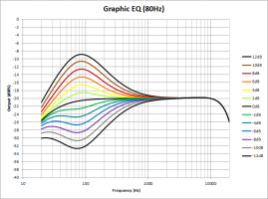](http://foobazaar.com/podhd/toneGuide/pics/pfSmith0_EQ_pics/Graphic%20EQ/Graphic%20EQ%2080.png)[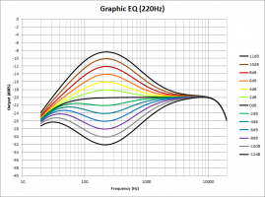](http://foobazaar.com/podhd/toneGuide/pics/pfSmith0_EQ_pics/Graphic%20EQ/Graphic%20EQ%20220.png)[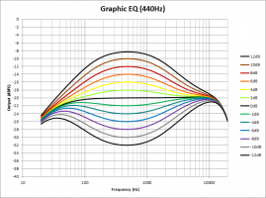](http://foobazaar.com/podhd/toneGuide/pics/pfSmith0_EQ_pics/Graphic%20EQ/Graphic%20EQ%20440.png)[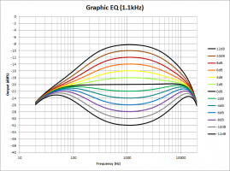](http://foobazaar.com/podhd/toneGuide/pics/pfSmith0_EQ_pics/Graphic%20EQ/Graphic%20EQ%201.1k.png)[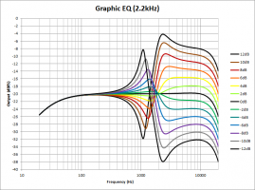](http://foobazaar.com/podhd/toneGuide/pics/pfSmith0_EQ_pics/Graphic%20EQ/Graphic%20EQ%202.2k.png)

I like this mostly for pre-EQ'ing my tone before it hits the amp. I have good control over whether I want more upper or lower mids and can also balance the amount of thump vs. punch, which allows me to thicken the tone without making it muddy. It would also work well to provide final EQ to a clean tone; however, I usually don't use it post-amp on my high gain patches, because I don't have enough bands to fine-tune how I want, at least not for the brighter half of the spectrum. Sometimes I use it to balance the upper and lower mids and punch, though.

[Top of EQ](#_VII._EQ)

### ii. Parametric EQ

The best effect on the Pod HD IMO is the parametric EQ. My only regret is that Line 6 doesn't make a dual parametric EQ, that ditches the Lows/Highs parameters and instead gives you another set of Freq, Q, and Gain controls; so you'd get two EQ's in one effect block (and you use less DSP). Its biggest problem is that it measures frequency in terms of percentage, instead of HZ. Here is the best translation I've seen, done by community member alpernar. His results seem to agree with the video Matt made which I linked above. The results I got seem to be a little higher than them, but I trust their results over mine. 2 beats 1.

|  |  |  |  |  |  |
| --- | --- | --- | --- | --- | --- |
| **%** | **Freq (HZ)** |  | **%** | **Freq (HZ)** |  |
| 0% | 50 |  | 55% | 1150 |  |
| 5% | 75 |  | 60% | 1400 |  |
| 10% | 105 |  | 65% | 1670 |  |
| 15% | 135 |  | 70% | 2000 |  |
| 20% | 175 |  | 75% | 2300 |  |
| 25% | 220 |  | 80% | 2750 |  |
| 30% | 315 |  | 85% | 3150 |  |
| 35% | 395 |  | 90% | 3600 |  |
| 40% | 540 |  | 95% | 4000 |  |
| 45% | 700 |  | 100% | 4500 |  |

[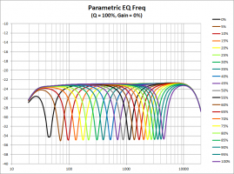](http://foobazaar.com/podhd/toneGuide/pics/pfSmith0_EQ_pics/Parametric%20EQ/Parametric%20EQ%20-Freq.png)[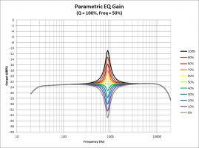](http://foobazaar.com/podhd/toneGuide/pics/pfSmith0_EQ_pics/Parametric%20EQ/Parametric%20EQ%20-Gain.png)[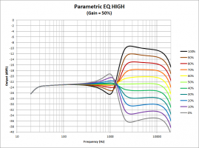](http://foobazaar.com/podhd/toneGuide/pics/pfSmith0_EQ_pics/Parametric%20EQ/Parametric%20EQ%20-High.png)[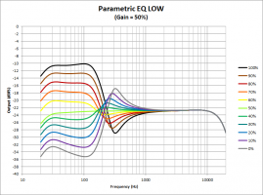](http://foobazaar.com/podhd/toneGuide/pics/pfSmith0_EQ_pics/Parametric%20EQ/Parametric%20EQ%20-Low.png)[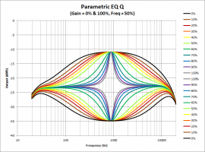](http://foobazaar.com/podhd/toneGuide/pics/pfSmith0_EQ_pics/Parametric%20EQ/Parametric%20EQ%20-Q.png)

The gain seems to provide +12/-15db for the parametric band. As for the shelves, the low shelf has around +/-15 db of gain, with everything below 100 HZ flat and a slope from 100 HZ to 200 HZ. The high shelf has around +/-12 db of gain, with everything above 2 kHZ flat and a slope from 1 kHZ to 2 kHZ.

I'll almost always use 1-3 Parametric EQ's on all my patches. No other EQ controls allows you pinpoint exactly a certain frequency range to boost/cut. This can be useful to make the entire signal brighter or darker, add a slight or dramatic mids cut/boost, add a touch of presence, suck out a boomy or fizzy spot, etc.

[Top of EQ](#_VII._EQ)

### iii. Studio EQ

The other EQ effect I like to use is the Studio EQ. It gives you two peak/valley controls, each with configurable center frequency and gain, both with a fairly wide Q (~4-6 octaves). I used to like to use it to adjust the very high and low end, but I have discovered the mid-focus actually does this better once you learn how to use it. The main advantage of this EQ is that it has two bands, so for general boost/cuts you can use it and take up less DSP than two Parametric EQs.

[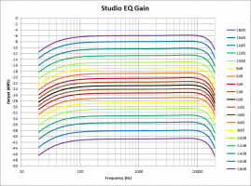](http://foobazaar.com/podhd/toneGuide/pics/pfSmith0_EQ_pics/Studio%20EQ/Studio%20EQ%20-%20Gain.png)[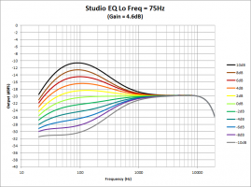](http://foobazaar.com/podhd/toneGuide/pics/pfSmith0_EQ_pics/Studio%20EQ/Studio%20EQ%20-%20Lo%20Freq%2075Hz.png)[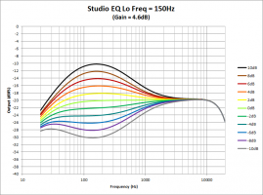](http://foobazaar.com/podhd/toneGuide/pics/pfSmith0_EQ_pics/Studio%20EQ/Studio%20EQ%20-%20Lo%20Freq%20150Hz.png)[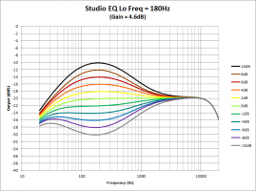](http://foobazaar.com/podhd/toneGuide/pics/pfSmith0_EQ_pics/Studio%20EQ/Studio%20EQ%20-%20Lo%20Freq%20180Hz.png)[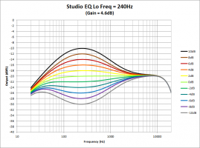](http://foobazaar.com/podhd/toneGuide/pics/pfSmith0_EQ_pics/Studio%20EQ/Studio%20EQ%20-%20Lo%20Freq%20240Hz.png)[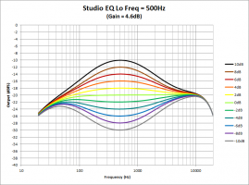](http://foobazaar.com/podhd/toneGuide/pics/pfSmith0_EQ_pics/Studio%20EQ/Studio%20EQ%20-%20Lo%20Freq%20500Hz.png)[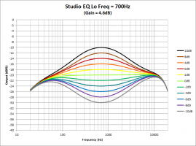](http://foobazaar.com/podhd/toneGuide/pics/pfSmith0_EQ_pics/Studio%20EQ/Studio%20EQ%20-%20Lo%20Freq%20700Hz.png)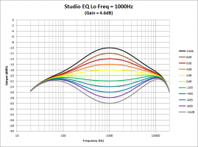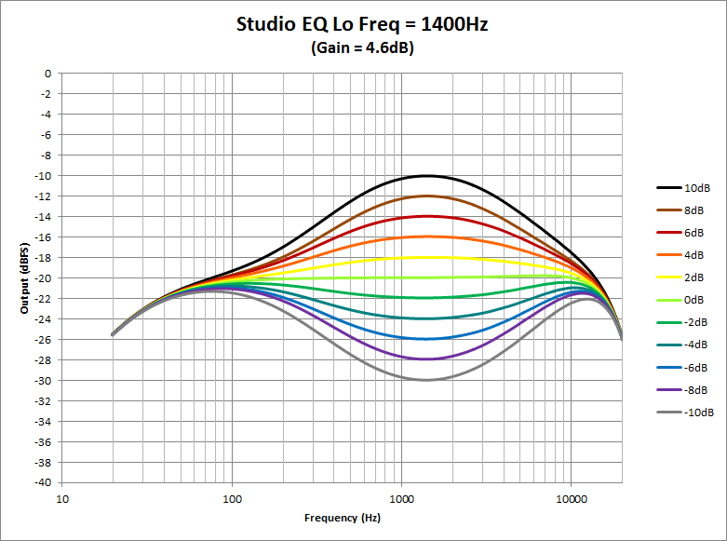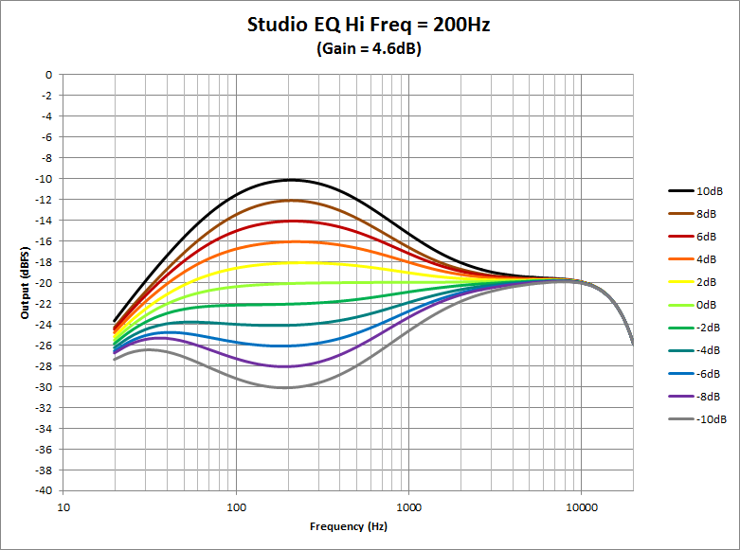

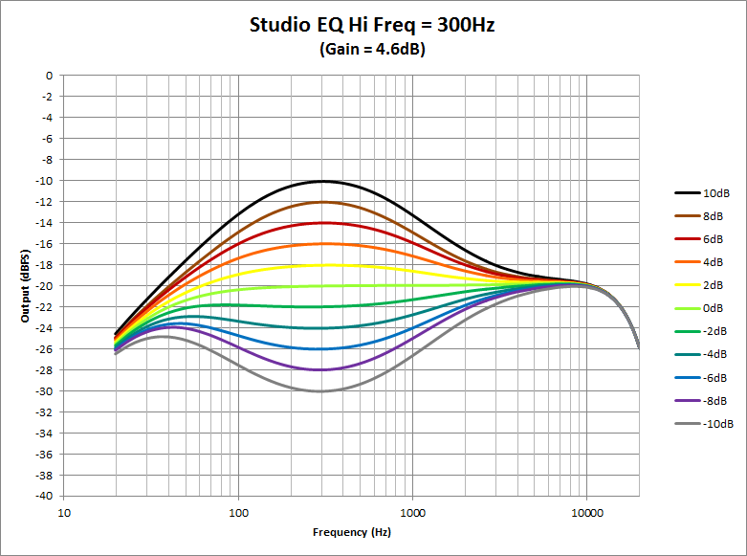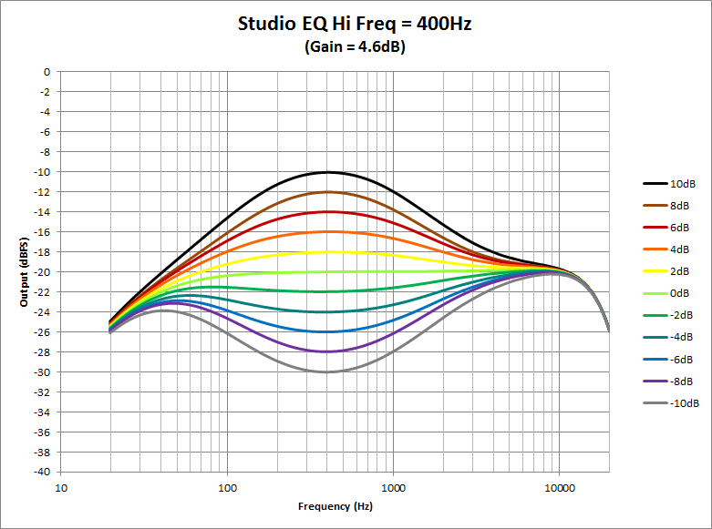

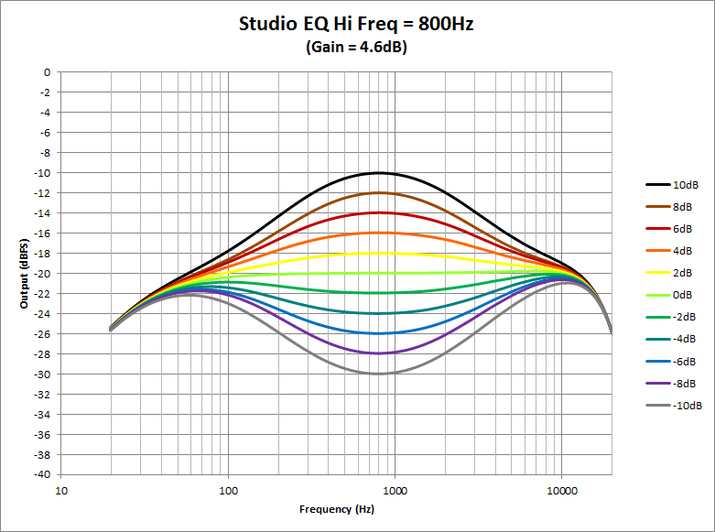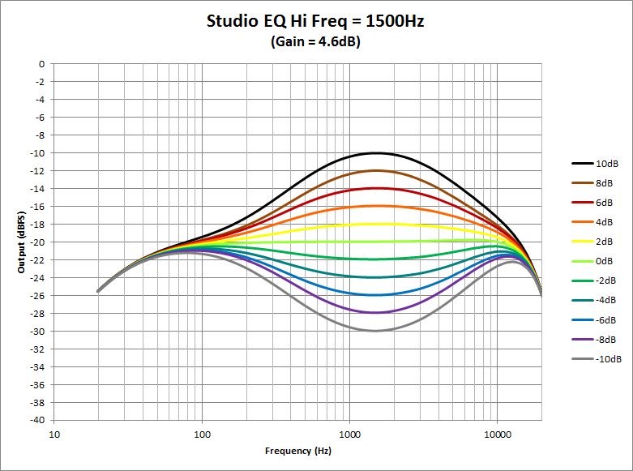

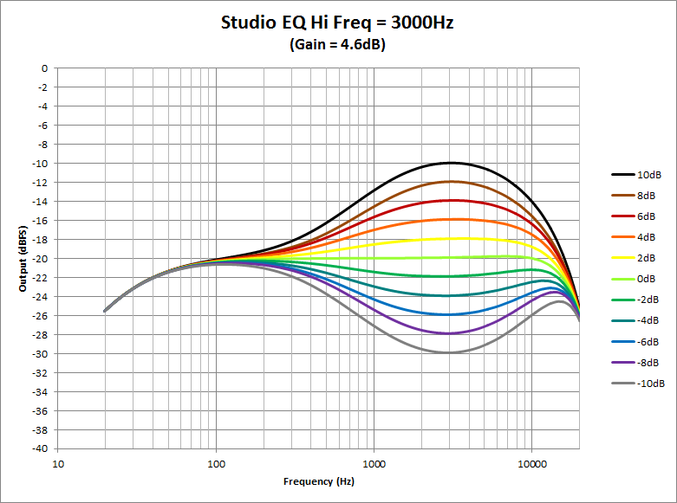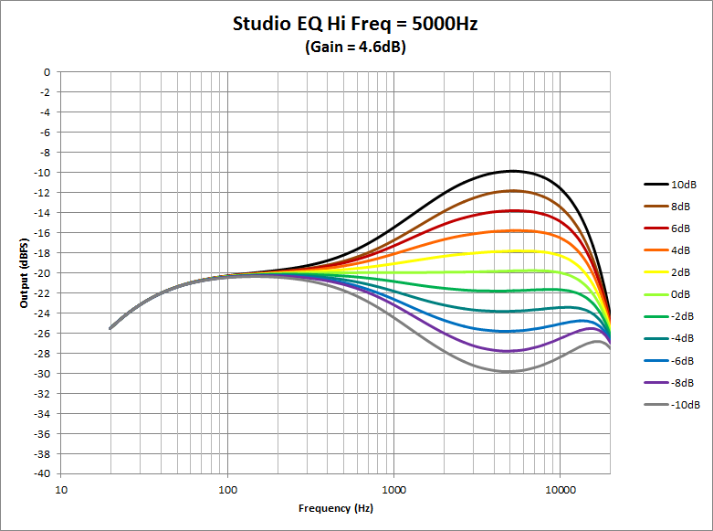

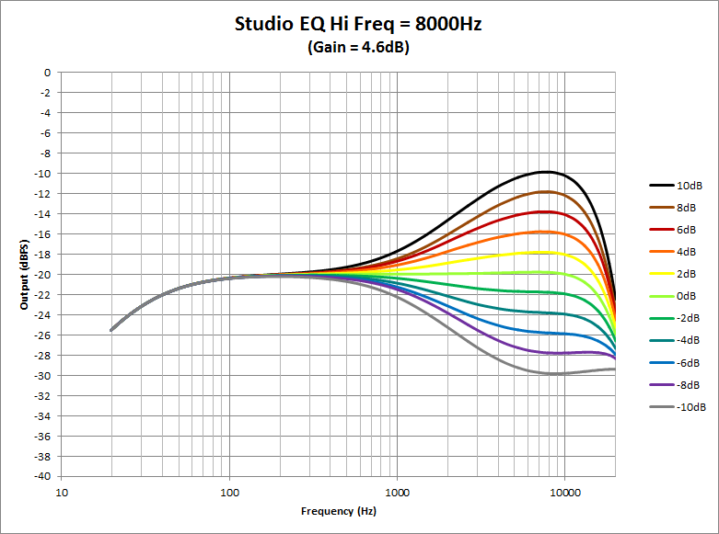

[Top of EQ](#_VII._EQ)

### iv. 4 Band Shift EQ

Honestly, I never use this EQ. It's not that it's unusable; it's just that you never really know what you're going to get. Read the description below and see if you could say, "Oh that's exactly what my patch needs!"

It provides 4 peak/dip band EQ's with gain denoted in db's already.

* Lo freq - centered around 90 HZ with shift at 50%, about 2 octaves wide. Use to boost/cut thump.
* Low mid - centered around 180 HZ with shift at 50%, about 2 octaves wide. Use to boost/cut punch.
* Hi mid - centered around 1 kHZ with shift at 50%, about 6 octaves wide. Use make the tone more or less midsy across the whole tone.
* High - centered around 4 kHZ with shift at 50%, about 5 octaves wide. Use like a treble control.
* Shift - causes the low and low mids bands to shift from higher to lower center frequencies, while causing the high and high mids bands to shift from lower to higher center frequencies, as shift moves from 0 to 100%. Shift move the center frequency of each band about 1 octave from its min to max setting.

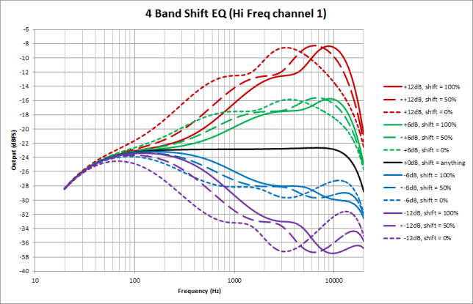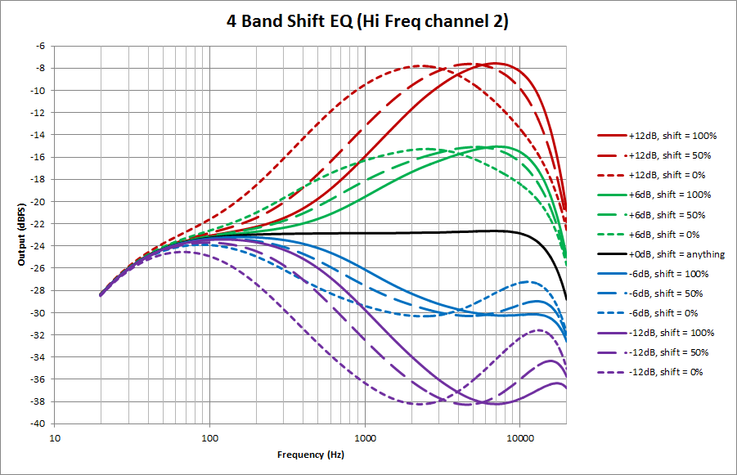

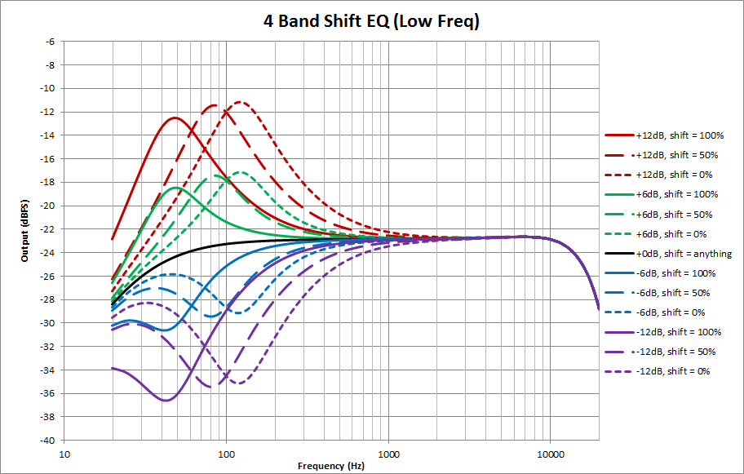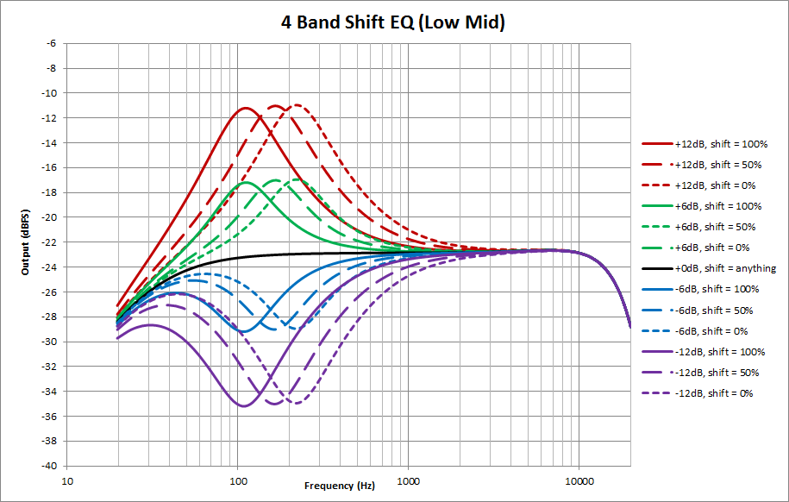

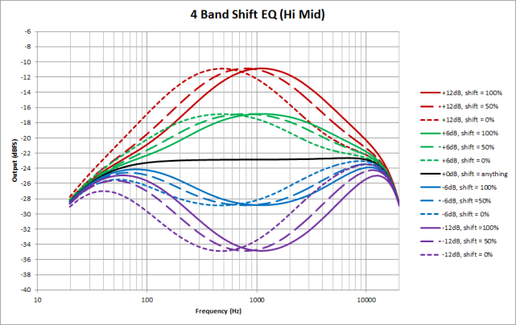

This could potentially be used in conjunction with or to replace the amp EQ controls. Or maybe if you're not using an amp, it would make a good replacement for those. For messing with shift, set it towards 0% if you want the bands to affect the frequencies closer to the mids, 100% if you want them further away. I wouldn't really touch Shift until you've set the other bands, then see if it makes a bit of an improvement. Good Luck!

[Top of EQ](#_VII._EQ)

### v. Mid-Focus EQ

As the name implies, this EQ boosts the mid frequencies by means of a high pass and a low pass filter. Its default settings are for a heavy mid boost, which can immediately turn people off. To make the EQ neutral, set hp freq 0%, lp freq 100%, both Q's at around 55% and turn gain down to almost 0%. I like to start here and gradually improve the tone.

This EQ has the only high-pass and low-pass filters, other than the Vintage Mic Pre effect. Also, the low pass frequency goes almost all the way to 20 kHZ, so it provides an excellent way to trim the high end. The cab DEP's include a high-pass filter now, which reduces the need for this EQ, but you get more control over it here because of the variable Q.

The Q settings affect the slope the rolloff, and when higher than around 60%, they actually form a resonance peak that slightly boosts the signal before rolling off above or below that point. At 100%, the boost is quite strong - around 10 db. Below are the frequencies of these resonant peaks with 100% Q.

|  |  |  |  |  |
| --- | --- | --- | --- | --- |
| **HP %** | **HP Freq (HZ)** | **LP %** | **LP Freq (HZ)** |  |
| 0% | 0 | 0% | 500 |  |
| 10% | 65 | 10% | 600 |  |
| 20% | 110 | 20% | 800 |  |
| 30% | 160 | 30% | 1,200 |  |
| 40% | 205 | 40% | 1,500 |  |
| 50% | 250 | 50% | 2,000 |  |
| 60% | 325 | 60% | 3,500 |  |
| 70% | 400 | 70% | 6,000 |  |
| 80% | 450 | 80% | 8,500 |  |
| 90% | 500 | 90% | 12,000 |  |
| 100% | 525 | 100% | 18,000 |  |
|  |  |  |  |  |

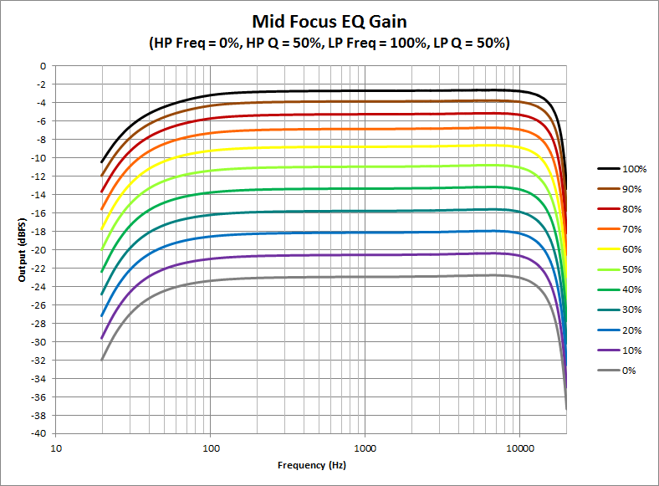

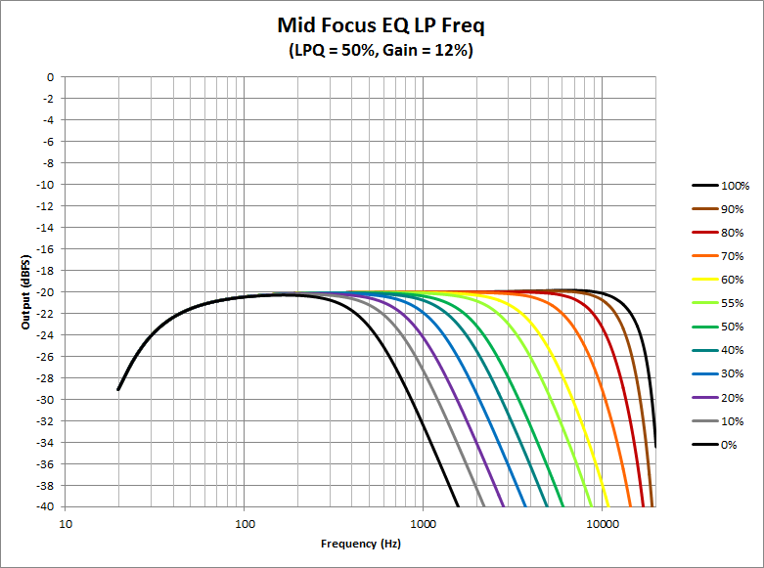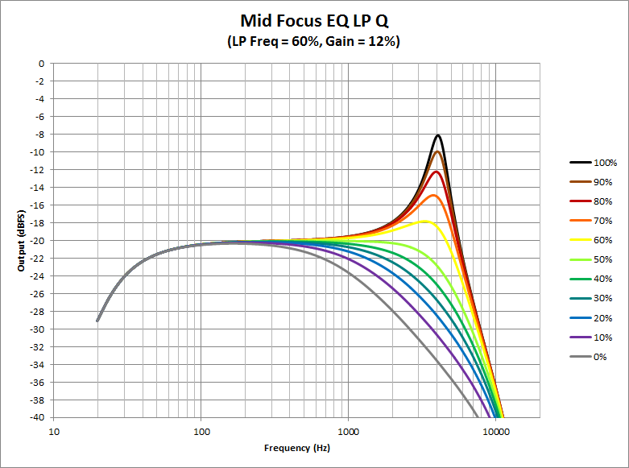

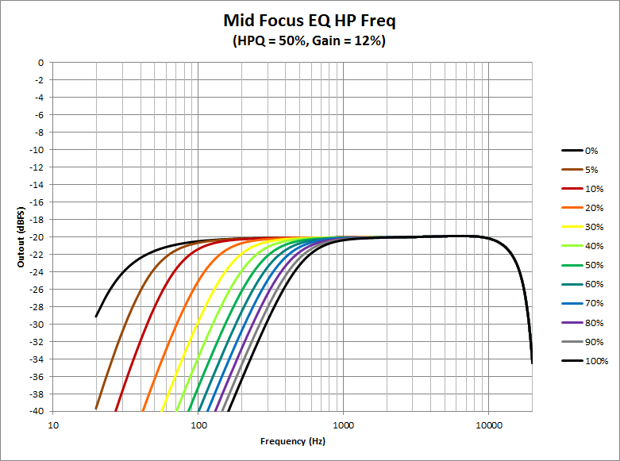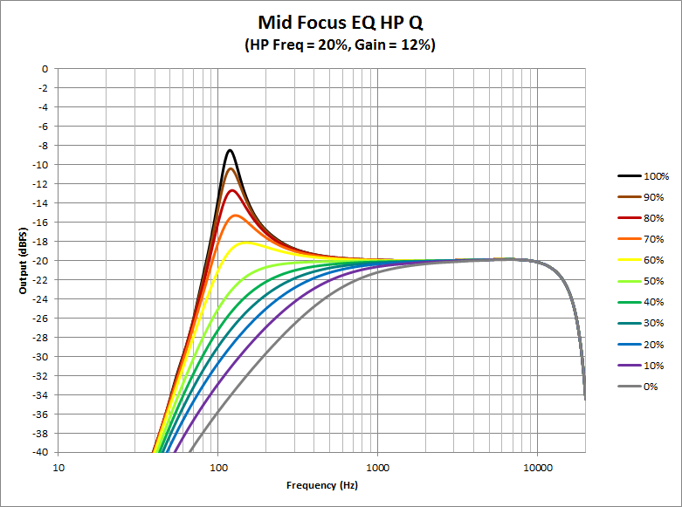

I recommend starting with Q around 55% and changing frequency to find the spot where you want to trim the high or low end. Then adjust Q and fine-tune frequency. 0% is a very wide, gradual roll-off, whereas 55% is relatively abrupt.

With Q higher than that and you're actually getting a resonant peak, boosting at that spot before dropping off. This can possibly create the opposite effect that you want, but for extreme highs and lows it's not as noticeable. It's also quite useful to fine tune the signal before the amp. You can filter the lows and highs as well as give a mild to extreme boost where you want to focus the amp's distortion on.

Also, notice how quickly the frequency moves from ~4 kHZ to ~18 kHZ for the low-pass. It's very sensitive, so be wary of that when you're trying to trim the high end - IE don't just adjust 5% at a time, move 1% at a time.

I typically use the SM 57 mic, which is very bright. To compensate, I need to use the low-pass on this EQ to roll-off those highs to get a more natural-sounding amp tone. I find the frequency around 60-75% works, and I use very low Q values (0-20%).

[Top of EQ](#_VII._EQ)

### vi. Q Filter

The Q Filter is actually found under the "Filter" category of effects, not "EQ". But...it's pretty much an EQ. You have 3 main options, whether it operates as a high-pass, low-pass, or band-pass filter. You have the usual Frequency and Q parameters, but additionally Gain and Mix.

|  |  |  |  |  |
| --- | --- | --- | --- | --- |
| **%** | **Freq (HZ)** | 50% | 805 |  |
| 0% | 190 | 55% | 920 |  |
| 5% | 302 | 60% | 1,030 |  |
| 10% | 415 | 65% | 1,140 |  |
| 15% | 490 | 70% | 1,220 |  |
| 20% | 530 | 75% | 1,330 |  |
| 25% | 570 | 80% | 1,590 |  |
| 30% | 600 | 85% | 1,860 |  |
| 35% | 645 | 90% | 2,120 |  |
| 40% | 690 | 95% | 2,400 |  |
| 45% | 750 | 100% | 2,670 |  |

Note: Certain Mix/Gain values cause a very steep, narrow band-stop at approximately the point where the "hump" from the Q-Filter's boost levels off on the high frequency side. So with Q at 0% and Frequency around 50%, the hump levels off around 5 kHZ. Here are some values where I noticed the drop-off was steep. Veering one parameter off of these values, while holding the other constant reduces the severity of it or causes it to go away completely.

|  |  |
| --- | --- |
| **Mix** | **Gain** |
| 80% | 0% |
| 70% | 10% |
| 60% | 30% |
| 50% | 90% |
| 30% | 70% |

The interesting thing here is how this effect kind of bridges the gap between EQ and Distortion effects. It provides the transparency and tweakability of an EQ, but the Gain control allows you to compress the tone and really focus on the selected frequencies. It doesn't get dirty like a Distortion but it definitely has big impact on the dynamic response and tone. I find this works well for a couple things when used as a boost. It causes the selected frequencies you want to peak for your amp distortion to be ever-prominent, whether you're chugging on mutes, playing single notes, playing big chords, sustaining notes, or have your guitar volume knob turned down. This is great to make sure your palm mutes get the same saturated chugging tone as your power chords, but if you use too much Gain all your playing sounds kind of stuck inside that one tone - I liken the effect to be similar to active pickups. It also helps from your guitar getting too dark when you turn the guitar volume knob down. I generally keep this setting low or totally down.

Mix works like Gain on an EQ, but it is a more appropriate term here, because you're not just filtering but adjusting compression on the selected frequencies. So mix is useful to blend in the right amount of Q Filter.

I like to use this to pre-EQ amp models. I'll use it as a band-pass and use a wide range of Mix, from 10 - 75% depending on how subtle or strong I want the effect to be. Q I set to 0% at least to start to get wide hump, not dramatically boosting any section of the tone over others. I'll tighten this up if I need a more focused tone later, but the higher you go the more of that cocked wah tone you'll get, especially with higher Mix settings. Frequency depends on the amp. For something like the Uber, where I need a nice bright boost to tighten up the amp and dial in more djent, I may go as high as 75%. For the Recto, I find it just needs a mild mids boost between 45-55%. For the ENGL and J800 models, I find they can get a little thin with a bright boost - I may use the Q Filter as a low pass (LP) or combine the band pass with some EQ to boost bass, or I'll use higher Gain to make sure my band pass is saturating the amp even during mutes. For Gain, I tend to remain in the 0-15% range. Many times I want it 0%, so the affect is more transparent, but other times I like it off 0% to get a little compression and feel like there's a little juice to the effect. But going too high can make the boosted frequencies too compressed, which makes the tone kind of stuck in the boosted sound, which sounds kind of fake, or similar to active pickups.

There's a wide range of tone in this relatively simple tool, and it's best to experiment. The more I use it, the more I feel like I need to add here. From a subtle presence boost to a midrange compression to an extreme almost-wah-wah filter, you can get a lot of mileage.

## D. EQ'ing your Patch

When I'm trying to dial in a tone, I start by picking the appropriate cab/mic. If that particular cab has bold EQ problems, I'll start by using a parametric EQ to try to fix it. Once the tone is in the ballpark, I'll try to fine-tune it with the amp's bass/mid/treble/presence controls. If it's still missing that spark, then I'll add another EQ or two to really dial it in, usually a cold or hot djent boost or a small honk cut. Then, if necessary, I'll use a Mid-Focus EQ to mess with the very low and high ends of the spectrum. If I don't need to trim the high-end, I can use the cab DEP low cut to trim the low end instead. I almost always cut a bit from the bottom. High frequency is a mixed bag. Sometimes I'll cut a little, but sometimes I'll boost there. Sometimes I'll boost some presence or even the fizzy range. Finally, I'll determine if there's an ugly-sounding fizzy spot or two that I need to cut using Parametric EQ's.

Again, keep in mind that not every EQ alteration falls neatly into my classification of the frequency spectrum. As I described in the "fizzy spots" section, sometimes you want to dial out a very, very narrow frequency range. Sometimes you want a peak that spans over several sections. When I feel the tone is missing some frequencies or has too many, I'll start with the approach described in the ["fizzy spots" section](#_E._Fizzy_Spots). Once I've found the offensive or missing frequency, I'll start lowering the Q until I feel like I've found the extent of how much I want to boost/cut. Then I adjust the gain to determine how much to boost or cut.

Once you've added at least one parametric EQ in the chain, you can compare using the "lows" and "highs" parameters on this effect versus adjusting the amp model's bass and presence/treble controls without needing to take up another effect block or DSP. If you don't have one, you may want to add one just to use those parameters, if you have the open effect block and the amp model's built-in controls aren't working like you want. They provide a more consistent means of dialing in bass/treble than using the amp model's bass and treble knobs. Or you could use a Studio EQ. One of these effects may be preferable to the amp's built-in controls, depending on the amp.

The reason I prioritize EQ'ing as described above is in case I run out of effects blocks. If you do run out, you have to start making sacrifices. Rather than cut the ultra low-end, maybe I can just turn down the entire bass range. Maybe the fizzy spot isn't "killing" the tone. This varies tone by tone, but in general I find the fizzy spots are the least noticeable, followed by the ultra high and low end. The most noticeable is if the tone is simply out of balance - with too much presence or too much boominess or honk, etc. Also, try to minimize the number of EQ's you use by making smart choices on which one to use - don't use two Parametric EQ's where one Studio EQ works just as well. Don't use two Studio EQ's where one Graphic EQ works just as well. Using less EQ's usually means more work - it's up to you to determine if the results are worth it.

You've probably also noticed that certain cabs and mics have their own effect on the tone's frequency response. If you run out of EQ blocks or just can't get the desired tone, you may want to try switching these as an alternative method to trying to tweak further. I recommend picking cabs and mics that give you the tonal nuances you desire that likely cannot be dialed with EQ controls, then using EQ controls to give them the general frequency response you desire; however, in some cases this is just not practical. You'll have to make trade-offs. See ["cab and mic selection" section](#_VI._Cabs_and).

Always compare your tone to a sample target, such as a cd, preferably using the same monitoring device (see "monitors" section). This will really tell you if your tone is lacking something. Then you can experiment boosting or cutting different frequency ranges to see if you can get closer. You'll eventually start to identify how certain frequencies alter the feel of a tone and notice if a tone is missing this or that before even comparing it directly.

And don't fall into the trap of thinking that EQ will get you everywhere. Amp, cab, and mic selection is just as important. I recommend figuring out which of those have the nuances necessary to get the desired tone before trying to EQ the tone. You'll have to use your imagination, as some of the amps, cabs, and mics have frequency responses FAR from your desired tone. With a little experience, you'll be able to determine what can and cannot be dialed in/out.

## E. Fizzy Spots

As with most amp modeling, the Pod HD isn't perfect. This is most noticeable in that it unnaturally boosts certain upper-mid frequencies dramatically, which can make the tone sound "fizzy". These are emphasized most on high-gain patches. Sometimes these spots are pure noise - as you play different notes or chords, the fizz doesn't change sound at all.

You can dial these spots out using a Parametric EQ effect for each frequency. To find them, set the effect's Q to 100% and gain to 85%. Keep playing a palm muted open string than a ringing open string with your right hand, and use your left hand to slowly turn the knob controlling the EQ's frequency. If you can tune to drop D, it might be even easier to notice the problem spots. I tend to start at 70% and go upwards slowly. You'll hit one or two spots that sound louder and more noticeably annoying than others. I generally find them at 80% and 89%, but it depends on the amp. 95% and 100% can sometimes stand out as well.

You can also use this technique to find boomy spots, in the 12%-33% range. I also use to find if I want to cut some mids in the 40-50% range. Or if I want to boost mids (generally from 50 - 70%). This method works as a great way to "find" a particular frequency you want to target for cutting or boosting.

Once you've found the spot(s) you want to cut, turn the gain knob back to 50% and slowly start lowering it. You don't want to completely remove the frequency from the sound, but to have it fade into the overall tone. I find sometimes I'll only go down to ~44% before that frequency no longer stands out. I don't think I ever go below 35%.

Usually Q at 85-100% works for the fizzy spots. For the boomy spots, you may have to widen (lower) the Q a bit to cover the whole frequency range you want to cut.

I used to think dialing out fizzy spots was a game-changer for the Pod HD, but lately I've found it only offers mild improvements. I instead focus on [dual cabs](#_E._Dual_Cabs) and more aggressive EQ shifts, to dial out nastiness in cab sims and/or otherwise shape the general feel of the frequency response. Now I only apply them if I have "surplus" effects blocks.

Note that some mics are fizzier than others. I find the SM57's are good at not having fizz, whereas the dynamics and condensers are much worse. Also, some amps are worse than others.

[Top of EQ](#_VII._EQ)

# VIII. Tips and Pitfalls

[**Tips :-)**](#_A._Tone_Matching)

* [A. Tone Matching](#_A._Tone_Matching)
* [B. Branching/Evolving Patches](#_B._Branching/Evolving_Patches)
* [C. Setlist Tips](#_C._Setlist_Tips)
* [D. Effect Switching/Tips](#_D._Effect_Switching/Tips)
* [E. Recording Tips](#_E._Recording_Tips)
* [F. Monitoring](#_F._Monitoring)
* [G. DSP Allocation/Advice](#_G._DSP_Allocation/Advice)
* [H. Mesa/Boogie Mark II/IV tone](#_H._Mesa_Boogie)
* [I. Clean Boost](#_I._Clean_Boost)
* [J. Leveling Patches](#_J._Leveling_Patches)

[**Pitfalls :-(**](#_K._Clarifying_Confusing)

* [K. Clarifying Confusing Volume Controls](#_K._Clarifying_Confusing) 
  + [i. The Pad Switch](#_i._The_Pad)
  + [ii. The MASTER Knob](#_ii._The_MASTER)
  + [iii. Ch. Vol./VOLUME Knob](#_iii._Amp/Channel_Volume)
  + [iv. Mixer Levels](#_iv._Mixer_Levels)
  + [v. The Master DEP](#_v._Master_D.E.P.)
* [L. Clipping Guide](#_L._Clipping) 
  + [i. Input Clipping](#_i._Input_Clipping)
  + [ii. Signal Clipping](#_ii._Signal_Clipping)
  + [iii. Effects Clipping](#_iii._Effects_Clipping)
  + [iv. Clipping External Devices](#_iv._Clipping_external)
  + [v. "Digital" Clipping (Crossover Distortion) on "Full" Amp Models](#_v._\"Digital_Clipping\)
* [M. Bad Monitoring](#_M._Bad_Monitoring) 
  + [i. Acoustic Tone](#_i._Acoustic_Tone)
  + [ii. Bad Monitors](#_ii._Bad_Monitors)
  + [iii. Bad Room](#_iii._Bad_Room)
  + [iv. Low Volume](#_iv._Low_Volume)
* [N. Wrong Output Mode](#_N._Wrong_Output)
* [O. Gain Staging](#_O._Gain_Staging)
* [P. Outside vs. Inside a Mix](#_P._Outside_vs.)
* [Q. Using Others' Patches](#_Q._Relying_on)

## A. Tone Matching

If you are building a patch, the ABSOLUTE BEST thing you can do is find an artist whose tone is the closest to what you want to achieve, and finding a section in their music where the guitars are playing without any other instruments. If you can find one where it's only one guitar, not a double-track or quad-tracking, even better. Even if this clip is only 2 seconds long, it's an incredible reference point - you're likely to really hear the distortion tone, EQ'ing, and effects.

[Top of Tips and Pitfalls](#_VIII._Tips_and)

## B. Branching/Evolving Patches

The best process for making a patch is to use the Edit computer editor. Start by dialing in a tone you like. You'll hit a point where some changes you might think you like, but you aren't 100% sure. At this point it's time to start branching the patches, A/B'ing them, then keeping the better one.

Rather than editing the current patch, hold CTRL and mouse drag the patch to the next patch slot to copy it. Make your changes to the copy. Now you can A/B your edits to your initial patch - quickly and easily going back and forth. If the new version is an improvement, hold CTRL and mouse drag it on top the original. Then save the patch to the Pod.

I'll repeat this process anywhere from 4 - 20 times before I finalize my patch (no stoner reference intended). You can compare a number of cab/mic options, as well as EQ'ing tweaks, or compare effects models.

So for instance, if I think a cab/mic change might improve the tone, I'll copy the patch, change the cab/mic on the clone, then tweak the clone to have roughly the same EQ as the original. Now I can A/B accurately, rather than trying to flip settings back and forth for every comparison.

Sometimes you'll make a tweak and like both your original tone and the new version. You don't have to choose between them. You can keep them both and branch out from there. I'll often do this for a tone when I want a different set of effects on the patch, but the same general EQ'ing and distortion tone.

[Top of Tips and Pitfalls](#_VIII._Tips_and)

## C. Setlist Tips

When I build my setlist, I like to set each bank to have a similar set of 4 patches in this order – clean, crunch, rhythm distortion, lead. That way if you accidentally end up on the wrong bank, you're not way off tone-wise. You won't get a clean tone when you wanted a lead tone or vice versa. You can quickly correct yourself before anyone even notices.

If you have a patch with a common effect that you toggle on and off, set the footswitch that toggles the effect as the one above the patch's switch. For example, if you are using a patch located at "A", set the effect's toggle switch to FS1, which is right above "A" or FS5. If the patch is "B", use FS2, etc. This way, if you accidentally hit the footswitch on the lower row when you go to toggle the effect on/off, you won't switch patches. Also, if you want the effect on as soon as you enter the patch, you can press the patch switch with your heel, then quickly hit the effect toggle switch with your toe.

If you have patches with lots of effects that you will be toggling on/off, order your switches in the order that the effects appear in the chain. This is easier to remember, and if you have to guess, at least it's an educated guess.

Also, it's a good idea to make copies of your main setlist, and do a quick tweak to make the tone lighter or darker. Then when you get to a gig, if the sound is a little too bright or dark, you can just switch your setlist, instead of trying to tweak all your patches then, or rely on the sound guy dial you in.

The same thing goes if you're building your patches at a different volume level than you'll actually be practicing or gigging at. Make a setlist copy, but change all the "full" amps to "pre" (make sure you change all the amp, cab, and mic settings to how you had them before – changing amps will automatically load that amp's default settings). Then if your amp/power amp is getting cranked and changing the way your patches sound, you can switch setlists. I can't guarantee it'll necessarily sound better with the "pre" variants, but it COULD be a lifesaver. Of course, I recommend that you build your patches at the volume level you'll be using for practice and gigs; but if this is impossible, make an alternative setlist just in case.

[Top of Tips and Pitfalls](#_VIII._Tips_and)

## D. Effect Switching/Tips

You can assign one footswitch to control multiple effects. This is very helpful to switch from a rhythm to a lead setting, or if you always want to turn on/off 2 effects or more at a time.

You can control the amp volume parameter via the on-board pedal by setting it to be controlled by such. This keeps you from using an additional effects block on a volume pedal effect. Just be sure to set the max value to whatever the current level is, instead of 100%. At 100%, you might distort post-amp effects (see "effect clipping").

You can also use the expression pedal to control drive, or compression threshold. This allows you to move from sweet to searing leads, without doing the pedal-board dance, or adjusting your guitar's volume knob; so you can seamlessly build up gain throughout a solo.

When building a patch, I try to keep the effects order in the Edit software the same as the order they occur in the chain just to keep things simple. If I later want to move things around, I'll take a screen shot or write down my settings and re-do the patch.

[Top of Tips and Pitfalls](#_VIII._Tips_and)

## E. Recording Tips

The best way to get a heavy metal rhythm sound is to double track the guitars. It's quite noticeable if the two tracks are not in perfect rhythm. Tighten those chops up and always use a drum/click track or metronome to keep time.

I go back and forth on how to pan the two tracks - sometimes I like full left/right separation but sometimes I blend them a little. When they're run through the same speaker, you get some phasing. It's not a perfect phasing like a comb filter, but you can hear it anyhow. If you're listening through headphones, full left/right panning can sound harsh when only one side is playing; but it sound much more natural through speakers. Right now I'm leaning towards full left/right.

Also, make sure your monitoring volume doesn't exceed the volume of the tracks you've already laid down or your click-track/metronome. You might end up laying down a whole track only to realize later you inserted an extra beat in the beginning or something like that and never noticed. Similarly, don't overpower your current playing volume with already recorded tracks. Then you're basically playing air guitar and fooling yourself into thinking you're playing perfectly with the existing track(s) when you might not be.

Quad-tracking doesn't seem to offer much benefit to me, unless you're trying to mix in some other tones. If you use the same tones at the same volume, I find it ends up sounding like the tracks are "fighting" each other, just like if you pan two tracks to dead center. You have to basically turn down one left and one right track to subtly reinforce the other tracks. Plus, it's more work to get all 4 tracks in perfect time. If you listen to Meshuggah's Chaosphere or Metallica's And Justice For All, you notice a kind of phasing sound to the guitars in the few places you hear one guitar on the left or right side. I don't know if this is the way they recorded or if it's double-tracked with the same pan, but I'm not a fan of the sound.

The more tracks you lay down the thicker it will sound. But that also means that it can become too thick and sound like mush. If you end up with such a mix, try doing starting off with less distortion on your tones.

I try to start with my instruments pre-mixed more-or-less. I want each instrument to have a unique frequency range emphasized, so that they all stand out and do not clash with each other. For guitars, that's generally around 250-1,500 HZ.

[Top of Tips and Pitfalls](#_VIII._Tips_and)

## F. Monitoring

With the Pod, you have a number of different ways to actually hear your patch. Besides going "live" to a real amp, you can use headphones, studio monitors, stage wedges, PA equipment, etc. And each of these categories has a large variety of gear, all of which has a different sound to it. Just because your tones sound good on some set of monitoring equipment doesn't mean they sound good on another.

That doesn't mean you should make different patches for each set of monitors you may use. The best method is to make sure your patches sound good on as many kinds of monitors as possible. Then, if you are using the Pod to record, your guitar tone will sound good to most people on their own equipment, which you have no control over. Also, it's nice to be able to bring your Pod to a friend's, to jam through his equipment. Or to a gig, where you don't know what the PA will sound exactly like. Almost everyone should have some headphones lying around, hopefully a few different pairs.

I like to test my patches through 2 different pairs of headphones (commonplace consumer headphones and "pro-level" studio headphones), and through my studio monitors (which aren't that great but still sound good). If my patch sounds good across the board, it gets my approval. Sometimes it'll sound good on one piece of hardware, but have way too much or too little bass or some other frequency range on a different one. I have to adjust so it sounds balanced on EVERYTHING. For my "live" patches, I want them to sound good through my amp first. Once I think they're good, I set the cab to Treadplate 4x12 and the mic to the SM 57 off axis mic, and I test it through my headphones and monitors. I find this cab/mic simulation combo sounds most like a real amp, so it serves as a solid second reference.

[Top of Tips and Pitfalls](#_VIII._Tips_and)

## G. DSP Allocation/Advice

Here are a couple tips to avoiding "DSP limit reached" message. Dual amps are very expensive. If you want to use numerous effects, you probably can't get away with using them. If you need to use them, keep in mind the "pre" versions use a little less DSP than the "full" ones, possibly allowing you to squeeze in that least effect, but your tone will be altered.

Pitch shifters, especially the Smart Harmony and Pitch Glide, use a lot of DSP. If you know you want to use one in a patch, build the patch with that restriction in mind – don't build up an entire patch then try to put it in at the end, only to find the DSP error then have to backtrack to figure out how to get it in.

Spring reverbs are also quite expensive; I prefer to use chamber or hall reverbs instead unless I know DSP allocation isn't a problem. Reverbs are generally a little more expensive than other effects. You can use less DSP by using a delay with a very short setting (20-60ms). If you need even less DSP consumption, you can try to get away with using "E.R." instead. I believe "E.R." will be calculated as taking up DSP even when you set it at 0%, so it has zero cost to turn it up. Note that "E.R." only works in "Studio/Direct" output mode and a cab (not "no cab") is selected.

For a detailed analysis of DSP allocation, see [this thread](http://line6.com/support/thread/50339) and also [Appendix D](#_Appendix_D_–). Fester2000 did an excellent analysis of the amps and effects on the unit. Also note, there is a second guide posted by Fester later in the thread that provides analysis of each individual effect. The first guide (attached to the first post) is a general guide.

Try to use as few EQ effects as possible. If you can use one Studio EQ instead of two Parametric EQ's, that'll save you DSP. Or use one Graphic EQ or 4-Band Shift EQ instead of 2 Studio EQ's. If you can use the amp's EQ controls instead of EQ effects, that's better too.

Instead of using a volume pedal effect, use the tip about [assigning the amp/channel volume to an expression pedal](#_D._Effect_Switching/Tips).

Each group of effects has certain items that use more DSP than others. For instance, the Ping Pong Delay takes up less DSP than the Digital Delay and the Noise Gate uses less DSP than the Hard Gate. If you have to have \_\_\_ effect but can't fit the one you most wanted, you might still be able to fit something else that is similar. For instance, the Dimension can provide a decent modulation effect, but it is lower DSP than the Analog Flanger or Analog Chorus.

[Top of Tips and Pitfalls](#_VIII._Tips_and)

## H. Mesa Boogie Mark II/IV tone

I find I can get a good Mesa Boogie Mark II/IV tone from the Uber amp. The key tweaks is to pre-EQ. I like a Line 6 Drive with Bass 25%, Mids 65%, Treble 75%. I set Drive to 0% and Output to 100% - the common filter/boost pedal settings. I find even this still might break up a little, so I put a Volume effect in front and reduce the level to about 50%. This makes sure the Line 6 Drive is only acting as a filter.

I also like to turn the Hum Amp DEP up to 55% - just this small tweak makes the distortion thicker and darker and more aggressive. I turn Bias X up to ~70% - this gives notes more "bloom" but doesn't lead to unnatural compression or wonk to the tone.

[Top of Tips and Pitfalls](#_VIII._Tips_and)

## I. Clean Boost

There are several ways to perform a clean (solo) boost to your tone. The easiest is to use the Studio EQ effect - it has a Gain parameter that has nothing to do with EQ - it just sets the output level. This lets you boost or cut the signal level anywhere in your chain. For a clean boost, you should place this behind your amp/distortion. Then you just toggle it on/off for your boost

If you already have a Mid-Focus EQ in your chain, the Gain parameter acts as an overall output level control, not to adjust the amount of EQ applied. This EQ is harder to make neutral than the Studio EQ, and usually won't be toggled on/off, but you *can* use it to boost the signal.

You can do the same thing using the FX Loop. You place a patch cable from the send and receive connections, set send to 0 db and boost the receive level to your desired amount. Make sure mix is at 100%.

I believe the FX Loop uses less DSP than the Studio EQ, but it also requires a patch cable and that you aren't already using the loop. Also, the loop can introduce additional noise into the tone.

[Top of Tips and Pitfalls](#_VIII._Tips_and)

## J. Leveling Patches

For a single amp patch, the best way to set it up is to place all your effects and amp block in Channel A after the path split and in front of the Mixer. In the mixer, pan Channel A to center and mute Channel B. This prevents you from having to worry about [Input 2 issues](#_Input_2), as only Input 1 will feed into Channel A. Each channel is stereo, so it has no impact on stereo effects. The upside is that the Mixer block is last in the chain and can be used to level your patch without worry of [unwanted clipping](#_L._Clipping), which can occur by trying to level patches using the amp's Ch. Vol. control (physical VOLUME knob on the unit).

If you are using a dual amp patch, I like to use a Mid-Focus EQ or Studio EQ as the last (or close to the last) effect in my chain, behind the mixer. The Gain parameter on these EQ's does not affect frequency response, only output level. So you can use these to set a final patch level, keeping the amp blocks' Ch. Vol. control conservative, preventing unwanted clipping. The Mid-Focus EQ is not neutral by default and is sensitive to a hot input signal. I prefer the Studio EQ if I'm just using this effect for patch leveling. However, I'm usually using a Mid-Focus to roll off a bit of high and low end anyway, so it doubles as my final output control.

[Top of Tips and Pitfalls](#_VIII._Tips_and)

## K. Clarifying Confusing Volume Controls

For this guide I often use the terms MASTER Knob, VOLUME Knob (Ch Vol in Edit), Mixer Levels, and Master Volume (Master DEP). Below presents what exactly each one does and how I find they are best used.

### i. The Pad Switch

Pods come with an input padding feature that reduces the level of your guitar signal. I have started using this to prevent some input clipping on guitars with high-output humbucker pickups. It also makes your signal a bit more manageable inside the Pod. I have tested the tone after compensating levels, and there seems to be insignificant tonal differences. Most of the issues with the Pod are that your signal is too hot rather than too weak. So this switch is a no-brainer for me. I had previously thought it had a unwanted tonal impact, but I was using a flawed test.

It's just a switch and easy to do a quick experiment with. Try it out before you spend money on buffer pedals or engage in laborious adjustments to your guitar.

[Top of Tips and Pitfalls](#_VIII._Tips_and)

### ii. The MASTER Knob

*The MASTER Knob* is the physical knob labeled "MASTER". When I refer to it in this guide I always use the word knob to avoid confusion with the Master DEP control. This knob controls an analog attenuator that affects the output volume of the analog outputs. It is part of an analog gain stage, so its setting has some impact on the signal-to-noise ratio; however, it has no effect on the modeling algorithms. It has no impact whatsoever when outputting digitally (USB, SPDIF, or AES). This is a global setting that affects all patches equally. It has no digital representation and cannot be saved per patch - the knob's current setting is what the Pod will use. The Pod HD Getting Started Guide recommends turning this all the way up to get the best signal-to-noise ratio; however, some users have reported their tone suffers when doing so. In particular, high settings might clip whatever you're outputting the Pod into. For gig/practice applications, I set it to 65%, just shy of clipping the amp I run the Pod into. I advise you to turn it as high as possible unless you are clipping something downstream, using your amp's master volume control to dial in your desired final volume level. If your amp doesn't have a master volume controls, such as the Peavey ValveKing or 6505, you can use this in its place.

Also, keep in mind that the Pod is designed for high resistance headphones. The headphones I have are 64 ohm, far below what Line 6 suggests using. Most consumer headphones fall into this category. If I were to turn up the Master Knob when using headphones, I'd deafen myself. I make sure to turn down the Master Knob to 20-60% when using headphones, unless they are high-ohm studio headphones.

[Top of Tips and Pitfalls](#_VIII._Tips_and)

### iii. Amp/Channel Volume aka VOLUME Knob

*The Volume Knob* is also a physical knob, but it controls a digital setting which can be set and saved to different settings for each patch. When a patch is pulled up, it is set to the saved value, not the value the physical knob is currently set to. The digital setting will only change to the knob's value when you start turning it, like the EQ knobs. It controls the Vol/Ch Vol parameter located on each amp block, again similar to the EQ knobs. This is a tone-transparent control, not designed to change how the amp model behaves - to get the "cranked" amp tone, you use the Master DEP, discussed below.

The particular quirk to note about this control is that it boosts/cuts at the location of the amp model in the signal chain. Thus, any effects downstream of the amp will respond differently if they are level dependent. If set too high, you can get [effects](#_iii._Effects_Clipping) or [signal](#_ii._Signal_Clipping) clipping.

I sometimes call this control *Amp Volume Knob* or *Channel Volume Knob*. I try to make sure I say "Knob", so you don't confuse this with the *Master Volume DEP* (explained below). Also, I sometimes capitalize "VOLUME" like how it's labeled on the Pod itself.

I generally use a conservative volume on this control, keeping it around 40-50%. When I use [dual cabs](#_E._Dual_Cabs), I use this control to balance the levels between each channel. Then I'll use the mixer levels (or a Studio/Mid-Focus EQ's Gain level) to try to set my overall patch volume. The mixer levels have less resolution than this control, so I'll come back to this to fine-tune the final levels where necessary.

[Top of Tips and Pitfalls](#_VIII._Tips_and)

### iv. Mixer Levels

*Mixer Levels* refer to the digital Channel A and Channel B level controls in the Mixer block. They are digital settings, saved per patch, accessible by selecting the Mixer block in the Pod's edit window or the Mixer tab in Edit. Like the above control, boosting too high can cause [digital clipping](#_L._Clipping) or affect the behavior of volume-sensitive downstream effects, but otherwise the mixer levels are tone-transparent.

I like to use these to adjust my patch final volumes, but if I need to fine-tune I go back to the amp/channel volume control, since it offers a bit more resolution.

[Top of Tips and Pitfalls](#_VIII._Tips_and)

### v. Master D.E.P.

*Master DEP* refers to the Master Volume deep-editing parameter (DEP). It is designed to model the amount of power amp distortion achieved in the amp modeling algorithms. It does have some affect on the patch's volume level, but you should not use it to adjust volume levels - use the amp/channel volume or mixer levels instead. It is a digital setting that can be saved per patch. It is accessible on the unit itself by double-clicking the "ENTER" button when selecting an amp block in the Pod's edit window to bring up the amp's settings, then clicking the right arrow. In Edit, the control is visible under the standard Drive and EQ controls on the AMPS tab.

For more on how to use this control, see the [amp DEP's section](#_F._Power_Amp). Usage will vary for each amp and desired tone.

[Top of Tips and Pitfalls](#_VIII._Tips_and)

## L. Clipping

You will be VERY frustrated trying to dial in the Pod if there's clipping somewhere in your signal chain. I've experienced numerous types of clipping on the Pod HD 500, so hopefully I can steer you away from my mistakes. Below is a description of the different types of clipping you may encounter. For a more systematic process of diagnosing what is causing your clipping, see the [clipping section](#_D._Tone_has) on the [troubleshooting page](#_IX._TroubleShooting).

[Top of Tips and Pitfalls](#_VIII._Tips_and)

### i. Input Clipping

The Pod can get input clipping, which occurs on the Pod's Guitar input A/D converter. Be especially wary of this. Very few controls will actually affect the signal before this converter, and they are limited in how they can help here. If you have such clipping, you can't dial it out later in the chain; and you might tweak for hours in futility. It is best dialed out by lowering one's pickup height.

Many have complained about this as a weakness of the Pod; however, I think it's generally in spec with most other devices. I also have a computer audio interface I can plug my guitar directly into. Even with its gain at 0, I was still clipping that device as well. Both devices cleaned up at the same output level. Just lower your pickup height. I had input clipping on a guitar where I could not just adjust pickup height, so instead I raised the action. To be honest, my action was kind of experimentally low, and I would definitely regard it as "too low" in retrospect.

If you are still getting clipping, you may have a problem in your cable or your guitar's electronics. Or you might be unfortunate enough to have a defective Pod. Try other guitars and cables and see if the tone cleans up when you turn down the guitar's volume knob.

Many have claimed adjusting input impedance lower (either via the [input](#_I._Input_Settings) settings or using a device like the Radial Dragster), cleans up clipping and/or improves tone on the Pod. I didn't need to use one to get rid of my input clipping. Also, I don't like the looser and darker tone associated with the low impedance. But if you can't dial out clipping any other way, it's a good option to research and pursue.

Turning down the guitar's volume knob is unacceptable in my mind. It is tough to keep it always in the same non-max position, so that you get the desired amount of distortion/compression in your patches. It is only useful to diagnose the problem.

In the same vein, the effects loop return on the Pod connects to an A/D converter, which can also be overdriven. I'm not sure if reducing the return level setting in the Pod will help reduce clipping or not. It is best to reduce the output level of the final effect in the loop until the clipping disappears.

[Top of Tips and Pitfalls](#_VIII._Tips_and)

### ii. Signal Clipping

Like any digital device, if you try to amplify the digital signal too much, you'll push the amplitude larger than the device can handle, and it will result in digital clipping. The basic point is that you can't turn your amp, mixer, and every effect in your chain to output as large a signal as possible and expect it to sound good.

However, this is deceptive. Even if you don't max out the signal, you can still get effect clipping, which is covered in the next section. The only volume knob/control I recommend setting anywhere close to maximum is the [MASTER knob](#_ii._The_MASTER) - I believe this is an analog signal amplification occurring after all digital processing, thus not subject to digital signal clipping. ALL others are digital and subject to clipping.

[Top of Tips and Pitfalls](#_VIII._Tips_and)

### iii. Effects Clipping

Some of the effects on the Pod seem to have modeled clipping into them. The most notorious from my experience is the Parametric EQ effect. I often run these after my amp/cab and mixer in the chain. If I had the amp volume or mixer settings turned up a bit, I'd find there was clipping in my signal. If I turned off the EQ effect, all the sudden the tone cleaned up, even with the same volume levels, far lower than clipping the device itself or even different effects. I now have a relatively surefire method to prevent effect clipping, while still getting strong output levels.

Keep all your volumes conservative until the end of your patch, where you do a clean boost to bring the volume up to the desired level. This means I keep the Ch. Vol/VOLUME knob around or lower than 50%, and I place EQ's that cut before the ones that boost. I try to keep other effects, like compressors, to have unity gain rather than boost the signal.

My preferred way to get the clean boost at the end is a Mid-Focus EQ. Its Gain parameter does not relate to how much EQ'ing you get, only the final output level. Same thing for the Studio EQ. I generally use a Mid-Focus EQ on nearly all of my patches, though, so it's commonly also used to set my final patch volume.

The other way doesn't require an EQ effect to give me a clean boost. I just put EVERYTHING in Channel A, so that the mixer is the last piece of my signal chain, and I use the mixer levels to boost the volume to where I want it. This is an effective method, but it is no good for dual amp patches. Since I routinely use dual cabs, I rarely use this method.

[Top of Tips and Pitfalls](#_VIII._Tips_and)

### iv. Clipping external devices

If you send too hot of a signal out the Effects Loop or analog outputs (XLR, 1/4"), you can clip external devices. If you find you are clipping an external device, try flipping the line/amp switch on the device to amp or reducing the Master knob. Generally, I use "line"; line-level effects should be able to handle such. Also, it is the preferred setting if you are running into a real amp's effects loop return (also known as power amp in). Also, you can configure the Pod's FX Loop send/receive levels if that's where you're sending too much juice.

With my patch volumes, I can't run the Master knob at full blast into my Spider Valve Mk I combo, or I get a nasty distorted sound. I find I have to turn it down to about 60-70% to dial that out. Switching to "amp" with Master knob at 100% produces less volume, so I prefer to still use "line" but turn down my Master knob.

If you are running into the front guitar input of an amp, you should set line/amp to amp and be very careful of how high you set the Master knob.

[Top of Tips and Pitfalls](#_VIII._Tips_and)

### v. "Digital Clipping" (Crossover Distortion) on "Full" Amp Models

Line 6 modeled the crossover distortion produced by the power section of some class AB tube amps when pushed. This is a particularly-nasty sound that resembles digital clipping. This was notorious with the Blackface Twin and Deluxe models, but it also applies to the Vox amps.

The simplest way to get rid of this is to reduce the Drive on the amp (or turning down the "gain" on a Studio EQ before the amp or change the input settings or pad switch - anything to attenuate the signal hitting the amp's power section). You can also clean them up by using the deep-editing parameters (DEP's). Set Bias/Bias X closer to 100%, and/or turn down Master DEP. Another idea is to find the frequencies that are really pushing the amp into that nasty distortion, and dial them back before the amp using EQ effects, or even using the EQ knobs on the amp itself. For instance, if tones with a lot of presence really bring out a lot of crossover distortion, dial the presence back on or before the amp. To make up for lost presence, use an EQ effect after the amp to dial it back in.

For more on this topic see the [elusive clean tone](#_I._The_Elusive) section.

[Top of Tips and Pitfalls](#_VIII._Tips_and)

## M. Bad Monitoring

Below are some common issues people have with monitoring, preventing them from dialing in patches that sound best across a wide variety of locations and gear.

### i. Acoustic Tone

Use headphones or re-amp to find your tone, especially if you are trying to dial in tone at lower volumes (which is generally a bad idea). The acoustic tone from your electric guitar will mislead you as to what your recorded/amplified tone actually sounds like. Using the HD's looper pre-position is a great way to dial in a tone. Or you can record a dry guitar, output it to a mp3 player, then play the clip on repeat from your mp3 player into your Pod. I use a 1/8" male to 1/8" male cable into a 1/8" female to 1/4" male converter into the guitar input of the Pod. You may need to adjust the gain, because your mp3 player's output level may vary from your guitar, but that's a simple adjustment. It's a good process that works.

[Top of Tips and Pitfalls](#_VIII._Tips_and)

### ii. Bad Monitors

Similarly, take note of the crappiness of whatever monitoring device you are using. If you are using headphones with low bass response, and you dial in your tones so they sound full-range on those headphones, your tones will probably sound dark as can be on other speakers. The best you can do is match how another artist sounds through those same headphones. Don't tweak from memory, especially when you have monitors that clearly do not have a flat response.

Ultimately, the best thing you can do is buy excellent monitors. But this doesn't mean you have to spend a fortune. I use M-Audio BX8a's, which can be found for dirt cheap on Ebay. They're not exactly professional monitors, but I make it work. Conversely, you can spend lots of money on monitors that sound great but aren't necessarily a flat response, which prevents patches you dial in on them sounding good on other systems. Read lots of reviews with emphasis on a flat response. Also, if they have voicing options, try to set them up as described in the manual to neutralize any room colorations.

[Top of Tips and Pitfalls](#_VIII._Tips_and)

### iii. Bad Room

Also watch out for bass traps and other madness in the location you are tweaking. I was going crazy thinking the Pod just had crazy issues with the 120 HZ frequency spot, as all my low B notes had a lot more bass than any other notes. I blamed the Pod and was setting up all my patches to suck out bass in that range, then my patches sounded like crap in other settings. I blamed my monitors. Only recently did I figure out it's my room. I've limited myself to mastering my patches using good headphones, or by walking around the room to listen at different places. The tone has drastically less bass across the room.

Ideally, the best way around this is to treat your room. Do some research on this. You don't want to cover every inch of your walls and ceiling with foam wedges - the room will sound "dead". Foam wedges probably aren't even cost effective, but they are easier to put up than buying rigid insulation and building frames and fabric covers.

Your main goals should be to eliminate bass nodes and ringing. Most foam bass traps aren't actual bass traps, but they are thick foam and will absorb more bass than other foam wedges. Just keep in mind they will also absorb other frequencies as well. Prevent ringing by arranging your dampeners off-center from each other to prevent sound from reflecting back and forth on parallel walls. If you have hard, flat, parallel ceilings and floors, at least put a rug down on the floor.

[Top of Tips and Pitfalls](#_VIII._Tips_and)

### iv. Low Volume

Every rookie guitarist makes the mistake of dialing in his patches at bedroom level, only to get to practice (or worse a gig) and discover that his tone makes his amp very unhappy or is way too harsh. This is in part due to the frequency response amps and speakers expect - very bass or treble-heavy tones may cause them to distort. But it also has to do with how the human ear perceives loudness differently over frequency and sound pressure levels. See [this Wikipedia entry](http://en.wikipedia.org/wiki/Equal-loudness_contour) on the subject.

In those diagrams you'll notice two main things - the exponential curve on the left-hand side from 20 HZ - ~400 HZ and the smaller dip centered around 3-4 kHZ. The curve on the left means you'll have to dial in more and more bass at lower and lower volumes to have it sound the same as at higher volumes. So if you tweak at low volumes, getting a nice thick bass in the tone, at louder volumes the bass will overwhelm the tone, likely causing your amp or speakers to distort. The dip at 3-4 kHZ means at lower volumes, you'll dial in too little in that range compared to the 5-8 kHZ treble. When you turn the volume up, you have not enough mids and too much treble.

Thus, good tones at high volumes often sound wimpy at lower volumes - they don't seem to have enough bass and warmth, and can sound a little cold. Also, they tend to emphasize more mids, especially the upper mids/lower treble around 3 kHZ, which can make them sound tinny and thin.

[Top of Tips and Pitfalls](#_VIII._Tips_and)

## N. Wrong Output Mode

As I mention in the [output modes section](#_A._Understanding_Output), the output mode determines what the cab/mic block does. In Studio/Direct output mode, it uses true cab/mic simulation. This is ideal when using headphones, when hooked up to a PA system, a mixing board, a home stereo, or a DAW, as long as you are not using an external IR to simulate a guitar cabinet. Otherwise, you are probably running the signal into full-range speakers, which will not attenuate the ice pick highs like (a) guitar cab/speakers do(es). The tone will sound like a swarm of bees - buzzy, fizzy, thin, and plastic.

Conversely, if you do use Studio/Direct output mode into a real guitar amp and cab, you are effectively running a simulation of a cabinet through a real cabinet, getting 2x the attenuation of the highs, plus various phase inaccuracies. The low-end you get will sound "teh brootz" - plenty of chuggage; however, the tone itself will sound like it has some kind of comb filtering going on, and the highs will be washed out. Sometimes running this way is acceptable depending on the real amp and cab you're using, but the tone will generally have more clarity using the correct output mode. If you want the brutal bass, try dialing it in a different way. If you don't like the high-end "fizz", roll it off using a [Mid-Focus EQ](#_v._Mid-Focus_EQ).

[Top of Tips and Pitfalls](#_VIII._Tips_and)

## O. Gain Staging

Be very aware of how much gain you feed each block in your signal chain, as well as real effects or amps outside of the Pod. This will often change the tone you get from them.

Slight volume increases across a number of effects can amount to one giant volume increase that results in [clipping](#_L._Clipping). Particularly watch out for clipping EQ effects behind the amp model or mixer. Or setting a Compressor output too high running into a Distortion effect may cause it to add more distortion into the tone than you want, especially if you're using it as a filter/boost/overdrive, where you're setting its Drive parameter very low. Similarly, the usual practice of using a filter/boost/overdrive is to set the output level to max. This may cause you to want to set the Drive of the amp lower to compensate if you don't want it to distort very much. But setting Drive down low on certain amps (particularly Marshalls) can hurt the tone.

Also, watch the amp/line switch and the MASTER knob settings. Setting line and full MASTER knob can often cause external gear to clip. Similarly, watch the send/receive levels on the FX Loop.

[Top of Tips and Pitfalls](#_VIII._Tips_and)

## P. Outside vs. Inside Mix

Don't expect to get a tone that sounds like you're in a full mix when you're not, especially for metal. A guitar tone sounds a lot beefier when a kick (bass) drum and bass guitar line is underneath it. And it sounds thicker and smoother in the top end when it is double-tracked. Next time you are listening to your favorite metal albums, see if you can find a spot where the guitar is playing by itself. It'll probably sound shockingly whimpy/muffled/etc.

Don't try to be something you can't be. Piling on the gain or cranking the bass won't make you sound like you're a full mix. Accept the somewhat gritty top-end and learn to love it. If you don't feel comfortable with your tone, record it double tracked with the parts panned hard left and right. If you can record bass and program drums, even better. Try to get as good of an idea as possible what it WILL sound like in a full mix.

There's a common trick on the Pod to set a delay effect with the delay time set as low as possible. I don't like this. It sounds like you're playing inside a McDonald's play place or in front of a giant wall or something. Yeah, it thickens the tone up a little. So does cranking the gain. I recommend doing neither. If you want to sound heavier, play in a full mix or just use your imagination. I know Petrucci sometimes uses the delay trick - well curse the gods - Petrucci is an idiot.

I break this rule myself way too often, and it always comes back to haunt me later on when I go to jam with someone or record a song. Funny thing is that once you are forced to make your tone slightly less heavy, I really like it. I guess it wears off over time.

[Top of Tips and Pitfalls](#_VIII._Tips_and)

## Q. Relying on Others' Patches

The Pod HD is only one part of a system that goes from your fingers to your ears. In between those parts of your body there is also a guitar, pickups, cables, speakers, and a listening environment (room). There may additionally be an actual amp and other effects processors. While the Pod HD is common to your gear and anyone else who makes a Pod HD patch, every other factor is probably different, including not only the ears of the person who built it but also his musical tastes.

This means it's highly unlikely for you to download someone else's patch and have it sound the same when you use it as it sounded to the creator. This doesn't mean the patch is unusable, only that it likely needs to be tweaked to fit your needs. I suggest reviewing the [guitar setup](#_III._Guitar_Setup) and [amp tone](#_V._Amp/Distortion_Tone) pages to understand where differences may have existed and how you can bridge any gaps.

[Top of Tips and Pitfalls](#_VIII._Tips_and)

# IX. TroubleShooting

* [A. Too much noise](#_A._Too_much)
* [B. Tone is fizzy](#_B._Tone_is)
* [C. Tone is harsh](#_C._Tone_is)
* [D. Tone has digital clipping](#_D._Tone_has)
* [E. Tone is muffled](#_E._Tone_is)
* [F. Distortion is muddy/fuzzy/farty](#_F._Distortion_is)
* [G. Distortion is dirty/gritty](#_G._Distortion_is)
* [H. Tone is thin](#_H._Tone_is)
* [I. Software Knobs move on their own](#_I._Software_Knobs)
* [J. I'm Getting DSP Limit Reached Errors](#_J._I'm_Getting)

## A. Too much noise

This section addresses a constantly-noisy signal, not noisy tone. For a noisy tone, see the [next section](#_B._Tone_is).

First turn off all the amp models and effects in your signal chain, to see if your bypass signal sounds ok. This will tell you if you have possibly hooked the Pod up incorrectly. If so, see the [setup page](#_IV._Pod_Setup).

If the bypass is ok, toggle each effect in the chain on then back off, seeing if one makes it sound noisy. Once you've tested them individually, turn them on one at a time and try to determine which one pushes the sound over the edge. Usually this will be the amp model using a lot of distortion or a compressor or distortion effect. You may have an effect before this one that amplifies the signal strongly, causing it to distort/compress much more than you want. Also, sometimes you feed such a unit an unconventional signal (extremely bright or full of deep bass) and it reacts unexpectedly. See if the distortion/compression stages clean up if you turn off an effect or two before that one. Or dial back the distortion/compression. Compressors use "threshold" instead of "drive". Unlike "drive", "threshold" compresses less at higher settings.

You can mildly reduce noise by changing the input settings from their defaults, which pull in numerous inputs, some of which are likely unused. (see ["input settings" section](#_I._Input_Settings)) Note: this setting is NOT necessarily global. Just because you changed it once doesn't mean that all your patches have unused inputs disabled.

I have heard reports that the effect loop on the Pod can cause tone suck or additional noise. I haven't experienced that, and I wouldn't know how to get around it other than to make sure you are gain staging everything correctly or simply put your effects in front/behind the pod rather than in its loop.

Finally, you might just have noisy pickups or a noisy cable, or be picking up some kind of ground hum. While this is less noticeable on a clean signal, when you compress/distort it, all that noise will be amplified. Try using a different guitar and cables to determine if they are the problem. You may want to get a hum eliminator.

You can also use the [noise gate](#_J._Noise_Gates) effects in the Pod. I recommend setting this as the first effect in your chain, and adjusting it so that it is just sensitive enough to get rid of the noise when your guitar is muted. Setting it too sensitive will cause it to kill sustaining notes unnaturally. Setting it even higher will make your tone sound thin (for the "Noise Gate", not "Hard Gate"). See the link for my favored method of dialing it in.

[Top of Troubleshooting](#_IX._TroubleShooting)

## B. Tone is fizzy/noisy

By "fizzy" I mean the tone has a "shhhh"/"sssss" type sound in the 3-5kHZ range. It isn't exactly musical. It's basically high-pitched noise that seems stuck in the tone. Unfortunately, the Pod HD has a few spots like this that stand out on the high gain amp models. They stand out much more when you are using the Pod's cab and mic modeling, running "direct", rather than to a real amp.

For "fizz" that seems more like excessive high-end, see the [next section](#_C._Tone_is).

My first suspect would be the cab/mic choice. Mics other than the SM 57's tend to have more noise in the tone, particularly the ribbon and condensers. This can sound fizzy. Try switching mics, then cabs.

The Cab DEP's may also help. I find turning down Res. Level a little can often add more crispness and clarity to the tone.

One option is to use a parametric EQ effect with max Q to dial out the fizzy spot. See the ["fizzy spots" section](#_E._Fizzy_Spots). Of course, don't confuse what I refer to as "fizzy spots" with the entire 3-5kHZ range, which I classify as "fizz" (see ["EQ" section](#_VII._EQ)). By fizzy spots, I'm talking about very, very narrow frequency ranges that sound like noise whether you're playing power chords or single notes anywhere on the fretboard. Fizz, on the other hand, is a crucial part of a good guitar tone.

For running direct, while I prefer the SM 57 off axis mic, I can understand why some people would consider it too fizzy. The best advice I can give you is to use the SM 57 on axis instead - it has a very clean high end. If this has too much treble for your taste, dial it back with the amp's treble control or an EQ effect. Also, try to dial in bass and mids - this generally works better and results in a cleaner sound than trying to dial in treble with other mics. When you do that you are amplifying noise and will get a noisy, fizzy sound in the high end. I like the SM 57 on axis mic because it sounds the "cleanest" in the high end, in my opinion. However, I find the SM 57 off axis sounds more "natural", even if the highs are a bit noisy/fizzy. See [mic selection](#_D._Mic_Selection).

Also, you may be using a ton of gain. This can make the tone sound fizzy. Try dialing it back a bit. You don't need a ton of gain to sound heavy. See the [guitars in vs. outside a mix](#_P._Outside_vs.).

[Top of Troubleshooting](#_IX._TroubleShooting)

## C. Tone is harsh

"Harsh" is a bit generic. Here I'm talking about a tone that's extremely bright/trebly or has some midrange to treble frequency range that's so loud it gets to the point of hurting your ears when turned up loud. If instead you are getting a really nasty distortion tone, see the ["gritty/dirty distortion tone" section](#_G._Distortion_is) below. Or even try the ["digital clipping" section](#_v._"Digital_Clipping").

If you are running the Pod "direct" to full-range speakers, headphones, powered monitors, a mixer board, a PA, etc. (anything besides a dedicated guitar amp with guitar loudspeakers), your output mode should be "Studio/Direct" to engage cab+mic simulation (the only true speaker simulation), which severely rolls off the high end of the frequency spectrum. Without this the tone will be incredibly harsh in the very high-end frequencies. See ["output modes" section](#_A._Understanding_Output).

I like the SM 57 on axis mic, but it can be a little harsh for certain cabs. The best way to dial it in is to use a [Mid-Focus EQ](#_v._Mid-Focus_EQ). You can also use the "highs" parameter on a parametric EQ effect, or by setting the appropriate "high freq" and "high gain" on a studio EQ effect. Note that 100% "freq" on a parametric EQ is only like 4.5-5kHZ and "highs" affects all frequencies at about 1.5kHZ and above, whereas the Studio EQ will let you select all the way up to 3, 5, or 8 kHZ to start your cut. For more details on how the EQ effects work, see [here](#_VII._EQ).

Or use the SM 57 off axis (or another mic) instead.

While harshness is usually associated with too much high end, sometimes the tone can be described as harsh if it has too much upper mids, or some part of the frequency spectrum is out of balance with the rest of it. Try the technique described in the ["fizzy spots" section](#_E._Fizzy_Spots) of using a parametric EQ to cycle through the frequency range, trying to notice if any particular spot makes the tone much worse. Once you find it, you can dial it back and get a well-rounded tone.

Also, the Treadplate V-30 4x12 cab is by nature very bright and much louder than the other cab models. Keep that in mind when setting up your patches. See [cab selection](#_VI._Cabs_and).

If you are running to an amp, make sure your amp/speaker isn't what is causing the signal to become too bright and harsh. For instance, I know the Peavey 5150 combo comes stock with a Sheffield speaker, which is much harsher than a Celestion Vintage 30 or similar speaker, which are often used for high gain tones. Many people even feel the Vintage 30 is a harsh speaker. So one option is to replace your speaker or cabinet. Trying to EQ around a harsh speaker can be very difficult or even futile. If you can close the back to your cab, that will get you a darker tone, but it will give you less volume. Sometimes even if you do all this, when you crank up the volume, the speaker distorts into mush, because it simply isn't designed to produce that kind of tone. Also, many amps, particularly 1x12's, are really bright directly in front the amp. You could try to use something like a Beam Blocker or Mitchell Donut (I recommend the Mitchell Donut, not the Beam Blocker) to even out the sound, or just stand slightly off center.

If you are plugging into your amp's guitar in jack, the amp's pre-amp may be amplifying some high frequencies more than the rest of the spectrum.

If you are driving your amp hard, it's power section might be clipping a bit, adding high-end distortion on top the tone. Also, your amp could have worn-out tubes.

Note: the full amps tend to have more bite than the pre-amp only models. If you are using full amp models, try using the pre-amp only ones (see [full vs pre](#_H._"Full"_vs.)).

Similarly, the full amp models DEP's can have pretty strong effects on the tone. Try messing with the Master Volume and Bias parameters to see if they help dial out harshness.

Finally, see [I tried all this and it doesn't sound good](#_E._I_Tried). You may have an unconventional rig or just different tastes, and you might want to try Studio/Direct output mode and cab+mic simulation.

[Top of Troubleshooting](#_IX._TroubleShooting)

## D. Tone has digital clipping

Below are step-by-step instructions to determine the exact source of the clipping and eliminate it. For more info on the types of clipping that can occur in the Pod, see the ["clipping" section](#_L._Clipping). This covers every area where the tone may be clipping, including input clipping, digital signal clipping, effect clipping, "digital clipping" on "full" amp models, and clipping external devices. Additionally, you may want to read the [gain staging](#_M._Gain_Staging) or the [elusive clean tone](#_I._The_Elusive) sections

. Note, it might not sound like digital clipping if you are using a guitar amp and speaker cab, rather than running "direct". If something isn't right with your tone, you may want to give this section a read just to make sure this isn't your issue.

1. Start by verifying all your cables and guitar electronics are not an issue. Plug them into something else and verify you get a solid, clean tone from them - no pops, cracks, grit, or filtering in the tone. once this is verified, only plug in one cable from guitar to pod guitar input. Use headphones to monitor the output. Keep the big knob labeled "Master" on the Pod at around 20-40% - most headphones will be plenty loud at this volume. If you have high ohm headphones, you may want to turn them up a bit more. Just don't push them to the point where they might be distorting as well. Finally, verify you are using the [correct power supply](http://line6.com/support/thread/51303) - using the wrong one might get you a signal, but it can be all messed up tone-wise. This eliminates false positives for the tests below.
2. Verify you do not have [input clipping](#_i._Input_Clipping). Set the pod's signal chain to have all null effect blocks and "no amp" selected. Verify the mixer levels are 0 db and panned hard left/right for each channel. Set your pickup selector to your bridge pickup (unless you have a louder one) and strum the guitar about as loud as you'd want to play it. Lower the guitar's volume knob and try again. Repeat. See if reducing the guitar output level cleans up the signal.
   * If the clipping doesn't clean up and you are 100% sure the issue isn't your guitar's electronics or your cables and you're not driving the headphones too hard, something is wrong with the Pod. Try a [factory reset](http://line6.com/support/thread/46908), then re-update the firmware and try again. If the issue persists, there may be a physical issue with the Pod or with the power supply. Test with another power supply if possible. If that's the issue, replace the power supply. Otherwise, you probably have to have your Pod serviced.
   * If the clipping cleaned up as you lowered the guitar volume knob, you were overloading the pod's A/D converter. The best way to clean this up is to lower your pickups. You can also try using the pad switch, but i find it doesn't do very much and changes the tone in a bad way IMO. You can also change the input impedance settings to lower values, but this will likely change the tone, perhaps in a way you do not like. The final option is to get some kind of pedal that will allow you to lower the signal level before reaching the Pod. Any other tweaks in the Pod will do absolutely nothing to dial out input clipping. Tweaks such as changing Input 2 to Variax happen after the A/D converter, after the tone has reached clipping.
   * If you are using external effects in the Pod's effects loop, you should test whether you are overloading the effects loop return A/D converter the same way. While the Pod's software does provide receive level controls, I do not know if this control an analog attenuator that buffers the signal before reaching the A/D converter or if it is a digital algorithm implemented afterwards. If the latter, the clipping will be in the signal before reaching it, and the clipping cannot be dialed out at that point. The best way to eliminate this is to lower the final output of the last effect in the external chain.
3. Verify you are not clipping external gear. If you have effects in your effects loop, try to send a rather weak signal back to the Pod by lowering the output of your last external effect to verify that you're not clipping the effects loop return input on the Pod. Then lower the effects loop send level on the Pod and see if any clipping present cleans up - this would indicate you were previously clipping external effects. Also try testing each external effect one at a time. This issue might be one of the external effects clipping another one, which has nothing to do with the Pod.
   * If you are connecting the Pod to a real amp using a 1/4" unbalanced cable and are running to the front input of the amp, you will likely get clipping unless you set the line/amp switch to amp and are conservative with the "Master" knob. If you are running into the amp's effects loop return/power amp in, you can give it more juice, but you can still clip a buffer for such inputs. If the tone becomes nasty when you move from the headphones to the real amp, try dialing back the Master knob to see if the tone improves. Same goes for running to a PA/mixer using XLR outputs.
   * If you are connecting to a DAW digitally (SPDIF, AES, USB), verify in your audio interface that the levels are not clipping the DAW. SPDIF has send level controls in the system menu. For USB, there is a control panel for the Pod HD driver you can pull up in your computer to adjust the USB volume. I think the default is +18 db which seems ridiculous - turn the boost off. Generally if your Pod isn't clipping, your DAW shouldn't either - they should have a matching digital signal resolution. Don't worry about sending the DAW a super strong signal - even if it's quite weak you're not losing any precision since it's a digital floating-point, signal. Boosting inside the DAW is the same thing as boosting inside the Pod.
4. Start adding stuff to your signal chain while verifying you are not exceeding the Pod's internal digital resolution. Anything in the signal chain that affects volume has the potential to push the signal's amplitude beyond the precision of the Pod's digital circuitry. I believe this is 24 bits, which is quite large. The two obvious ones are the Amp/Channel Volume (Volume Knob) and the Mixer levels. But many other things will boost the signal as well. Delays and Reverbs can add a little volume. The Mid-Focus EQ's default settings heavily boost the signal, and any of the EQ's can boost the signal with certain settings.

The Pod uses digital algorithms and a digital signal. Unlike analog circuits, where you want to gain stage each piece to near clipping to get the best signal-to-noise ratio, the Pod can convert from low to high and high to low signal levels without losing precision or adding noise. So it's best to keep the signal level conservative, far away from digital clipping.

1. Be aware that certain effects in the Pod will clip even if you aren't clipping the overall signal level. The Parametric EQ is particularly troublesome here. Try toggling effects on and off and see if the tone improves and if the problem is related to overall signal level or a particular effect.

* Maximize the tone for analog outputs, if applicable.
  + You want the signal to be as loud as possible at the end of the signal chain (without clipping as mentioned above), before it is converted from digital to analog, in order to get the best signal-to-noise ratio. But if the patch has a Parametric EQ behind the amp, this means you have to keep the amp volume knob conservative to avoid clipping it. I do one of two things to work around this issue. For a mono single-amp tone, I put all my post-amp effects after the amp but before the Mixer. I use the Mixer to boost the signal level and pan to center for that channel, and I mute the other one. If I want a stereo tone or dual amp tone where that option isn't available, I try to put a Studio or Mid-Focus EQ as the last effect in my chain and boost with the Gain parameter (this has no effect on how much EQ'ing is happening). I get as close to clipping as possible, and I test it with a few different guitars and style of play to make sure no aggressive playing or certain notes don't push it into clipping.
  + You want the Master knob to be set as high as possible to achieve the best signal-to-noise ratio, but you have to balance this against clipping an external device. Follow the same guidelines as above - you definitely want to be below clipping but try to get it as high as possible.
* Certain full amp models model crossover distortion in their power section such as the Blackface Dbl, AC15, and AC30 models - it sounds similar to digital clipping. I find the best way to dial this back without altering tone is to use the DEP (deep editing parameters). Turn Master down and Bias X up. Other methods to reduce the clipping is to reduce the amp Drive parameter, change Input 2 to Variax (or Mic or some other null input), or put a Studio EQ in front the amp model and turn down the Gain parameter. See [here](#_I._The_Elusive) for more details.

[Top of Troubleshooting](#_IX._TroubleShooting)

## E. Tone is muffled

For a "direct" setup, most cab and mic combinations sound muffled for high gain. Simply turning up the treble might not do it. Use all your EQ options at your disposal to dial in the high end. (See ["EQ" section](#_VII._EQ))

Note that trying to dial in the high end for an amp/cab/mic combination that happens to be very muffled-sounding will just give you a very noisy high-end that sounds artificial or processed, or fizzy. Dialing in frequencies that were never there to begin with means you are just amplifying noise. Thus, [cab and mic selection](#_VI._Cabs_and) is important.

I usually use the SM 57 off axis mic, as it sounds the most natural to me, with rich mids and highs. But you may want to try the SM 57 on axis mic; it has the cleanest and brightest high end.

My favorite cabs are the Hiway, Treadplate, Greenbacks, Uber, and XXL 4x12's. Of these, the Treadplate is very bright, the Uber, Hiway, and Greenbacks are relatively balanced, and the XXL is very boomy. I like to use parametric EQ's to neutralize the extreme parts of the cabs, and/or dial in the mids. See [cab and mic selection](#_VI._Cabs_and).

For a "live" setup, I like to use "no cab" as my cab. Even if you do not use "Studio/Direct" output mode, selecting a cab will use "live-voiced cabs" (see ["output modes" section](#_A._Understanding_Output)). These tend to reduce the high end. Also, the "pre" versions of the amps tend to have more mids and less high end, although I wouldn't consider them "muffled" - you just have to EQ them a bit differently. Just because you are using a real guitar power amp doesn't mean you're guaranteed to prefer using the pre-amp only model more than the full model (see [full vs. pre](#_H._"Full"_vs.)).

[Top of Troubleshooting](#_IX._TroubleShooting)

## F. Distortion is muddy/fuzzy/farty

I have to wonder if Line 6 modeled these amps using a guitar with really bright pickups (or vintage pickups with low bass response). When you use what I consider "normal" or "full-range" pickups, the distortion tends to be a little dirtier and fuzzier than tight and djenty, even on the high gain amps. If you fall into this category, you can use a distortion effect as an overdrive or an EQ effect before the amp distortion to pre-eq the tone you send the amp, changing the way it distorts. See [this section for more](#_B._Pre-EQ'ing_1).

[Top of Troubleshooting](#_IX._TroubleShooting)

## G. Distortion is dirty/gritty

You may want to sculpt the tone before your distortion stage. See [this section for more](#_B._Pre-EQ'ing_1). Sometimes you want to send the amp more of a mid-range than high end peak frequency range to get a smoother distortion. This is particularly the case for power amp distortion with the Park 75 and JCM-800 models. If you turn up the presence control too much, you may notice the distortion seems to go splat or get real nasty, even on a single note high up on the fretboard that should be smooth and sing. I usually turn presence to 0% on the Park 75, because this is so bad. See the [this whole page](#_V._Amp/Distortion_Tone) for more.

Also, note that the "pre" versions of the amps tend to be a little cleaner than the "full" version as far as their distortion character. While I prefer to use "full" amps and use EQ's and distortion sculpting to dial in my tone, it may yield better results for you to try out the "pre" amps. (see [full vs. pre](#_H._"Full"_vs.))

Or you can try turning down Master Volume or playing with the Bias DEP's on the full models. These can often reduce the dirtyness of an amp model's distortion and smooth it out.

You can also get some nasty distortion sounds if you try to chain multiple distortion phases. In the Pod, you can have a distortion effect distort, than the amp model's pre-amp, plus the amp model's power amp. If you're using a real amp and speakers, both of these can distort as well. Having serious distortion in more than one of these is likely going to create a nasty distortion tone. See [layering distortions](#_M._Gain_Staging).

Similarly, if you are trying to use two distorted amps as a dual amp patch, and have them both panned to center (or both left or both right), they'll likely produce some kind of comb filter effect and sound pretty nasty. (see ["dual amps" section](#_E._Dual_Cabs)).

Finally, you may be getting input clipping and your distortion is making it sound like a nasty amp distortion rather than digital clipping. See if your tone has clipping when you turn off the amp model and other effects. (see the ["clipping" section](#_L._Clipping))

[Top of Troubleshooting](#_IX._TroubleShooting)

## H. Tone is thin

I find the "pre" versions of the amps are a little "thinner" sounding than the "full" versions, and tend to use the "full" versions, even if I'm running my setup "live" (through an amp and guitar cab). They tend to have more bass and just sound a bit richer. (see ["full vs. pre" section](#_H._"Full"_vs.))

If that doesn't help, see [I tried this and it doesn't sound good](#_E._I_Tried). You may have an unconventional setup, and you might want to try Studio/Direct output mode and cab+mic simulation, even though you're running through an amp and speakers.

For "direct" tones, I like to use the SM 57 on/off axis mic, but find this can leave the tone a little thin. I compensate mainly by boosting the bass and/or low mids with a parametric EQ effect (freq at 15-30%). If this creates too much "thump" or ultra-low bass, I will EQ that out with a Mid-Focus EQ effect. I find this works better than using a Dynamic mic, which already has lots of bass dialed in, but that's another option. See the [mic selection](#_D._Mic_Selection).

I also developed a "dual cab" method to try get the best features of two cabs that excel at opposite sections of the frequency range. See [Dual Cabs](#_E._Dual_Cabs).

[Top of Troubleshooting](#_IX._TroubleShooting)

## I. Software Knobs move on their own

Wowsers! Did that knob just move itself?! Yes, this can happen. It is particularly troublesome when it happens with a volume knob. You can fix this by moving the knob back and forth many, many times, all the way from their min to max position and back. This seems to get the dust or whatever else that causes the knob to malfunction out of there.

[Top of Troubleshooting](#_IX._TroubleShooting)

## J. I'm Getting DSP Limit Reached Errors

To clear up a few misconceptions, the error isn't about how much DSP you are *actually* using but how much you could potentially be using, if you turned on every effect/amp in your chain and were using them in a manner that required the most processing power. Effects toggled off will count towards your DSP limit. A Pitch Glide effect currently set to no pitch change is calculated as taking up as much as one doing a 2 octave shift.

So each effect/amp is assigned a fixed DSP cost in the firmware. When you add anything into the signal chain, the Pod sums the DSP cost of everything in the chain, and if this will exceed the maximum DSP it believes it requires to maintain real-time processing it throws the error and removes the effect/amp from the chain.

The analogy would be if you were a factory worker assigned to place labels on bottles as they passed by you on a conveyer belt. The bottles are evenly spaced and the belt moves at a constant motion, but you have enough time to do your task for every bottle. If your boss tells you to start placing 3 independent labels on each bottle, now you can't keep up. You have to either knock some bottles of the belt or let them pass by without having labels applied. Same with the audio stream passing through the Pod. It would have to drop out audio or let some of pass through unprocessed to fulfill the processing demands placed upon it, so it doesn't let you tell it to do more than it can.

While overclocking the chips inside the Pod may make more DSP available, the software is not calculating available DSP versus what it assigned to do. It uses the DSP costs baked into the firmware. So unless you can write your own firmware, hacking your Pod won't do you any good here. Your only option is to make sacrifices.

[See here](#_G._DSP_Allocation/Advice) for DSP allocation advice.

[Top of Troubleshooting](#_IX._TroubleShooting)

# X. FAQ and Links

* [A. Frequently Asked Questions](#_A._Frequently_Asked) 
  + [i. Tone](#_i._Tone) 
    - [Is the tone better when using Input 2: Variax (or another unused input)?](#_Is_the_tone)
    - [Should I use "full" or "pre" amp models?](#_Should_I_use)
    - [Where should I set the MASTER knob?](#_Where_should_I)
    - [What does the Master DEP do for amps models where there was no master volume on the original?](#_What_does_the)
  + [ii. Output/Routing](#_ii._Output/Routing) 
    - [Can I output dual output modes with the HD-500 or Pro?](#_Can_I_output)
    - [Can I output W/D/W (wet/dry/wet)?](#_Can_I_output_1)
    - [Can I reamp over USB?](#_Can_I_reamp)
    - [Why don't I get any output from Channel B?](#_Why_can't_I)
    - [Why don't I have stereo output?](#_Why_don't_I)
  + [iii. Usage](#_iii._Usage) 
    - [How Should I Level my Patches?](#_How_Should_I)
    - [Why can't I get a natural volume swell with the Exp. Pedal?](#_Why_can't_I_1)
    - [How do I use the Pitch Glide?](#_How_do_I)
  + [iv. Compatibility/Hardware](#_iv._Compatibility/Hardware) 
    - [Does the Pod HD work with Gearbox?](#_Does_the_Pod)
    - [Can I use HD-xxx patches on HD-yyy?](#_Can_I_use)
    - [What is the differences between the Pod HD models?](#_What_is_the)
    - [Can I use a different power adapter?](#_Can_I_use_1)
    - [Can I modify my Pod HD to gain more DSP power?](#_Can_I_modify)
    - [Is the variable Input Impedance feature simulating the effect via software?](#_Is_the_variable)
  + [v. Misc](#_v._Misc.) 
    - [How do I submit a feature request to Line 6?](#_How_do_I_1)
    - [Why don't your patches have enough bass?](#_Why_don't_your)
    - [Do you take tone requests?](#_Do_you_take)
* [B. Links](#_B._Links) 
  + [i. General](#_i._General)
  + [ii. Forums](#_ii._Forums)
  + [iii. Pod HD Reference Material](#_iii._Pod_HD)
  + [iv. Guides](#_iv._Guides)
  + [v. Patches](#_v._Patches)
  + [vi. Site Artwork](#_vi._Site_Artwork)

## A. Frequently Asked Questions

### i. Tone

#### Is the tone better when using Input 2: Variax (or another unused input)?

In many cases, yes. One advantage is that it reduces the input signal level, which allows the clean amp models to stay a bit cleaner. It can also prevent the signal level from clipping on a guitar with hot pickups.

But besides serving up hotter signal levels, Input 2: Guitar/Same seems to create a very slight out-of-phase tone to the signal. Most people would never notice this it is so slight. It's worst when using a mono-summing effect before the channel split, but even without such you can hear it slightly muddy up leads.

For most simple patches, there's no reason to not use Input 2: Variax. For dual amp patches where there is no mono-summing effect before the channel split, things are a bit more difficult. Input 2 needs an input source or no signal will get to Channel B. One method is to simply add a mono-summing effect - the most transparent would be a noise gate with the threshold set so far down that it does nothing.

If the DSP isn't available to do so, the lowest-DSP-cost mono-summing effect is the FX Loop, but you have to use a patch cable and set mix to 100%. This means you are going through D>A and A>D convertors, and gaining some noise in the process. I find if you can boost the signal before the Loop, this helps improve the SNR.

Another smart solution I've heard is to split the guitar signal before the Pod and run one side into the Guitar input and the other into the Aux input. Then use Input 2: Aux.

[Top of FAQ and Links](#_X._FAQ_and)

#### Should I use "full" or "pre" amp models?

This depends on your rig, whether you are pushing your rig into distortion, and your personal preferences. If you have a transparent power amp with plenty of headroom, you may find the "full" models sound more like the amps they are attempting to model, especially the Marshalls or other amps where the brunt of the distortion tone is coming from the power section. You also get more versatility with the "full" amps, as you can lower the Master DEP to get closer and closer to the "pre" tone.

The "pre" models tend to be a little more crisp, but also thinner and more midsy. Regardless of your rig, you may prefer one or the other, or you may use "pre" for some applications and "full" others. Try them both out.

Note that if your real power amp gets some distortion at higher volumes, it may sound mushy or poorly-defined in combination with the distortion from the modeled power amp and pre-amp. But this is not always the case - some layered distortions work very well together. Again, the best advice is to experiment and see what works for your rig and preferences before following any strict rules.

For more on this see [here](#_H._"Full"_vs.).

[Top of FAQ and Links](#_X._FAQ_and)

#### Where should I set the MASTER knob?

This knob controls an analog gain stage that occurs after the D>A converters. It only affects the analog outputs, and it has enough headroom so that it won't distort at its maximum setting. For the best signal-to-noise ratio, Line 6 recommends setting this to maximum (along with setting the amp/line switch to line). Depending upon what you're running your Pod into, this can overdrive that piece of gear. If you find the tone is weird or is clipping or has other unwanted distortion, try slowly backing off this control until the tone cleans up. I have to run mine at around 65% or it distorts the effects loop return on my amp.

[Top of FAQ and Links](#_X._FAQ_and)

#### What does the Master DEP do for amps models where there was no master volume on the original?

Essentially, Line 6 is simulating what the amps would be like if they were modified to include a master volume knob after the pre-amp circuitry but before the power amp. At 100% Master DEP, there is no difference between the original amp and the model. Changing the value allows you to get tones only a modded amp would be able to acheive, varying the ratio of pre-amp to power amp gain available.

[Top of FAQ and Links](#_X._FAQ_and)

### ii. Output/Routing

#### Can I output dual output modes with the HD-500 or Pro?

Yes, this is possible, but the unit was not designed to do this. I describe how to do so [here](#_F._Dual_Output).

Keep in mind that there are some serious DSP disadvantages to doing this, as you are required to run dual amps, which consume a large amount of DSP. I recommend you bug Line 6 to implement this feature without needing to use dual amps via their feature request form.

[Top of FAQ and Links](#_X._FAQ_and)

#### Can I output W/D/W (wet/dry/wet)?

Yes, this is possible, but the unit was not designed to do this. You basically have to give up your FX Loop. Or you can do a mono wet, mono dry output by panning each half of the mixer to different outputs and only placing "wet" effects in one channel. I describe how to do so [here](#_G._Wet/Dry/Wet_Output).

[Top of FAQ and Links](#_X._FAQ_and)

#### Can I reamp over USB?

No, this feature was not included in the Pod HD. The HD Pro features a dry guitar out, which I believe is nothing more than a passive Y-splitter on the guitar input. You can use this to record dry guitar via an analog 1/4" input on your DAW interface. To re-amp, you would need to send the signal back to the Pod's 1/4" guitar input from your DAW.

Ideally, if you want high-quality re-amping capability, you should have a DAW interface that can receive and send multiple analog signals and an active reamping box that buffers the signal and allows you to fine-tune the signal level sent to your DAW.

[Top of FAQ and Links](#_X._FAQ_and)

#### Why can't I get any output from Channel B?

The way the signal flows through the Pod is a bit deceptive. All the lines you see for the signal chain are stereo signals. For the very front of the chain, Input 1 is fed into the left half of the signal, and Input 2 is fed into the right half. When this signal hits the channel split, the left half goes to Channel A and the right half to Channel B. So if Input 2 is Variax (or another unused input), if you do not have any [mono-summing effects](#_B._Internal_Signal) before the channel split, you will get no signal into Channel B. I prefer the tone of Input 2: Variax, so I put a mono-summing effect, such as any Dynamic or Distortion effect, before the split. For more on signal routing, see [here](#_B._Internal_Signal).

Otherwise, make sure Channel B is not muted in the mixer, or panned full left or right where there is no output cable connected. For the analog outputs, 1/4" will sum to mono if only one output is used. For XLR, they never sum to mono; so you only get what you connect. Lastly, make sure your amp model's Ch. Vol. control is not set too low. If none of the above helps, you probably have an effect that is causing the trouble in Channel B - try toggling them on/off and see if you get output.

[Top of FAQ and Links](#_X._FAQ_and)

#### Why don't I have stereo output?

Let's start from the output connections and work backwards. 1/4" outputs sum to mono if only one is connected. If you want stereo output, you must connect both. XLR never sums to mono. So if you connect the XLR left and 1/4" right, you will get the left signal in the XLR, but you get left + right in the 1/4".

Check to see if you have any [mono-summing effects](#_B._Internal_Signal) behind your mixer block. These will mix whatever stereo signal you had back down to mono before hitting the outputs.

If you're doing dual amps and want one in the left channel and one in the right, you want to pan them hard left/right in the mixer block. If you don't want to keep Channel A and B separate, note that the mixer preserves stereo effects from each channel. So panning hard right on Channel B will not cause the left half of Channel B to get "pushed" into the right half of the signal leaving the mixer. It will cause the left half of Channel B's signal to get dropped entirely.

[Top of FAQ and Links](#_X._FAQ_and)

### iii. Usage

#### How Should I Level my Patches?

The simplest way to do so is to use the VOLUME knob on the unit, also known as the Ch. Vol. control in HD Edit. This controls the amp block's output level, and it is designed to have no effect on the tone. The problem is that boosting this control too high can introduce clipping into your signal, either by boosting the volume beyond the Pod's internal digital resolution or by overdriving sensitive effects downstream of the amp block. I find the latter is particularly troublesome when using EQ effects, particularly the Parametric EQ.

There are two workarounds I commonly use. The first I use for any single-amp patch. I put all my effects and amp block in Channel A, so that the mixer is the last piece of my signal chain. Then I keep my volume conservative in my patch and use the mixer to boost the final volume to my liking. The second way is to place a Studio or Mid-Focus EQ as the last effect in my chain. These EQ's have a Gain parameter that is not linked to the EQ filtering they perform. So I can use these to boost the volume to the appropriate level, while keeping everything before that conservative.

For more on clipping, see [here](#_L._Clipping).

[Top of FAQ and Links](#_X._FAQ_and)

#### Why can't I get a natural volume swell with the Exp. Pedal?

Normal volume pedals use an audio taper to create a logarithmic output level given a linear input. In other words, as you move smoothly from heel to toe position, the actual output increases at a higher rate during the beginning of the movement than the end. This corresponds to how humans perceive volume differences.

In contrast, the Pod's expression pedal follows a linear path, which makes it appear to exponentially increase in volume as the pedal is moved smoothly from heel to toe. For a smoother volume swell, bug Line 6 to offer alternative curves for the expression pedal to follow or for the volume pedal effect to behave like a normal volume pedal via the feature request form.

[Top of FAQ and Links](#_X._FAQ_and)

#### How do I use the Pitch Glide?

This is designed to simulate the DigiTech Whammy pedal. It can go from -2 octaves to +2 octaves, and you can set the mix of the pitch shifted tone with the bypass tone. The pitch shift parameter is measured in half steps. 12 half steps = 1 octave. 7 half steps = 1 perfect fifth.

I believe the default settings do not use the exp pedal. You have to go to the controllers tab/page, and assign EXP-1 or EXP-2 to control the Pitch Glide's Pitch parameter. This is where things get confusing. You want the minimum and maximum to control the amount of pitch shift you get when going from heel to toe position. If you set min to 25% and max to 50%, this means it will go from -1 octave to unison. So 0% is -2 octaves, 75% is +1 octave, and 100% is +2 octaves. You can set min and max to go the other way, for instance setting min to 50% and max to 25%, so that as you move from heel to toe, the pitch shifts downward an octave.

Unfortunately, percentages do not match perfectly to half steps. There are 101 percentage values available but 481 pitch values available. Since these numbers do not divide evenly into each other, it is impossible to set the percentages to be perfect intervals, other than the octaves just mentioned. For example, to get a perfect fifth up, you would have to set the percent to 64.58333%, which is not available.

If you want this functionality, please bug Line 6 via their product feedback form.

[Top of FAQ and Links](#_X._FAQ_and)

### iv. Compatibility/Hardware

#### Does the Pod HD work with Gearbox?

No, the Pod HD will only interface with the appropriate HD Edit software, given your HD model.

[Top of FAQ and Links](#_X._FAQ_and)

#### Can I use HD-xxx patches on HD-yyy?

There are 5 different models of the Pod HD (300/400/500/Desktop/Pro). Each model uses a different patch format (.h3e, .h4e, .h5e, .hbe, .hre). From my limited testing, the more recent versions of the HD Edit software will sometimes convert these patches automatically where there is no potential conflict. For example, I can drag a .hbe file into HD 500 Edit, and it will usually load without a problem.

However, in many cases, the HD Edit software will give an error message about invalid patch data and set the entire patch to a blank patch. The different products have different feature sets that may not 100% translate between units. For instance, the 300 and Desktop do not have an effects loop. The 300/400 use a different signal chain layout than the other units. The 300 does not have effects that are available in the other units. Even where feature sets (related to the patch) are identical, HD Edit may not automatically convert them. For instance, I can't load .hre (Pro) patches into HD 500 Edit.

Ideally, the software should translate what it can, and drop the rest from the patch, and where features are dropped or compromised, the user gets a warning that the patch had to be altered during translation (possibly even saying what was dropped). Bug Line 6 to incorporate such features via the feature request form.

Jzab has made a nice conversion program to translate patches from the 500/Pro/Desktop formats to 300/400. I'm sure this involves dropping some features from the source patches, as the 300/400 architecture is much more limited than the others, but it's better than nothing. Check it out here: <http://www.jzab.de/content/pod-hd>.

[Top of FAQ and Links](#_X._FAQ_and)

#### What is the differences between the Pod HD models?

For a simple table highlighting feature set differences, see here: <http://line6.com/podhd/multi-effects/compare.html>

Additionally, many of the 300/400's effects are grouped into 4 slots. You can only use one effect from each slot. For instance, slot 1 contains the Distortion, EQ, and Spring Reverb effects. So you cannot use a Distortion + an EQ effect in the same patch. I find this quite limiting. Also, most of the EQ effects are not designed to be an "all-in-one" EQ like a 10 band graphic EQ or the EQ on the Pod XT/X3. I use an HD 500 and find I usually need to use multiple EQ's per patch, which would be impossible on the 300/400.

[Top of FAQ and Links](#_X._FAQ_and)

#### Can I use a different power adapter?

Yes, but it has to match the voltage and wattage of the original, as well as provide DC, not AC power. The power supplies from previous-generation Pods will not work.

[Top of FAQ and Links](#_X._FAQ_and)

#### Can I modify my Pod HD to gain more DSP power?

No, this error occurs due to the way the software calculates DSP, which I seriously doubt is based upon real-time analysis of the hardware's performance. There is more likely a fixed value representing available DSP, and each effect is assigned a DSP cost based on the maximum amount of processing power necessary for it to work. If the sum of the effects and amp model costs exceed the max value, the error is displayed and the effect is removed from the chain.

If you were able to mod the hardware to increase its horsepower, you'd additionally need to hack the firmware and change the software to change the way DSP usage is calculated for each effect or increase the maximum available.

[Top of FAQ and Links](#_X._FAQ_and)

#### Is the variable Input Impedance feature simulating the effect via software?

Line 6 has said that the impedance is actually a hardware-related change, even though it can be switched from software. I've [tested](http://foobazaar.com/podhd/impTest/) active vs. passive pickups, and AFAIK, the feature is implemented via hardware.

[Top of FAQ and Links](#_X._FAQ_and)

### v. Misc.

#### How do I submit a feature request to Line 6?

Use this form:[http://line6.com/company/contact/productfeedback/](http://line6.com/company/contact/productfeedback/" \l "_blank) BROKEN LINK

[Top of FAQ and Links](#_X._FAQ_and)

#### Why don't your patches have enough bass?

I can't say for sure that I nailed the "correct" amount of low-end - it is the most difficult thing to accurately dial in. If you feel my patches are "off", feel free to tweak them!

I tried to dial in my patches on my M-Audio BX8 monitors and Sennheiser HD280 Pro headphones, compared to source material for the artist I attempted to match, using a medium to loud volume. I tried to find places in the source material where the guitar track(s) was playing by itself, outside the mix. I find my patches are comparable to the source material in bass response.

Also, I don't have a professional studio, just a bedroom studio. I have not acoustically treated my room (yet), and I am aware that there are some bass nodes that make it difficult to dial in the appropriate amount of bass. However, these nodes should also be present when playing back the source material. And the headphones don't have such issues.

Often, the kick drum and bass track makes a guitar tone sound much thicker and chunkier than it actually is. Trying to get a guitar tone by itself to have the low-end of a full mix is going to end up muddying a mix when playing with a drummer and bassist.

Finally, keep in mind that the loudness of different frequencies is perceived differently at different volumes (<http://en.wikipedia.org/wiki/Equal-loudness_contour>). This means lower volume tones need to dial in much more bass for the bass to seem balanced and thick in relation to the other frequencies. However, as you raise the volume, this bass quickly dominates the entire tone. Using such in a mix would surely muddy the mix and prevent the guitars from "cutting through".

[Top of FAQ and Links](#_X._FAQ_and)

#### Do you take tone requests?

I did accept requests a few months ago, but I have work and personal issues that currently prevent me from fulfilling any requests. As soon as I have time to take requests, I will be glad to take them in exchange for a meager donation.

In the meantime, the patches I made and posted cover a wide variety of artists and genres. Perhaps you can use one or two of them as a starting point. See my [Patch Demo](http://foobazaar.com/podhd/toneDemo/)

[Top of FAQ and Links](#_X._FAQ_and)

## B. Links

### i. General

* [wikipedia page on distortion](http://en.wikipedia.org/wiki/Distortion_%28music%29)
* [wikipedia page on equal volume contours (Fletcher-Munson curve)](http://en.wikipedia.org/wiki/Equal-loudness_contour)
* [Ibanez Rules Guitar Setup Page](http://www.ibanezrules.com/tech/setup/index.htm)
* [Acoustically Treating a Room](http://www.ethanwiner.com/acoustics.html), [bass traps](http://www.ethanwiner.com/basstrap.html)
* [Me Am Bobbo's Pod HD Hub](http://www.foobazaar.com/podhd/)
* [Me Am Bobbo's Pod HD Patches](http://www.foobazaar.com/podhd/patches/)
* [Strange Guitar Works](http://www.strangeguitarworks.com) - This is the website of my guitar tech, Benjamin Strange. He has a great blog where he catalogs the jobs he has done. My RGA 8 is up there - check out the new nut he put on there! He does great work, so if you're in the New Orleans area or want to ship your guitar for work, send him an email.

### ii. Forums

* [Line 6 Pod HD Community Support Forum](http://line6.com/support/community/support/pod_support/pod_hd?view=all) BROKEN LINK
* [Sevenstring.org Gear and Equipmunk Forum](http://www.sevenstring.org/forum/gear-equipment/)
* [TheGearPage.net Modeling Forum](http://www.thegearpage.net/board/forumdisplay.php?f=53)

### iii. Pod HD References

* [Line 6 Pod HD manuals](http://line6.com/support/manuals/) (Click "Effects" in left-hand menu)
* [Line 6 Pod HD model comparison](http://line6.com/podhd/multi-effects/compare.html)
* [Jim Reynolds 4 Cable Method Document](http://line6.com/support/docs/DOC-2504) BROKEN LINK
* [Fester2k's Thread on DSP used per effect/model](http://line6.com/support/thread/50339)
* [Line 6 Pod HD FAQ page](http://line6.com/support/docs/DOC-2301)
* [Line 6 Stereo/Mono Effects Document](http://line6.com/support/servlet/JiveServlet/previewBody/2099-102-1-4356/Stereo%20Preserving%20FX%20%28HD500%29.pdf) BROKEN LINK
* [Pod HD Global Factory Reset Video](http://line6.com/support/docs/DOC-2057), [300/400](http://line6.com/support/docs/DOC-2043)
* [Pod HD Thread on how to enter safe/test mode, firmware upgrade mode, factory reset, and calibrate pedal](http://line6.com/support/thread/78396)
* [Line 6 Product Feedback/Feature Request Form](http://line6.com/company/contact/productfeedback/) BROKEN LINK

### iv. Guides

* [MerlinFL's Pod HD Start-up Guide Thread](http://line6.com/support/message/384325) BROKEN LINK
* [Sevenstring.org Pod HD Thread](http://www.sevenstring.org/forum/gear-equipment/133583-line-6-pod-hd-thread.html)
* [Line 6 Pod HD Thread covering this guide](http://line6.com/support/thread/71651?tstart=0)
* [TheGearPage.net Thread covering this guide](http://www.thegearpage.net/board/showthread.php?t=989928), [Update Thread](http://www.thegearpage.net/board/showthread.php?t=1034025)

### v. Patches

* [Pod HD Best Patches Thread](http://line6.com/support/thread/83949)
* [customtone.com - Pod HD patch database](http://www.customtone.com)
* [Legendary Artists Thread](http://line6.com/support/message/262505) BROKEN LINK
* [GuitarGeek.com - Famous Artist Guitar Rig Database](http://www.guitargeek.com)
* [Jzab's Pod HD Patch Convertor](http://www.jzab.de/content/pod-hd)
* [Thread on how to convert HD500 patches to work on Desktop/Bean](http://line6.com/support/thread/82955) BROKEN LINK

### vi. Site Artwork

* [lattieink Facebook Page](http://www.facebook.com/pages/Tim-Lattie-Lattie-Ink/286798551346605)
* [lattieink.com](http://www.lattieink.com)

# XI. Wish List

* [A. Output Modes, Cabs, and IR's](#_A._Output_Modes,)
* [B. Amps](#_B._Amps)
* [C. Utilities](#_C._Utilities)
* [D. Routing](#_D._Routing)
* [E. EQ's](#_E._EQ's)
* [F. Footswitches/Controls/Midi](#_F._Footswitches/controls/Midi)
* [G. Effects](#_G._Effects)
* [H. DSP Saving Features](#_H._DSP_Saving)
* [I. Devkit](#_I._Devkit)

If you agree with the suggestions I am making below, please send Line 6 [product feedback](http://line6.com/company/contact/productfeedback/#_blank) BROKEN LINK letting them know you agree with my requests.

## A. Output Modes, Cabs, and IR's

The whole [Output Modes](#_A._Understanding_Output) setting is confusing and unnecessary. The Line 6 forum sees countless posts solved by setting up the unit correctly - most don't know these settings exist, and when they select a cab/mic when setting up their patch, they expect cab/mic simulation OR they accidentally apply cab/mic modeling when running to a real amp, since by default when you select an amp it automatically applies a cab/mic combination. Get rid of output mode altogether and replace it with the following components:

* Global EQ - replaces the "front" modes which use EQ controls to adjust the EQ at the end of the digital signal chain. Adding a bass boost switch replaces the difference between Stack/Combo modes.
* Cab Voice EQ - replaces the "live-voiced cabs" in all modes other than Studio/Direct, which essentially applies an EQ curve to the signal.
* Convulution Reverb - replaces how the cab/mic selections operate in Studio/Direct mode, running impulse responses (IR's).

Allow the user to simply enable/disable these features and place them in the chain. For direct tones, you just turn on the convolution reverb. Otherwise disable it or remove it from the chain. This would also allow you to run a real pre-amp into the Pod just to use effects and guitar cab/mic IR's without having amp simulation enabled then run direct to PA or DAW.

Live-voiced cabs can be kind of confusing. If you're already running to a Mesa/Boogie Rectifier cabinet and select the Treadplate 4x12 on the Pod, it's not going to leave the tone unaltered. This feature should have a choice for the actual cab you are using and the desired cab tone you want to determine the EQ curve to apply to the signal.

Allow the convolution reverb block to load 3rd party IR's. If Digitech does it on a much cheaper unit, Line 6 should do it for their flagship line.

The mic choices are good. The mic options are not. There should be greater ability to virtually position and/or angle the mics.

It would also be nice to be able to set each output to apply or not apply cab/mic simulation. This would be simple if the cab/mic simulation is applied at the very end of the chain. Then you split the outputs directly at the end, so you have 4 signals - w/ cab/mic sims L/R and w/o cab/mic sims L/R. This would minimize any DSP hit that would otherwise occur if you split the signal before applying effects. Users can currently use a dual amp setup with full L/R pan in the mixer to get a single w/ cab/mic sim signal and a single w/o cab/mic sim signal, but this requires far more DSP and takes more time to match settings on both amp models...and you only get 2 mono signals. If the cab and amp blocks were separated, you could also use the FX Loop to send the dry signal and the main outputs for the wet signal.

I have noticed that when using dual amp patches, there can be some comb filtering due to the two signals becoming out of phase. If the cab DEP's included a short variable delay (0 - 10 or 20ms), this could be fixed. I am currently using EQ's to try to achieve phase correction which has very limited accuracy. See [this thread](http://line6.com/support/thread/88099).

[Top of Wish List](#_XI._Wish_List)

## B. Amps

Separate the pre-amp and power amp components of the amplifiers into separate blocks. This would allow mixing pre-amps with other amps power amps, as well as being able to place effects between pre-amp and power amp (otherwise known as an effects loop).

Add some of the following high-gain amp models: Peavey 5150, Peavey 5150II, Mesa/Boogie Mark IIC+, Mesa/Boogie Mark IV, Diezel VH4, Diezel Herbert, Soldano SLO-100 (available on 300/400 as of 7/18), Randall Warhead, Bogner Ecstacy, Krank Revolution, Carvin Legacy. The least you could do is port the XT/X3's "Mississippi Criminal" or "Big Bottom" models.

Level the amp models, so they have roughly the same output volume at default values.

Lower the default Master Volume DEP settings for cleaner amps that tend to exhibit crossover distortion. For instance the Blackface Dbl is defaulted to 100%, when it offers no tonal benefit to do so (unless you like crossover distortion). Especially change the Elektrik's MV off of 100% - it sounds like garbage at that setting.

[Top of Wish List](#_XI._Wish_List)

## C. Utilities

Include a clip meter for anytime the signal exceeds the max resolution in the chain or at the input, preferably indicating exactly where in the chain the clipping is occurring.

Include DSP management tools. Have a DSP meter display how much DSP is currently being used. When selecting a new effect, rather than put it right into the chain causing the DSP error message and blanking out the effect block, display how much more DSP it would take up before you actually add it to the chain.

[Top of Wish List](#_XI._Wish_List)

## D. Routing

The routing is a bit confusing. There should be better care to document how it actually works. Additionally, it would be nice to display how the signal lines are actually stereo signals and are mixed down for mono effects. Or otherwise, indicate in either Edit or the onboard editor whether an effect is mono or stereo.

The mixer, the end of the signal chain, or even a separate effect should be able to set a very precise, short, and variable delay (0.00 - 5.00 ms)to each side of the signal. This would be useful to achieve phase correction and avoid comb filtering, due to delays introduced into the signals by using different signal chains. Or even add the delay into the biggest offenders, effect-wise. I imagine this would be the most DSP intensive effects, or the ones that require the largest discrete time samples.

[Top of Wish List](#_XI._Wish_List)

## E. EQ's

Have a dual Parametric EQ without the "lows" or "highs".

Include the EQ from the XT/X3 - two shelves, and two peak/valleys, all with adjustable gain and frequencies. If 8 parameters is not possible, do two shelves and one peak/valley.

Include a Mesa Mark graphic EQ: 80, 240, 750, 2200, 5500 HZ.

Include a notch EQ: 3 sets of frequency and gain to dial out narrow ugly spots in the frequency spectrum.

Always display frequency in HZ, not %. Similarly, display gain in db, not %.

Include a global EQ (possibly as mentioned in the Output Modes section above). Include a Fletcher Munson switch/dial to compensate for the varying frequency sensitivity the human ear has as different volumes.

Include a view in Edit and possibly in the Pod itself to sum the various EQ effects and display the resulting EQ curve dialed in, similar to how it was done in Gearbox.

Increase the headroom in the Parametric EQ (and Graphic and Mid-Focus EQ's), so it doesn't clip on hot input. Its headroom should be as high as the Pod's digital resolution.

[Top of Wish List](#_XI._Wish_List)

## F. Footswitches/controls/Midi

Allow footswitches to toggle effects between two sets of parameters, not just on/off. Similarly, allow footswitches to always turn effects on or off, independent of their current state, rather than just toggling them.

In addition to the expression pedal(s), include adjustable LFO's (frequency and waveform) that can be assigned to control parameters. For example, one could use this for auto-wah.

When assigning the expression pedal to a parameter, give us the choice for the pedal to follow a linear or logarithmic path. For instance, in logarithmic mode, if the pedal goes 0%, 25%, 75%, 100%, the actual values sent would be something like 0%, 50%, 75%, 87.5%, 100%. Thus, when controlling volume, the change would sound more like a linear movement, rather than the exponential movement it currently sounds like. If anything else, change the volume pedal effect to follow such a path. The current effect does not sound like a real volume pedal.

Allow the Pod to respond correctly to on/off Midi CC messages, rather than just toggling the specified effect.

More control over the footswitch "modes". For instance, I wouldn't mind an all-patch-switch mode, where all 8 footswitches change patches, FS1-4 access patches 2A-2D while FS5-8 access patches 1A-1D for instance. Also, allow the bank up/down switches to be used for next/previous patch, which would be really helpful in pedalboard mode, so you don't have to hit two switches to change patch.

[Top of Wish List](#_XI._Wish_List)

## G. Effects

Spend some more time on the Screamer. It's not very accurate, and it's one of the most commonly used effects in the Pod.

There have been complaints about the mod effects, particularly the flanger, but also the chorus. While I don't think they're horrible, they do leave room for improvement. It would also be nice to have a basic mono chorus. The analog chorus can screw with the L/R balance - even if accurate, it's annoying not to have another option.

Add a mix parameter to the 80A and AC Flangers. I currently have to place my amp block before the mixer, and only place the Flanger in Channel B so that I can use the mixer levels to simulate a mix parameter. I don't care if it's not authentic. The Bass/Treble knobs on the Screamer aren't authentic either, but I'm glad they're there.

Allow daily trails through patch switches where enough DSP is available.

[Top of Wish List](#_XI._Wish_List)

## H. DSP Saving Features

Have stripped down versions of effects, so DSP is not consumed for features that aren't often used. For example, have a Parametric EQ without the "lows" or "highs" shelves and have a delay without tone controls.

Have lower quality versions of effects, such as a reverb that uses the same DSP as most effects.

Separate the amp and cab blocks, so you can route 1 amp to 2 cabs or 2 amps to 1 cab - this should use up much less DSP.

If it will use less DSP, make mono versions of the stereo effects. This could particularly help with the Reverbs.

[Top of Wish List](#_XI._Wish_List)

## I. Devkit

Create a devkit for the community and developers to create their own firmware. I envision there would be two API's. One would be used to create and compile amp models or effects - anything that would be used to process the audio signal(s). This API would compile this code down to machine code and wrap it in an information and interface layer (to access data about the object and manipulate accessible parameters) used by the other API. The other API would handle the system-level functionality of the unit, including manipulating the display, controlling how footswitches and other user input are handled, routing audio signals, placing audio-processing-elements in the signal chain, etc. If done properly, Line 6 would not have to divulge its existing amp models' and effect models' code beyond at a machine code and interface level; but it would provide enough power to developers to implement all the requests listed above.

[Top of Wish List](#_XI._Wish_List)

# XII. Effects

* [A. Preferred Effects](#_A._Preferred_Effects)
  + [i. Chorus](#_i._Chorus)
  + [ii. Flangers](#_ii._Flanger)
  + [iii. Compressors](#_iii._Compressors)
  + [iv. Reverb](#_iv._Reverb)
  + [v. Delay](#_v._Delay)
  + [vi. Pre-EQ](#_vi._Pre-EQ)
* [B. Dialing in the Flangers](#_B._Dialing_in)
* [C. Substitutes](#_C._Substitutes)
* [D. Ordering](#_D._Ordering)

I'm not a huge effects guy, but I had to learn a few things to really dial in some patches, and I thought I should share.

## A. Preferred Effects

These are my personal preferences for certain types of effects, with why I prefer them.

### i. Chorus

* *Analog Chorus* - Good traditional chorus sound. Just be aware that it only affects one side of the stereo spectrum. If you are running mono, be sure to place a mono effect behind this to force the sound to sum to mono. Don't put this in one of the two channels in the path split, then pan that channel hard left/right in the mixer.
* *Dimension* - Great modulation tone. Despite lacking configurability, it seems to give me the tone I want from a Mod unit. Also it takes up very little DSP.
* *Pitch Glide* - Yes, Pitch Glide. Turn the expression controller off for the pitch, and set pitch to +/- 0.1. Now you're just getting a slight detune effect, which is the same thing as a chorus (although a real chorus actually modulates the amount of small pitch shift). Some prefer this tone to the true chorus effects. I think it's a great tone, but I can rarely justify the DSP consumption.

[Top of Effects](#_XII._Effects)

### ii. Flanger

* *AC Flanger* - Honestly, this is the only flanger I use. It needs to be specifically dialed in to sound right ([See Below](#_B._Dialing_in)).
* *80A Flanger* - Good but not great. Easiest to dial in and instantly get that flanger sound, but a bit dark and really messes with your tone.
* *Analog Flanger* - According to the model gallery, this is a variation of the AC Flanger.

[Top of Effects](#_XII._Effects)

### iii. Compressors

* *Tube Comp* - This is the only compressor I like. It is very transparent to the tone, but offers a nice compression. It can squash a clean tone or thicken up a distorted tone. The other compressors tend to kill your pick attack, or do something funky to the tone.

[Top of Effects](#_XII._Effects)

### iv. Reverb

* *Spring Reverb (Either one)* - Most lush-sounding reverb in the Pod, but a high DSP price.
* *Hall Reverb* - This is my go-to. Great tone and natural decay. It's also mono wet, stereo dry, so you get stereo bleed via the effect, which I find sounds nice, but may be a dealbreaker if you're running dual outputs.
* *Room Reverb* - Similar to the Hall Reverb but not quite as nice and its hard to get the decay to sound completely natural. True stereo effect, though.
* *Plate Reverb* - Pretty good and basic reverb sound. Maybe less expensive DSP-wise than Room Reverb?

[Top of Effects](#_XII._Effects)

### v. Delay

* *Digital Delay* - I like my delay to sound simply like delay. Here it is in full transparency. However, to make it sound more like a real echo, turn the treble down a hair.
* *Digital Delay w/ Mod* - If I can't fit a Mod effect due to DSP constraints or I want a very subtle mod in the tone, I like this effect.
* *Echo Platter Dry* - This is what I use if I want to let the delay shape the tone a little. This effect warms it up a bit.
* *Stereo Delay* - If I wanna sound 80's.
* *Ping Pong Delay* - I actually dial this in so there's no ping-pong effect, but I like to use it because it takes up the least DSP, allowing me to squeeze in another effect.

[Top of Effects](#_XII._Effects)

### vi. Pre-EQ

For more on Pre-EQ'ing, see the [Amp/Distortion page](#_V._Amp/Distortion_Tone)

* *Q Filter* - I set this as a band-pass with low Q, medium low Mix, and center the frequency around 56%. Somehow it works better than a Parametric EQ. It's eery how well this works to boost an amp.
* *Line 6 Drive* - With a Mids parameter that actually sets the center frequency of a mids-boost, this Distortion effect is equipped to be used as a boost. Find the sweet spot for mids, then compensate with bass/treble.
* *Screamer* - Classic overdrive pedal. Low drive, high output, leave the bass/treble around 50% (don't even exist on the real deal), and slowly increase Tone until you find the sweet spot. I find it's a little scratchier/brighter than the Line 6 Drive, which can sometimes be too much but other times be the extreme sound you want.
* *Tube Drive* - A bit more vintage than the 2 above options.
* *Mid-Focus EQ* - Useful to trim bass to dial out the mud or some extreme high end to make the amp less scratchy or splatty. I use this in addition to one of the other offerings on occasion.
* *Graphic/Parametric EQ* - Either can be used to put a nice hump shape in the frequency response to get that mid-boost you need to get a tight distortion from an amp. The Graphic gives you a bit more ability to shape the low end at the expense of finding a good center frequency.
* *Wah Pedals* - I don't usually use this approach, but some have found luck using a Wah as a filter to dial in a tighter amp tone. I believe the Pod's wah offerings include a mix parameter, so if you keep that low, you won't sound like you're just using a cocked wah.

## B. Dialing in the Flangers

The flangers suck! Or do they?!!? I've tried to dial them in for a while and found a couple paradigms I liked, but only recently truly figured them out.

The quirk is the inclusion of the "Manual" parameter. This control seems designed to be assigned to the expression pedal. Then you can use Width 0% and manually manipulate the "sweep" using the pedal. So you'd think if you don't do that, the setting for "Manual" shouldn't really matter, OH BUT IT DOES! If you set it too low, the sweep seems to bypass the "neutral" position, causing a double-swoosh sound as the sweep hits the extremes. It sounds pretty crappy. So you have to take into account how large you set Width and increase Manual enough to avoid the double-swoosh. But if you go too high, it dilutes the flanging effect. So if you adjust Width, also adjust Manual to find the sweet spot.

The other trick is not to use too large a Width setting. You'd think a higher Width is a bigger sweep sound, but if it's too large, the flanger's comb filter will get into frequencies that are outside the core midrange frequencies that guitar really focus on. This is especially true when running the flanger in front a distorted amp. You hear the swoosh in the middle part of the sweep, but less so on the extremes. I like to keep Width lower and use Manual to center the sweep on the core frequencies where you can really hear it. I like to use the looper to record some simple palm mutes when run before distortion, or some big chords if after. Use settings that get you strong action on that.

High feedback/regen settings can initially sound off-putting and fake, but they really emphasize the flanger sound. I rarely like 100%, but you can't be afraid of it. That said, you don't have to put it high if you want a more subtle effect.

Although some of the flangers include mix settings, they might not actually do anything, so keep that in mind. If you NEED a mix, you'll have to put the flanger in Channel A and use the Mixer to blend it against the "dry" Channel B. You can put your amp behind the mixer.

[Top of Effects](#_XII._Effects)

## C. Substitutes

Instead of a reverb, you can use multiple delays - I typically set one short and one longer. They mask the obviousness of each other and get you an ambient sound, but it's different from reverb. It may also consume less DSP.

Instead of a chorus, you can use a Pitch Glide with -/+ 0.1 Pitch for a similar detune effect. Also if you can't fit a mod effect but need a delay, you can use the Delay w/Mod delays. This is more subtle than a true mod effect, but it adds that aspect to your tone.

[Top of Effects](#_XII._Effects)

## D. Ordering

Effects that affect dynamics or distortion are sensitive to what is being sent into them, compared to non-dynamic effects. Be aware of how ordering effects matters, and experiment with each effect before or after a compression or distortion element. For instance, the whole section on distortion character was mostly about how the way a signal is EQ'ed impacts how distortion will operate. EQ before distortion sounds completely different from EQ after distortion. This equally applies to Wah pedals, phasers, choruses, and other effects. On the other hand, certain effects will operate virtually the same and have negligible impact on other effects independent of where it occurs in the effects chain, such as a pitch shifter.

The best advice is to experiment, but here are some general tips:

**Noise Suppressors/Gates**

The general consensus is to make this the first effect in your chain. There it will simply mask your pickup noise when you are not playing. It has the most impact on tone at the end of the chain but can lead to unnatural sounding cut-off on notes. An interesting place for it is after a compressor but before distortion. Sometimes you can use two on each side of a compressor/gain stage to tighten up how effectively it works. This is how Periphery gets their very punchy tone, going quickly from searing power chords to complete silence. For more on noise gates, [see here](#_J._Noise_Gates).

**Chorus/Phaser/Flanger**

Generally, you get the expected swooshing sound behind your distortion phase, but placing it beforehand can give a very difficult to describe but interesting sound. I kind of like it in this position, because it has less of a swooshing sound to it, which I find detracts from the actual music. It also makes your distortion character change, which makes it a bit more interesting, especially if you're playing a very repetitive part, such as straight palm-muted single notes. I use mod effects in both positions.

**EQ**

As mentioned [in the amp/tone page](#_B._Pre-EQ'ing_1), EQ before distortion has a much larger effect on how the distortion operates than how the frequency response is changed. I generally use a single Studio EQ or Mid-Focus EQ to sculpt the distortion character, while I use multiple Parametric EQ's and/or a Mid-Focus EQ after distortion to dial in the desired frequency response in my final tone.

**Delay/Reverb**

I don't know how anyone gets away with putting delay before a distortion phase. The distortion will compress it and cause the delayed signal to be just as loud or nearly as loud as what you are currently playing, sounding like two guitars fighting for space, playing different things at the same time. People have said EVH put his delay in front his amp distortion, but I can't get it to sound right. I think they're wrong and his echoplex was being used for tonal changes, not actual delay.

I generally put my delay and reverb last (or close to last) in the chain. I don't think it matters which goes first. Occasionally I'll use two delays.

**Pitch Shifters**

(Octave, Whammy [Pitch Glide], Smart Harmony) - I like these in front my distortion phase usually. The whammy especially sounds more like a real whammy bar that way. Smart Harmony I like behind my distortion - then it sounds like you're playing with another guitarist or double-tracking it. When in front, it sounds more like you're playing double-stops. Experiment with the mix when pitch shifting, especially when you put it in front your distortion - low settings will subtly change your tone rather than sounding like you're adding another track at a lower volume.

Sorry if this section is a little light, but I'm not so much an effects guy. I focus on getting a good distortion sound, rather than layering up a bunch of effects.

[Top of Effects](#_XII._Effects)

# XIII. Glossary

* [A. Signal-Based Terms](#_A._Signal-Based_Terms)
  + [i. Clipping](#_i._Clipping)
  + [ii. Distortion](#_ii._Distortion)
  + [iii. Signal](#_iii._Signal)
  + [iv. Noise](#_iv._Noise)
  + [v. Signal-to-Noise Ratio (SNR)](#_v._Signal-to-Noise_Ratio)
  + [vi. Impedance](#_vi._Impedance)
  + [vii. Signal Chain](#_vii._Signal_Chain)
  + [viii. Mono](#_viii._Mono)
  + [ix. Stereo](#_ix._Stereo)
  + [x. Field](#_x._Field)
  + [xi. Balance](#_xi._Balance)
  + [xii. Pan](#_xii._Pan)
* [B. EQ-Based Terms](#_B._EQ-Based_Terms) 
  + [i. Frequency Response](#_i._Frequency_Response)
  + [ii. Equalization/EQ](#_ii._Equalization/EQ)
  + [iii. Filter](#_iii._Filter)
  + [iv. Band-Stop](#_iv._Band-Stop)
  + [v. Band-Pass](#_v._Band-Pass)
  + [vi. Low/High Pass](#_vi._Low-Pass/High-Pass)
  + [vii. Shelf](#_vii._Shelf)
  + [viii. Peak/Valley](#_viii._Peak/Valley)
  + [ix. Q](#_ix._Q)
  + [x. Cutoff](#_x._Cutoff)
  + [xi. Parametric EQ](#_xi._Parametric_EQ)
  + [xii. Graphic EQ](#_xii._Graphic_EQ)
  + [xiii. Notch EQ](#_xiii._Notch_EQ)
* [C. Tone-Based Terms](#_C._Tone-Based_Terms)
  + [i. Tone](#_i._Tone_1)
  + [ii. Fizz](#_ii._Fizz)
  + [iii. Buzz](#_iii._Buzz)
  + [iv. Grinding](#_iv._Grinding)
  + [v. Crunchy](#_v._Crunchy)
  + [vi. Chunky/Punchy](#_vi._Chunky/Punchy)
  + [vii. Fuzzy](#_vii._Fuzzy)
  + [viii. Cold](#_viii._Cold)
  + [ix. Warm](#_ix._Warm)
  + [x. Hot](#_x._Hot)
  + [xi. Dry](#_xi._Dry)
  + [xii. Wet](#_xii._Wet)
  + [xiii. Dark](#_xiii._Dark)
  + [xiv. Bright](#_xiv._Bright)
  + [xv. Smooth](#_xv._Smooth)
  + [xvi. Squishy/Saturated](#_xvi._Squishy/Saturated)
  + [xvii. Djenty](#_xvii._Djenty)
  + [xviii. Splatty](#_xviii._Splatty)
  + [xix. Crackly](#_xix._Crackly)
  + [xx. Clanking](#_xx._Clanking)
  + [xxi. Ice-Pick](#_xxi._Ice-Pick)
  + [xxii. Harsh](#_xxii._Harsh)
  + [xxiii. Muddy](#_xxiii._Muddy)
  + [xxiv. Thin](#_xxiv._Thin)
  + [xxv. Brittle](#_xxv._Brittle)
  + [xxvi. Thick](#_xxvi._Thick)
  + [xxvii. High Gain](#_xxvii._High-Gain)

## A. Signal-Based Terms

### i. Clipping

Clipping is a form of distortion where the amplitude of a signal is too powerful for the medium transmitting it. This could be a cable, a vacuum tube, or a digital device's internal resolution. Looking at the resulting waveform, it appears that the peaks of the signal are "clipped" off. Different devices clip differently, and while some forms of clipping are desirable (most often tube clipping), others are usually undesirable (cables or digital clipping).

### ii. Distortion

Any transformation of a signal can technically be called distortion. For guitars, it usually refers to a specific, desired transformation - the sound of vacuum tube clipping, even if these are emulations by solid state analog devices like stomp boxes, or created by digital algorithms in modelers.

### iii. Signal

A signal is the physical embodiment of information communicated from one device to another. In guitar terminology, this usually means the strings inducing electric potentials in guitar pickups, which are passed on through cables into amplifiers, then into speakers where it is converted to sound and sent to the audience's ears. The signal is the message desired to be communicated. Hum, noise, and other interference are generally not considered the signal. In fact, they are considered to degrade the signal.

### iv. Noise

Noise is essentially randomness in the signal. Being chaotic, noise transmits little information, other than that it is noise. Whereas a signal indicates timbre, pitch, and harmony, noise does not convey any of these qualities. The timbre of a guitar can change based on playing style, string gauge, pickups, woods, build quality...noise is always noise.

### 

### v. Signal-to-Noise Ratio (SNR)

A measure of the noticeability of the signal compared to the noticeability of noise. The higher the ratio, the "cleaner" and more "high fidelity" the sound.

### vi. Impedance

Electrical resistance to an alternating current. Direct current circuits amount of current is limited by the voltage of the power source and the resistance of the circuit. Similarly, impedance determines the amount of current flowing in an alternating current. Where the two concepts are fundamentally different is that impedance is variable depending on frequency. Normally, devices will have a resonant frequency where the impedance is least around a certain frequency, allowing a stronger flow of current at that frequency, while frequencies above the resonant frequency has increasingly high impedance and roll-off high frequencies.

### vii. Signal Chain

A signal chain is simply the ordered list of each device that affects the signal from its point of origin (the guitarist/guitar) until it is turned into sound waves. Typically displayed as text with arrows between each piece of the chain, showing the direction of the signal as it is transformed. For example: Ibanez guitar with Dimarzio Pickups > Ibanez Tube Screamer stomp box > MXR Flanger > Marshall JCM-800 amplifier > Marshall 1968 4x12 cab with Celestion T-75 speakers

### viii. Mono

Refers to a single, independent signal. Most simple guitar signal chains are mono - the guitar is generating a single signal from a single pickup (or two pickups wired together), going through a single cable into a single amplifier input, into a single speaker cabinet. Any device that has a single input and output is said to be mono.

### ix. Stereo

Stereo refers to two independent signals operating in parallel. Most home stereos systems are called stereos because they output two independent signals through a pair of speakers. And these are often arranged to the left and right of the listener. In guitar terms, the stereo signals originate from a single point - the guitar, even if the guitar outputs from two independent pickups, such as a piezo and a magnetic (or 2 independent magnetics). Also, the signals are often sent to the same or similar devices designed to process both signals. Thus, the two signals are often referred to as a single stereo signal. Most often, stereo signals don't come into play until an amplifier's fx loop, where a mono signal is sent to a stereo fx unit where it is split, processed differently for each signal and output as a stereo signal. The amp then will amplify each signal independently and send them to two different cabs. Or a mono single is split and sent to two amps. Or as previously mentioned the guitar itself outputs stereo from 2 different pickups.

### 

### x. Field

For a stereo signal, one of the two independent signals is often called a field. So every stereo signal has two fields, usually called a left and right field.

### xi. Balance

In reference to a stereo signal, balance refers to the relative volume of the left vs. right fields. Turning the balance all the way to the left would completely mute the right field.

### xii. Pan

Pan refers to the proportion of how a signal is routed into the left or right field of a stereo signal. For example, if you have mono guitar signal in a mixer or DAW, panning center means the signal is equally audible in both the left and right fields. Panning full left would mean the signal is just as loud in the left field as when panned center but is muted in the right field. Occasionally, a pan control will be applied to a stereo input signal, and in this case, the center setting will retain the original balance, but panning left or right will push both fields into either the left or right field.

Notice the difference between balance and pan. Balance operates by adjusting the relative volume of each field of a stereo signal. Panning "pushes" a signal into one field or the other or both.

## B. EQ-Based Terms

### i. Frequency Response

Any signal can be broken down into an infinite number of amplitude levels for an infinite number of frequencies. Many devices will tend not to equally affect all frequencies - this effect on the signal can be called its frequency response. Speakers often have unique responses, and will often display a frequency response graph - a visual representation of how it affects frequencies input into it. All devices have their own responses, but many (most obviously amplifiers) include EQ controls to vary this.

### ii. Equalization/EQ

Refers to the technique of altering the amplitude of certain frequency ranges of a signal. Despite being called "equalization", EQ controls are often purposefully used to create a frequency response that features unequal amplitudes across the frequency spectrum.

### iii. Filter

All analog EQ's work by reducing the amplitude of some frequencies vs. others. Thus, they are commonly called filters as they "remove" some frequencies but not others. EQ's that claim to boost some frequencies are actually filtering out all the other frequencies, then amplifying the entire signal.

### 

### iv. Band-Stop

A filter designed to reduce frequencies around a specific target frequency.

### v. Band-Pass

Basically the opposite of a band-stop - reduces all frequencies except for those around a specific target frequency.

### vi. Low-Pass/High-Pass

A low-pass filter allows low frequencies to pass, but filters out frequencies above a certain point. It can be rather gradual so that as frequencies get higher and higher they get slightly softer and softer until they are inaudible, or it can be rather abrupt, where frequencies lower than the cutoff frequency are nearly completely unaffected, but frequencies above the cutoff are completely inaudible. A high-pass filter is the reverse - high frequencies are allowed to pass but low frequencies are filtered more and more powerfully the lower the frequency.

### vii. Shelf

A Shelf is similar to a low-pass or high-pass filter; however, instead of the signal getting softer and softer as the frequencies get higher and higher (or lower and lower), the effect only occurs over a range of frequencies. Any frequencies higher (or lower) than that point are not reduced any further. The effect's result on the frequency spectrum looks like two parallel shelves. IE: ---- becomes --\_\_. Often the filtered frequencies are called the low shelf and the unfiltered the high shelf.

### viii. Peak/Valley

Just another term for band-pass or band-stop filters. Their resulting effect on the frequency spectrum looks similar to a mountain peak or a valley.

### ix. Q

This is the "width" or steepness of a filter's effect on the frequency spectrum. A high Q on a band-stop indicates a very narrow range of affected frequencies, often used to "notch" out a small offensive frequency. Whereas a low Q may affect nearly the entire audible frequency spectrum. For a high-pass or low-pass filter, a high Q will be a steep, abrupt drop-off in frequencies at the cutoff frequency, while a low Q is a more gradual roll-off. Similar a Shelf with a low Q will have a gradual, smooth transition from the high shelf to the low shelf, while a high Q implies a dramatic, steep jump.

### x. Cutoff

The cutoff frequency on a low/high pass or shelf EQ is the frequency where the EQ acheives 3 db signal reduction - basically the frequency when you start to notice the effect.

### 

### xi. Parametric EQ

A parametric EQ is a band-pass/band-stop filter with adjustable cutoff frequency, Q, and gain (or mix).

### xii. Graphic EQ

A graphic EQ consists of a number of band-pass/band-stop filters at fixed frequencies throughout the frequencies spectrum to provide a near continuous effect across the spectrum, usually controlled by vertical sliders to approximate the visual appearance of the filters' effect on the spectrum.

### xiii. Notch EQ

Usually has multiple bands, but is designed to provide very high Q band-stop filters to create narrow "notches" in the frequency response to filter out offensive frequencies - can be useful to remove an unwanted fixed frequency fizz or hiss or hum.

## C. Tone-Based Terms

### i. Tone

Musicians often use this term to cover any feature the sound of any particular instrument or device contributes to. Some common usages refer to frequency balance - how much high frequencies are present compared to lower frequencies or vice versa...or a particular characteristic of the frequency range (ex. dark tone, bright tone, midsy tone, scooped tone, etc.). Another usage describes the fidelity of the signal, often referring to tone as though it is a quantified amount. For example, someone might call some device a tone-suck, which means the device increased the noise relative to the signal. Or he might say some device has a huge tone, meaning the output is high-fidelity - low noise and low unwanted distortion. It can also refer to the amount of distortion the device produces. While those are the typical usages of the term, it can even refer to more quirky features, like being swirly, or shimmering, or ambient.

### ii. Fizz

The Pod tends to get a lot of complaints about "fizz", which is high-frequency noise, taking its name from the sound you get after pouring a carbonated soda into a glass. It also sounds similar to saying, "shhh" or the background noise you hear while flying on an airplane. It becomes prominent from around 3kHZ and up. Fizz is not limited to the Pod, but appears in some form in all modelers, and many analog devices such as microphones. There is no surefire way to eliminate it in the Pod, but I find the best benefits are from careful cab/mic choices and narrow Parametric EQ reductions. It tends to effect high-gain tones more than others due to their extended emphasis on higher frequencies.

### iii. Buzz

If fizz is "sshhh", buzz is "zzzzz". It is lower frequency than fizz, but still a feature of the upper end of the frequency spectrum. It's most common representation is a sawtooth wave, also called a buzzsaw. While a triangle, sine, or square wave could be considered "smooth", a sawtooth or similar wave featuring buzz is "rough" or grinding, like there's a little distortion in the tone.

### iv. Grinding

This gets its name because it sounds similar to stones or metal being grinded. Somewhere in between crunch and buzz - a characteristic of a rather raucous distortion. Can sound kind of "throaty", like a sustained hardcore/metalcore yell.

### v. Crunchy

Similar to buzz but lower in frequency, like trying to say, "kkkkkk". Most distorted guitar tones tend to have at least a little crunch to them. This becomes confusing because amplifiers often label their channels as "clean", "crunch", and "lead". Clean and Lead channels can have crunchy aspects to them. A crunch channel is often marked a mild distortion that is focused on being crunchy in nature, as opposed to fuzzy or grinding. Similarly, sometimes a crunchy tone is assisted by being dry, so that the crunch sound is more easily heard. While squishy and crunchy are somewhat in contention, a tone can be both squishy and crunchy at the same time. Generally, however, getting the maximum amount of squish means sacrificing some crunch and vice versa. Crunch tones are often acheived by using very balanced or slightly scooped tones into a distortion stage.

### vi. Chunky/Punchy

Refers to the amount of low-end in the tone. I associate chunk with the ultra-low-end around 100 HZ and punch more around 240 HZ, but many people use the terms interchangeably. Depending on the genre of music and the target guitar tone, it may refer to slightly different things. For example, in heavy metal, chunk is often in reference to how much squishy low end a palm mute generated, whereas for genres that have only mild distortion on guitars, punch might refer low-end percussiveness on the attack of a note or chord.

### vii. Fuzzy

A fuzzy tone is a distorted tone where most of the break-up is occurring in the lower frequencies. Fuzzy tones are known for an unfocused or loose bottom end and a buzzy high end. This can leave it difficult to discern the pitch of fast passages in lower registers, and thus fuzz is often avoided in metal. Additionally, simultaneous notes on different strings tend to "fight" each other for audible dominance. Chords tend to get extremely distorted and difficult to discern. Fuzz is often used in small amounts or in lead settings, although some alternative, indie, and post-rock musicians tend to enjoy the out-of-control tone it can generate at high gain levels.

### viii. Cold

This term incorporates multiple facets of the tone. In the most general sense, it is a tone that is somewhat discomforting to hear for long stretches at a time, although a full mix with a cold guitar tone isn't necessarily difficult to listen to. It can refer to a dry tone (see "dry" below), or a scooped tone, but even if a tone has plenty of mids, it can still be considered cold. Generally the area of midrange in question is around 350 - 800 HZ. It can also refer to a bright tone (see "bright" below), as well as an overly crunchy or a grinding tone (see crunchy and grinding below). It can also refer to a tone that focuses intensely in one frequency range.

### ix. Warm

Opposite of a cold tone - easy to listen to, with most frequencies in balance, and a healthy dose of "warm" frequencies from 350-800 HZ. Likely to have some resonance or reverb or delay to add at least some ambiance.

### x. Hot

This actually refers to something different than the warm/cold dichotomy above. In reference to signal levels, a hot signal is used to describe a signal that is exceeding or nearly exceeds its maximum level before clipping/distorting. In reference to tone, this translates into the amount of distortion applied to the tone. A "hot" tone has lots of distortion. It can be used to express negative or positive connotations towards the level of distortion. For example, one may say the tone is "too hot", or one may say, "Man, that tone is hot!"

### xi. Dry

This has two different contexts. One is used to describe the ambiance of the tone, which factors in resonance, reverb, or delay. A dry tone would have very little ambiance. The other context is used to describe how much effects are mixed into the tone. This context is often used when describing a Wet/Dry or Wet/Dry/Wet (W/DW) setup, where the main guitar signal is split in two (or three), with one side having no effects and the others having effects, such as modulation, reverb, delay, pitch shifting, etc. applied. Often the individual effects will have their maximum or otherwise extremely high mix settings used, and this "wet" signal(s) is mixed against the "dry" (no effects) signal to find the right balance of how "wet" the tone should be. The greater the balance of the "wet" signal(s) vs. the "dry" signal, the "wetter" the tone is said to be.

### xii. Wet

Opposite of dry. See "dry".

### xiii. Dark

Has two somewhat synonomous meanings. One describes a tone with greater emphasis on lower frequencies vs. higher frequencies as judged from the frequency response heard. The other refers to the nature of the distortion resulting from a dark signal being fed into a distortion stage. The distortion will usually be fuzzy and be quite broken up.

### xiv. Bright

Opposite of dark. In reference to distortion, a bright distortion will often sound crunchy or sizzling (see "crunchy" and "sizzle"), perhaps even grinding (see "grinding"). The low-end will be "tight" and have more focus - no fuzzyness.

### xv. Smooth

Generally the opposite of buzz. Sounds more like "oooo" than "zzzz". Also can refer to a lack of crackle in the tone/signal (see crackle).

### xvi. Squishy/Saturated

This refers to the nature of the tone's distortion, mainly in reference to the attack and sustain of palm mutes. A squishy tone has a weak attack and a long sustain - the opposite of a percussive sound. Overall, the tone sounds more like a synth than a drum. The squishy characterstics are all present in unmuted playing - while there may be much more attack there, the tone is still very compressed and sustains relatively long. Two factors that contribute to a squishy tone are plenty of distortion and a mid-range focus to the signal being distorted.

### xvii. Djenty

Term used to describe squishy palm mutes with a strong presence focus that makes them stand out. It is evident when playing muted power chords, particularly when using 4 or more notes.

### xviii. Splatty

Describes a tone that is not smooth at all, but not necessarily buzzy. Similar to crackly, but whereas crackly is marked by a cracking/tearing type sound in the tone, splatty is marked more by random drop-outs to the tone and high-pitched squeals. It generally occurs by feeding an extremetly bright signal to a heavily distorted amp.

### xix. Crackly

A noisy cracking or tearing type sound in the tone, noted by a seemingly random (irregular) appearance in the signal. Often caused by bad connections due to worn out cables or turning bad guitar pots. Rarely caused by settings, but can appear due to distorting multiple gain stages in succession to a high degree.

### xx. Clanking

Basically just a grinding distortion but the "clanking" nature is emphasized when the tone is more percussive than squishy.

### xxi. Ice-Pick

This refers to a tone that is so extremely bright, it hurts to listen to. It is said to be like driving an ice-pick into your ears. It can be due to high amounts of high frequencies that are normally very low volume compared to other frequencies in guitars - such as anything over 5-8 kHZ. But it can also be due to a peak frequency lower than this (such as 3kHZ) that is simply extremely loud.

### 

### xxii. Harsh

A harsh tone is any tone that is difficult to listen to at high volumes or for long periods of time, generally due to an overly bright frequency response or crackly, buzzy, or grinding nature of distortion.

### xxiii. Muddy

Generally a tone that is too dark or has distortion on the low-end, causing it to lose focus and tightness, similar to fuzz. Basically fuzz applied just to the low-end. Almost always used in a negative context - unwanted mud.

### xxiv. Thin

Usually means the tone is too bright, but isn't just related to the frequency response. It can also mean the tone is too dry or the distortion isn't squishy or warm or punchy enough. The term relates to the association of thinner strings or objects having less mass and producing less momentum, resonance, and lower frequencies.

### xxv. Brittle

see "thin"

### xxvi. Thick

Opposite of "thin" and often used in a positive context. You are more likely to hear "too dark" than "too thick".

### xxvii. High-Gain

High-gain typically refers to an amplifier designed to add large amounts of distortion into the signal. Early guitar amps had no "Drive" or "Gain" control, only a master volume control. After amp manufacturers realized many players were turning up their amps as loud as possible to purposefully induce distortion, they incorporated this ability into their pre-amp circuits, where the player had more control over the level of distortion without having to make his amp deafeningly loud. Technically, any amp with a pre-amp "Drive" or "Gain" control is considered a "high-gain" amplifier, although different amps will provide different characteristics and levels of distortion.

# XIV. Change Log

### 10/18/13

Added some new favorite dual cab combos based on mixing Uber and XXL 4x12's.

### 8/23/13

Updated the docx and .pdf versions

### 5/10/13

Added some [incredible EQ frequency/gain analysis pics by pfSmith0](#_C._The_Pod) on the EQ page.

### 5/6/13

Added the /[pdf version](http://www.foobazaar.com/podhd/toneGuide/tripGuitar_cab_delay.pdf#_blank) of the dual cab/mic latency-matching (phase correction) spreadsheet. Big ups to ya boy [trip guitar](http://www.sevenstring.org/forum/members/tripguitar.html#_blank) on [SSO](http://www.sevenstring.org/#_blank) for making it available to the community.

### 4/17/13

Revised [Dual Cabs Spreadsheet](http://www.foobazaar.com/podhd/toneGuide/CabsDelayTimes_V3.xlsx) and the [dual cabs section](#_E._Dual_Cabs) to be more readable and accurate.

Added % to HZ translation for the [Q Filter](#_vi._Q_Filter).

### 3/23/13

Added a [nut section](#_H._Nut_1) to the [Guitar Setup page](#_III._Guitar_Setup), as well as other changes inspired and influenced by my local tech, [Benjamin Strange](http://foobazaar.com/podhd/toneGuide/www.strangeguitarworks.com), who recently custom made a bone nut for my RGA 8 to replace the problematic stock locking nut.

Added an [Effects page](#_XII._Effects) to handle some common tips on preferred effects and tips to dial them in.

Added a [Q Filter section](#_vi._Q_Filter) to the [EQ page](#_VII._EQ).

### 2/27/13

Made a bunch of changes to the [Cabs/Mics](#_VI._Cabs_and) page. Added Brit T75 cab description. Added graphic displays of subjective cab properties (loose/tight, vintage/modern, dark/bright, etc.). For each cab and mic description, I now address how it works for dual cabs as well as single cab usage - the way it sounded before is that a lot of cabs and mics I had written off completely, yet I find them awesome when used in conjunction with a complementary cab/mic. Made some changes to the dual cab section to hopefully better simplify how to dial them in, and made some corrections to EQ treatment. Updated my favorites list of dual cabs.

### 11/2/12

Added the new 2.1 amp models and slightly revised the Distortion effects sections on the [amp page](#_V._Amp/Distortion_Tone). Added E.R. tricks to [dual cabs](#_vi._E.R._Settings) section and updated favorite dual cab combinations.

### 9/28/12

Added use of amps with different gain levels to [dual amps](#_G._Dual_Amps) section.

### 9/27/12

Altered the CSS and page format. Added guitarist pictures and logo. I am now selling ad-space for interested buyers.

Added a [quirks section](#_A._Quirks) to the quick guide. Added massive research to the [dual cabs section](#_E._Dual_Cabs), with spreadsheets allowing for phase correction on basically any combination of cab/mic pairs. Added a [patch leveling section](#_J._Leveling_Patches). Updated [action](#_C._Action) and [single-coil vs. humbuckers](#_i._Single-Coil_vs.) sections to reflect the technical responsibility for the tonal changes, as brought to my attention by ozbadman on the Line 6 forums.

### 8/20/12

Added a [FAQ and Links](#_X._FAQ_and) page.

### 8/21/12

Changed the [Gain Staging section](#_M._Gain_Staging), to better illustrate the principles and practices.

### 8/18/12

Changed the [Input Settings section](#_I._Input_Settings), to reflect that I'm almost always using Input 2: Variax now. Also, made it one of my [top ten tweaks](#_I._Top_Ten).

### 7/26/12

Reorganized entire site. Dialing in a Patch page is divided up into [Amp/Distortion Tone page](#_V._Amp/Distortion_Tone), [Cab/Mic page](#_VI._Cabs_and), and [Tips and Pitfalls page](#_VIII._Tips_and). Odds and Ends page has mostly been moved to [Tips and Pitfalls](#_VIII._Tips_and). Cheat Sheet has been mostly turned into the [Quick Guide page](#_II._Quick_Guide), but it is mostly overhauled. Hookup and Setup pages have been merged into [Setup page](#_IV._Pod_Setup).

Various edits have been made to keep everything up to date. [Cab DEP's](#_F._Cab_D.E.P.'s) have more info. Some cab/mic favorites and descriptions have changed.

[Distortion Effects](#_E._Distortion_Effects) now have their own section in the [Amp/Distortion Tone page](#_V._Amp/Distortion_Tone).

Old version available [here](http://foobazaar.com/podhd/toneGuide/old).

### 4/26/12

[.doc](http://foobazaar.com/podhd/toneGuide/MeAmBobbo_PodHD_Guide.doc) and [.pdf](http://foobazaar.com/podhd/toneGuide/MeAmBobbo_PodHD_Guide.pdf) versions updated.

### 4/24/12

Changed the look and feel of the site. Moved a few sections around and made various edits.

### 4-17/12

Changed the [amp DEP's](#_N._Amp_DEP's_2) and [Uber](#_iv._Uberschall) sections to document a strange, faint, digital-sounding ghost signal that emerged when moving Hum upward from 50% on the Uber model.

Updated the [fake Mesa/Boogie Mark tones](#_H._Mesa_Boogie) section to reflect latest successes. I think this will be the last time this gets changed 8-)

### 4-9-12

Revised the WishList page a little.

### 4-9-12

Added a systematic diagnosis and prescription process to eliminating unwanted clipping in the [troubleshooting clipping section](#_D._Tone_has). Slightly modified the [clipping section](#_L._Clipping) on the setup page.

### 4-5-12

Added a [power amp DEP's section](#_F._Power_Amp) outside of the cheat sheet.

Overhaul to [EQ page](#_VII._EQ), especially the [effects section](#_C._The_Pod). This is due to some research on EQ's I never bothered to figure out how to use by Matt Mayfield.

### 4-4-12

Pod HD 2.0 firmware is here! Updated the [amps page](#_V._Amp/Distortion_Tone) to include the [Plexi](#_ii._Plexi_Bright_1). Added a [cab DEP's section](#_F._Cab_D.E.P.'s).

Updated [Input Settings section](#_I._Input_Settings) to get rid of "Input 2: None" references, which is a little confusing. I was referring to using Variax, Mic, or Aux input when nothing is connected to it.

### 4-2-12

Updated .doc and .pdf versions, accessible from the [home page](http://foobazaar.com/podhd/toneGuide/index.html). Fixed an error regarding how the Bias DEP works in the Cheat Sheet section.

### 3-30-12

Major overhaul to [dual cab](#_E._Dual_Cabs) section, describing how to setup, achieve phase correction, EQ, and manage DSP for dual cab patches.

CSS background changes.

### 3-26-12

Major overhauls to the [cab/mic section](#_VI._Cabs_and). I am now mainly using the [Hiway 4x12](#_iii._Hiway_4x12) as my main cab sim. I also moved information about using cabs for [live purposes](#_C._Cab_Selection) to its own section, and modified the [dual cab](#_E._Dual_Cabs) section to be a little more informative about IR's and reflect the new cab/mic selections I'm using.

### 3-13-2012

Added section on wet/dry output to odds and ends page.

### 3-5-2012

Changed CSS. Should be easier to read and look better on mobile devices.

Added section on dual outputs to odds and ends page and linked to it on hookup page.

Added some footswitch mode and bank change switch options to the [wishlist](#_XI._Wish_List).

### 02-29-2012

Moved [output mode section](#_A._Understanding_Output) to [Hookup page](#_IV._Pod_Setup) and revised it.

### 02-25-2012

Created [Wishlist page](#_XI._Wish_List) with my favorite recommended feature requests for the Pod HD firmware updates.

### 02-20-2012

Change Log added. I've made a bunch of updates this month, so I'll try to recap my changes.

Guide converted from .doc/.pdf to web version. .doc/.pdf versions are updated and accessible via [Contents](http://foobazaar.com/podhd/toneGuide/index.html) page; however, they are not completely update (currently missing input/output routing section). Also, 3 sets of contents for easier navigation.

[String gauge section](#_B._String_Gauge) now has links to Petrucci's website for string gauge recommendations and a link to the string tension applet with text input used for my guitars. Added [fret buzz](#_D._Fret_Buzz) and [intonation](#_E._Intonation) sections to guitar setup. Added link to Ola Englund's video comparing various Seymour Duncan pickups to illustrate the differences pickup frequency response have on distortion tone in the [pickups frequency response](#_iv._Frequency_Response) section. Also added [pickups suggestions](#_ix._Pickup_Suggestions) section.

Added [I tried this and it doesn't sound good](#_E._I_Tried) section to Pod hookup page.

Added [Clarifying Confusing Volume Controls](#_K._Clarifying_Confusing), Myths Regarding Input/Output Settings, [gain staging](#_M._Gain_Staging), How do I set up my Tech 21 power engine, and [Input/Output Routing](#_B._Internal_Signal) sections to Pod setup page. Also added impedance input options to [input settings](#_Impedance) section.

On the Dialing in a Patch page, added subsections to the getting the right distortion section. Combined [cab and mic selection](#_VI._Cabs_and) sections and created various sub-sections for easier flow and navigation. Added [dual cab](#_E._Dual_Cabs) section, demonstrating my technique of using dual cabs to get the highest quality direct tone from the Pod. Added [The Illusive Pure Clean Tone](#_I._The_Elusive), Clean Boost, and [Noise Gates](#_J._Noise_Gates) sections. (Clean boost was formerly on the setup page)

On the [amps page](#_V._Amp/Distortion_Tone), updated all of the info to try to organize each amp for the following: general tone and feel (naming artists that it could emulate well), general tips on how to dial in the amp, quirks for certain controls, and how the DEP's affect the tone. I also disavowed use of the Elekrik completely.

Added a Cheat Sheet page useful for quick hints without having to read through the whole guide. Note: I have been updating the fake Mesa/Boogie Mark section pretty much all month. The current text reflects my latest success.

# Appendix A – Line 6 Effect Processing Diagrams

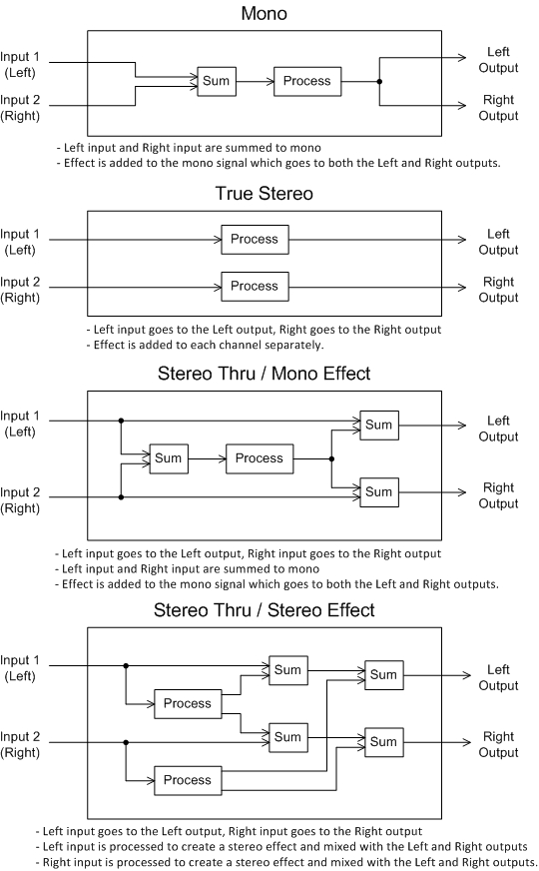

# Appendix B - Line 6 Effect Processing Table

|  |  |  |  |  |  |  |
| --- | --- | --- | --- | --- | --- | --- |
| **Category** | **Name** | **Processing** |  | **Category** | **Name** | **Processing** |
| Vol/Pan | Volume Pedal | True Stereo |  | Vol/Pan | Pan Pedal | True Stereo |
| Dynamics | Boost Comp | Mono |  | EQ | Graphic EQ | True Stereo |
| Dynamics | Red Comp | Mono |  | EQ | Studio EQ | True Stereo |
| Dynamics | Blue Comp | Mono |  | EQ | Parametric EQ | True Stereo |
| Dynamics | Blue Comp Treb | Mono |  | EQ | 4 Band Shift EQ | True Stereo |
| Dynamics | Vetta Comp | Mono |  | EQ | Mid Focus EQ | True Stereo |
| Dynamics | Vetta Juice | Mono |  | Wah | Vetta Wah | True Stereo |
| Dynamics | Tube Comp | Mono |  | Wah | Fassel | True Stereo |
| Dynamics | Noise Gate | Mono |  | Wah | Weeper | True Stereo |
| Distortion | Tube Drive | Mono |  | Wah | Chrome | True Stereo |
| Distortion | Screamer | Mono |  | Wah | Chrome Custom | True Stereo |
| Distortion | Overdrive | Mono |  | Wah | Throaty | True Stereo |
| Distortion | Classic Dist | Mono |  | Wah | Conductor | True Stereo |
| Distortion | Heavy Dist | Mono |  | Wah | Colorful | True Stereo |
| Distortion | Colordrive | Mono |  | Filter | Tron Down | True Stereo |
| Distortion | Buzz Saw | Mono |  | Filter | Tron Up | True Stereo |
| Distortion | Facial Fuzz | Mono |  | Filter | Seeker | True Stereo |
| Distortion | Jumbo Fuzz | Mono |  | Filter | Obi-Wah | True Stereo |
| Distortion | Fuzz Pi | Mono |  | Filter | Voice Box | Stereo Thru/Mono Effect |
| Distortion | Jet Fuzz | Mono |  | Filter | V Tron | Stereo Thru/Mono Effect |
| Distortion | Line 6 Drive | Mono |  | Filter | Throbber | True Stereo |
| Distortion | Line 6 Distortion | Mono |  | Filter | Spin Cycle | True Stereo |
| Distortion | Sub Octave Fuzz | Mono |  | Filter | Comet Trails | True Stereo |
| Distortion | Octave Fuzz | Mono |  | Filter | Slow Filter | True Stereo |
| Delay | Tube Echo | True Stereo |  | Filter | Octisynth | Stereo Thru/Mono Effect |
| Delay | Tube Echo DryThru | True Stereo |  | Filter | Synth O Matic | Stereo Thru/Mono Effect |
| Delay | Tape Echo | True Stereo |  | Filter | Attack Synth | Stereo Thru/Mono Effect |
| Delay | Tape Echo DryThru | True Stereo |  | Filter | Synth String | Stereo Thru/Mono Effect |
| Delay | Multi-Head | Stereo Thru/Mono Effect |  | Filter | Growler | Stereo Thru/Mono Effect |
| Delay | Analog Echo | True Stereo |  | Filter | Q Filter | True Stereo |
| Delay | Analog w/Mod | True Stereo |  | Modulation | Opto Tremolo | Stereo Thru/Mono Effect |
| Delay | Sweep Echo | True Stereo |  | Modulation | Bias Tremolo | Stereo Thru/Stereo Effect |
| Delay | Sweep Echo DryThru | True Stereo |  | Modulation | Pattern Tremolo | True Stereo |
| Delay | Lo Res Delay | True Stereo |  | Modulation | Phaser | Stereo Thru/Stereo Effect |
| Delay | Digital Delay | True Stereo |  | Modulation | Dual Phaser | Stereo Thru/Stereo Effect |
| Delay | Digital Delay w/ Mod | True Stereo |  | Modulation | Panned Phaser | Stereo Thru/Stereo Effect |
| Delay | Stereo Delay | True Stereo |  | Modulation | Barberpole Phaser | True Stereo |
| Delay | Ping Pong | Stereo Thru/Stereo Effect |  | Modulation | Script Phase | True Stereo |
| Delay | Reverse | Stereo Thru/Mono Effect |  | Modulation | U-Vibe | Stereo Thru/Mono Effect |
| Delay | Dynamic Delay | True Stereo |  | Modulation | Analog Flanger | Stereo Thru/Stereo Effect |
| Delay | Auto Volume Echo | True Stereo |  | Modulation | Jet Flanger | Stereo Thru/Stereo Effect |
| Delay | Echo Platter | True Stereo |  | Modulation | AC Flanger | Stereo Thru/Stereo Effect |
| Delay | Echo Platter Dry Thru | True Stereo |  | Modulation | 80A Flanger | Mono |
| Reverb | ‘63 Spring | Stereo Thru/Stereo Effect |  | Modulation | Analog Chorus | Stereo Thru/Stereo Effect |
| Reverb | Spring | Stereo Thru/Stereo Effect |  | Modulation | Tri Chorus | Stereo Thru/Stereo Effect |
| Reverb | Plate | Stereo Thru/Stereo Effect |  | Modulation | Pitch Vibrato | Stereo Thru/Mono Effect |
| Reverb | Room | Stereo Thru/Stereo Effect |  | Modulation | Panner | Stereo Thru/Stereo Effect |
| Reverb | Chamber | Stereo Thru/Stereo Effect |  | Modulation | Rotary Drum | Stereo Thru/Stereo Effect |
| Reverb | Hall | Stereo Thru/Stereo Effect |  | Modulation | Rotary Drm/Hrn | Stereo Thru/Stereo Effect |
| Reverb | Ducking | Stereo Thru/Stereo Effect |  | Modulation | Dimension | Stereo Thru/Stereo Effect |
| Reverb | Octo | Stereo Thru/Stereo Effect |  | Modulation | Ring Modulator | Stereo Thru/Stereo Effect |
| Reverb | Cave | Stereo Thru/Stereo Effect |  | Modulation | Frequency Shifter | True Stereo |
| Reverb | Tile | Stereo Thru/Stereo Effect |  | Pitch | Bass Octaver | Stereo Thru/Mono Effect |
| Reverb | Echo | Stereo Thru/Stereo Effect |  | Pitch | Smart Harmony | Stereo Thru/Mono Effect |
| Reverb | Particle | Stereo Thru/Stereo Effect |  | Pitch | Pitch Glide | Stereo Thru/Mono Effect |

# Appendix C – Cabinet/Mic Phase Correction Timing Data

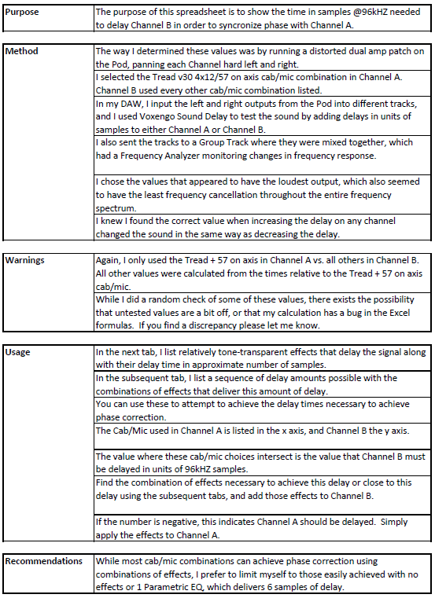

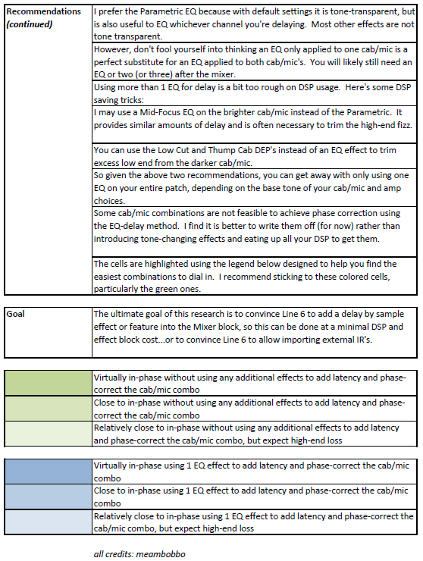

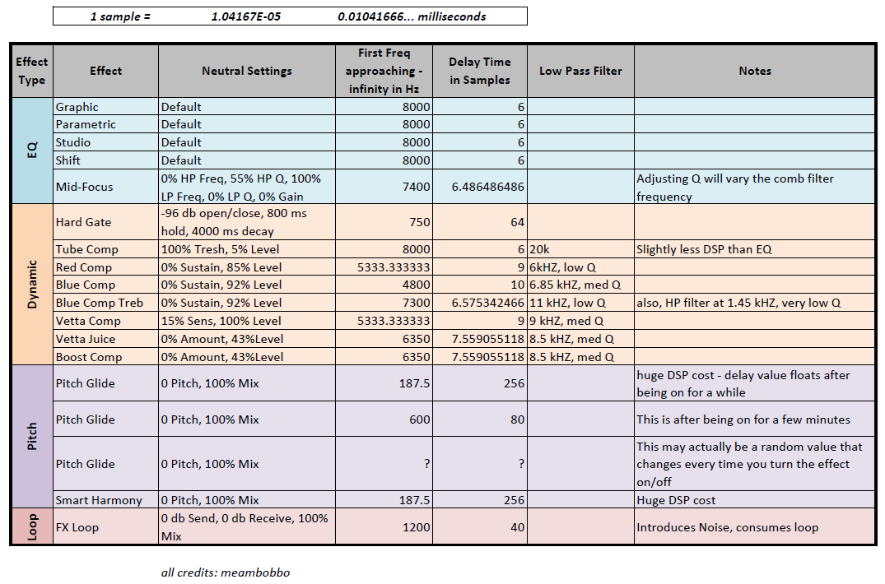

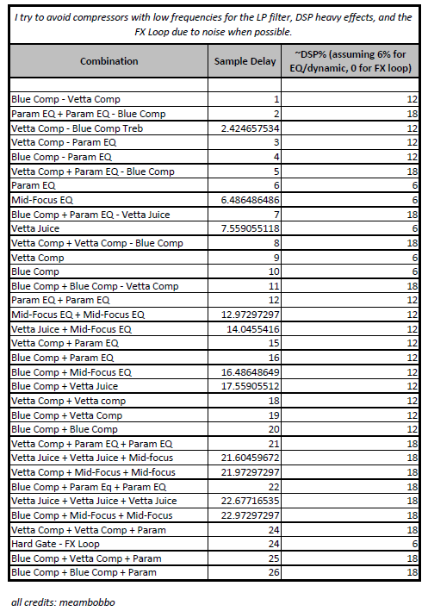

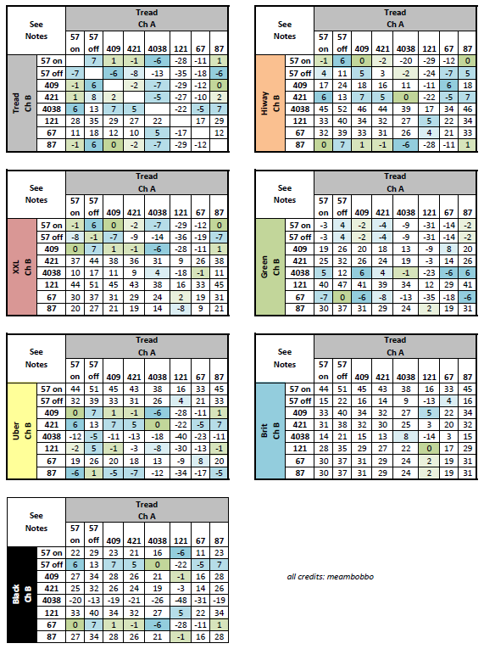

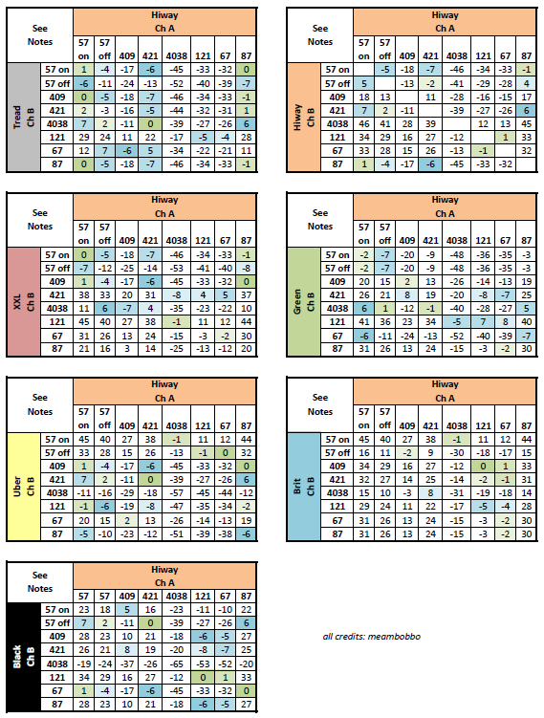

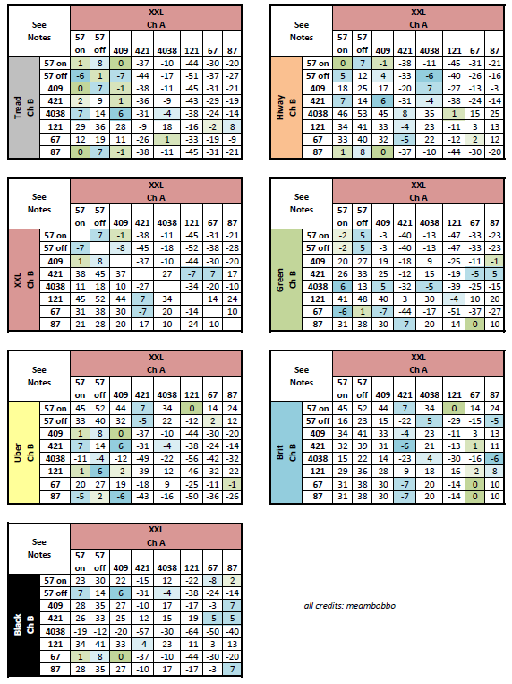

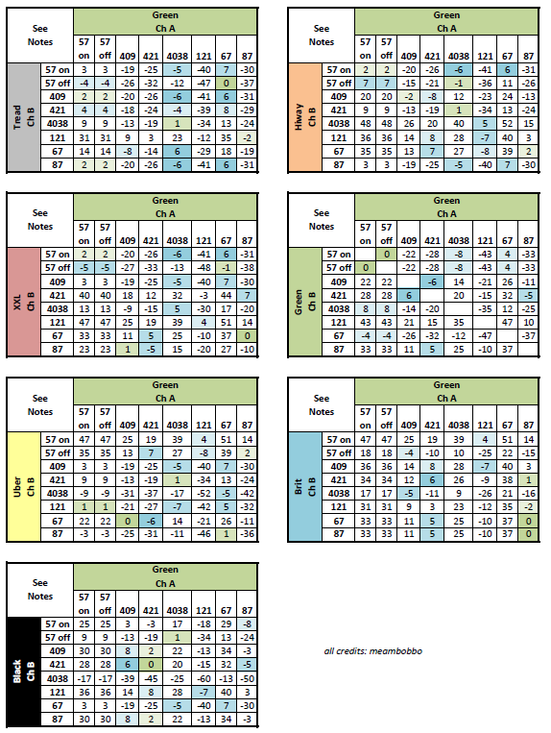

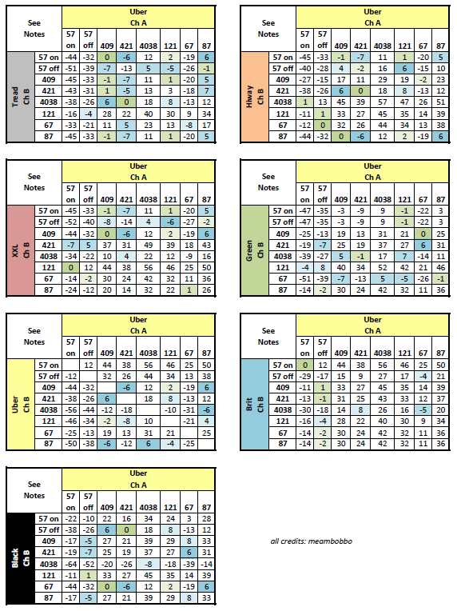

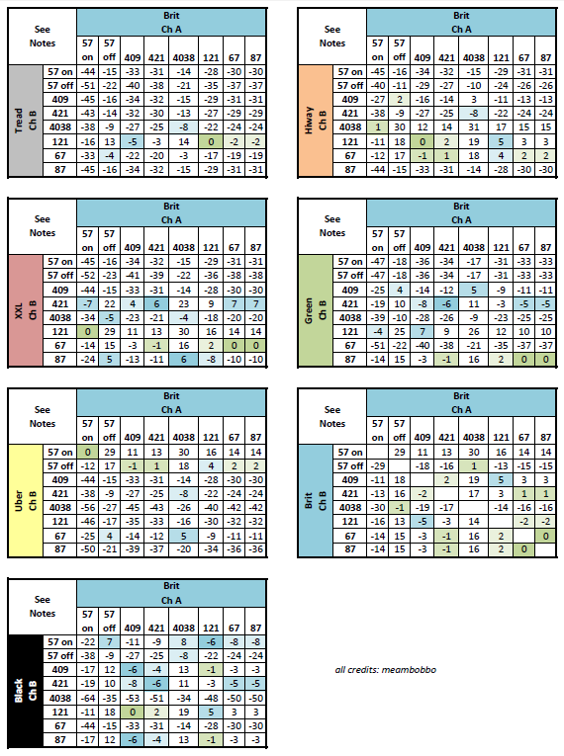

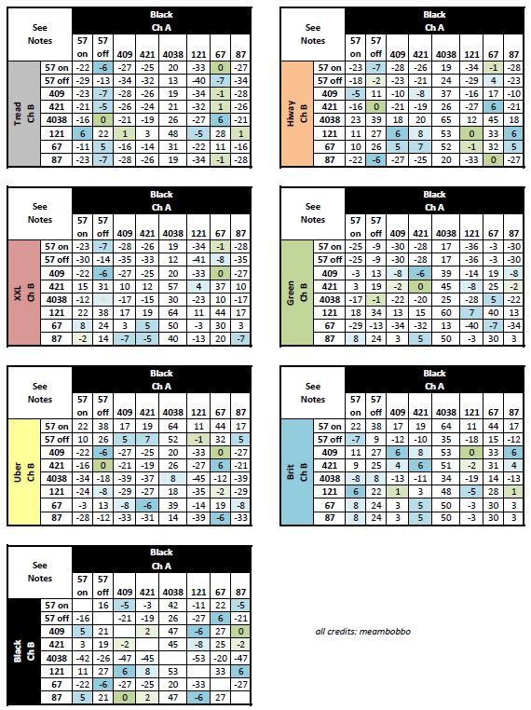

# Appendix D – DSP Usage of Effects

